My markdown demo

Christopher Wilson

28/10/2020

# Introduction

This is text.

# Method

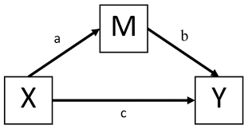

This is an image.

## Design

The design of this study is.

The variables were…

## Participants

* Item 1
* Item 2

# Results

|  |  |  |
| --- | --- | --- |
| route | meanHours | SDHours |
| FullTime | 3.66 | 2.361338 |
| PartTime | 4.40 | 2.610810 |

# Discussion

This is a blockquote