The job card flow is starting to get confusing with the new update. I need to refocus it and the scheduling isnt very user friendly and has created a complexity to this that i do not like. It should be alot easier than this. This is step by step what i deal with when i click start new job
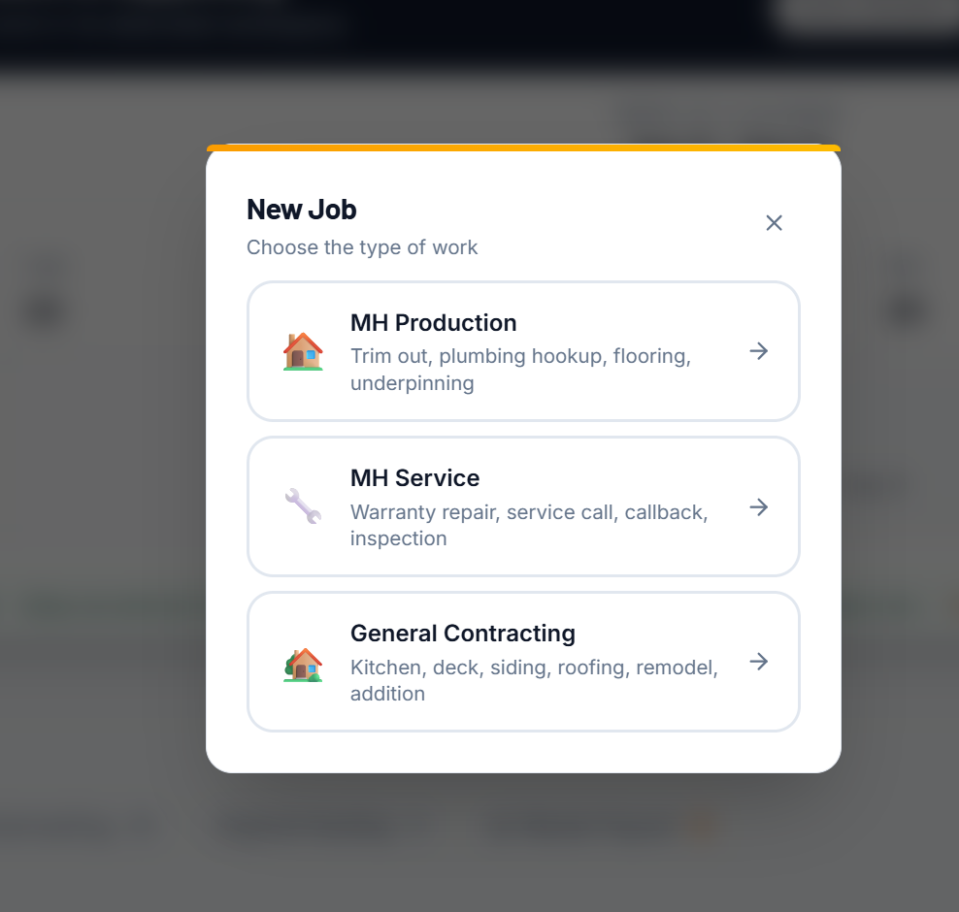
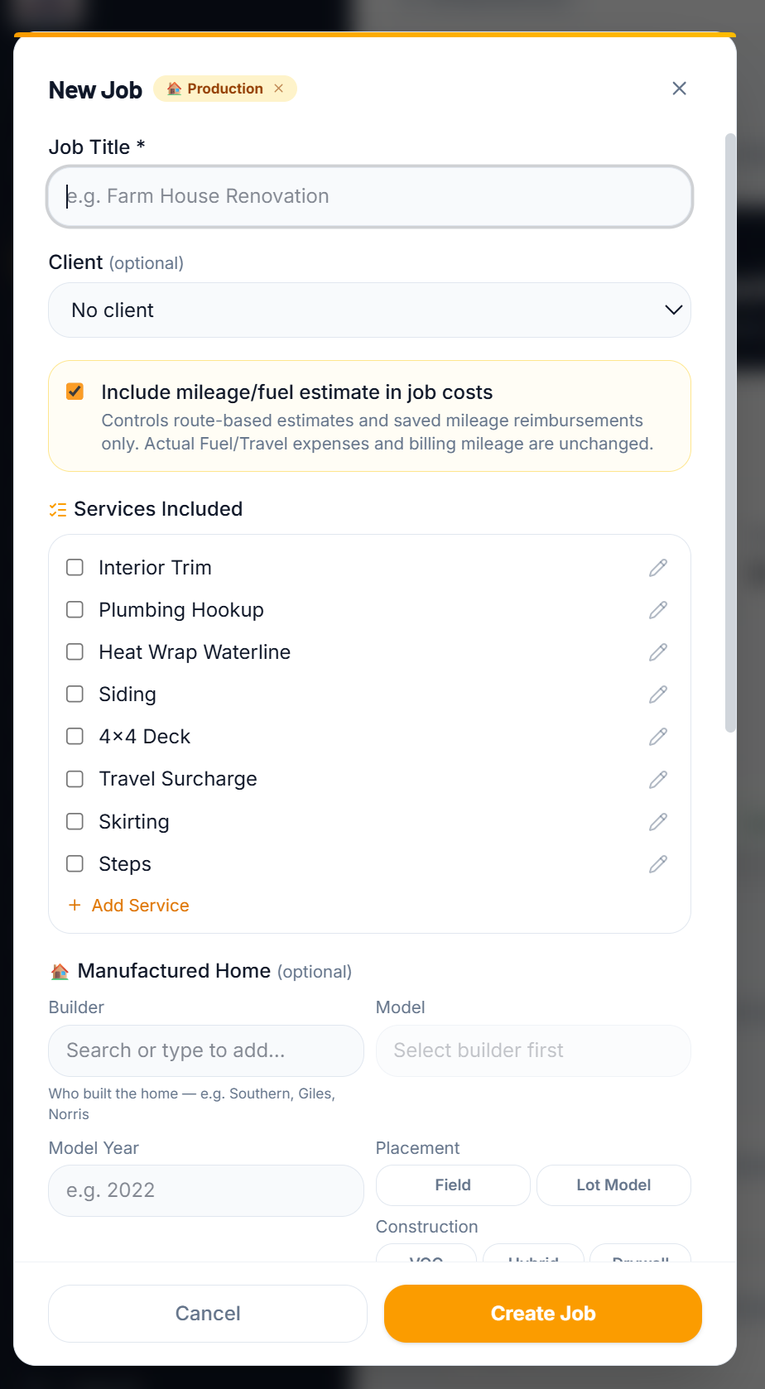
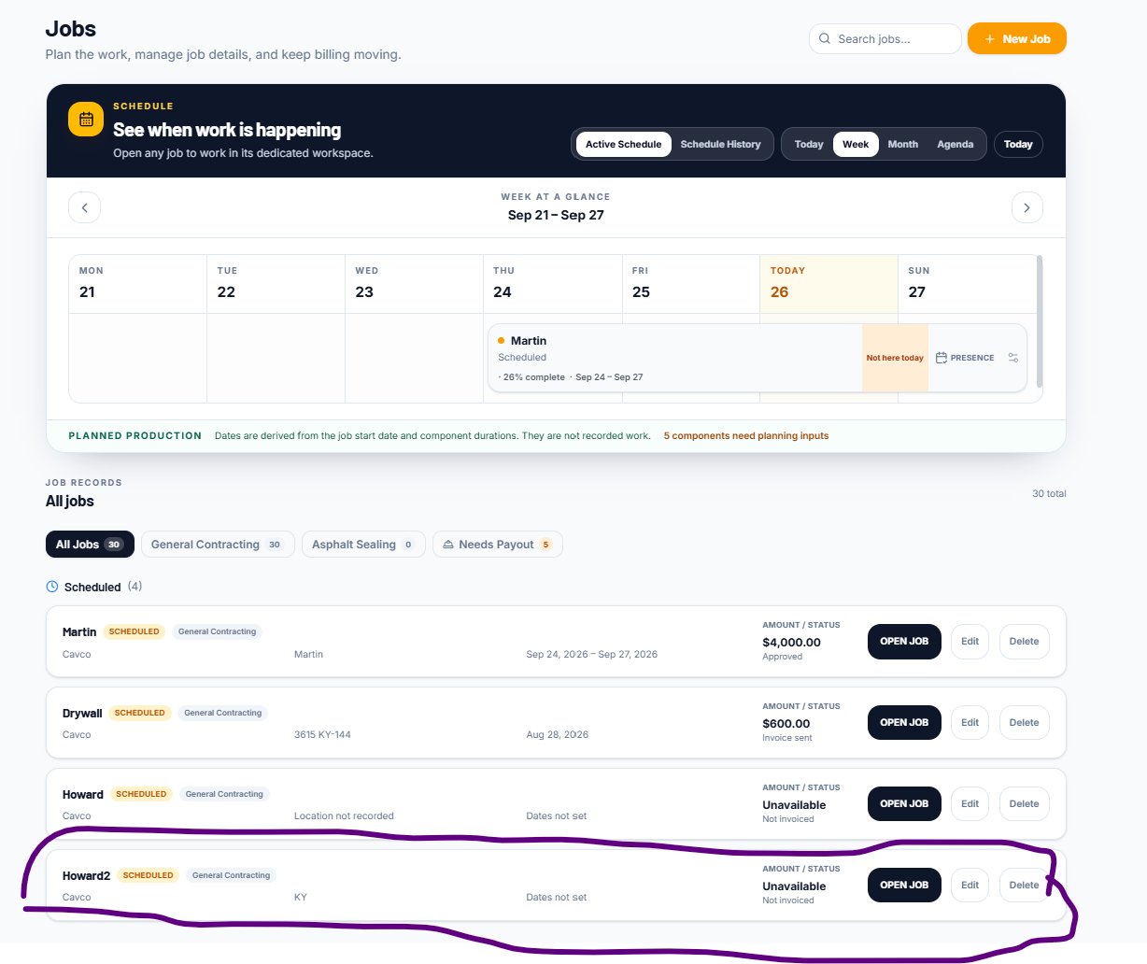
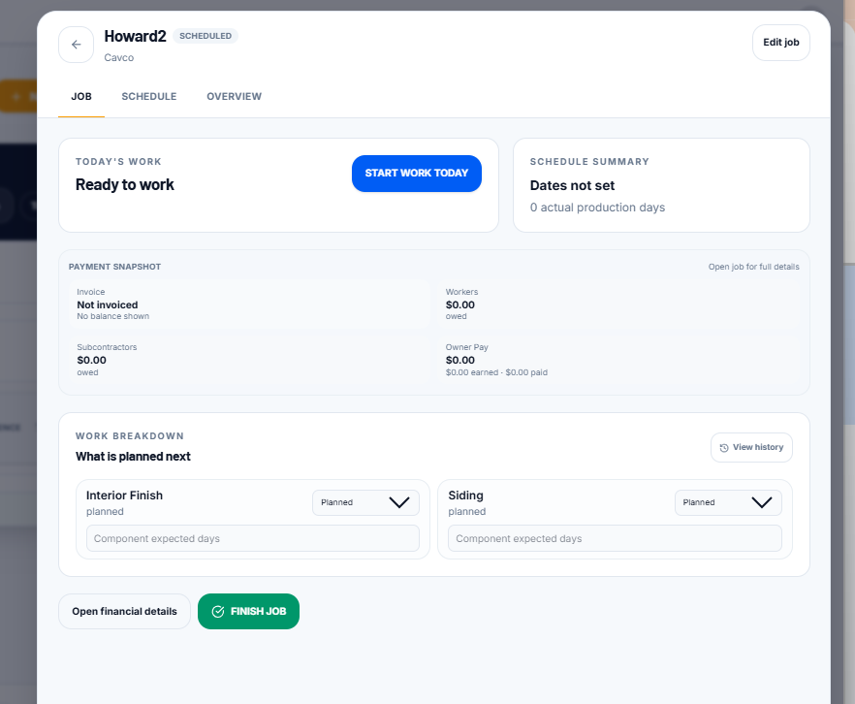
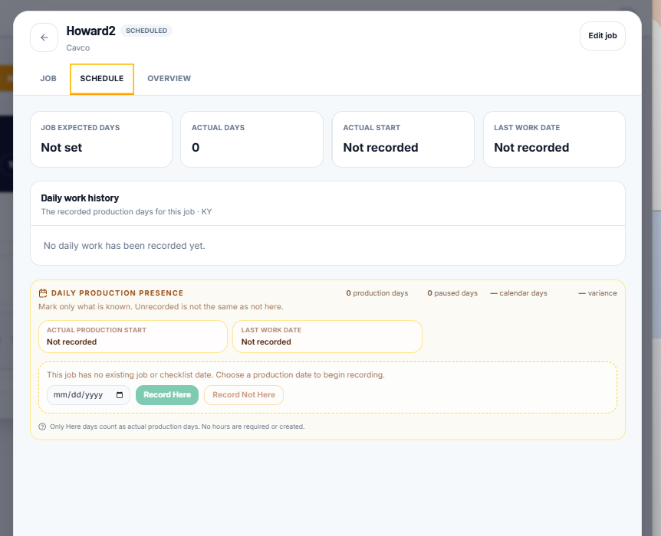
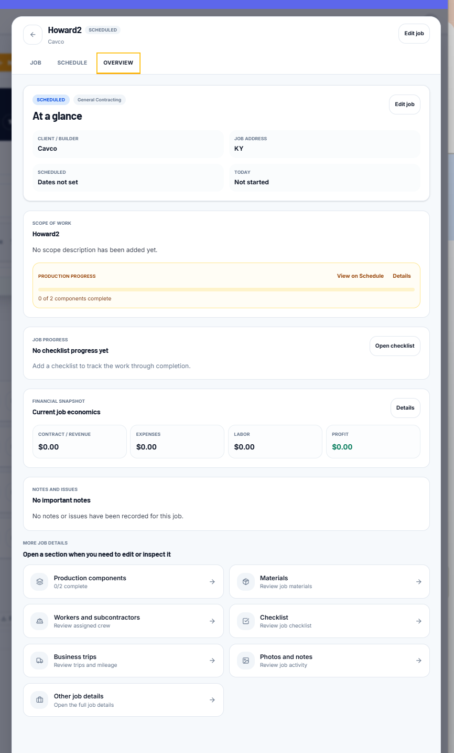

Where is the invoice and and if there is no financials then where is the 8680.00 coming from?
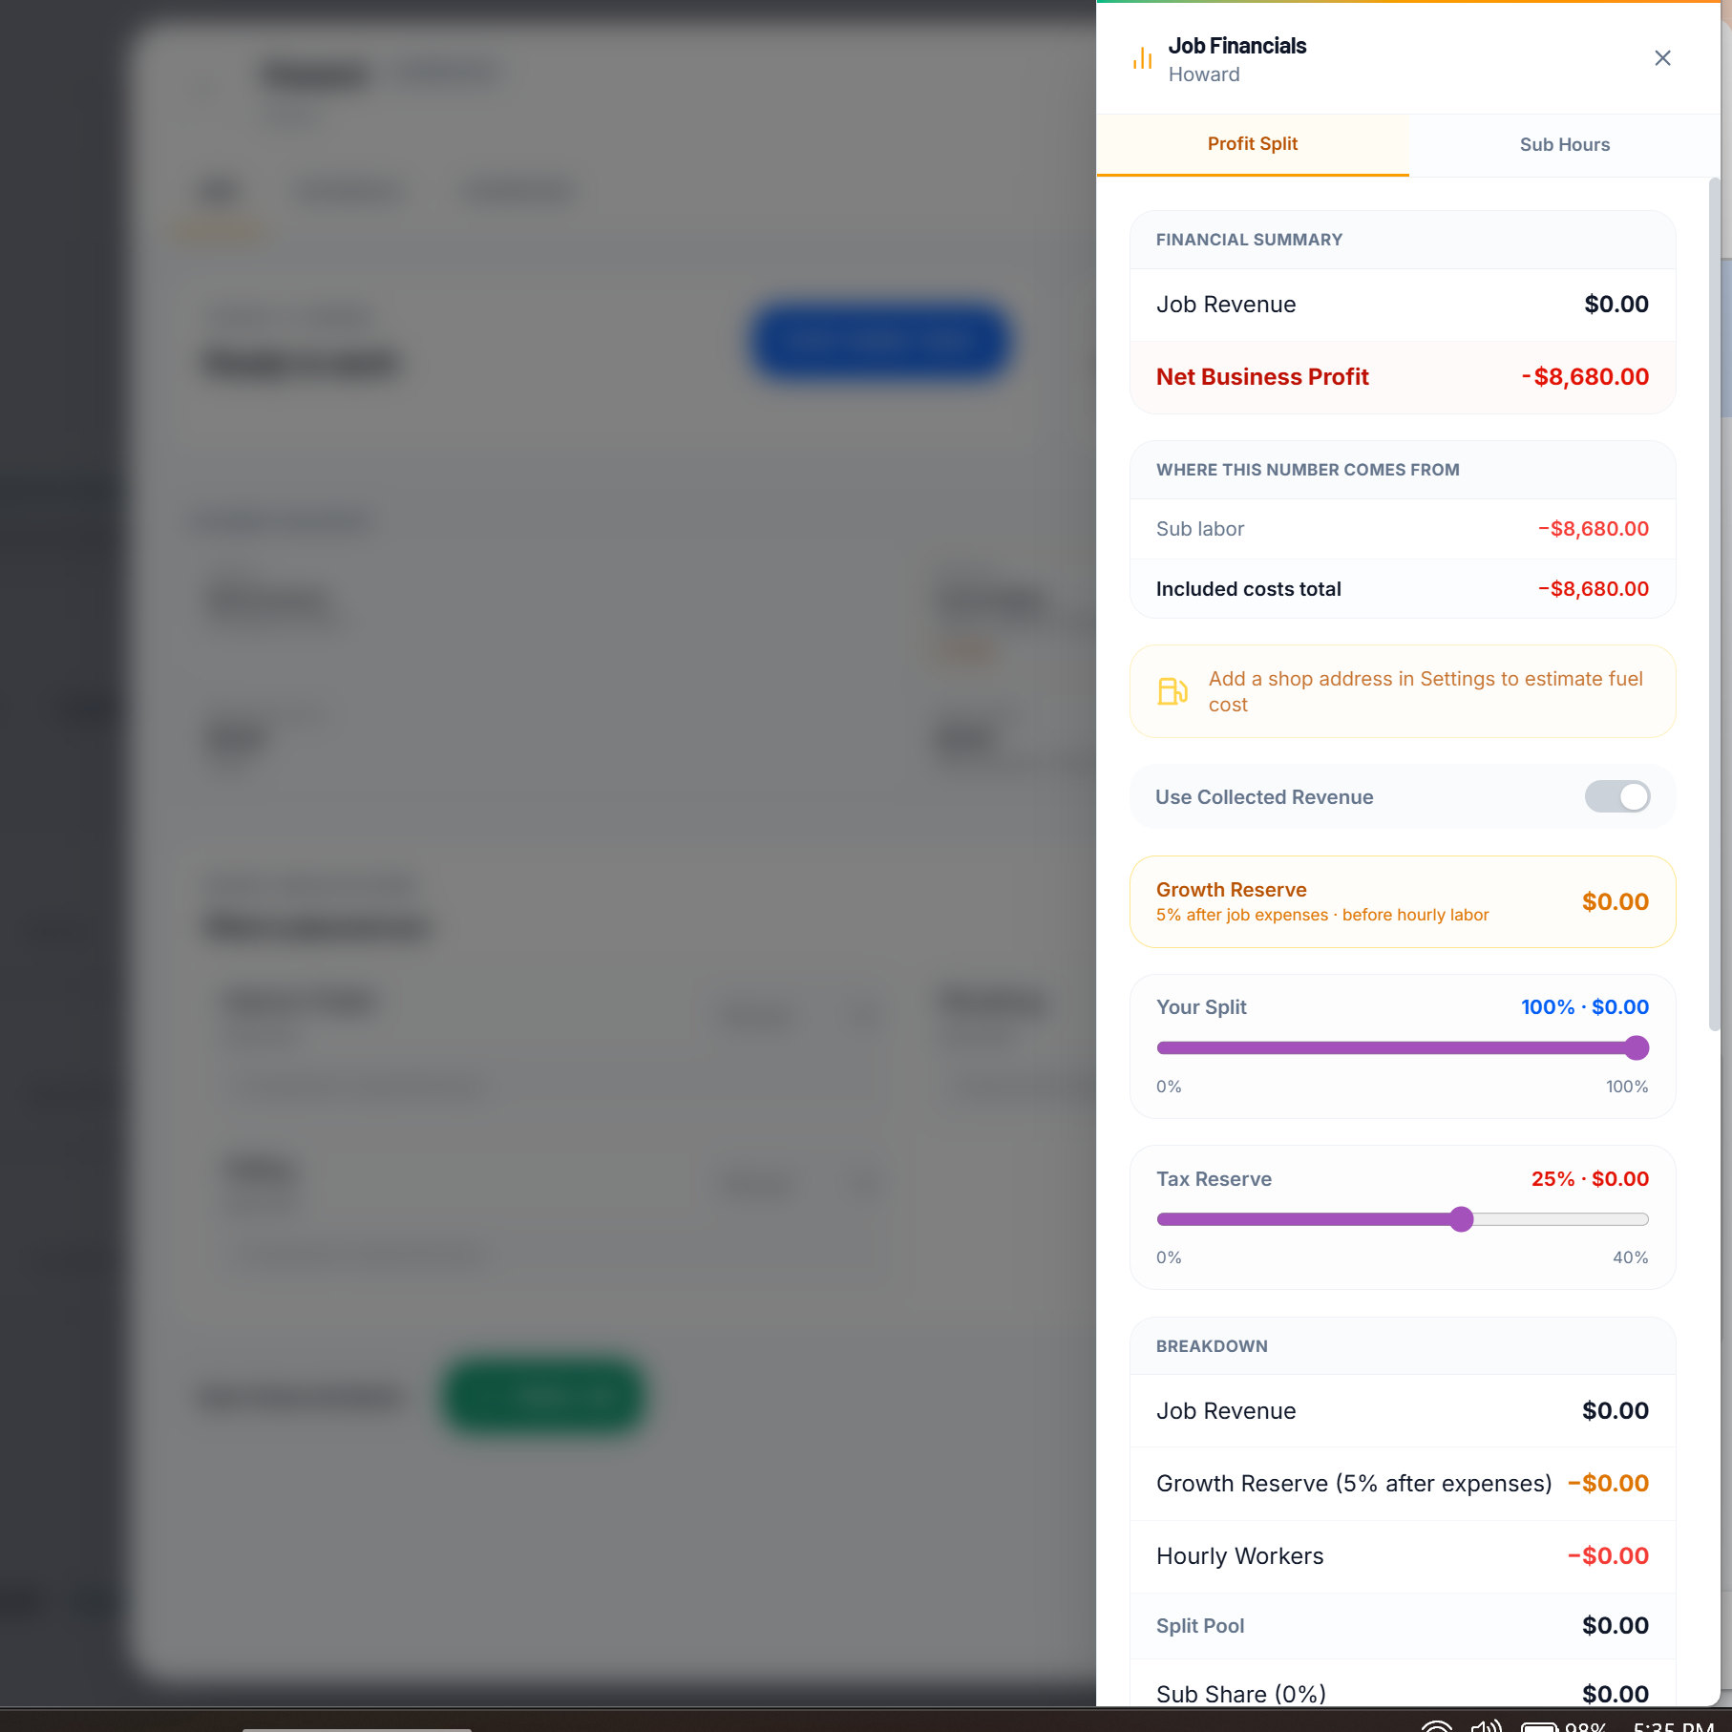
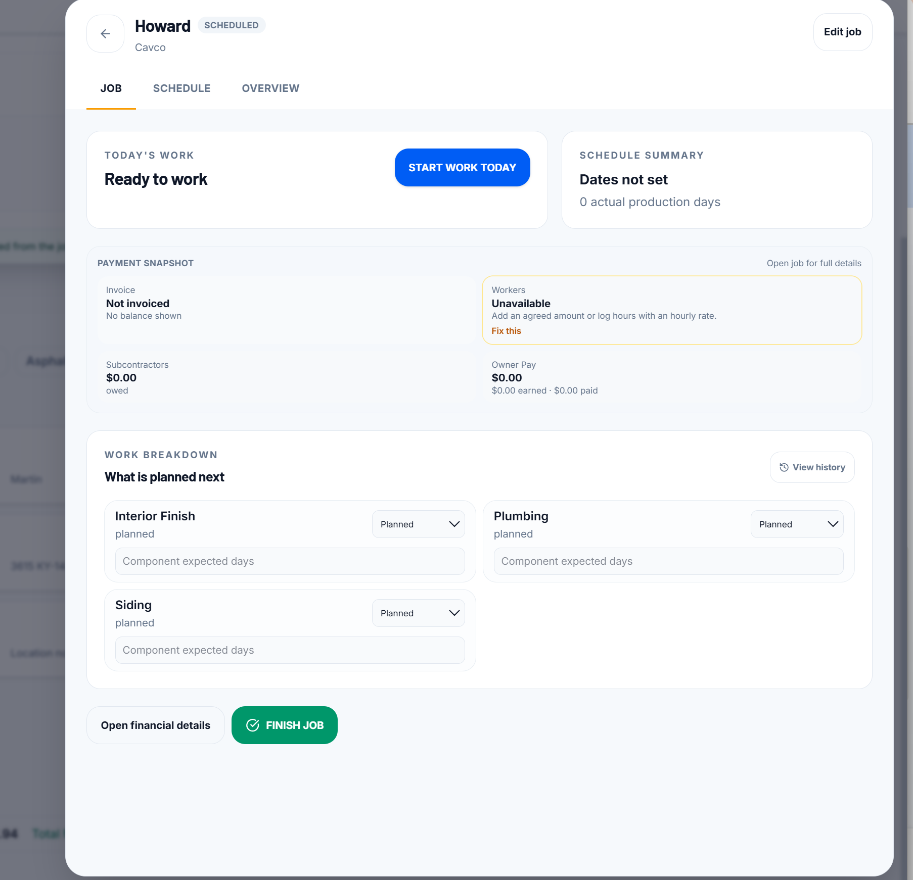
This is what it does when i hit edit that i circled it pops up a screen to edit the job in the background.
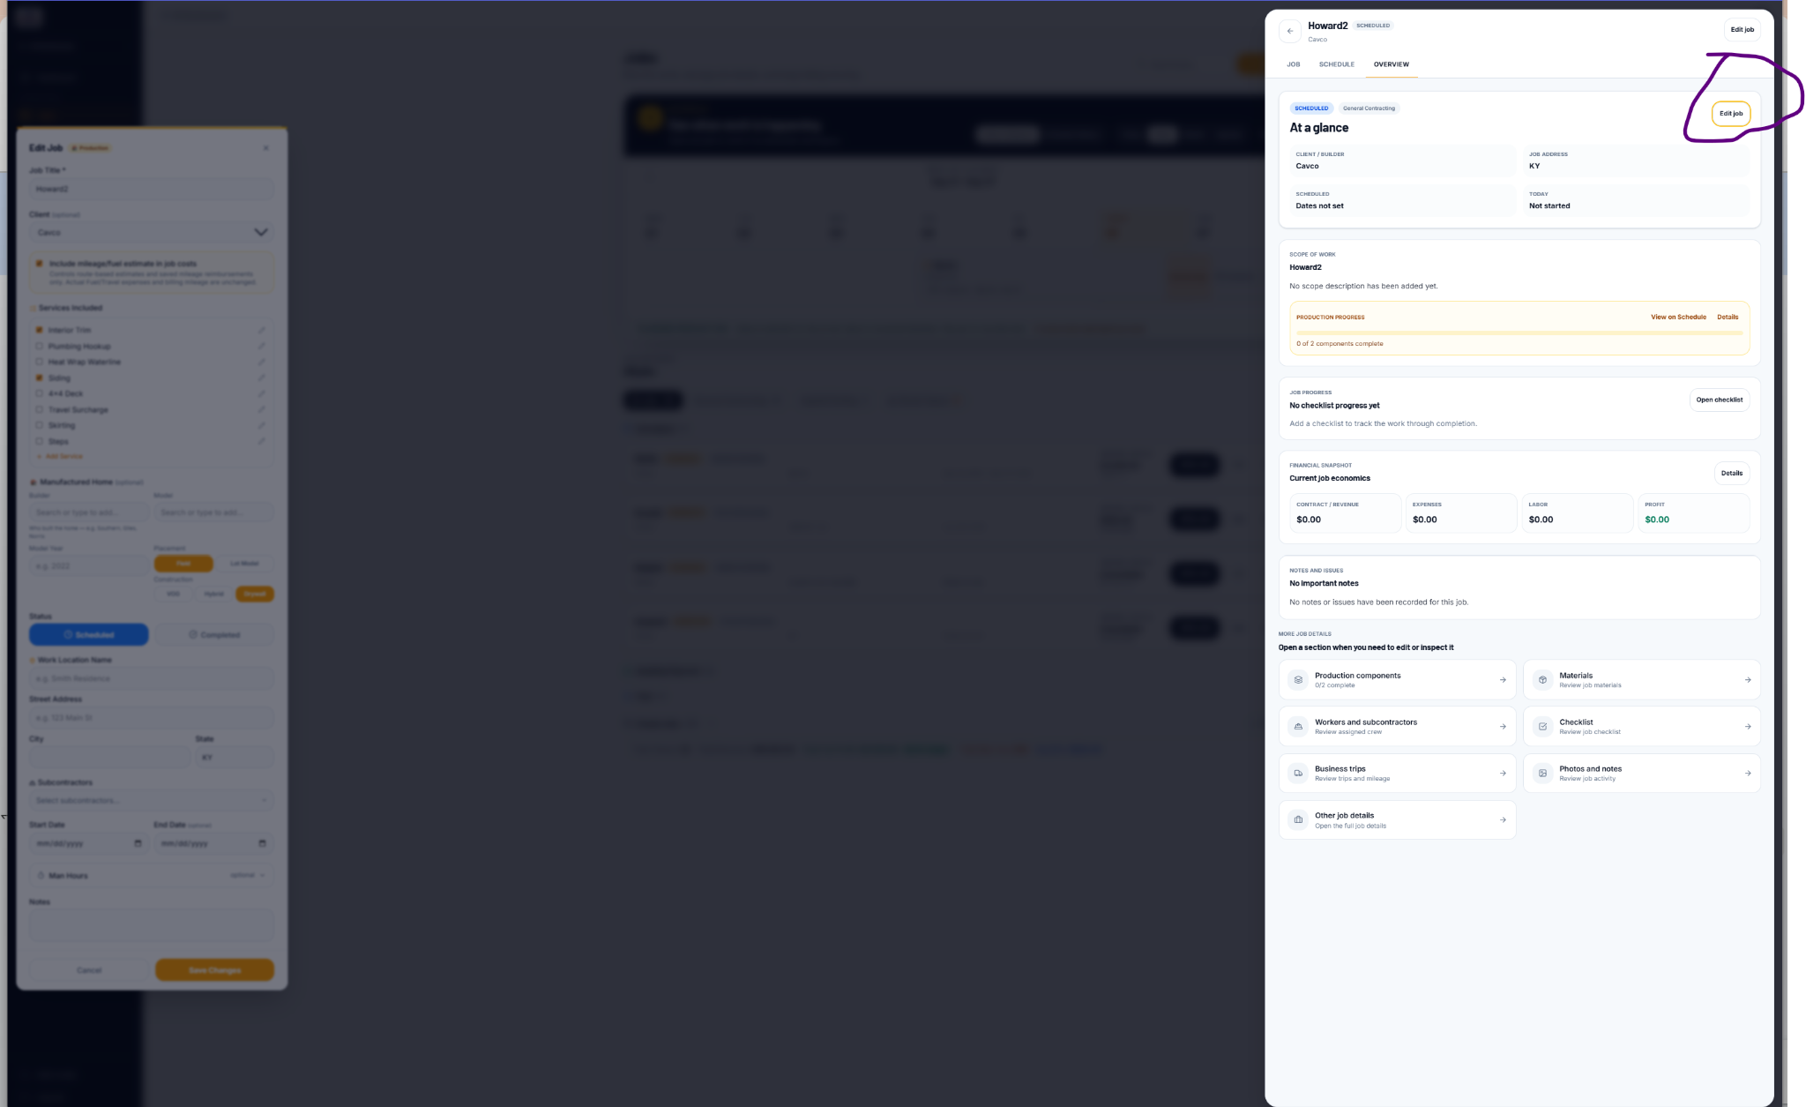



This is all too much and all over the place and starting work doesnt work still and its not needed, i just want to be able to select if we were there that day or not and be done with that. So the calender is just a useless thing and hard to see. Way to complicated for me when i just asked for something very simple.
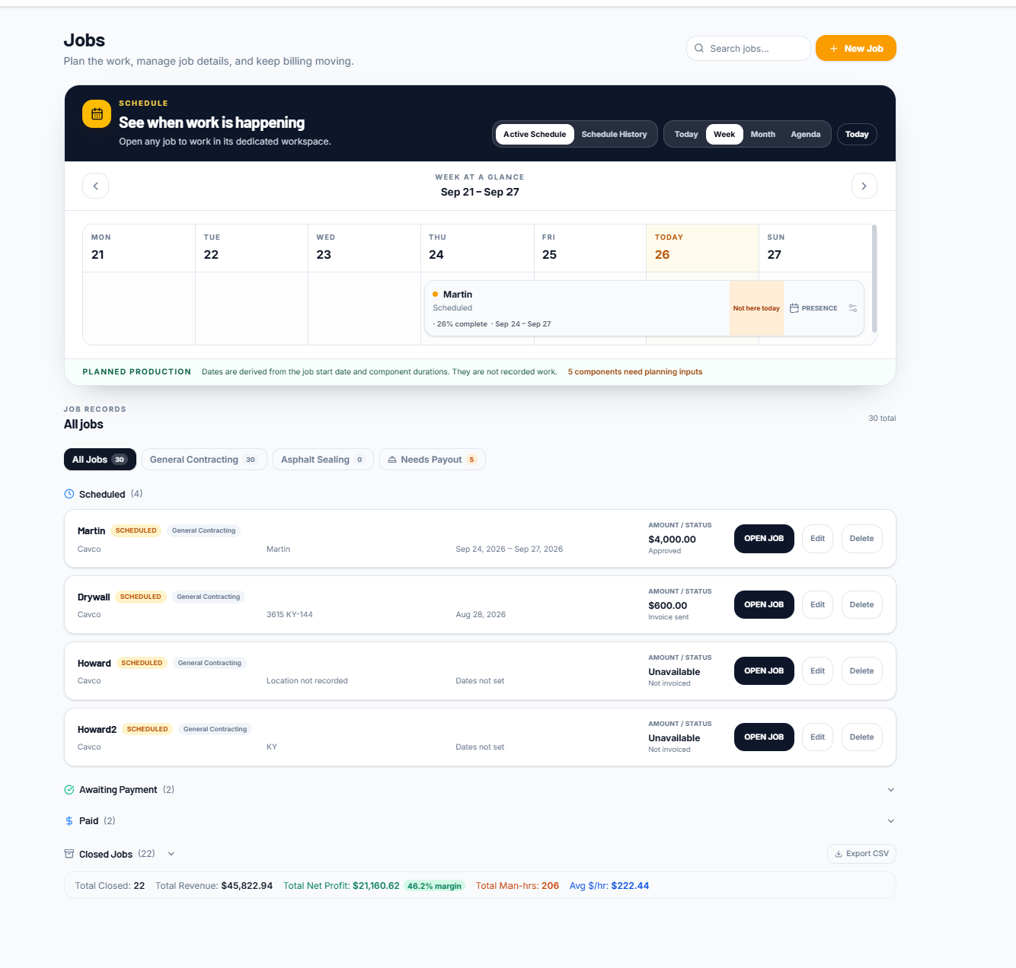
Who can look at that as see whats going on or coming up?
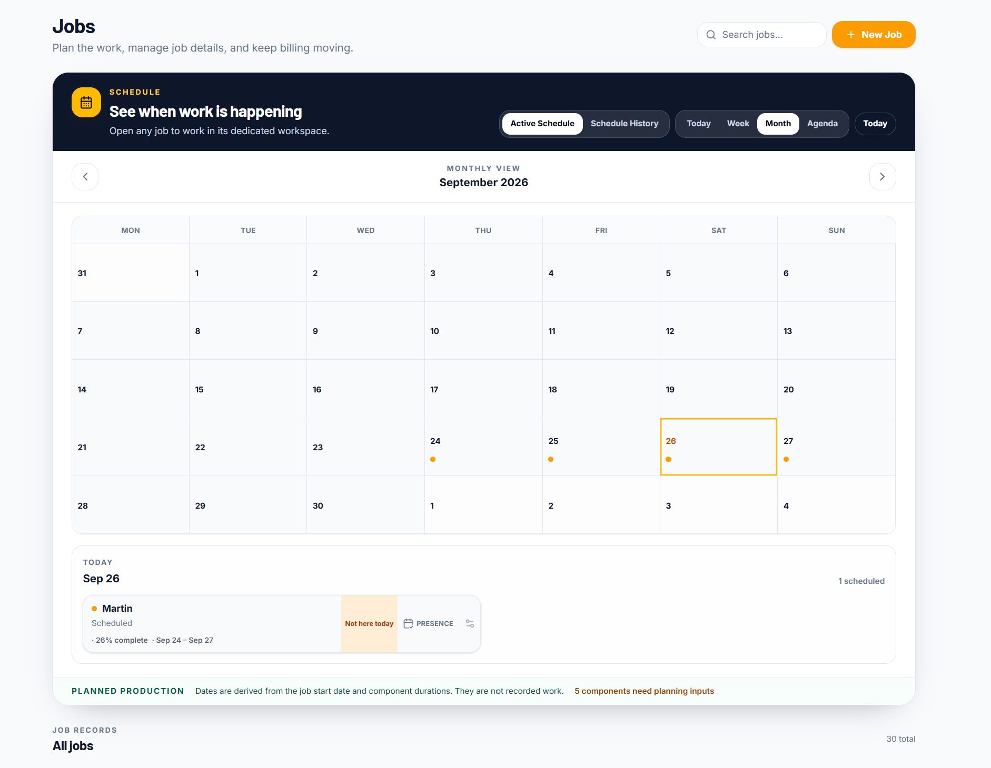
I see dots but have no clue whats going on those days. Or even know what we have lined up.

Also still no way to close out my paid jobs
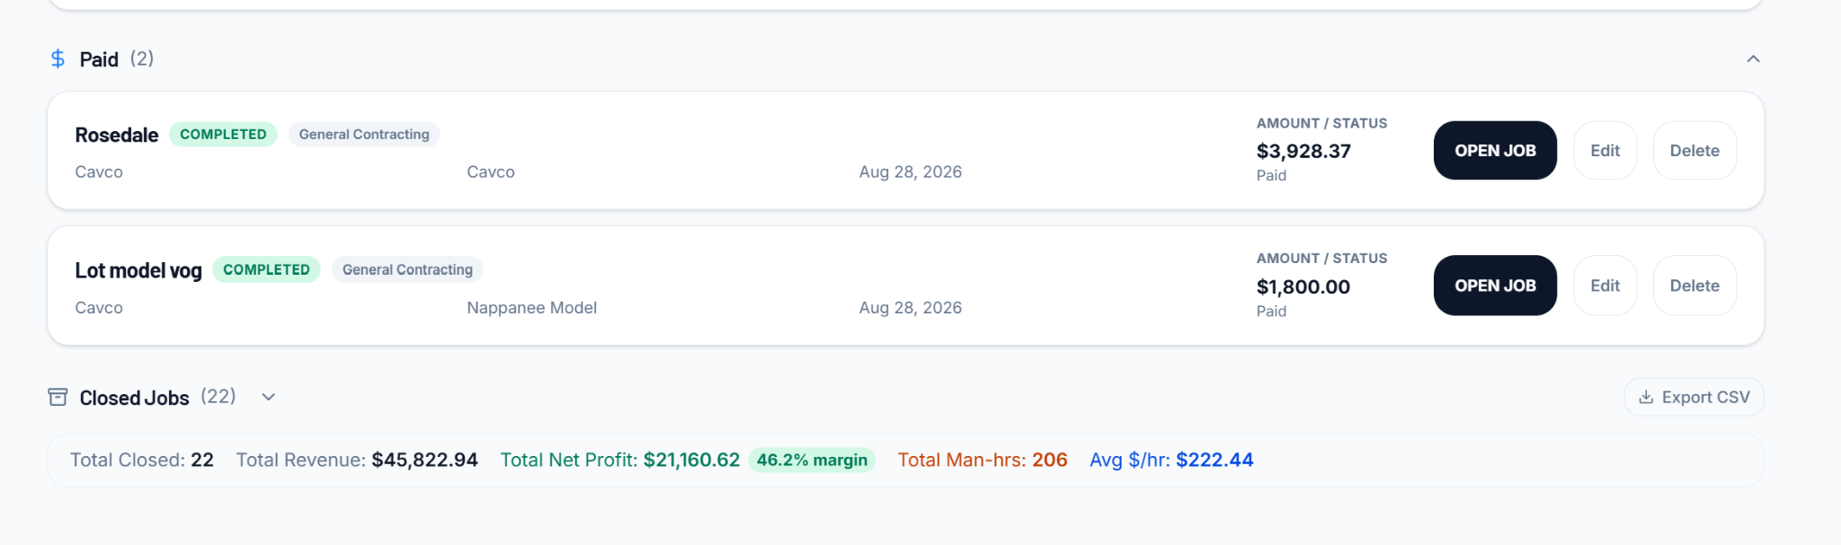

Something i would like to see for my clients is the ability to connect multiple contacts to a client, this way that would help organize my contact page I can just go to the client page to quickly look up someone or maybe just take someone out of the contact and put them in the right client and show their position in that business or something of that nature.


