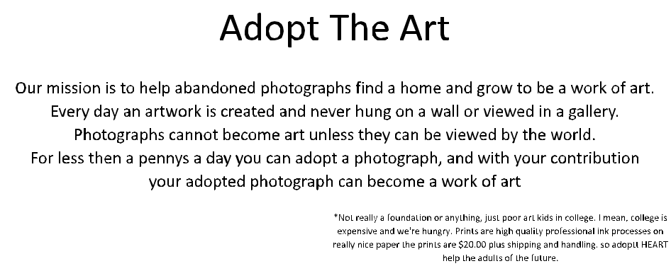

Our mission is to help abandoned photographs find a home and grow to be a work of art. Everyday an artwork is created and never hung on a wall or viewed in a gallery. Photographs cannot become art unless they can be viewed by the world. For less then a one cup of coffee you can adopt a photograph, and with your contribution your adopted photograph can become a work of art.*

* Not really a foundation or anything, just a poor art kid in college, I mean college is expensive and I’m poor. All work displayed on site is by myself Christopher McAdams; the prints are high quality professional pigment prints on some nice paper. The prints are $20.00 plus shipping and handling. So anyways, please have a heart and adopt some art.

stop();

about.addEventListener(MouseEvent.CLICK, clickSelection);

buy.addEventListener(MouseEvent.CLICK, clickSelection);

home.addEventListener(MouseEvent.CLICK, clickSelection);

function clickSelection (evtObj:MouseEvent)

{trace ("the "+evtObj.target.name+" button was clicked")

gotoAndStop (evtObj.target.name);}

cm.addEventListener(MouseEvent.CLICK, callLink);

function callLink(e:MouseEvent):void {

var request:URLRequest = new URLRequest("http://www.christophermcadams.com");

navigateToURL(request,"_black");

}