

**UNIVERSITI MALAYSIA SARAWAK**

**Faculty of Computer Science and Information Technology**

**Assignment/Report Cover Sheet**

|  |  |  |  |
| --- | --- | --- | --- |
| **Student Name (lecturer group number)** | **Student Id Number** | **L. Group** | **Signature** |
| Holifield William (L.G01) | 69861 | 04 |  |
| Muhd Hamarudin bin Omar Ali (L.G01) | 70653 | 04 |  |
| Christopher Sii How Chiong (L.G01) | 69385 | 04 |  |
| Mohd Zaki bin Ahmad Mustafa (L.G01) | 72368 | 04 |  |
| Siti Hamizah binti Zainul Abidin (L.G01) | 72676 | 04 |  |
| Ting Lee Ji (L.G01) | 72713 | 04 |  |

|  |  |  |  |  |
| --- | --- | --- | --- | --- |
| Subject Code: **TMF2223 G1** | | Subject Name: **Object Oriented Software Development** | | |
| Assignment Title: | **Assignment 1** | | Lecturer: | **Dr. Chai Soo See** |
| Due Date: **27/11/2020, 10:00am** | | | Date Submitted: **27/11/2020** | |

***Plagiarism and Collusion are methods of cheating that falls under Peraturan Akademik Universiti Malaysia Sarawak para 11: Etika Akademik***

**Plagiarism**

Plagiarism is the presentation of work which has been copied in whole or in part from another person’s work, or from any other source such as the internet, published books or periodicals without due acknowledgement given in the text.

**Collusion**

Collusion is the presentation of work that is the result in whole or in part of unauthorized collaboration with another person or persons.

Where there are reasonable grounds for believing that cheating has occurred, the only action that may be taken when plagiarism or collusion is detected is for the staff member not to mark the item of work and to report or refer the matter to the Dean. This may result in work being disallowed and given a fail grade or if the circumstances warrant, the matter may be referred to a Committee of inquiry for investigation. Such investigation may result in the matter being referred to the University Discipline Committee, **which** has the power to exclude a student.

**MARK :**

**Upon placing signature above, I certify that I have not plagiarized the work of others or participated in unauthorized collusion when preparing this assignment.**

**I also certify that I have taken proper case in safeguarding my work and have made all reasonable efforts to ensure that may work not be able to be copied.**

**Table of Contents**

**1.0** **Question 1** 1

1.1 Use case diagram 1

1.2 Use case specification 2

1.2.1 Use case specification for EUC-1 Register detail. 2

1.2.2 Use case specification for UC-1 Log in. 3

1.2.3 Use case specification for UC-2 Make an appointment. 4

1.2.4 Use case specification for UC-3 Confirm appointment. 5

1.2.5 Use case specification for UC-4 Cancel appointment. 6

1.2.6 Use case specification for UC-5 View profile. 7

1.2.7 Use case specification for UC-6 View schedule. 8

1.2.8 Use case specification for UC-7 Make payment. 9

1.3 Requirements. 10

**2.0** **Question 2** 11

2.1 Sequence diagram. 11

2.1.1 Register detail sequence diagram. 11

2.1.2 Log in system sequence diagram. 12

2.1.3 Make an appointment system sequence diagram. 13

2.1.4 Cancel appointment sequence diagram. 14

2.1.5 View profile sequence diagram. 15

2.1.6 Make payment sequence diagram 16

**3.0** **Question 3** 17

**4.0** **Individual Contribution** 18

# **1.0 Question 1**

Using Visual Paradigm, develop a **use case diagram** with **use cases** (6 to 10 use cases) to reflect the requirements of the given case study. Noted that each use case must couple with correspondent **use case description**.

## 1.1 Use case diagram

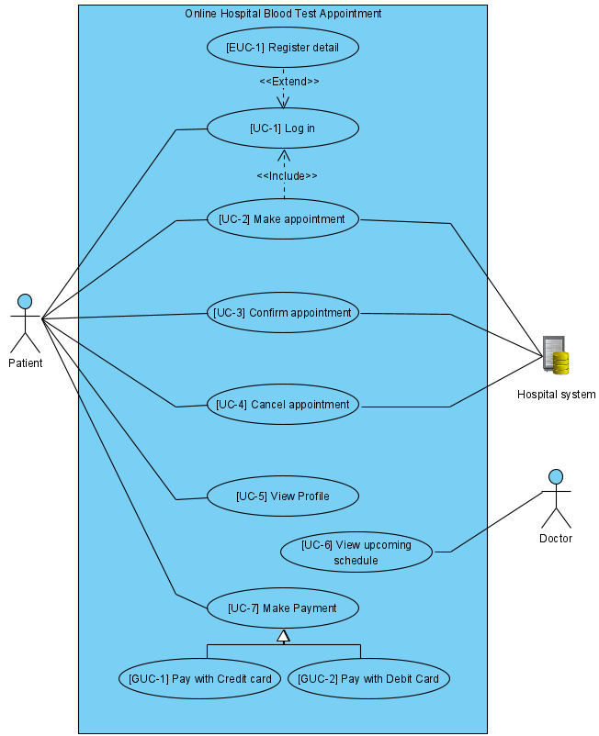

*Figure 1*. Use case diagram.

## 1.2 Use case specification

### 1.2.1 Use case specification for EUC-1 Register detail.

*Table 1.*  Use case specification for EUC-1 Register detail.

|  |  |
| --- | --- |
| **Use Case ID:** | EUC-1 |
| **Use Case Name** | Register detail |
| **Short Description:** | Registers an account for patient which will enable selection slot of appointment. |
| **Trigger Action:** | Patient creates a new account |
| **Actors:** | Patient |
| **Requirements:** | R1.1; R1.2; R1.3; R2.1; R2.2; R2.3 |
| **Pre-Conditions:** | 1. Patient accesses to the “*Register*” page |
| **Post-Conditions:** | 1. Patient able to access his/her account |
| **Main Flow:**   1. Patient clicks “*Register Now*” button. 2. System display registration form. 3. Patient inputs required information (name) [E1] 4. Patient inputs required information (date of birth) [E1] 5. Patient inputs required information (IC number) [E1] 6. Patient inputs required information (address) [E1] 7. Patient inputs required information (E-mail) [E1] 8. Patient inputs required information (mobile num.) [E1] 9. Patient uploads photo of identity card. [E1] 10. Patient creates username, and password. [E1] 11. Patient clicks “*Submit*” button. [A1] [E2] 12. System displays registration successful message. 13. System adds new patient account into database. 14. Patient accesses to the relevant homepage. | |
| **Alternate Flows:**   1. Patient cancels registration.  Post-condition→ no account was created. | |
| **Exception Flows:**   1. Patient inputs any invalid or empty personal data or document.   System displays “*Invalid data entered, please try again*.”  Post condition → Use Case resume at main flow (2).   1. Account already exists.   Post-condition → no account was created | |

### 1.2.2 Use case specification for UC-1 Log in.

*Table 2.* Use case specification for UC-1 Log in.

|  |  |
| --- | --- |
| **Use Case ID:** | UC-1 |
| **Use Case Name** | Log in |
| **Short Description:** | Allows Patient to login into a his/her account to manage personal appointment. |
| **Trigger Action:** | Patient creates a new account |
| **Actors:** | Patient |
| **Requirements:** | R1.1; R1.3; R1.4; R2.2 |
| **Pre-Conditions:** | 1. Patient accesses to the “Log in” page |
| **Post-Conditions:** | 1. Patient accesses to the relevant homepage. |
| **Main Flow:**   1. Patient clicks “Log in” button. 2. Patient inputs username. [A1] 3. Patient inputs password. 4. Patient clicks “Submit” button. [A2] 5. System verify username and password. [E1] 6. System displays a successful message. 7. System displays relevant homepage. | |
| **Alternate Flows:**   1. Patient has no account.   Post-condition→ patient accesses “*Register Now*” page.   1. Patient forgot username or password.   Post-condition→ patient accesses “*forgot username/password*”  page. | |
| **Exception Flows:**   1. Patient enters invalid username or password.   Post-condition→ system displays error message, and the Use Case  resume at main flow (2). | |

### 1.2.3 Use case specification for UC-2 Make an appointment.

*Table 3.* Use case specification for UC-2 Make an appointment.

|  |  |
| --- | --- |
| **Use Case ID:** | UC-2 |
| **Use Case Name** | Make an appointment |
| **Short Description:** | The patient will use this function to select their appointment slot. Once logged on to patient account, patient will be able to access “M*ake an appointment*” page where patient can select available slot for appointment allocated which is one hour apart. There is a limit of 15 appointments for each slot. |
| **Trigger Action:** | Patient makes an appointment |
| **Actors:** | Patient |
| **Requirements:** | R1.7; R2.2; R2.3 |
| **Pre-Conditions:** | 1. Patient successfully logged in. 2. Patient accesses to the “M*ake an appointment*” page. |
| **Post-Conditions:** | 1. Patient appointment successfully created. |
| **Main Flow:**   1. Patient clicks “*Log in*” to access patient account. 2. Patient fills in username and password. 3. System checks username and password validity. 4. System displays the relevant homepage. 5. Patient clicks “*Make an appointment*” button. 6. System retrieves available slot. 7. Patient selects an appointment slot. 8. System displays message “*Only 15 appointments for each slot. Every appointment is one hour apart.”* 9. System displays available times for selected slot. (E1) 10. Patient selects an available time. 11. Patient clicks “*Submit*” button. (A1) 12. System records selected time into the patient database. 13. System displays “*Your appointment successfully created. Please confirm the appointment at least 3 days or at most 3 months in advance.”* | |
| **Alternate Flows:**   1. Discard appointment  Post-Conditions→ No appointment was made | |
| **Exception Flows:**   1. All 15 appointments for selected slot are fully booked. System   displays “*All available time has been booked. Select another slot.*”  Post-Condition→ Use case resumes at main flow 7. | |

### 1.2.4 Use case specification for UC-3 Confirm appointment.

*Table 4.* Use case specification for UC-3 Confirm appointment.

|  |  |
| --- | --- |
| **Use Case ID:** | UC-3 |
| **Use Case Name** | Confirm appointment |
| **Short Description:** | The patient will use this function to confirm a booked appointment. A verification email confirming the appointment will be send to the patient once “*confirm*” button clicked in the system. |
| **Trigger Action:** | Patient confirms created appointment. |
| **Actors:** | Patient |
| **Requirements:** | R.1.8; R2.2; R2.3 |
| **Pre-Conditions:** | 1. The patient has successfully logged in.  2. The patent has successfully made an appointment. |
| **Post-Conditions:** | 1. The confirmation appointment was recorded by the system. |
| **Main Flow:**   1. Patient clicks “*Log in*” to access patient account. 2. Patient fills in username and password. 3. System checks username and password validity. 4. System displays the relevant homepage. 5. Patient clicks “*Confirmation appointment*” button to access list of appointments booked by patient. 6. Patient clicks “*Confirm*” button right next to the selected appointment list. [A1] 7. System sends a verify mail to patient. 8. System displays “*A verification mail has been sent to your E-mail.*” 9. The patient received an email notification. 10. The patient clicks the provided link to confirm the appointment. 11. The user clicks the button “*confirm”.* [E1] 12. The confirmation was recorded by the system | |
| **Alternate Flows:**   1. Cancel booked.  Post-Conditions→ No confirmation appointment was made. | |
| **Exception Flows:**   1. exceed the confirmation period given by the system.  Post-Conditions→ Reject application. | |

### 1.2.5 Use case specification for UC-4 Cancel appointment.

*Table 5.*  Use case specification for UC-4 Cancel appointment.

|  |  |
| --- | --- |
| **Use Case ID:** | UC-4 |
| **Use Case Name** | Cancel appointment |
| **Short Description:** | The patient will use this function to cancel a booked appointment. The patient can cancel the successful appointment 1 day before the actual date. Reason for cancellation should be given. Once a cancellation is successful, a free slot will be available. |
| **Trigger Action:** | Patient cancels created appointment. |
| **Actors:** | Patient |
| **Requirements:** | R1.9; R2.2; R2.3 |
| **Pre-Conditions:** | 1. The patient has successfully logged in.  2. The patent has successfully made an appointment. |
| **Post-Conditions:** | 1. System frees the cancellation slot to available slot. |
| **Main Flow:**   1. Patient clicks “*Log in*” to access patient account. 2. Patient fills in username and password. 3. System checks username and password validity. 4. System displays the relevant homepage. 5. Patient clicks “*Cancel Appointment*” button to access list of appointments booked by patient. 6. Patient clicks “*Cancel*” button right next to the selected appointment list. [A1] 7. Patient clicks “*Submit*” button. [E1] 8. System updates the selected slot to available slot. | |
| **Alternate Flows:**   1. Patient clicks “Add reason of cancellation”. Patient fills in reasons   of cancellation.  Post-Conditions→ System records reason of cancellation | |
| **Exception Flows:**   1. exceed the cancellation period given by the system.  Post-Conditions→ Reject application. | |

### 1.2.6 Use case specification for UC-5 View profile.

*Table 6.* Use case specification for UC-5 View profile.

|  |  |
| --- | --- |
| **Use Case ID:** | UC-5 |
| **Use Case Name** | View profile |
| **Short Description:** | The patient will use this function to view account information. Once logged on to patient account, they will be able to access “*View profile*” page where patient can view their personal detail and appointment history. |
| **Trigger Action:** | Patient views personal detail and appointment history. |
| **Actors:** | Patient |
| **Requirements:** | R1.5; R1.6; R2.2; R2.3 |
| **Pre-Conditions:** | 1. The patient has successfully logged in |
| **Post-Conditions:** | 1. The patient views personal details and appointment history. |
| **Main Flow:**   1. Patient clicks “*Log in*” to access patient account. 2. Patient fills in username and password. 3. System checks username and password validity. 4. System displays the relevant homepage. 5. Patient clicks “*View Profile*” button. [A1] 6. System retrieves personal details and appointment history. [E1] 7. System displays personal details and appointment history | |
| **Alternate Flows:**   1. Patient clicks “*Edit detail*” button.   Post-Condition→ Patient modifies personal detail. | |
| **Exception Flows:**   1. System database error.   Post-Condition→ No data retrieve to be view. | |

### 1.2.7 Use case specification for UC-6 View schedule.

*Table 7*. Use case specification for UC-6 View upcoming schedule.

|  |  |
| --- | --- |
| **Use Case ID:** | UC-6 |
| **Use Case Name** | View schedule |
| **Short Description:** | The doctor will use this function to view upcoming appointment schedules information. Once logged on to system with provided account, they will be able to access “*View upcoming appointment schedule*” page where doctor can view their patients’ schedule. |
| **Trigger Action:** | Doctor views upcoming appointment schedule. |
| **Actors:** | Doctor |
| **Requirements:** | R2.3 |
| **Pre-Conditions:** | 1. The Doctor has successfully logged in with provided account. |
| **Post-Conditions:** | 1. The Doctor views upcoming appointment schedule. |
| **Main Flow:**   1. Patient clicks “*Log in*” to access patient account. 2. Patient fills in username and password. 3. System checks username and password validity. 4. System displays the relevant homepage. 5. Patient clicks “*Billing*”. 6. System retrieves outstanding bills. 7. System offers option to pay either credit card or debit card. 8. Patients selects either one payment method. 9. Patients clicks “*Submit*” button. [A1] 10. System displays card credential forms. 11. Patient fills in the credential of the card. 12. Patient clicks “*Submit*” button. [E1] [E2] 13. System receives payment. 14. System generates receipt. 15. Patient receives receipt. | |
| **Alternate Flows:**   1. Doctor clicks “*View patient profile*”   Post-Condition→ The doctor views patients’ profile | |
| **Exception Flows:**   1. System database error   Post-Condition→ No data retrieve to be view. | |

### 1.2.8 Use case specification for UC-7 Make payment.

*Table 8.* Use case specification for UC-7 Make payment.

|  |  |
| --- | --- |
| **Use Case ID:** | UC-7 |
| **Use Case Name** | Make payment |
| **Short Description:** | The patient will use this function to make payment. Once logged on to patient account, patient will be able to access “Billing” page where patient can make payment via online using credit or debit card. |
| **Trigger Action:** | Patient pays outstanding bills. |
| **Actors:** | Patient |
| **Requirements:** | R1.10; R2.2; R2.3 |
| **Pre-Conditions:** | 1. The patient has successfully logged in. 2. The appointment has been confirmed. |
| **Post-Conditions:** | 1. The patient receives receipt |
| **Main Flow:**   1. Patient clicks “Log in” to access patient account. 2. Patient fills in username and password. 3. System checks username and password validity. 4. System displays the relevant homepage. 5. Patient clicks “Billing”. 6. System retrieves outstanding bills. 7. System offers option to pay either credit card or debit card. 8. Patients selects either one payment method. 9. Patients clicks “Submit” button. [A1] 10. System displays card credential forms. 11. Patient fills in the credential of the card. 12. Patient clicks “Submit” button. [E1] [E2] 13. System receives payment. 14. System generates receipt. 15. Patient receives receipt. | |
| **Alternate Flows:**   1. The user cancels the transaction.   Post-Condition→ No payment was made. | |
| **Exception Flows:**   1. In sufficient fund to pay for appointment fee. The user is informed   and the Use Case Terminates.   Post-Condition→ No payment was made.   1. The payment unsuccessful.  Post-Condition→ No payment was made. | |

## 1.3 Requirements.

1.3.1 Performance requirements:

1. All the operations carried out in the system must respond within 2 seconds.
2. The user should be able to register and manage his appointments online at any time.
3. Sufficient disk space and RAM for system minimum requirement
4. The user should be able to login into the system any time.
5. The user can view his profile info at any time.
6. The user can change profile info at any time.
7. The user shall be able to choose the available time allocated for each slot.
8. The user can receive an email of confirmation of appointment.
9. The user can cancel the successful appointment 1 day before the actual date.
10. The user should be able to pay his bill through the system.

1.3.2 Security requirements.

1. The password should be at least 8 characters, 1 Upper case, 1 lower case and 1 number.
2. Actions which cannot be undone should ask for confirmation.
3. Database must store all the information efficiently without any information loss.

# **2.0 Question 2**

Based on the use cases you provided in Question 1, draw **TWO (2) system sequence diagrams (SSD)**. For the other use cases you did not draw SSD, draw **FOUR (4) sequence diagrams (SD)**.

## 2.1 Sequence diagram.

### 2.1.1 Register detail sequence diagram.

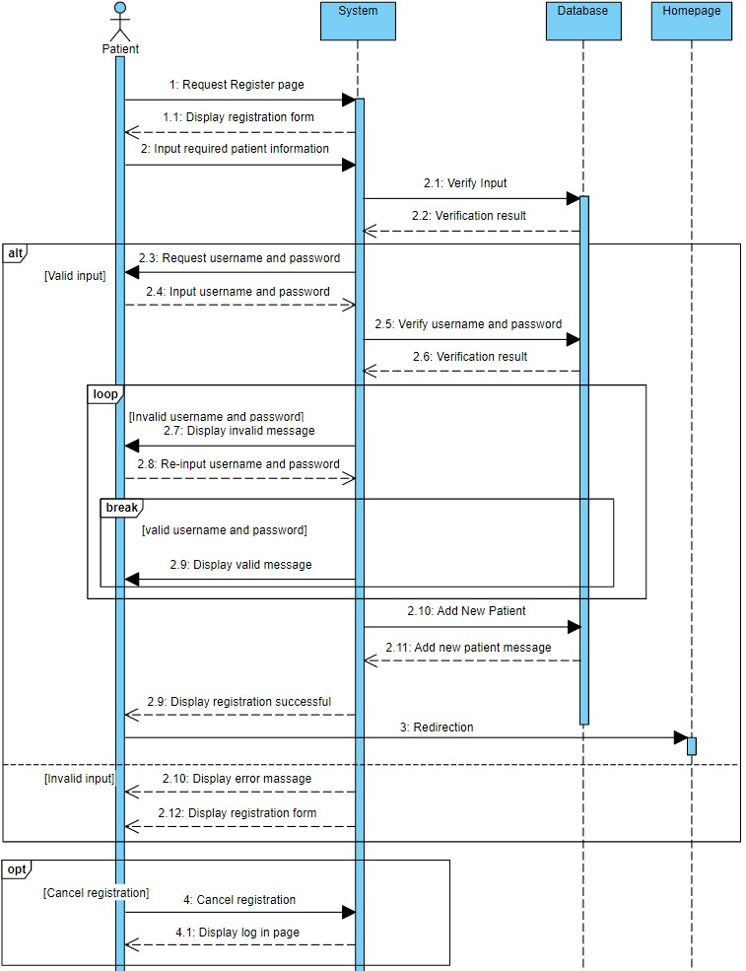

*Figure 2.* Register detail sequence diagram.

### 2.1.2 Log in system sequence diagram.

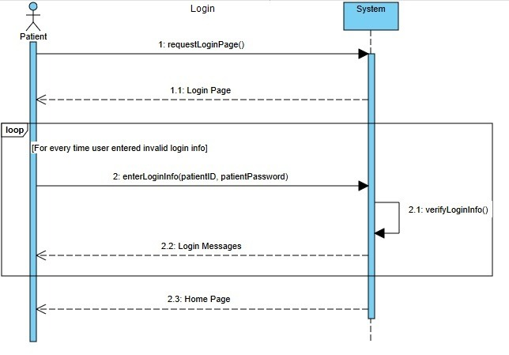

*Figure 3*. Log in system sequence diagram.

### 2.1.3 Make an appointment system sequence diagram.

*Figure 4*. Make an appointment system sequence diagram.

### 2.1.4 Cancel appointment sequence diagram.

*Figure 5.* Cancel appointment sequence diagram.

### 2.1.5 View profile sequence diagram.

*Figure 6.* View profile sequence diagram.

### 2.1.6 Make payment sequence diagram

*Figure 7.* Make payment sequence diagram.

# **3.0 Question 3**

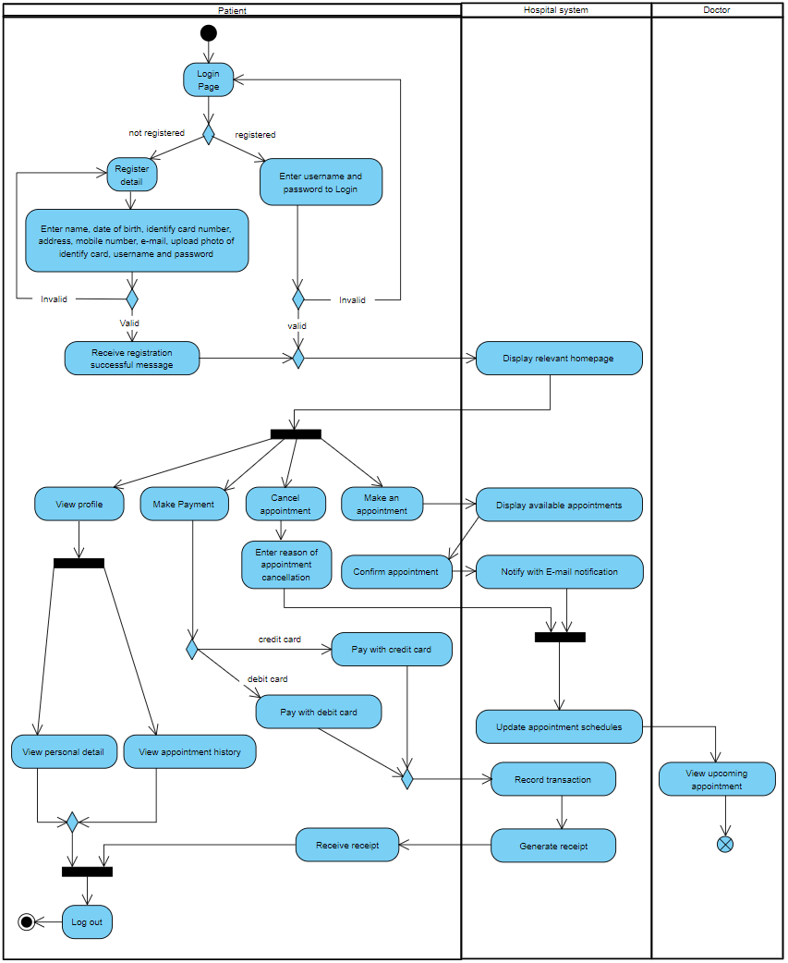Develop **ONE (1) activity diagram** to represent the business process of the proposed system.

*Figure 8*. Business process model.

# **4.0 Individual Contribution**

*Table 9:* Individual Contribution

|  |  |  |  |
| --- | --- | --- | --- |
| **Q** | **Task** | **Creator** | **Date** |
| 1 | Use Case: Register detail | 69385- Chris | 10/11/20 |
| Use Case: Log in | 69861- Holy | 10/11/20 |
| Use Case: Make an appointment | 69861- Holy | 10/11/20 |
| Use Case: Confirm appointment | 70653- Amar | 10/11/20 |
| Use Case: Cancel appointment | 72713- Lee | 10/11/20 |
| Use Case: View profile | 72713- Lee | 10/11/20 |
| Use Case: View schedule | 72368- Zaki | 10/11/20 |
| Use Case: Make payment | 72676- Mizah | 10/11/20 |
| Use Case specification: Register detail | 69385- Chris | 17/11/20 |
| Use Case specification: Log in | 69861- Holy | 17/11/20 |
| Use Case specification: Make an appointment | 69861- Holy | 17/11/20 |
| Use Case specification: Confirm appointment | 70653- Amar | 17/11/20 |
| Use Case specification: Cancel appointment | 72713- Lee | 17/11/20 |
| Use Case specification: View profile | 72713- Lee | 17/11/20 |
| Use Case specification: View schedule | 72368- Zaki | 17/11/20 |
| Use Case specification: Make payment | 72676- Mizah | 17/11/20 |
| Requirement: Performance requirement | 69385- Chris | 17/11/20 |
| Requirement: Security requirement | 69385- Chris | 17/11/20 |
| 2 | Sequence diagram: Register detail | 69385- Chris | 24/11/20 |
| Sequence system diagram: Log in | 70653- Amar | 24/11/20 |
| Sequence system diagram: Make an appointment | 69861- Holy | 24/11/20 |
| Sequence diagram: Cancel appointment | 72368- Zaki | 24/11/20 |
| Sequence diagram: View profile | 72713- Lee | 24/11/20 |
| Sequence diagram: Make payment | 72676- Mizah | 24/11/20 |
| 3 | Business process: Login page | 69385- Chris | 25/11/20 |
| Business process: Register detail | 69861- Holy | 25/11/20 |
| Business process: Enter username & password | 69385- Chris | 25/11/20 |
| Business process: Enter patient detail | 69861- Holy | 25/11/20 |
| Business process: Receive successful message | 69861- Holy | 25/11/20 |
| Business process: Display relevant homepage | 69861- Holy | 25/11/20 |
| Business process: view profile | 72713- Lee | 25/11/20 |
| Business process: make payment | 70653- Amar | 25/11/20 |
| Business process: cancel appointment | 70653- Amar | 25/11/20 |
| Business process: make an appointment | 72368- Zaki | 25/11/20 |
| Business process: display available appointment | 72368- Zaki | 25/11/20 |
| Business process: confirm appointment | 69385- Chris | 25/11/20 |
| Business process: Notify with E-mail | 70653- Amar | 25/11/20 |
| Business process: Enter reason of cancellation | 70653- Amar | 25/11/20 |
| Business process: Update appointment schedule | 72368- Zaki | 25/11/20 |
| Business process: View upcoming appointment | 72368- Zaki | 25/11/20 |
| Business process: Pay with credit card | 72676- Mizah | 25/11/20 |
| Business process: Pay with Debit card | 72676- Mizah | 25/11/20 |
| Business process: Record transaction | 72676- Mizah | 25/11/20 |
| Business process: Generate receipt | 72676- Mizah | 25/11/20 |
| Business process: Receive receipt | 72676- Mizah | 25/11/20 |
| Business process: View personal detail | 72713- Lee | 25/11/20 |
| Business process: View appointment history | 72713- Lee | 25/11/20 |
| Business process: Log out | 69385- Chris | 25/11/20 |