**Adobe AfterEffects  
Tutorial 1 - BASICS  
19.02.2014  
v.3.0**

**SYNAPSY INTERNAL**

**Index ( Click on entries to follow links! )**

1. Create new project 2

2. Workspace constitution 2

3. Hints 3

4. Cool effects 3

5. Tools 3

1. Create new project

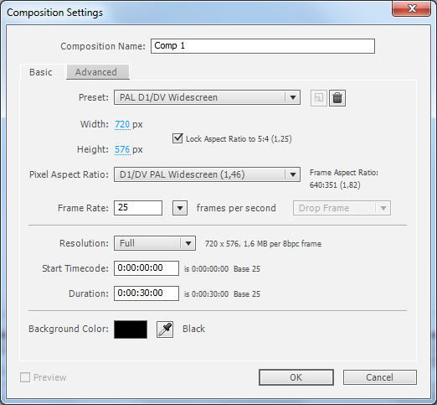

Any video resolution and pixel aspect ratio can be set here.

2. Workspace constitution

This is our preferred workspace layout:

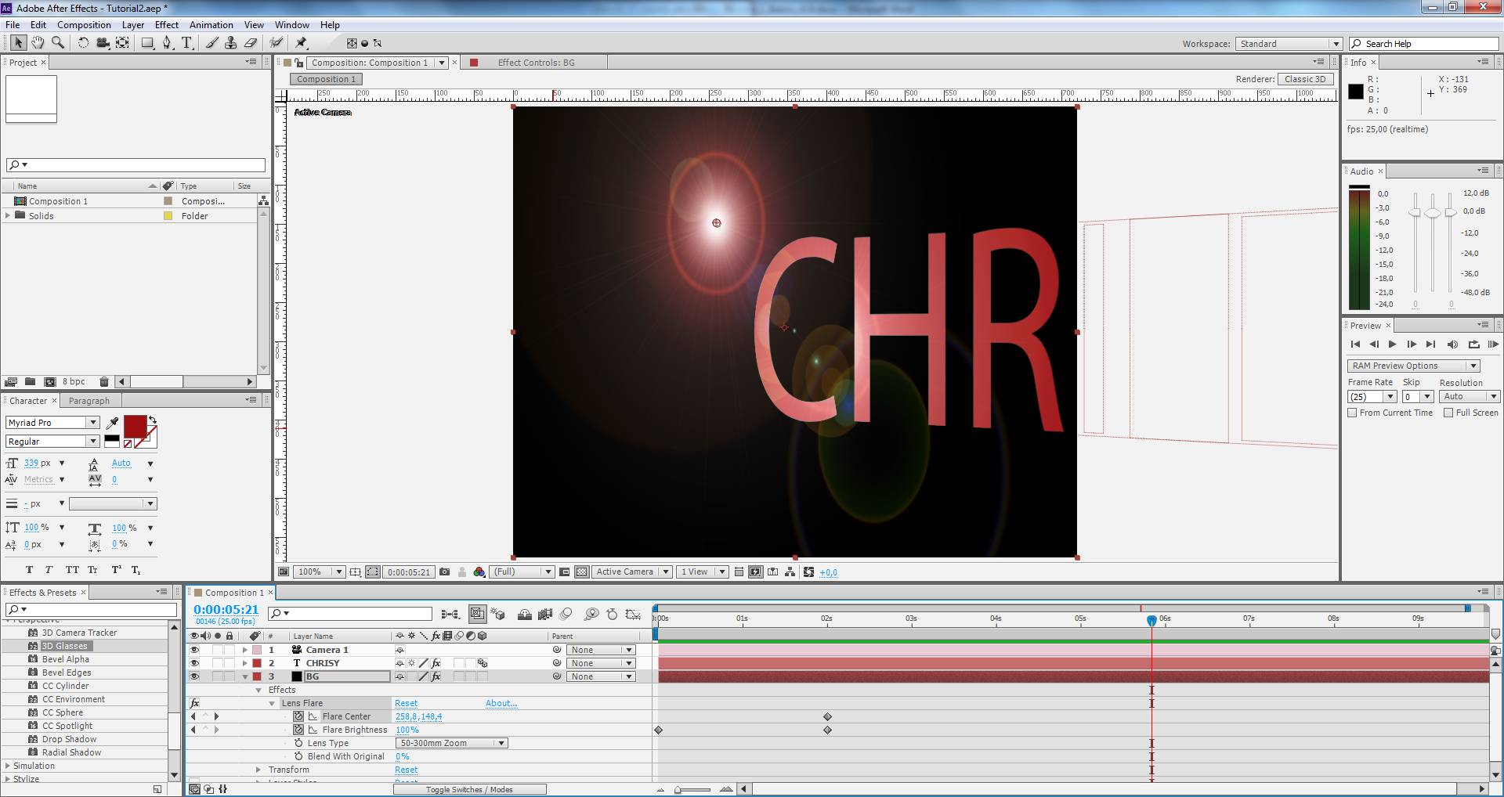

3. Hints

* Set a camera effect via **Layer > New > Camera**
* The history can be viewed via **Edit > History**
* Drag **imported video footage** to the **New composition** button in order to use and directly turn them into a composition.
* Compositions can be inserted into other compositions, turning them into **sub compositions**. Layers ( and adjustment layers ) can be grouped this way.

4. Cool effects

* **Generate > Lens Flare**

5. Tools

* The **“Unified Camera Tool”** makes it easy to align a **camera layer**.  
  Use the **left mouse button** to **spin 3D.**Use the **right mouse button** to **zoom 3D**.  
  Use the **center mouse button** to **pan 3D**.
* The **“Unified Camera Tool”** moves **all** layers that are marked as “3D layer”!

6. Masks

* Applying a rectangle to a layer will mask it.
* **Mask feather** will smooth the edge of the mask.

7. Shortcuts

* **F4** will toggle more options in the layer panel.

8. Adjustment layers

* Adjustment layers can be used to apply effects to underlying layers.

**Effekt > Verzerren > Turbulentes Versetzen**

**Effekt > Weich & Scharfzeichnen > Schneller Weichzeichner**