3dsmax modifiers
TAPER | 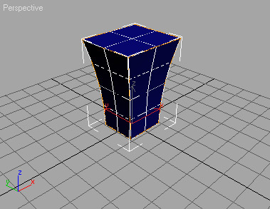 | BEND | 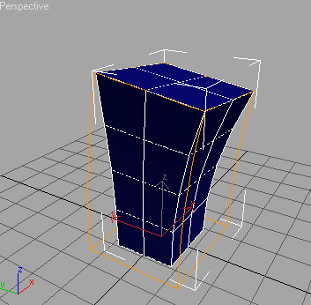
LATHE  set Align  Weld Core will combine all vertices at the center of the spline into one. | 