**Adobe Illustrator  
Tutorial 1 - BASICS  
21.11.2013  
v.1.0**

**SYNAPSY INTERNAL**

**Index ( Click on entries to follow links! )**

1. Create new project 2

2. Workspace constitution 2

3. Resolution 3

4. Workflow 4

5. Important commands and windows 5

6. Useful effects 6

7. Clipping Masks 6

8. Typeface 6

9. Primary tools and their shortcuts 7

1. Create new project

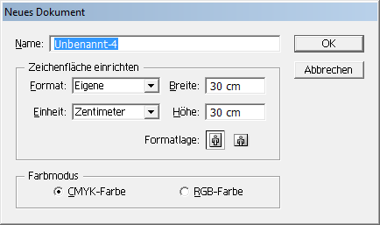• Use any dimension, e.g. 25x25cm,  
and always use the **‘CMYK color mode’**  
for your 1st example project.

• After the canvas size has been changed,  
the crop area of the canvas must be readjusted  
by selecting nothing and choosing  
**Objekt > Schnittbereich > Erstellen**

2. Workspace constitution

• The white background can be changed to the transparency grid via  
**Ansicht** > **Transparenzraster einblenden**

• Make sure to show all rulers!  
**Ansicht** > **Lineale einblenden**

• Make sure to show all gizmos!  
**Ansicht** > **Begrenzungsrahmen einblenden**

• The black border around the canvas can be hidden via  
**Ansicht** > **Zeichenfläche ausblenden**

• Illustrator allows placement of object outside of the canvas,  
but only the canvas will be considered on exporting files.

Here is our preferred workspace constitution:

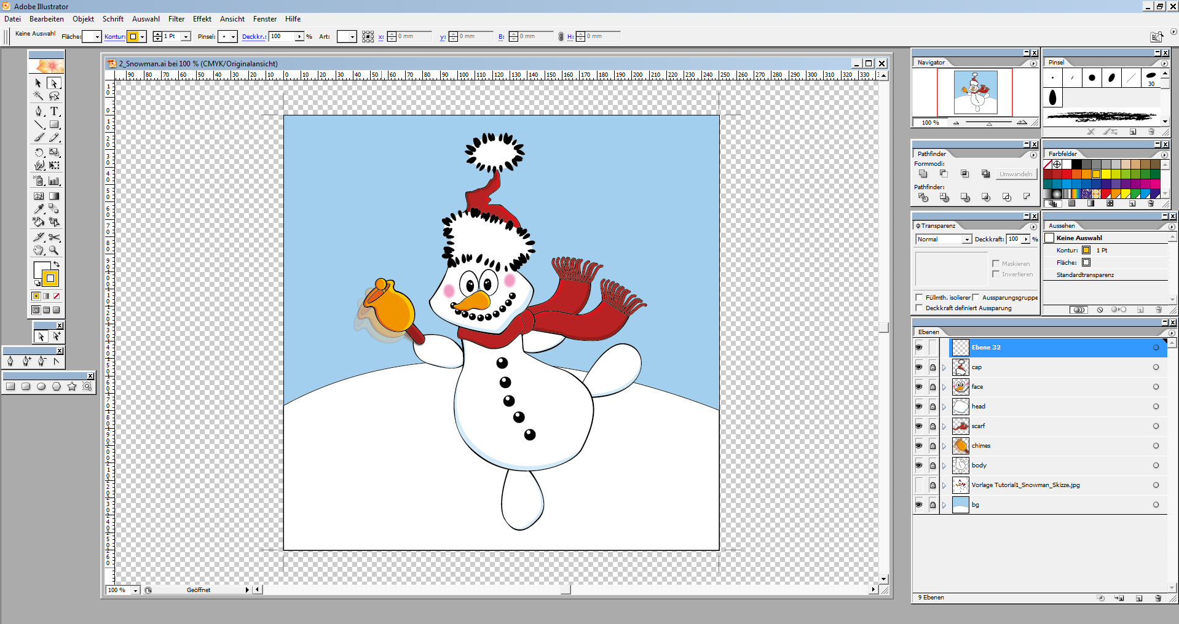

3. Resolution

• Adobe Illustrator always displays the workspace with the screen resolution **72 dpi**.

• The resolution of the exported image can be specified in the export dialog.

• The resolution for rasterized effects can be adjusted via  
**Effekt** > **Dokument-Rastereffekt-Einstellungen**

4. Workflow

• Import images ( bg sketches etc. ) via  
**Datei** > **Platzieren**If “Vorlage” is checked in the dialog, the image will be set as a template layer with an initial opacity of 50%.

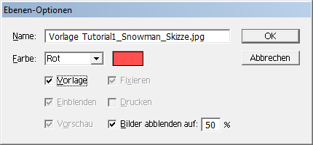• Doubleclicking the small icon of a layer ( not a sublayer! ) will display the layer dialog, where some more options can be adjusted:

**The color of the paths for this set.**

**If this set shall be treated as a template.**

**If the layer shall be fixed.**

• Always **lock** layers and paths that aren’t currently altered.

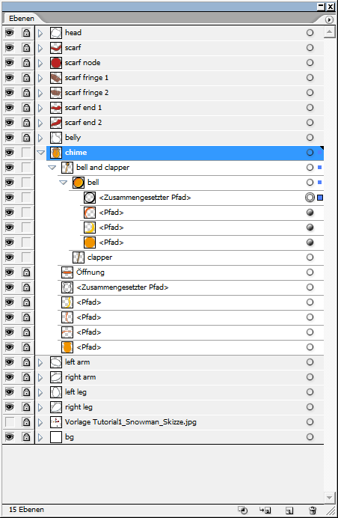• Clicking the small circle ( “**Target Icon**” ) of any layer will select this path or all paths in the layer group.

Only **unlocked** layers will be selected or included in the selection!

Dragging one circle to a circle of another layer will copy and paste the layer style.

The **Target Icon** is indicated by a dark color, if this layer has effects or a different style – This can be checked in the **Appearance window**.

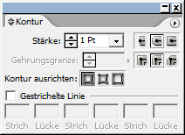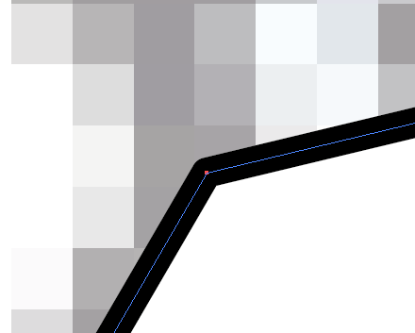• Outlines can be adjusted. E.g.: Stubs and corners can be set to ‘rounded’.

• Multiple paths can be adjusted or distributed,  
analog to layers in Photoshop.

• Paths don’t need to be closed, if the outline should be omitted on a specific side.

• Here is the initial movement scheme for fillings before separating path elements via path finder. Of course, the position of the shadow and the glow can vary. Important is, that both of them will always find themselves in opposite directions.

GLOW

SHADOW

• Check **STRG + H** if paths seem to be hidden but the rectangular gizmo is visible!

• Make sure to **unlock** all layers / paths of a group before applying scalation or rotation on it!

5. Important commands and windows

• Separate the outline and the shape of an object by selecting it and choosing  
**Objekt** > **Pfad > Konturlinie**The outline can be adjusted different from the shape this way, enabling interesting effects.

• **STRG + C** will copy a shape into the clipboard. **STRG + V** will paste a shape from the clipboard, **altering** its original position.  
**STRG + F** will paste a shape from the clipboard, **constraining** its original position.

• Handy colors are already defined in the  
**Farbfelder** > **Kontextmenu > Farbfelder-Bibliothek öffnen**

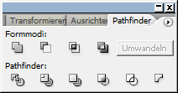• The window **Pathfinder** displays various actions in order to handle multiple paths:  
  
**Fläche aufteilen  
Überlappungsbereich entfernen  
Verdeckte Fläche entfernen  
Schnittmengenfläche  
Kontur aufteilen  
Hinteres Objekt abziehen**The button **“Umwandeln”** enables merging multiple paths.

• Select all paths of the selected layer via **STRG + A**.

• Unselect all currently selected paths via **STRG + SHIFT + A**.

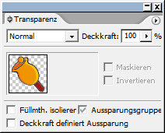• The **Transparency** window enables different blend modes and opacity-adjustment for layers or paths.

• The **Appearance** window shows all differing styles for the selected layer or path.  
  
All assigned effects ( outer glow etc. ) can be managed here.  
  
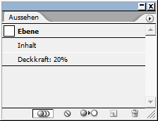Layers that have entries in the **appearance** window are flagged by a **black target icon**.

• **Rightclick > Transform**  
  
On any path offers various transformation options.

• Points can be deleted with the **Direct Selection** tool ( Select and **DEL** ).  
This enables gaps in a closed path.

• The **Knife Tool** can be used to close a path ( e.g. if one vertex has been deleted ).  
Simply draw a circle around the shape that’s path shall be closed.  
It can also be used to cut a path into multiple segments. Hold **ALT** before clicking in order to cut straight edges!

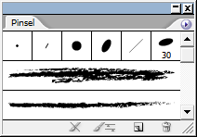• The window **Brushes** offers different brushes that will be applied to a shape’s **outline**.  
  
The option **New Brush** in its context menu offers the creation of own brushes. Select ‘**Special brush**’ here in order to create a brush from the currently selected shape

6. Useful effects

These can be selected via the **Effekt** menu item.

After an effect has been disposed, the path can be adjusted via

**Objekt > Aussehen umwandeln**

• **Effekt > Stilisierungsfilter > Ecken abrunden**  
Will round all corners of the form with the specified radius.

• **Effekt > Verkrümmungsfilter > ALL**  
Will bend the shape, offering various options.

• **Effekt > Stilisierungsfilter > Weiche Kante**   
Will smoothen all edges of this form.

7. Clipping Masks

• To create a clipping mask, select multiple layers and click  
**Rightclick > Schnittmaske erstellen**  
  
The upper layer will be used as a mask.

• The mask and the masked layer(s) MUST remain in a separate group!  
The mask won’t have an effect otherwise!

• Masks can directly be edited with the **Direct Selection** tool.

• Masks appear **underlined** in the **layer panel**.

8. Typeface

• Text layers can be altered via the **Appearance** window.

• More text options can be adjusted in the various **Typeface** windows or in the control bar.

9. Primary tools and their shortcuts



|  |  |
| --- | --- |
| Selection ( **V** ) | Direct Selection ( **A** ) |
|  |  |
|  |  |
| Pen ( **P** ) |  |
| Line ( **:** ) | Rectangle ( **M** ) |
| Brush ( **B** ) | Pencil ( **N** ) |
|  |  |
|  |  |
|  |  |
|  |  |
|  |  |
|  |  |
|  |  |
|  |  |
|  |  |
|  |  |
|  | Knife |
| Hand ( **H** ) - **SPACE** for quick use |  |
|  |  |
| Color selection **FILL** and **OUTLINE** | |