**Adobe InDesign  
Tutorial 1 - BASICS  
14.02.2014  
v.2.0**

**SYNAPSY INTERNAL**

**Index ( Click on entries to follow links! )**

1. Create new project 2

2. Workspace constitution 2

3. Color profiles 2

4. Preferences 3

5. The golden ratio 3

6. Pages 3

7. Reference linies 3

8. Site setup 3

9. Page spread ( ‘Satzspiegel’ ) 4

10. The Baseline Grid 4

11. The Document Grid 5

12. Page Master ( “Mustervorlage” ) 5

13. Dead or alive? 5

1. Create new project

Leave all default values for offsets. Use DIN A-4 format for your first example.

2. Workspace constitution

This is our preferred workspace layout:

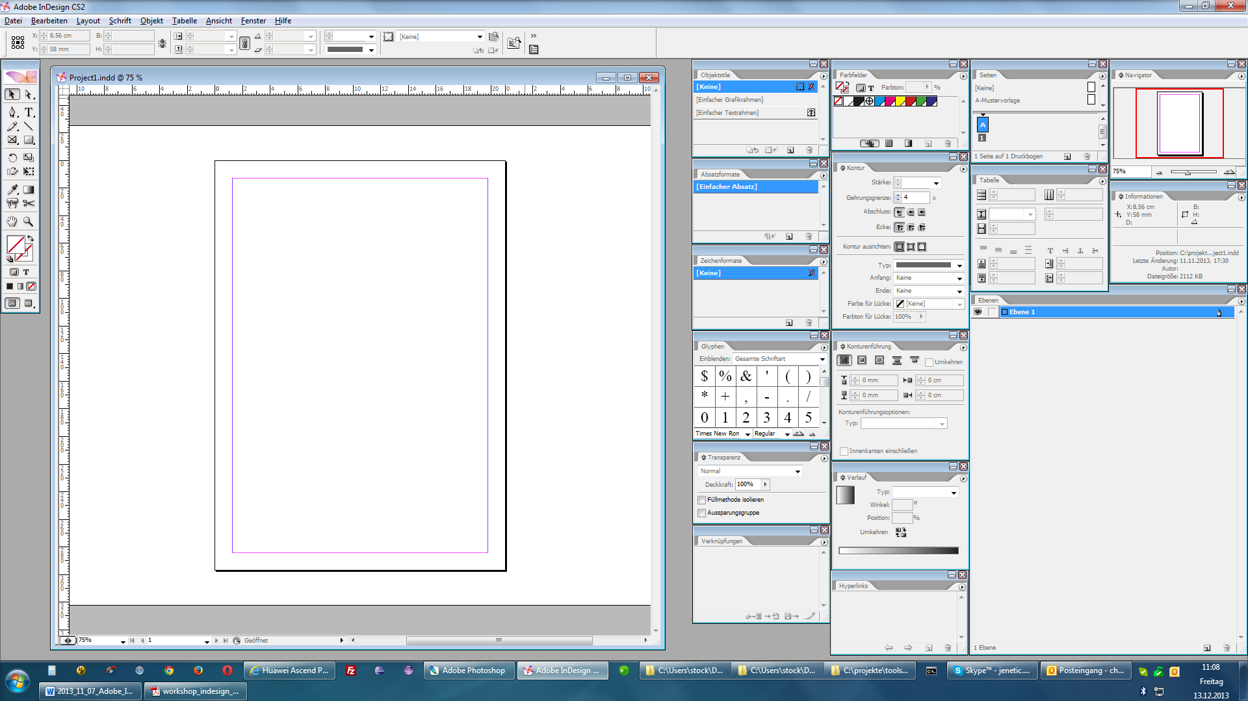

3. Color profiles

The color profile ‘CMYK’ should be used for all documents.

The European default CMYK-profile “ISO Coated v2” or “ISO Coated v2 300%” can be downloaded from the website of the **European Color Initiative**:

**http://www.eci.org**

Color-profiles ( icc files ) can directly be copied to

**C:\Windows\System32\spool\drivers\color**

They are globally available this way.

4. Preferences

**•** Use “**Alle Schwarztöne korrekt anzeigen**” unter  
**Bearbeiten > Voreinstellungen > Schwarzdarstellung**

**•** You should enable showing text chain gizmos via  
**Ansicht > Textverkettungen einblenden**

**•** Enable snapping reference lines via  
**Ansicht > Raster & Hilfslinien > Am Dokumentraster ausrichten**

5. The golden ratio

Two quantities are in the **golden ratio** if their ratio from major to minor is the same as the ratio of their sum to the major. The major always has a ratio of **61,8%**!

6. Pages

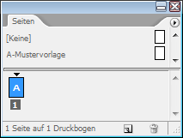

The “**Seiten**” panel helps to create new pages or delete  
existent pages.

7. Reference lines

The reference lines are shown in the color of the according layer after being selected.

Reference lines become invisible after the according layer has been hidden.

Multiple reference lines can easily be set using

**Layout** > **Hilfslinien erstellen**

Hold **STRG** on dragging reference lines in order to make it a reference line for the **Printed Sheet**.

8. Site setup

The site can be set up on creating a new document. Afterwards, it can be changed via

**Datei** > **Dokument einrichten**

9. Page spread ( ‘Satzspiegel’ )

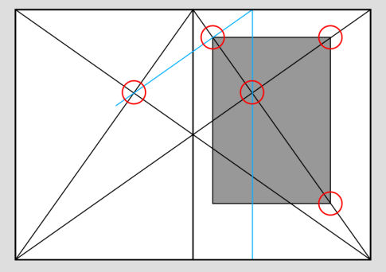

Typography specifies the page spread as   
the useful area of a print layout.

Traditional page spread

|  |  |  |  |
| --- | --- | --- | --- |
| Item EN | Item DE | Size ( Single A4 page ) | Size ( Double A4 page ) |
|  |  |  |  |
| Top Margin | Kopfsteg | 33,0 mm | |
| Bottom Margin | Fußsteg | 66,0 mm | |
| Text width | Textbreite | 140 mm | |
| Text height | Texthöhe | 198 mm | |
| Inner Margin / Gutter | Bundsteg | 35,0 mm | 23,3 mm |
| Outer Margin | Außensteg | 35,0 mm | 46,7 mm |

This relationship of

**3 : 4 : 6 : 8**

specifies the relationship between

**Inner margin : Top Margin : Outer Margin : Bottom Margin**

The margins can be specified via

**Layout** > **Ränder und Spalten**

10. The Baseline Grid

The baseline grid ( ‘**Grundlinienraster**’ ) asserts a constant distance between all lines of text.

The baseline grid should be specified to

**Voreinstellungen** > **Raster** > **Grundlinienraster**: **Relativ zu**: **Oberer Textrand**

The baseline grid can be toggled via

**Ansicht** > **Raster & Hilfslinien** > **Grundlinienraster einblenden**

**STRG + ALT + ß**

11. The Document Grid

The document grid ( ‘**Dokumentraster**’ ) offers a grid to align texts and images to.

The document grid can be toggled via

**Ansicht** > **Raster & Hilfslinien** > **Dokumentraster einblenden**

**STRG + ß**

And the dimensions of the grid can be adjusted via

**Voreinstellungen** > **Raster** > **Dokumentraster**

12. Page Master ( “Mustervorlage” )

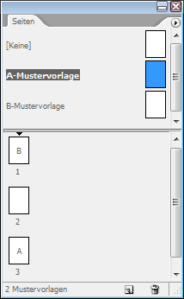The page master can easily apply different views or backgrounds to specified pages.

It can manage the page number and dead or alive column titles.

The “**pages**” panel shows and manages all specified page masters.

Doubleclicking a page master will show it. The panel shows, which page uses which master.

One page master can be dragged to a specified page in order to assign all presets for this page master.

13. Setting the page number and handling auto texts

Page numbers must be set in a **master page**!

When working inside a textfield, rightclicking enables to insert auto-fields and other values.

The margins of the textbox can be adjusted via

**Objekt > Textrahmenoptionen**

Or with the shortcut

**STRG + B**

14. Dead or alive?

Column titles are the headlines over the single pages of a book.

**Dead column titles** ( like page numbers ) are located outside of the page spread.

**Living column titles** are often used for technical documentations. In addition the page number, it contains information concerning the content or chapter title. The living column title is located inside of the page spread.

Living column title can be inserted using the “Text variables” feature.

This feature is **not** implemented in CS2.

15. Paragraph and type formats

**Paragraph formats** contain formats for paragraphs and types.

**Type formats** only affect types and are specified, if the format should differ from the paragraph’s format.

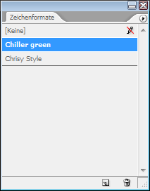16. Type formats

A handy solution for storing and assigning format sets from or to types.

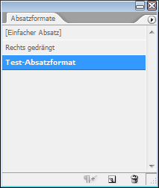17. Paragraph formats

Analog to the type formats, the panel “Paragraph formats” allows storing  
and assigning different formats from or to paragraphs.