Oracle Tutorial 1
v.0.0.1
23.06.2014

CLASSIFIED

Index ( Click on entries to follow links! )

1. General 2
1.1. Version 2
1.2. Installation 2
1.3. Oracle Application Express 2
1.4. SQL Developer 3
2. Application Express 4

3. JDBC Access 4

4. Perl Access 4

5. Open Questions 5

1. General

1.1. Version

We’re using

Oracle Database Express Edition 11g Release 2

from

4th June 2014

1.2. Installation

Find a complete installation tutorial on

http://docs.oracle.com/cd/E17781_01/admin.112/e18585/toc.htm

https://apex.oracle.com/pls/apex/f?p=44785:24:123063439587718:PRODUCT:::P24_CONTENT_ID,P24_PREV_PAGE,P24_PROD_SECTION_GRP_ID:6281,141,116

The installation is performed via the Oracle Universal Installer (OUI).

We are choosing the

Advanced Installation

using the SYS and the SYSTEM database account password

Chris1

1.3. Oracle Application Express

This tool can be accessed via

http://127.0.0.1:8080/apex

1.4. SQL Developer

This DBMS-tool can be downloaded via

http://www.oracle.com/technetwork/developer-tools/sql-developer/

Start the tool and create a new connection.
Go with these figures:

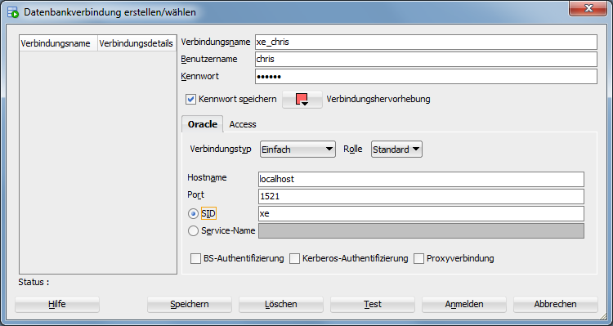

2. Application Express

You can use Oracle Application Express to create applications with forms linked to tables and data in the database. I don’t think that we need this right now.

3. JDBC Access

Connecting to the Oracle Database via the JDBC interface succeeded using the Oracle JDBC Library

ojdbc5.jar

This library can be found at

http://www.oracle.com/technetwork/database/enterprise-edition/jdbc-112010-090769.html

The solution is hosted at

http://stupid-simple-website.googlecode.com/svn/_BAUSTELLE/oracle/j2se-connection/

4. Perl Access

Connecting the Oracle Database via Perl is possible using the built in module

DBD::Oracle

The solution is hosted at

https://stupid-simple-website.googlecode.com/svn/_BAUSTELLE/oracle/perl-connection

5. Open Questions

- Why are all preset field and table names in the database in upper case letters?

- Why is the chapter “establish a connection via J2SE” so inflated?

http://docs.oracle.com/cd/B25329_01/doc/appdev.102/b25320/getconn.htm

- Is “Application Express” useful in practice?

