Adobe Premiere Professional
Tutorial 1 - BASICS
28.10.2013
v.1.0
SYNAPSY INTERNAL

Index ( Click on entries to follow links! )

1. Create new project 2
2. Workspace constitution 2
3. Importing Assets 3
4. Clip monitor 3
5. Sequencer 4
6. Tools 5
7. Title generator 5
8. Default effects 6
9. Transition effects 6

1. Create new project

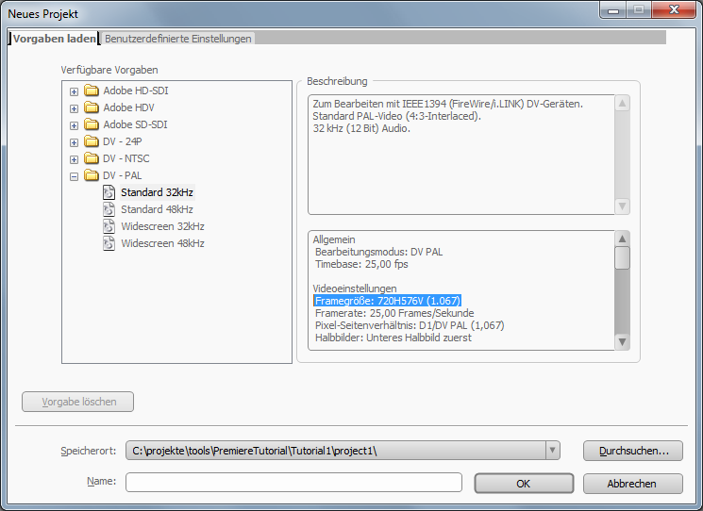
• European PAL default format is:
Video-Resolution: 720x576px
Framerate: 25fps
Audio-Samplerate: 32kHz/s
Use these settings
for your first example project!

2. Workspace constitution

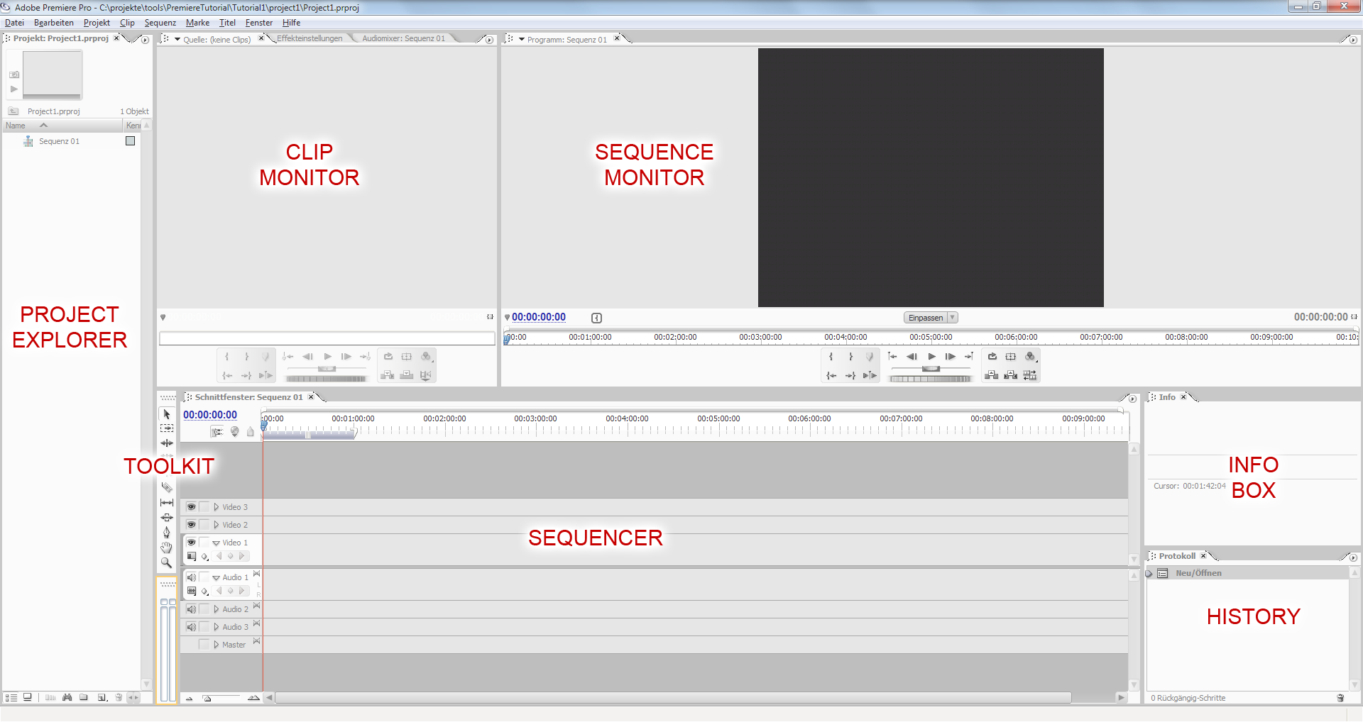

• Brightness of the user interface can be adjusted via
Bearbeiten > Voreinstellungen > Benutzeroberfläche
• Make sure to assign a drive with sufficient disk space for all entries of
Bearbeiten > Voreinstellungen > Arbeitslaufwerke

3. Importing Assets

• Double-click the blank area of the PROJECT EXPLORER in order to import any supported media asset.
• Create folders with the folder-icon on the bottom of the explorer in order to group all assets. All assets can be dragged and dropped between folders and the root layer.

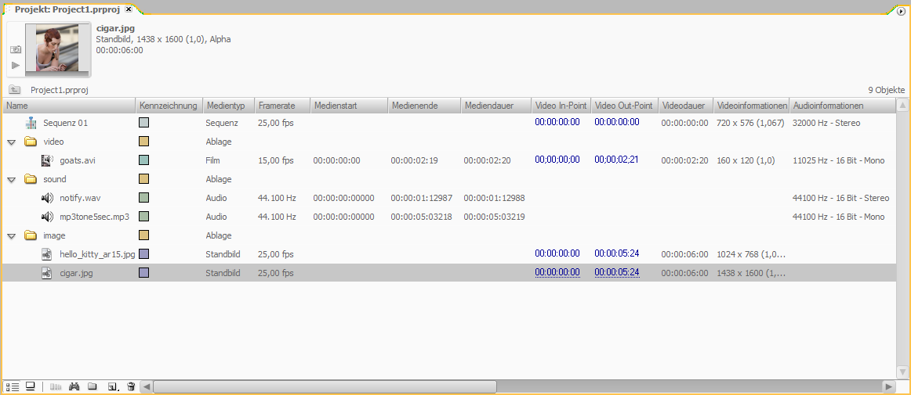

4. Clip monitor

• Double-clicking any asset ( sound, video or image ) in the PROJECT EXPLORER will display this asset in the CLIP MONITOR.
• Use the navigation buttons and the shuttle or jog for a convenient navigation through the video clips.
• The In-Point and Out-Point of an asset can be set here in order to adjust the video playtime that shall be used. This will apply as the default setting for all instances of this asset that are imported to the SEQUENCER.

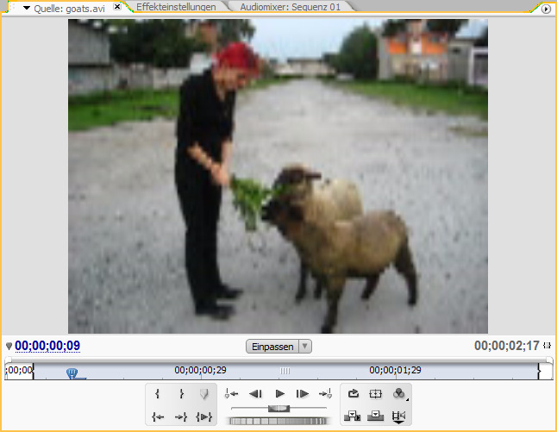
5. Sequencer

• Every clip can be dragged from the CLIP MONITOR to a desired layer of the SEQUENCER.
• The SEQUENCE MONITOR offers the same navigation control as the CLIP MONITOR.
The In-Point and Out-Point for the whole sequence can be adjusted here.
• Analog to Photoshop’s layer panel, the sequencer panel specifies the layers for video and audio. Layer stated above in the sequencer list will overlap layers stated below in the sequencer list.
• Double-clicking any clip in the SEQUENCER will reopen it in the CLIP MONITOR, allowing independent adjustment of its In-Point and Out-Point.
• Multiple instances of any asset can be imported into the sequencer.
• The length of all clips can directly be altered in the SEQUENCER by dragging the left or the right edge. Notice that all clips, except image clips, have a maximum length.
• Audio clips can either be dragged to a mono of a stereo audio layer.
• New layers can be created via rightclick on any layer name.
• Each layer can be hidden ( disables all clips of this layer ) or locked ( keeps it from unintended changes ).
• Snapping of clip adjustment can be toggled. ( Shortcut S )
• The Video and Audio clip of imported videos are linked until the link is removed via context menu > unlink onto one of these elements.
• Video and Audio-Clips can be linked again on selecting both ( hold SHIFT and click both clips ) and select context menu > link.

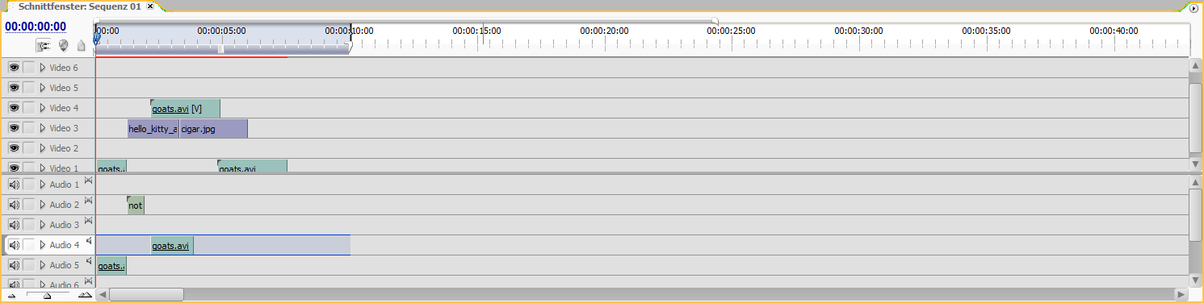

6. Tools

All tools are exclusively to be applied to the SEQUENCER.

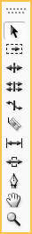
SELECTION (V) Selects and moves clips in the sequencer.
SELECT TRACK (M)
DELETE GAP (B)
ROLL (N)
SCALE RATE (X) Scales the video rate of video clips by altering its speed.
CUTTER (C) Cuts movie clips in the sequencer into two clips.
PLANT (Y)
MOVE (U) Moves the clip horizontally in the sequencer.
PEN (P)
HAND (H) Pans the sequencer lane.
MAGNIFIER (Z) Zooms the sequencer. Use ALT + Click to zoom out.

7. Title generator

Generates a video clip in the assets that can be handled like any other asset.

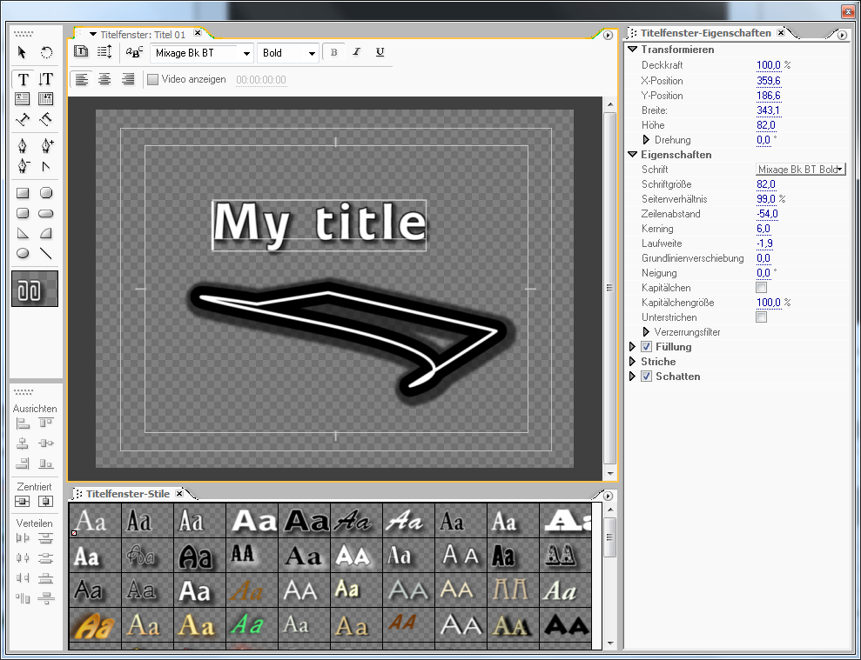

8. Default effects

• Open the panels EFFECTS and EFFECT ADJUSTMENTS. Each effect can be dragged from EFFECTS onto a clip in the SEQUENCER. All effects for one clip can be managed in the EFFECT ADJUSTMENTS panel.
• Make sure to expand the EFFECT ADJUSTMENTS panel with the >> button so the keyframes of the clip are displayed. Keyframes can be set by expanding the according video- or audio-layer in the SEQUENCER.
• Switching through the keyframes of a clip and changing the effect values for ANIMATION EFFECTS will apply animated effects ( fade in / out etc. ).

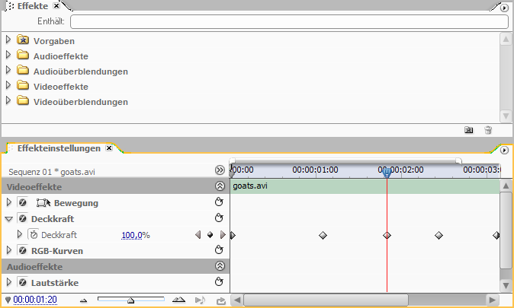

9. Transition effects

• To apply a transition effect, drag an effect from the EFFECTS ( “Videoüberblendungen” ) onto the end or the beginning of a clip in the SEQUENCER.
• Like the default effects, transition effects can be adjusted in the EFFECT ADJUSTMENTS panel.

