County Presidential Summary — Descriptive Statistics
Source table: county_presidential_summary in data/pda.db (22,076 county-year rows)
Scope: real, FIPS-coded counties only. Non-county MIT reporting units (CT/ME/RI overseas & write-in precincts under placeholder FIPS 'NA', and MO Kansas City under '2938000') are excluded. Standard deviation is the sample standard deviation. dem_margin = (dem_votes − rep_votes) / total_votes (positive = Democratic lean).

Overall (all county-years pooled)
Column | N | Min | Max | Mean | Std Dev
Total votes | 22,076 | 0 | 4,264,365 | 42,464.39 | 123,477.99
Democratic votes | 22,076 | 0 | 3,028,885 | 21,139.73 | 77,078.70
Republican votes | 22,076 | 0 | 1,189,862 | 20,263.42 | 47,308.70
Other votes | 22,076 | 0 | 200,201 | 1,060.07 | 3,994.37
Democratic margin (share) | 22,071 | -0.9309 | 0.8741 | -0.2466 | 0.2964

Democratic Margin and Counties Carried, by Year
dem_margin statistics across all FIPS-coded counties each year, plus counties carried by each party (Dem = dem_votes > rep_votes; Rep = rep_votes > dem_votes). Counts are of counties, not voters, so they over-represent small rural counties; the average margin is likewise unweighted.
Year | Counties | Dem counties | Rep counties | Min margin | Max margin | Average margin | Std Dev
2000 | 3,153 | 674 | 2,478 | -0.8564 | 0.7620 | -0.1723 | 0.2366
2004 | 3,154 | 585 | 2,568 | -0.8479 | 0.7984 | -0.2149 | 0.2495
2008 | 3,154 | 882 | 2,271 | -0.8773 | 0.8592 | -0.1528 | 0.2762
2012 | 3,154 | 708 | 2,445 | -0.9241 | 0.8741 | -0.2099 | 0.2958
2016 | 3,154 | 503 | 2,650 | -0.9097 | 0.8678 | -0.3144 | 0.3087
2020 | 3,153 | 557 | 2,596 | -0.9309 | 0.8675 | -0.3138 | 0.3217
2024 | 3,154 | 469 | 2,685 | -0.9213 | 0.8381 | -0.3482 | 0.3138
Exact dem/rep ties: 2000 (1), 2004 (1), 2008 (1), 2012 (1), 2016 (1) (excluded from both columns).

PDA County → FIPS Match Methods
How each of the 14,009 report-county rows was resolved to a county FIPS code, across the three matching passes (exact → fuzzy → LLM) and the intentional non-matches (tribal/reservation rows, counties absent from the MIT source, and a small residual). Bars use a log scale so the smaller categories remain visible.
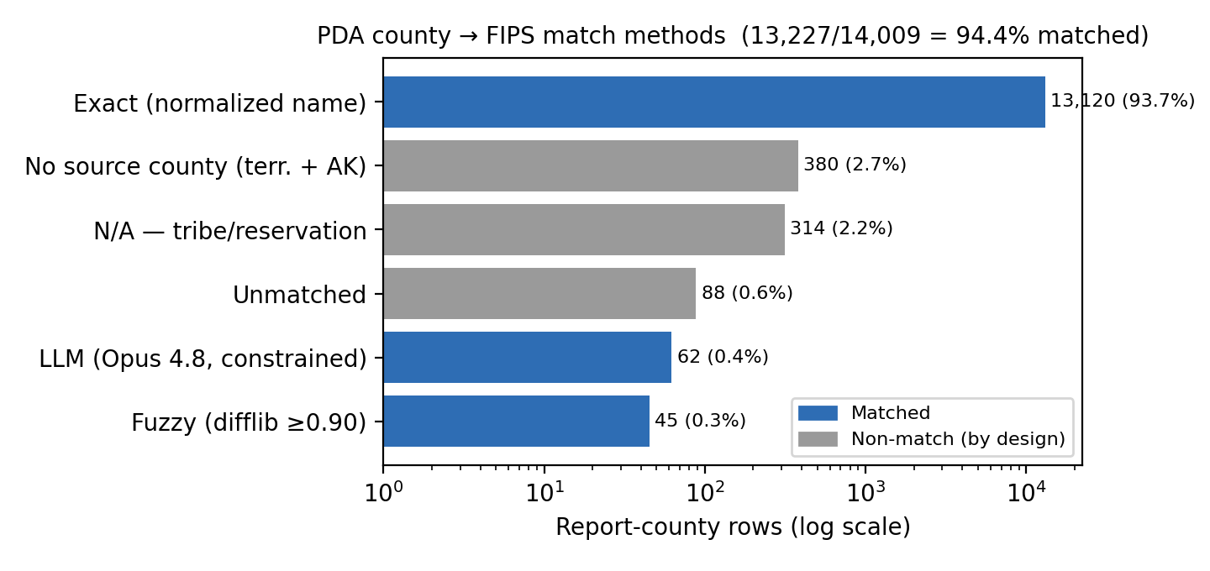
Method | Count | Share
Exact (normalized name) | 13,120 | 93.7%
No source county (terr. + AK) | 380 | 2.7%
N/A — tribe/reservation | 314 | 2.2%
Unmatched | 88 | 0.6%
LLM (Opus 4.8, constrained) | 62 | 0.4%
Fuzzy (difflib ≥0.90) | 45 | 0.3%
Total | 14,009 | 100.0%

Generated 2026-06-09 from branch feat/mit-voter-fips.

