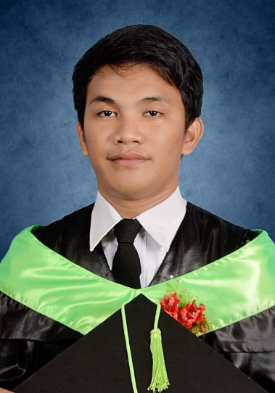**SUMMARY**

Taken classes at Surigao del Sur State University helps me to truly discovered my passion in life and that is software development, on my perspective programming is not just writing some code that helps other people to solve their problems It also involves discipline, attitude, and communication.

**PERSONAL DATA**

Age : 22 years old

Sex : Male

**Christopher Vistal**

Purok Paradise Awasian

Tandag City

09672570114

<christophervistal25@gmail.com>

Place of Birth : Sto. Niño Commonwealth Quezon City

Date of Birth : January 6, 1997

Religion : Roman Catholic

Status : Single

Dialects : Tagalog, Bisaya, English

**EDUCATION**

**Surigao del Sur State University (MAIN CAMPUS)**

*B.S. Computer Science* – April 2019

**SKILLS**

**Languages: Additional Skills in:**

* JAVASCRIPT • Java
* PHP • HTML5
* LARAVEL • JQuery
* LUMEN

**INTERSHIP EXPERIENCE**

**Surigao del Sur State University (Main Campus) April – May 2018**

* Developed an application for Guidance Office that handles student admission results.
* Developed an application for student evaluation for their instructors.
* Participate in the development and implementation of smaller modules

**REFERENCES**

Mark Santing, (09101764905)

Web Developer, Surigao del Sur State University

<santingmark13@gmail.com>