Page 1 of 1

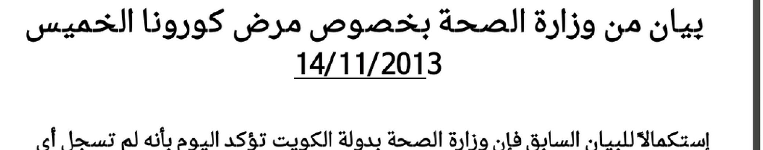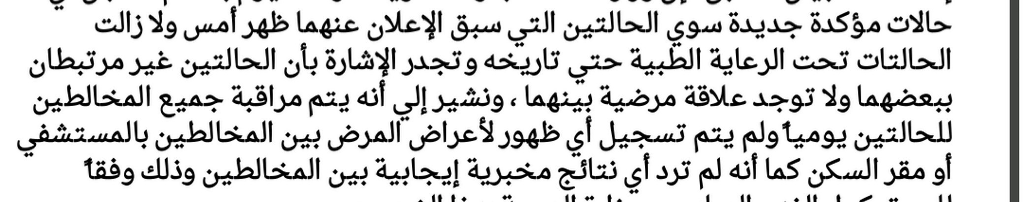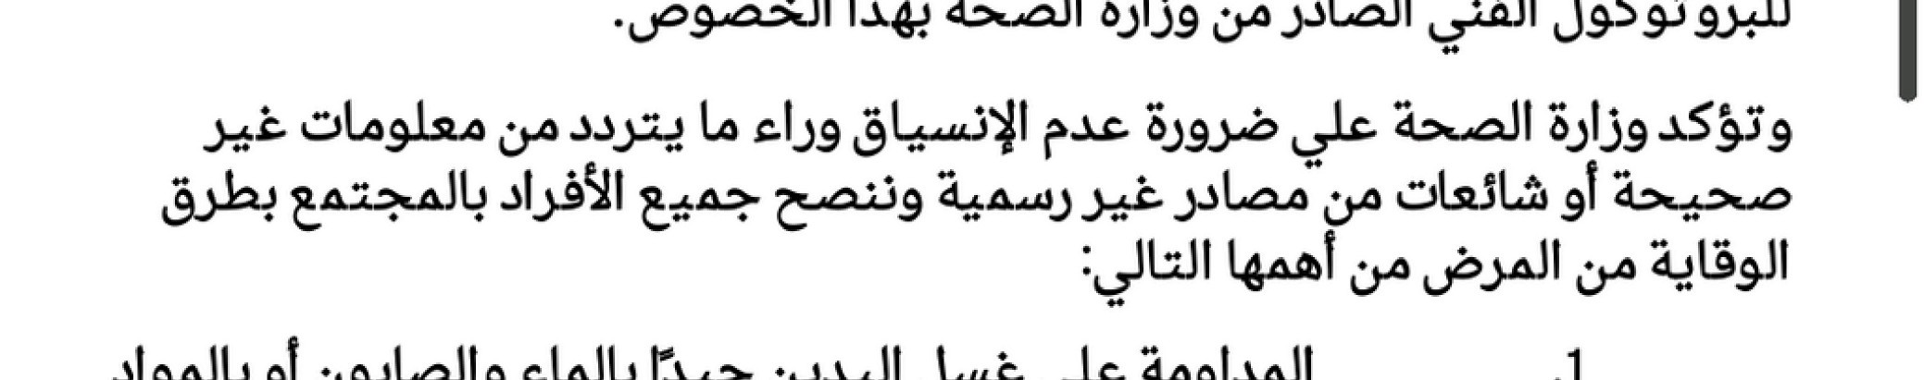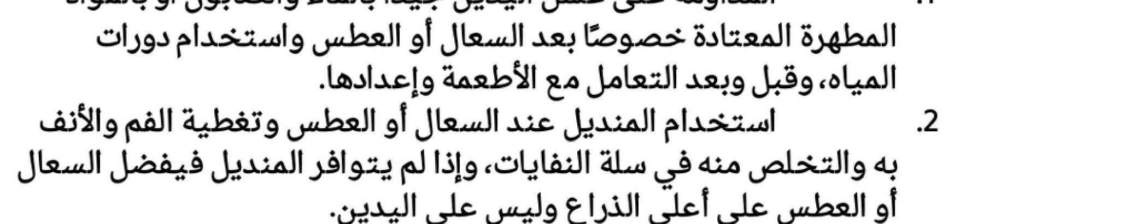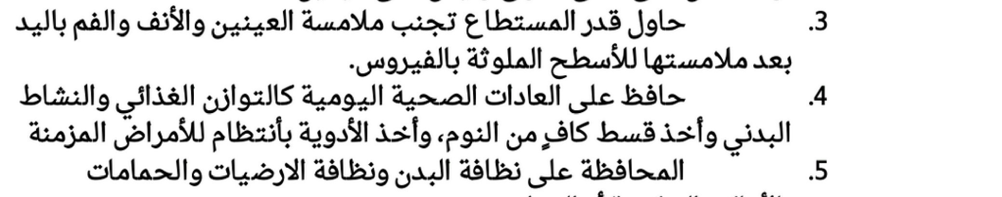

https://pbs.twimg.com/media/BZBvyQkIgAAH1Es.png:large 11/14/2013