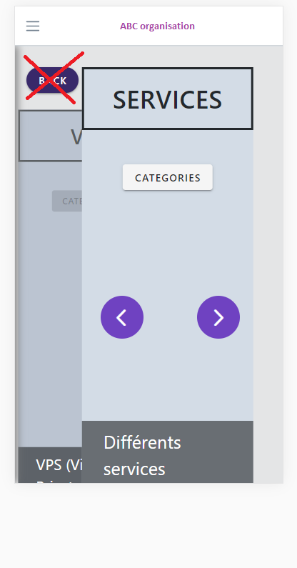 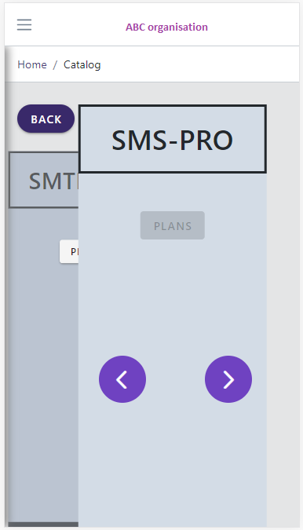 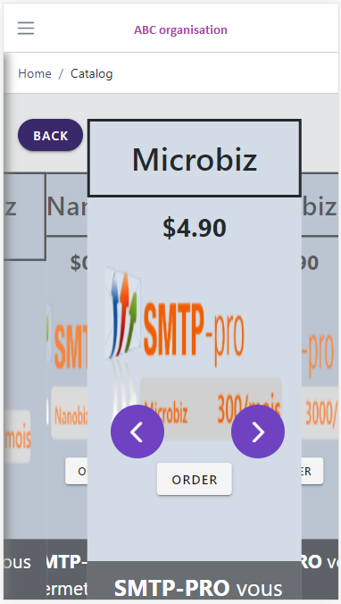

STEP 3/3

STEP 2/3

STEP 1/3

Hi , I am sending you my screen captures with the code attached for a carousel (VUEJS) that I am working on. I have 3 questions:

1. Can you please guide me on how to **REMOVE** the “BACK button” on the Step 1/3 ?
2. Can you please show me how to modify the code so that it jumps to the previous SCREEN instead of STEP 1/3 **(EXAMPLE STEP 3/3 -> STEP 2/3)** when I press on the “BACK button”?
3. On STEP 2/3, it should show SMTP-PRO first as opposed to SMS-PRO. Can you please help me how to resolve it?