**News**

**World Open Innovation Conference 2019 in Rome**



The 6th Annual World Open Innovation Conference took place in Rome, Italy, from December 12 to 13, 2019 at LUISS University.

This year’s conference theme was: “Opening up for Managing Business and Societal Challenges”.

Christoph Ihl was the conference chair of session 4B:

**Conceptualizing and Measuring Open Innovation**,

and together with Alexander Vossen they presented their paper:

[„Copyright Or Copy Right? Unsolicited User Behavior As Market Signals”](https://scholar.google.com/citations?hl=de&user=rOAPv_gAAAAJ&view_op=list_works&sortby=pubdate#d=gs_md_cita-d&u=%2Fcitations%3Fview_op%3Dview_citation%26hl%3Dde%26user%3DrOAPv_gAAAAJ%26sortby%3Dpubdate%26citation_for_view%3DrOAPv_gAAAAJ%3ArO6llkc54NcC%26tzom%3D-120)

* * *

The **14th Conference on “Innovation and Value Creation”** took place at Martin-Luther-Universitaet in Halle-Wittenberg from November 28 to 30, 2019.

All of our researchers together with Christoph Ihl participated in this research colloquium and took the chance to exchange and discuss their recent research results in this community. Every year members of renowned universities meet having research backgrounds such as innovation management, entrepreneurship, organization & workplace design, information systems, and public policy.

* * *

**23rd Annual Interdisciplinary Conference on Entrepreneurship, Innovation and SMEs**September 25th – 27th, 2019, WU Vienna University of Economics (Austria)

The 23rd Annual Interdisciplinary Conference on Entrepreneurship, Innovation and SMEs was held in Vienna from September 25th to 27th, 2019. Lead partner of the FGF e.V. was the WU Vienna University of Economics, Institute for SME Management and Entrepreneurship represented by Prof. Dr. Dietmar Roessl, who together with PD Dr. Alexander Kessler represented the presidency of the conference.

The overarching theme of the G-Forum 2019 in Vienna was:

**“Opportunities for SMEs in a globalized world”**

**Christoph received the extraordinary award together with Jan-Niklas:**

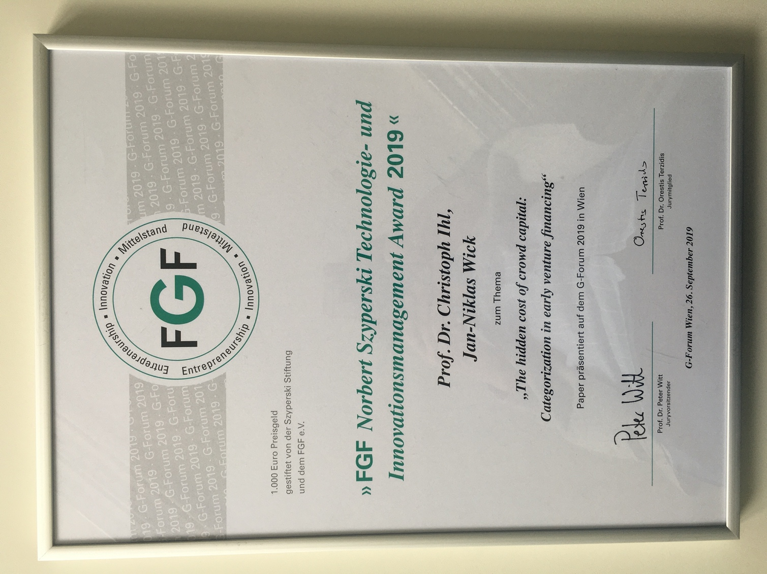

* * *

**VHB - TIE Conference 2019 at TU Darmstadt**

Christoph and Hannes participated in the VHB – TIE Conference at TU Darmstadt from September 11 to 13, 2019 organized by Alexander Kock (Department of Technology and Innovation Management) and Prof. Dr. Carolin Bock (Entrepreneurship).

In addition to the keynote speech of Prof. Dr. Kawa Nazemi, Darmstadt University of Applied Sciences, invited researchers belonging to the TIE Community presented their current research projects in the field of data science.

Further keynote speakers followed such as Dr. Andreas König (University of Passau), Prof. Dr. Dr. Holger Patzelt (TU Munich), Prof. Dr. Frank Piller (RWTH Aachen), Prof. Dr. Christoph Fuchs (TU Munich).

Beitrag über Christoph und Hannes .....

* * *

**2019 Academy of Management Annual Meeting**

The 79th Annual Meeting of the Academy of Management was held August 9-13, 2019 in Boston, Massachusetts, USA

Theme: Undestanding the inclusive Organization

The following Conference Proceedings had been presented:

**Winners Earn, Losers Learn? The Effect of New Venture Success on Crowdfunders’ Investment Decisions.**

by: Christoph Ihl & Jan-Niklas Wick

**Copyright or copy right? Unsolicited User Behavior as Market Signals**.

by: Christoph Ihl & Alexander Vossen

**Contingent Effects of Team Knowledge Diversity on Novelty in Management Research**.

by: Christoph Ihl & Dimitri Graf

**The Best Paper Award was given to Christoph:**

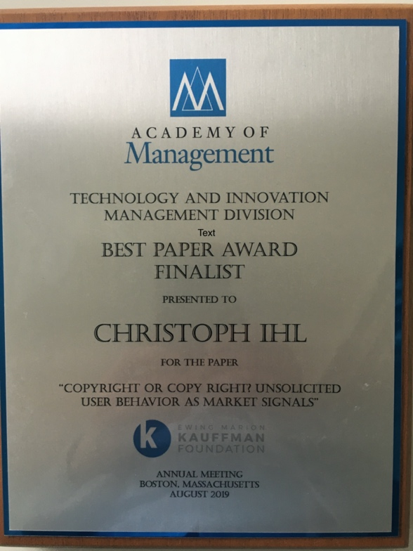

* * *

**2019 EURAM** took place in Lisbon from June 26-28, 2019

Participants: Christoph, Hannes, Dimitri

* * *

New AOM specialized Conference:

**From Start-up to Scale-up: Coping with Organizational Challenges in a Volatile Business Environment**

Hosted by: Hebrew University of Jerusalem, Technion-Israel Institute of Technology, and Tel Aviv University in collaboration with the AOM Divisions & Interest Groups.

This specialized AOM Conference took place in Tel Aviv from December 17 to 19, 2018. Christoph participated in this great event.

* * *

2018 **Academy of Management Annual Meeting**

Location: Chicago, Illinois, USA

Date: August 10-13, 2018

Theme: Improving Lives

The following Conference Proceedings had been presented:

**Herding and the Role of Experts in Equity Crowdfunding Markets**

by: Christoph Ihl & Jan-Niklas Wick

**How institutional entrepreneurs diffuse institutional logics to shape an emerging field**.

by: Christoph Ihl & Giulio Barth

**The Hidden Cost of Crowd Capital: Categorization of Organizational Deviance in New Venture Financing**.

by: Christoph Ihl & Jan-Niklas Wick

* * *

**The 16th Annual International Open and User Innovation Conference**

The 16th International **Open and User Innovation Conference** was held from August 6-8, 2018 at the Stern School of Business at New York University. The OUI **Conference** is the leading academic **conference** on **Open and User Innovation**.

* * *

**EURAM 2018** took place at the University of Iceland in Reykjavik from June 19 to 22.

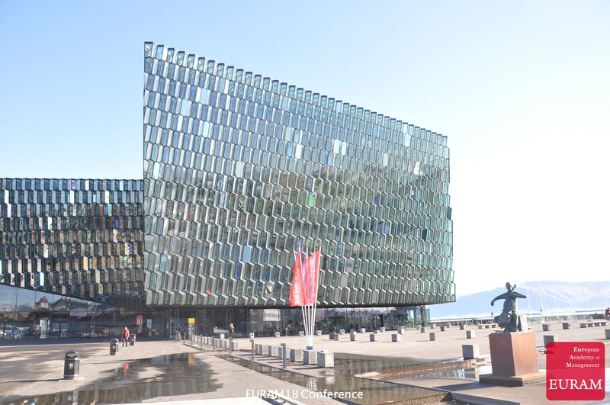



“Research in action, accelerating knowledge creation in management”, was this year’s topic.

We presented the following papers:

**What we know versus who we know;** by Dimitri Graf and Christoph Ihl

**Does Choice of Teams and Ideas improve Performance in Entrepreneurial Teams? Evidence from a Field Experiment**; by Viktoria Kessler, Christoph Ihl and  Rajshri Jayaraman (ESMT)

**Herding and the Role of Experts in Equity Crowdfunding Markets**; by Jan Niklas Wick and Christoph Ihl

* * *

The **DRUID Academy Conference 2018** took place in Copenhagen, Denmark from June 11 to 13, 2018

**The Effect of Choosing Teams and Ideas on Entrepreneurial Performance: Evidence from a Field Experiment** was presented by: Viktoria Kessler, Christoph Ihl, Linus Dahlander (ESMT) and Rajshri Jayaraman (ESMT)

**Herding in Equity Crowdfunding Markets - Heterogeneity Between Experts and Amateurs** was another paper by: Jan Niklas Wick and Christoph Ihl

**WHAT We Know versus WHO We Know,** was Dimitri Graf’s paper presented on this conference.

* * *

SEI Faculty Workhsop May 2018 at ESMT, Berlin

* * *

**VHB/TIE Tagung 2017 in Koblenz**

In September 2017 Christoph and Hannes joined the TIE-Conference in Koblenz-Landau.

* * *

**Big Data, Big Movies, Potsdam, September 2016**

How Algorithms transform the Film & TV Industry.

An International Conference dedicated to the effects of big data on the film and television industry.

* * *

2016 **Academy of Management Annual Meeting**

Location: Anaheim, California, USA

Theme: Making Organizations Meaningful

The following Conference Proceedings had been presented:

**More than words? How entrepreneurial identity shapes users’ reception of new product proposals.**

by: Christoph Ihl and Alexander Vossen

**Inflation and Self-correction in Entrepreneurship Science**.

by: Hannes Lampe, Jan Reerink & Christoph Ihl

**The Distance Dilemma: Effects of Knowledge Distance on Solvers’ Adoption of Broadcasted R&D Problems.**

by: Christoph Ihl, Robin Kleer & Jan Willem Reerink

* * *

**The 20th Anniversary Conference – Druid Society Conference 2016 took place in Copenhagen, Denmark, from June 13 to June 15, 2016.**

Main topic: “Innovation and the dynamics of change”

**Distance Dilemma: The Effects of Knowledge Distance on Solvers’ Participation in Innovation Crowdsourcing.**

was presented by Christoph Ihl, Robin Kleer & Jan Willem Reerink

* * *

3/16 ESMT Berlin, Arbeitskreis Unternehmensgründung

Christoph und Tia

* * *

10/15 TIE-Tagung in Potsdam

Host: Prof. Dr. Katharina Hölzle, University of Potsdam

* * *

2015 **Academy of Management Annual Meeting**

The 75th Annual Meeting of the AOM was held August 7 – 11, 2015 in Vancouver, B.C. Canada.

Theme: Opening Governance

Participants: Christoph, Hannes, Jan

* * *

From July 13 to 15, 2015 – The **International Open and User Innovation Meeting** (OUI)

took place in Lisbon, oragnized by:

The Católica Lisbon School of Business & Economics

It is the leading academic conference on Open and User Innovation. Around 200 researchers from various disciplines (such as innovation management, health, strategic management, organization, design, marketing, entrepreneurship, and public policy) meet annually, in order to exchange recent research findings and plans related to Open and User Innovation.

Participants: Christoph & Hannes

* * *

11/14 - 18. Forum Gründungsforschung in Oldenburg

10/14 TIE-Tagung in München

* * *

2014 **Academy of Management Annual Meeting**

Location: Philadelphia, Pennsylvania, USA

Theme: The Power of Words

* * *

**Christoph Ihl attended the 12th OUI in Boston**

From July 28 to July 30, 2014 the 12th International Open and User Innovation Workshop was held at the Harvard Business School campus in Boston, USA.

Organized by:  
Carliss Baldwin (HBS), Karim Lakhani (HBS), Stefan Thomke (HBS), Eric von Hippel (MIT) and Benjamin Mako Hill (U of Washington)

* * *

**SMS Special Conference in Copenhagen, June 13 – 15, 2014**

Conference Topic: Micro-Foundations for Strategic Management Research: Embracing Individuals

A big range of established scholars and practitioners gathered at the Copenhagen Business School. Lectures had been given to the following topics: “strategic decision-making,” “top-management teams,” “entrepreneurship,” “strategic human resources” “methodological issues.”



  