**DiNuzzo & Griffen – Technical discussion**

We here note some issues with the model of DiNuzzo and Griffen, that either make their model deviate from what is stated in their paper or can influence the simulation outcomes in undesirable ways. Relevant lines of their code are highlighted in yellow, see notes below:

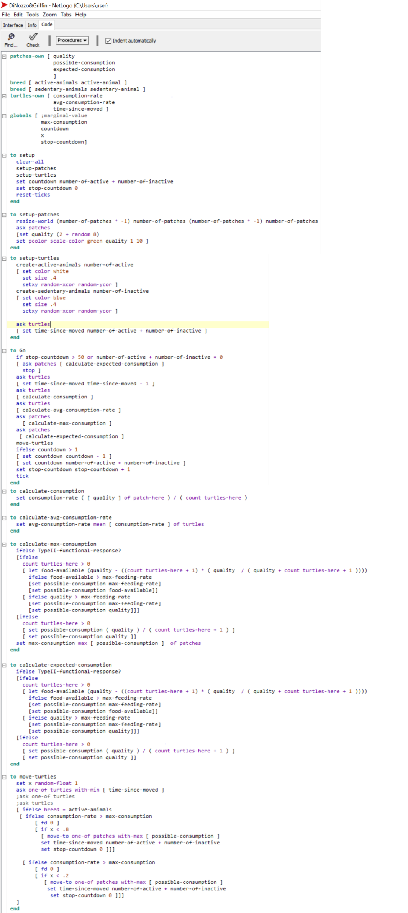

**(2)**

**(1)**

**(3)**



**(4)**

**(5)**

**(5)**

**(6)**

**(7)**

**(8)**

**(7)**

**(8)**

Notes:

1. Real dimensions of grid not equal to parameter, should go from 0 to number_patches – 1 instead of from – number_patches to + number_patches.
2. This initializes the patches with random quality levels between 2 and 9, instead of from 1 to 9 as claimed in the article.
3. The stop condition for the simulation does not perform a rigorous check whether the ideal free distribution is reached. It stops instead when individuals cease movements for 50 time steps.
4. Individuals calculate their current intake rate using this function, regardless of the functional response specified as a parameter. Hence the individual intake rate and the maximal consumption rate are calculated using different functions when a functional response type two is specified in the parameters.
5. Here, in case a type 2 functional response is used, possible-consumption is constrained to a maximum of one. This is problematic because a) in 4, no such constraint is posed, and b) then a lot of patches will have equal intake rates, leading to problems in (7). Instead, food-available could have been calculated using a function that saturates at a value of one, such as in Abrams & Ginsburg 2000.
6. Here, individuals are not randomly selected to move, as stated in the paper, but randomly within the individuals that have not moved for the longest time.
7. Individuals move also between patches when consumption-rate is equal to max-consumption. Since resources are discrete, this leads to individuals jumping between equal patches and risks an infinite loop under certain circumstances.
8. Here, individuals who have a consumption rate higher than any potential consumption rate are told to do nothing. Importantly, they do not update their time-since-moved, and hence remain and eventually fill up the one-of turtles with-min category (turtles that have not moved for the longest time). This is what ultimately brings the simulation to halt. As a side effect, it gets progressively more difficult to filter out the remaining non-optimal individuals from the optimal ones.