Can Cryptocurrencies Make the (Digital) World Go Round?
Christos Cunning
McGill University

Abstract
Current fiat currencies, though they have served us well for thousands of years, are faced with many intrinsic problems that cryptocurrencies are aiming to resolve. These include issues of centralization of power over these currencies within governments and banks, as well as scalability problems. To address these concerns cryptocurrencies like Bitcoin have introduced the concept of decentralized currencies using technology called the blockchain. The blockchain allows users to send and receive money without going through a third party and with a greater level of anonymity than fiat currencies. This paper assesses the viability of Bitcoin, Ethereum and Dash as fiat currency replacements on three main criteria: scalability, security and efficiency, and volatility. For the previously mentioned reasons, Ethereum has the most potential to replace fiat currencies, outperforming all other cryptocurrencies.
Keywords: Cryptocurrency, Bitcoin, Ethereum, Dash, blockchain, proof of work, currency, scalability, volatility, cryptography

Introduction
It is said that “money makes the world go round” and that has never been more true than in today’s fast-paced global society. Currency is the backbone of economies all over the globe and for such an integral part of our society, it has stayed mostly the same for thousands of years. Fiat currencies, whose value comes from being backed by the government or state that issues them [1], have served us well and continue to do so, however, they do have flaws.
For example, fiat currencies do not hold any real value and instead are controlled by the governments and banks who back them, so the value of one’s money is subject to the whims of the country’s economy. Another aspect is who we trust to hold our money. Chances are you have a vast majority of your money currently held by a bank somewhere. Despite the seeming protection of having all your money locked up in vault somewhere, banks are still companies whose main goal is to maximize profit, and many people take issue with the fact that their money is not in fact directly controlled by them [2]. Cryptocurrencies were invented with the goal of addressing some of these flaws. Instead of placing their trust in a country or bank, cryptocurrencies like Bitcoin allow one to place their money and trust in a branch of computer science called cryptography, more specifically the blockchain, while at the same time providing lower transaction fees [3].
While Bitcoin has gained enormous popularity due to its first to market advantage, it is by no means a perfect replacement for fiat currencies, and since its creation there have been over a thousand [4] alternative cryptocurrencies created to compete with it. The focus of this paper will be to compare promising alternates to Bitcoin, specifically Ethereum and Dash, to determine which has the most potential to become a globally recognized currency. According to the following analysis, Ethereum is the most promising form of cryptocurrency due to its low transaction time and fees, efficiency and security, and low volatility.
Background
The concept of the blockchain is the most important innovation introduced by Bitcoin and is outlined in Satoshi Nakamoto’s paper in 2008 [5]. The blockchain is like a digital ledger that records all transactions, and its structure is outlined in Fig. 1 [6]. The blockchain is what makes the decentralized aspect of cryptocurrencies possible [7]. The currency is decentralized because the computation required for the blockchain is not done by any single authority or repository but by the very act of using the currency.
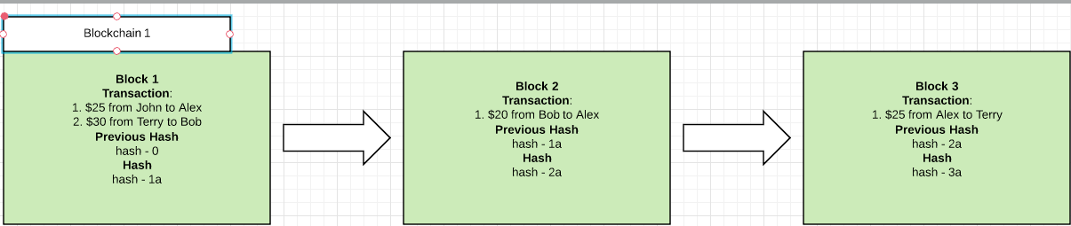
Fig. 1: Visualization of the blockchain [8].

The blockchain works by recording all transactions that happen in blocks and then adding those blocks to the chain. Whenever a new block is created, a miner (someone who is contributing computing power to the Bitcoin system) must solve a complex cryptographical problem and then ‘signs’ the block with the hash or ‘solution’ [9]. This is called the proof of work. Each block’s proof of work is linked to the next block in the chain so that if any transaction is changed or invalidated, then every single transaction and block after that one is also invalid. Therefore, to gain control of the system, a third party will have to control a majority of the computing power available in the system in order to create new blocks faster than everyone else can (this is called a 51% attack) [10].
Another important aspect of Bitcoin is the incentive system. The miners who contribute to the blockchain are compensated with transaction fees paid by the users as well as a block reward (currently 12.5 bitcoins per block) that is awarded whenever a block is completed and added to the chain [11]. Since these miners can be, in theory, anyone using Bitcoin, essentially it is controlled by anyone who uses it. It is also a democratic process because Bitcoin will always take the longest blockchain, that is, the chain that has had the most miners contributing computing resources towards solving proof of works, as the correct record of transactions [12]. The mining process is also illustrated in Fig. 2.
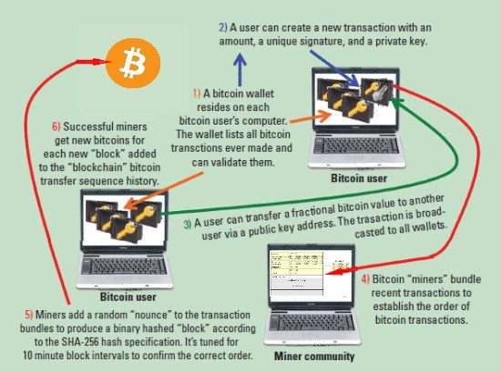
Fig. 2: How Bitcoin mining works [9].

Lastly, Bitcoin allows a level of anonymity that many find appealing. In our increasingly interconnected digital world, your name, personal information and history is everywhere online. However, with Bitcoin all that is tied to a user and their transactions is a specific transaction address (a randomized string of characters unique to each transaction). The blockchain is also public and the entire transaction history is viewable by anyone, adding to the decentralized and transparent appeal.
However, many of the innovations and appeals of Bitcoin, and cryptocurrencies in general, are also the source of some of its current problems. For example, the proof of work system used by Bitcoin, a cryptographic hash algorithm called SHA-256 [5], has been proven to be extremely easy to build specialized machines for [13], leading to a centralization of computing power. The system that incentivizes miners to contribute new blocks to the blockchain is also flawed because it allows miners to decide which transactions to include in their blocks based on the transaction fees provided. This leads to soaring transactions fees and times as miners purposely leave out the common small transactions with little fees in favour of bigger more lucrative transactions [11].
The first cryptocurrency that has the potential to be a viable solution to fiat currencies is Bitcoin. Despite some of the problems laid out in previous paragraphs, Bitcoin is still a very solid system and being the first to market has given it a huge advantage in terms of being by far the most commonly used and accepted coin. This alone may be enough to make it the most successful cryptocurrency. Its blockchain technology behind it is also the basic blockchain that most other altcoins are based on, so Bitcoin acts as a good control or baseline to compare other solutions against.
One of the main alternatives and competitors of Bitcoin is Ethereum. Ethereum is extremely interesting because as well as improving on many of the short comings of Bitcoin and other cryptocurrencies, it also adds a whole other layer of functionality and value above being just another coin [14]. For example, Ethereum has enhanced its blockchain to handle much more than just transactions; one of its main features is the smart contract. A smart contract is a piece of code that anyone can write using Ethereum’s own fully integrated programing language directly into the blockchain that can be used to facilitate the transfer of digital goods and services. Once incorporated into the blockchain, the smart contract becomes a self running program that automatically operates and completes once specific conditions are met [15]. This process is outlined in Fig. 3.
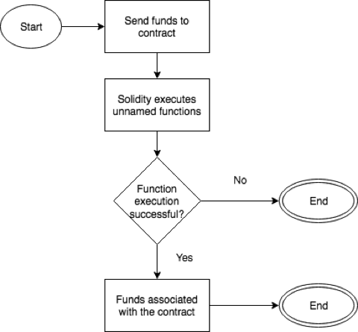
Fig. 3: The general outline of an Ethereum smart contract [16].

Dash is another interesting altcoin that has recently risen greatly in popularity and value in the last year or so [17]. It is fairly similar to Bitcoin however with many improvements and features such as its “two-tier incentivized network” [18], known as the MasterNode Network. This two-tier network allows the split of the mining network and the network involving transactions and spending, which allows faster transaction times and lower fees. Two important features of Dash are its InstantSend and PrivateSend features. InstantSend allows near instantaneous transactions [10], while PrivateSend enhances the anonymity of its users. Dash’s convenience because of these elements is important because it greatly enhance its usability as a day-to-day replacement of fiat currencies, something that Bitcoin and other alt coins are struggling with.
To determine which cryptocurrency has the most potential to become viable a replacement for current fiat currencies, the solutions will be evaluated according to 3 criteria. These criteria highlight the most important features a cryptocurrency must excel at in order to be practical and sustainable as a global currency. The first factor is scalability, the ability for the cryptocurrency to continue to be usable (ie: low transaction fees and times) while growing to accommodate users globally. Additionally, the proof of work system of cryptocurrencies must be resistant to specialization and centralisation. Lastly volatility of the cryptocurrencies presented will be examined because a coin must have a stable value for it to be useable.
Analysis
Scalability: Transaction Times and Fees
A cryptocurrency’s capacity to scale is one of the main indicators of its ability to be used in everyday scenarios as a replacement for fiat currencies. Transaction fees and transaction times must be low enough such that they are suitable for practical usage such as paying for lunch or taking the bus. Currently, Bitcoin can handle about 7 transactions per second [19] with fees soaring to upwards of $30 per transaction (note: all dollar amounts listed in this paper will be in USD) [20]. Meanwhile the VISA network can handle more than 24,000 transactions per second [21]. If cryptocurrencies are going to compete with our current financial systems, they will have to preform similarly.
As mentioned, Bitcoin has so far proven to have poor scalability, the cause of which can be attributed to factors such as proof of work being to computationally difficult and flaws with the network it is built on. Transactions must be verified by every node [22] [5] before being added to the blockchain, which greatly slows down transaction time. It is also getting harder for ordinary users to host nodes as each full node must download the entire blockchain [23] which has now reached a size of more than 160 GB [24]. More full nodes will be critical to maintain the scalability of the blockchain network and if it the bar is too high than that scalability is in jeopardy.
Ethereum faces many similar problems regarding scalability involving its node network. Transactions must be verified by every node [22] and full nodes must also download the full blockchain which could be as big as 100 TB in the future [22]. This could lead to centralization issues as only big corporate entities would have the resources to host a full node. Aside from these network problems Ethereum has the potential to be much more scalable than other solutions. With an average block time of approximately 0.24 minutes, transactions only take about 27 seconds and cost less than a dollar on average [25].
Dash takes a different approach to scalability, with its two-tier network implantation which gives it many advantages over the single-tier network of most other cryptocurrencies. This second tier of nodes allows dash to implement features such as PrivateSend and more importantly to usability, InstantSend [18]. InstantSend is a service that allows for near instantaneous transactions [18]. As well Dash already has a very low average transaction time of 2.6 minutes and fees ranging from $1.00 to $0.40 [26].
Proof of Work: Efficiency and Security
Bitcoin uses a proof of work system called HashCash which utilizes the SHA256 hashing algorithm [27]. This proof of work system is flawed for several reasons. First, it has become too easy to build application-specific integrated circuits, or ASICs, that are specialized to efficiently and quickly solve the encryption that HashCash is built on [28]. In the past even the most casual users of Bitcoin were able to mine for blocks using off the shelf computer hardware. The introduction of ASICs, which have rendered most other forms of mining so inefficient as to be obsolete [29], have increased the cost of entry barrier for normal users. This has resulted in the consolidation of mining power which is counter active to the decentralized intent of Bitcoin.
Ethereum, in contrast, uses a proof of work system called X11 [14]. Instead of one algorithm, X11 alternates between 11 different algorithms which makes creating specialized hardware much harder and, therefore, is resistant to machines such as ASICs. Dash also utilizes this method of multiple proof of work systems and both have shown that it is a clear improvement over the basic proof of work system such as that used by Bitcoin [18].
Volatility: Price Stability Analysis
The limited supply of bitcoins causes the price to fluctuate greatly with demand which is extremely unpredictable [22]. Additionally, the reward system means that early adopters are much more advantaged resulting in concentrations of wealth and making it hard for new users to start using Bitcoin [22]. Despite these draw backs, Bitcoin is one of the more relatively stable cryptocurrencies fluctuating between 2-4% per day [30]. This may be more to do with the that it has been around for a while than the technology behind it however. Newer currencies are more prone to high volatility as users attempt to gauge its worth before deciding to continue to use it or not.
Ethereum, on the other hand, has an unlimited supply of Ethereum available, and provides utility to its currency in the form of smart contracts, both of which help regulate the value. By adding value to its system (smart contracts) that is not related to demand, the Ethereum system can self-regulate its price fluctuations and its value is more predictable. It has a similar daily volatility to Bitcoin, of between a 3-4% price change per day [30], while also accomplishing so in a much shorter time frame than Bitcoin.
Despite a smaller capitalization and being a much more recent addition to the cryptocurrency market, Dash is almost as stable as other solutions and value changes per day do not usually rise above 2-5% [30]. It does, however, experience storm periods in which the price can fluctuate dramatically, by as much as 30-50% [30].
Conclusion
In conclusion, as the development of this still relatively new technology progresses, more and more of the problems hindering large scale adoption will be fixed and Ethereum, as well as cryptocurrencies in general will continue to flourish. Due to its high functionality and scalability as well as its low volatility, Ethereum offers the most promising future of cryptocurrency overall as a replacement for fiat currencies. Despite facing similar network node problems to Bitcoin, Ethereum’s low transaction and times and fees show promising potential for scalability. Moreover, it is clear that the resistance to specialization that Dash and Ethereum gain by employing a range of different proof of work algorithms instead of single one like Bitcoin give them an advantage to maintaining decentralization. Finally, although much newer than Bitcoin, Ethereum has already caught up in terms of volatility. Due to its addition of functionality in the form of smart contracts, it offers a method of determining value that is at least partially independent of the demand placed upon it by its users. Ethereum successfully fulfills all the criterion necessary to potentially replace fiat currencies in the future.

References

[1] | "Fiat Money," Investopedia, Last Updated: 2018. [Online]. Available: https://www.investopedia.com/terms/f/fiatmoney.asp.
[2] | D. Golumbia, The Politics of Bitcoin: Software as Right-Wing Extremism, Univ. of Minnesota Press, 2016.
[3] | A. Mikołajewicz-Woz´Niak and A. Scheibe, "Virtual currency schemes - The future of financial services," Foresight, vol. 17, no. 4, pp. 365-377, 2015.
[4] | "Cryptocurrency Market Capitalizations," CoinMarketCap, [Online]. Available: https://coinmarketcap.com/all/views/all/.
[5] | S. Nakamoto, "Bitcoin: A Peer-to-Peer Electronic Cash System," 2008. [Online]. Available: https://bitcoin.org/bitcoin.pdf.
[6] | M. E. Peck, "Blockchains: How they work and why they'll change the world," IEEE Spectrum, vol. 54, no. 10, pp. 26-35, 2017.
[7] | M. D. Pierro, "What is the Blockchain?," Computing in Science & Engineering, vol. 19, no. 5, pp. 92-95, 2017.
[8] | A. Lee, "Blockchain - A visual explination," Medium, 15 June 2017. [Online]. Available: https://medium.com/@kkomaz/blockchain-a-visual-explanation-afe82d19a234.
[9] | George F. Hurlburt and I. Bojanova, "Bitcoin: Benefit or Curse?," IT Professional, vol. 16, no. 3, pp. 10-15, 2014.
[10] | "51% Attack," Learn Cryptography, [Online]. Available: https://learncryptography.com/cryptocurrency/51-attack.
[11] | I. Eyal, "Blockchain Technology: Transforming Libertarian Crpyotcurrency Dreams to Finace and Banking Realities"," IEEE Computer, vol. 50, no. 9, pp. 38-49, 2017.
[12] | F. Tschorsch and B. Scheuermann, "Bitcoin and beyond: A technical survey on decentralized digital currencies," IEEE Communications Surverys and Tutorials, vol. 18, no. 3, pp. 2084-2123, 2016.
[13] | J. Barkatullah and T. Hanke, "Goldstrike 1: CoinTerra's First-Generation Cryptocurrency Mining Processor for Bitcoin," IEEE Micro, vol. 35, no. 2, pp. 68-76, 2015.
[14] | "White Paper," Ethereum, 2018. [Online]. Available: https://github.com/ethereum/wiki/wiki/White-Paper.
[15] | A. Rosic, "What is Ethereum? A Step-by-Step Beginners Guide," Blockgeeks, 2017. [Online]. Available: https://blockgeeks.com/guides/ethereum/.
[16] | S. J. Huckle, M. White and R. Bhattacharya, "Towards a post cash society: An application to convert fiat money into a cryptocurrency," First Monday, vol. 22, no. 3, 2017.
[17] | "Dash - Dash Charts," CoinMarketCap, [Online]. Available: https://coinmarketcap.com/currencies/dash/#charts.
[18] | D. Diaz and E. Duffield, "Dash: A Privacy-Centric Crypto-Currency," Dash, 2018. [Online]. Available: https://github.com/dashpay/dash/wiki/Whitepaper.
[19] | K. Croman, C. Decker, I. Eyal, A. E. Gencer, A. Juels, A. Kosba, A. Miller, P. Saxena, E. Shi, E. G. Sirer, D. Song and R. Wattenhofer, "On Scaling Decentralized Blockchains," 2016.
[20] | T. Lee, "Bitcoin's transaction fee crisis is over - for now," Ars Technica, 20 Feburary 2018. [Online]. Available: https://arstechnica.com/tech-policy/2018/02/bitcoins-transaction-fee-crisis-is-over-for-now/.
[21] | "Visa acceptance for retailers," Visa, [Online]. Available: https://usa.visa.com/run-your-business/small-business-tools/retail.html.
[22] | "Problems," Etherem, 19 December 2017. [Online]. Available: https://github.com/ethereum/wiki/wiki/Problems.
[23] | "Full Node - Bitcoin Wiki," Bitcoin Wiki, 14 February 2018. [Online]. Available: https://en.bitcoin.it/wiki/Full_node.
[24] | "Blockchain Size," Blockchain.info, [Online]. Available: https://blockchain.info/charts/blocks-size.
[25] | "Ethereum Avg. Transaction Fee historical chart," BitInfoCharts, [Online]. Available: https://bitinfocharts.com/comparison/ethereum-transactionfees.html.
[26] | "Dash Avg. Transaction Fee historical chart," BitInfoCharts, [Online]. Available: https://bitinfocharts.com/comparison/dash-transactionfees.html.
[27] | "Hashcash," Bitcoin Wiki, 25 March 2017. [Online]. Available: https://en.bitcoin.it/wiki/Hashcash.
[28] | "Comparison Between Litecoin and Bitcoin," Litecoin, 12 February 2018. [Online]. Available: https://litecoin.info/index.php/Comparison_between_Litecoin_and_Bitcoin.
[29] | M. B. Taylor, "The Evolution of Bitcoin Hardware," IEEE Computer, vol. 50, no. 9, pp. 58-66, 2017.
[30] | EXMO Team, "Volatility of TOP 5 cryptocurrencies. Comparison," EXMO, 6 December 2017. [Online]. Available: https://exmo.com/en/news_view?id=1940.
[31] | C. Lee, "Creating Litcoin," YouTube, 2017.

