**BIG BLUE DATA ACADEMY**

**DATA SCIENCE FULL TIME BOOTCAMP**

**WEEKLY PROJECT 1**

**NETFLIX ORIGINAL MOVIES**

**EFTHYMIOU CHRISTOS**

|  |  |
| --- | --- |
| **For this week’s project,**  **the goal was to analyze a dataset**  **in order to find interesting results**  **and take a glimpse of**  **whether the results contradict**  **to our everyday intuition**  **or not.** | Εικόνα που περιέχει άτομο, πόζα, ομάδα, άτομα  Περιγραφή που δημιουργήθηκε αυτόματα |

**This analysis merged the following KAGGLE datasets.:**

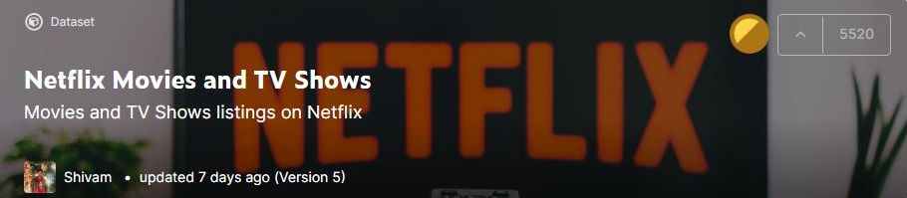

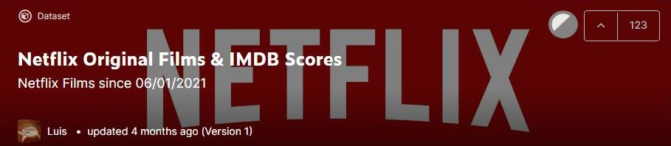

**DATA PREPARATION**

The merging of the above is a dataset

about **526** Netflix Original Titles, according to

**Genre**, **Runtime**, **IMDB Score**, **Language**, **Country**, **Release Year** and **Rating**,

which was based on each movie’s **Title**.

The data about Release Year **2021** refer to the year’s **first semester**.

Out of **584** initially, there were **58** movies removed,

not accompanied by information about their **Country** or **Rating**.



**Percentage of titles according to Rating**

|  |  |  |
| --- | --- | --- |
|  | **TV-G** | **Suitable for all ages.** |
| **G** | **Suitable for general audiences.** |
| **TV-Y** | **Aimed at a very young audience,**  **including children from ages 2–6.** |
| **TV-Y7** | **Most appropriate for children aged 7 and up.** |
| **PG** | **Parental guidance suggested.** |
| **TV-PG** | **Contains material that parents**  **may find unsuitable for younger children.**  **Parental guidance is recommended.** |
| **PG-13** | **Parents strongly cautioned.**  **May be inappropriate for ages 12 and under.** |
| **TV-14** | **May be unsuitable for children under 14 years of age.** |
| **TV-MA** | **Intended to be viewed by mature, adult audiences**  **and may be unsuitable for children under 17.** |
| **R** | **Restricted, children under 17**  **require accompanying parent or adult guardian.** |

**Mean IMDB Score according to Rating**

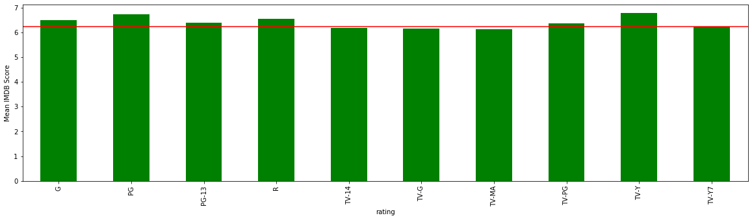

**Percentage of titles according to Release Year**

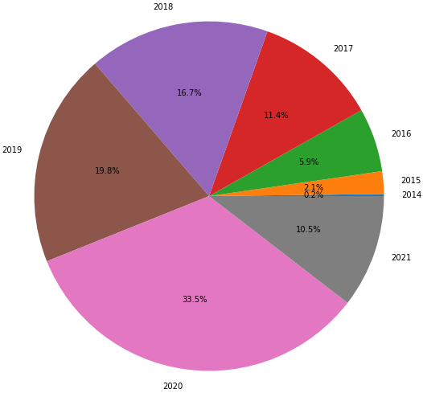

**Mean IMDB Score according to Release Year**

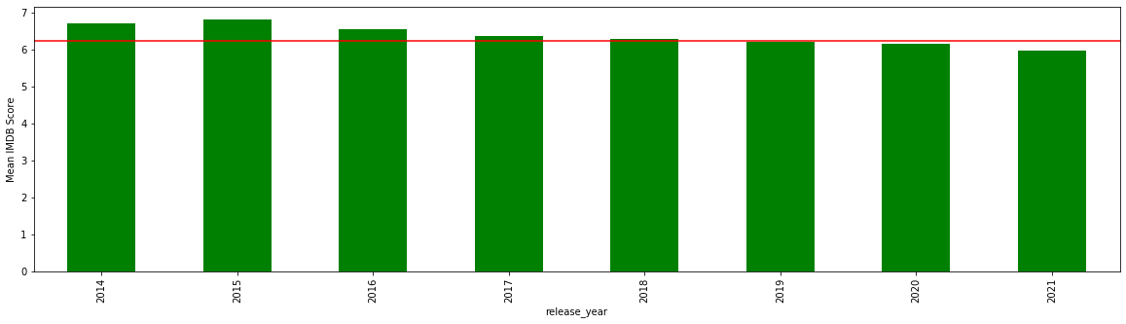

|  |  |
| --- | --- |
| **Number of titles**  **according to Country** |  |
| **Mean IMDB Score**  **according to Country** |  |

|  |  |
| --- | --- |
| **Percentage of titles according to Language** | **Mean IMDB Score according to Language** |
|  |  |

**Number of titles according to IMDB Score**

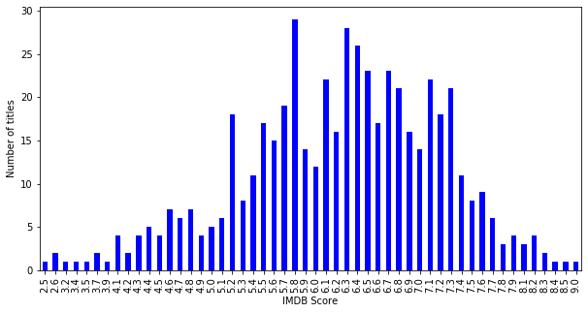

**Mean IMDB Score according to Runtime**

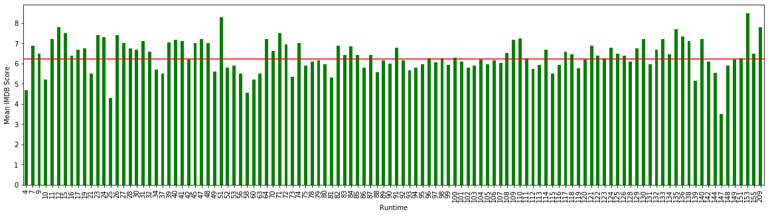

|  |  |
| --- | --- |
| **Number of titles**  **according to Genre** |  |
| **Mean IMDB Score**  **according to Genre** |  |

**Sources:**

<https://www.kaggle.com/shivamb/netflix-shows>

<https://www.kaggle.com/luiscorter/netflix-original-films-imdb-scores>