**Inno Monitor v1.0.8 beta User Manual**

Double-click Inno Monitor to open the Inno Monitor application as shown in Figure 1:

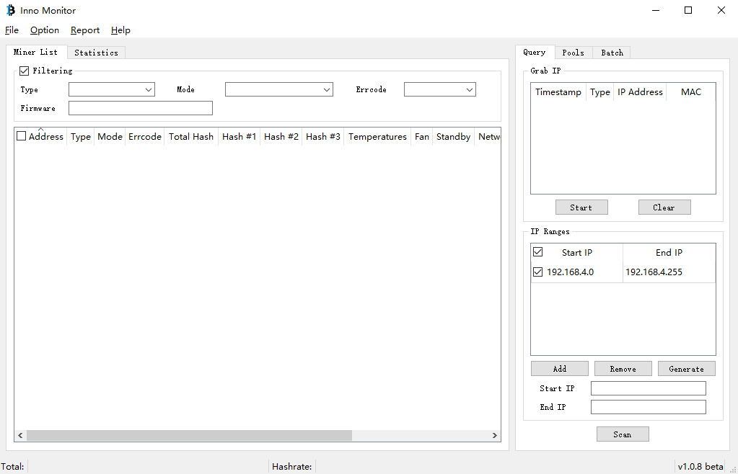

Figure 1

**Personalized Setting**

Click “Options”>> “Settings” to open the “Settings” dialogue as shown in Figure 2 for personalized settings.

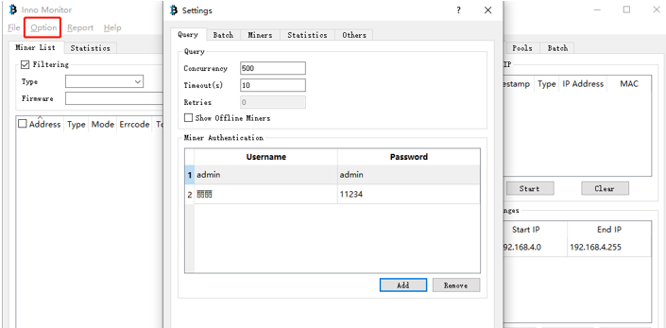

Figure 2

**Others**

Click the “Others” icon to set display language, browser path and firmware update check time as shown in Figure3.

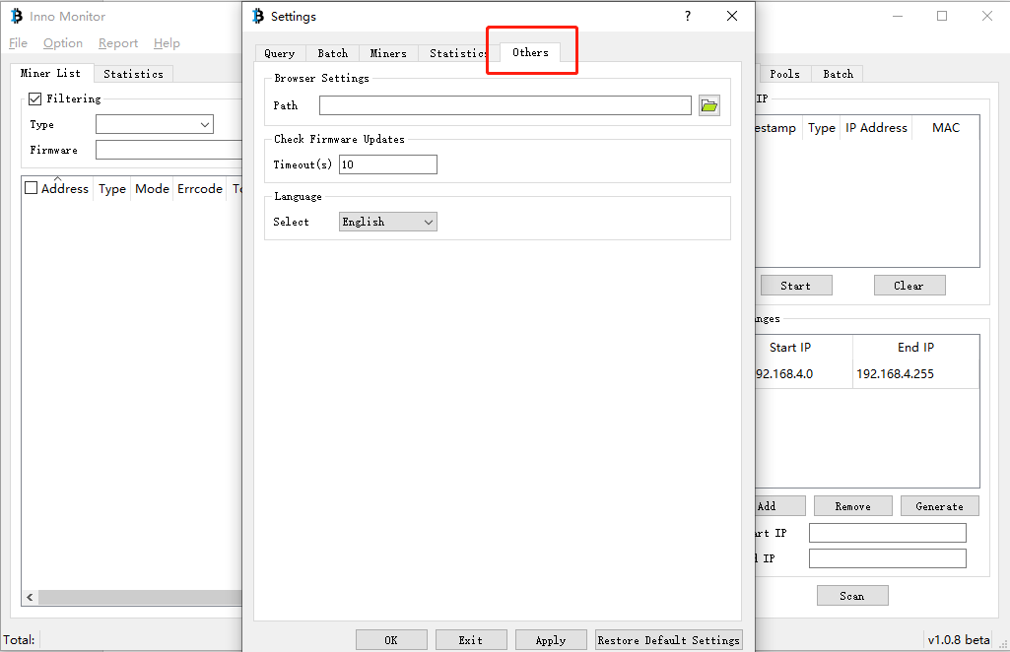

Figure 3

**Query**

Click the “Query” icon to set query parameters such as concurrency number and timeout and add or delete users as shown in Figure 4:

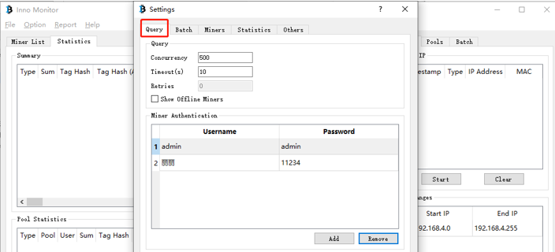

Figure 4

1. Concurrency: the available quantity of miners scanned at the same time
2. Timeout: The smaller the timeout is set, the faster the miners are scanned. It is suggested to set the timeout greater than 2s. When the tool fails to scan some miners but they turn to be normal when you go to the console, you need to prolong the timeout because of the bad network condition.
3. Add/Remove: Click the “Add” / “Remove” icon to add or delete users.

**Batch Management**

Click “Batch” to upgrade the firmware, configure the pool and performance mode, reboot and reset miners, reset the miner DHCP, add and delete user accounts as shown in Figure 5 in a batch.

Notes: The default username and password are “guest” and “guest”. The Batch Management tool can be only used to monitor the operation conditions of miners under the guest account and the guest user has no permission to configure the pool, upgrade the firmware and reset the miner to factory mode. (The guest account can be offered to the operation and maintenance engineer for user on spot.) Only the user with real account can perform the overall function of the tool. Therefore, the real account shall be kept in your own hands to better ensure the security of miners.

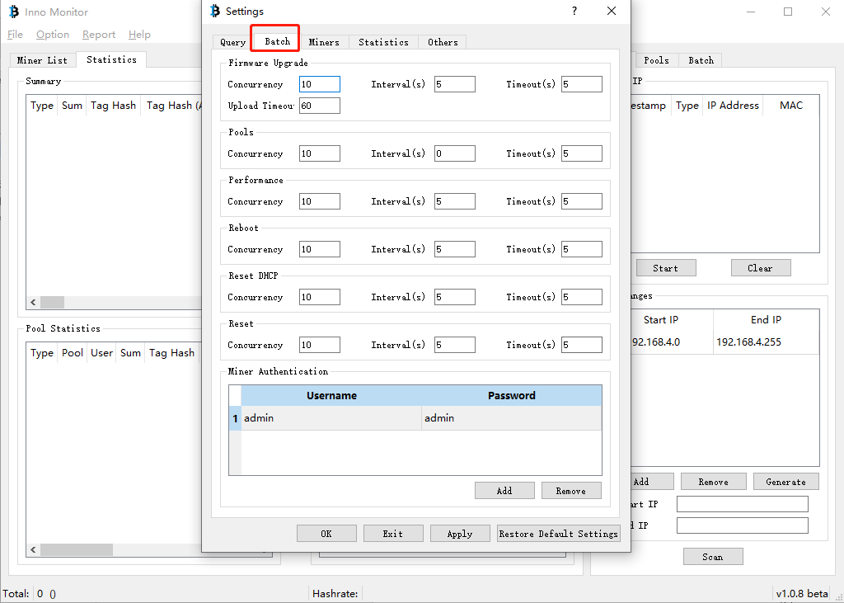

Figure 5

**Miners**

Click “Miners” to configure the relevant information displayed for miners in a batch as shown in Figure 6:

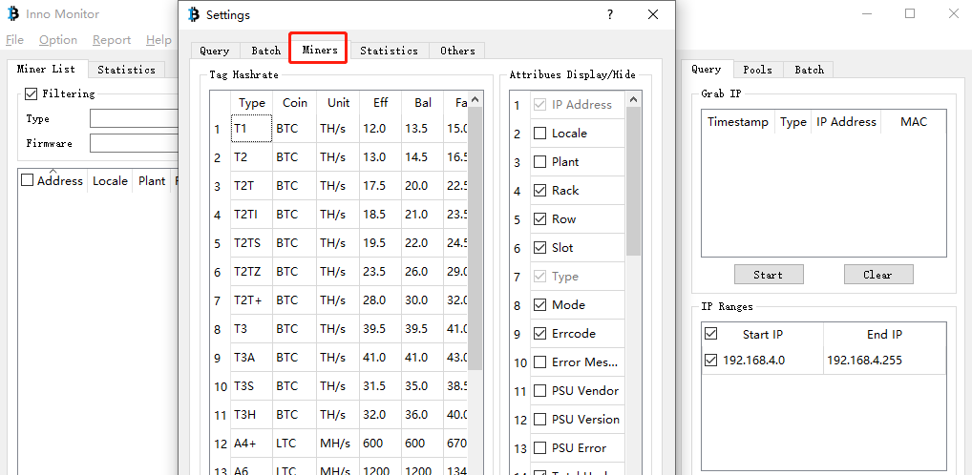

Figure 6

**Statistics**

Click “Statistics” to configure information including “Statistics”, “Summary attributes” and “Pool Statistics Attributes” as shown in Figure 7.

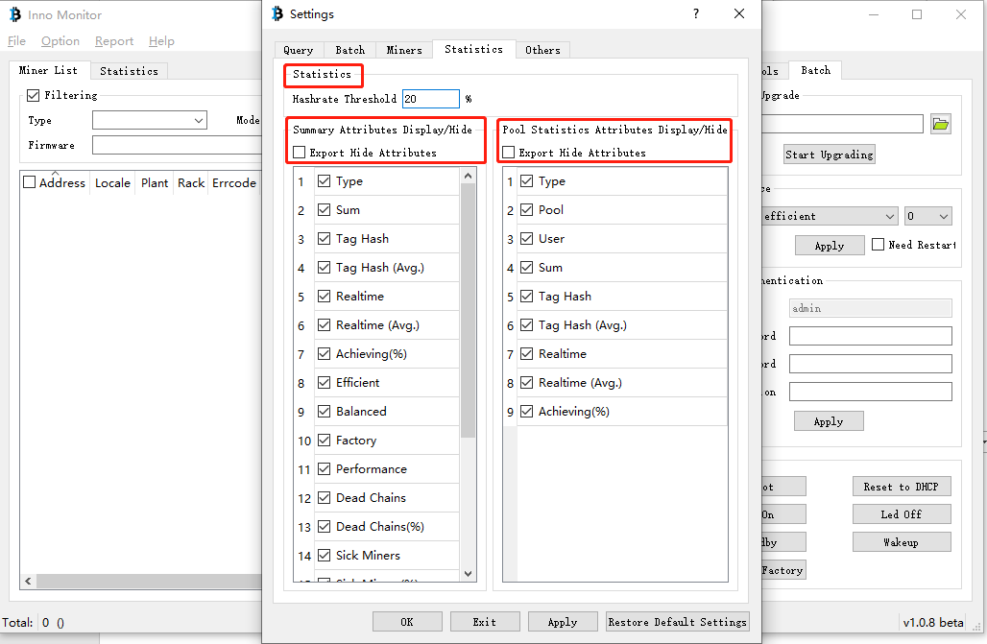

Figure 7

**Monitor the Miner in a Batch**

Enter the start IP and end IP within the IP range, click the “Scan” icon and the miner list within the IP range of the network will be displayed as shown in Figure 8: (Notes: the cross-network-segment scanning can be realized by the Batch Management Tool.)

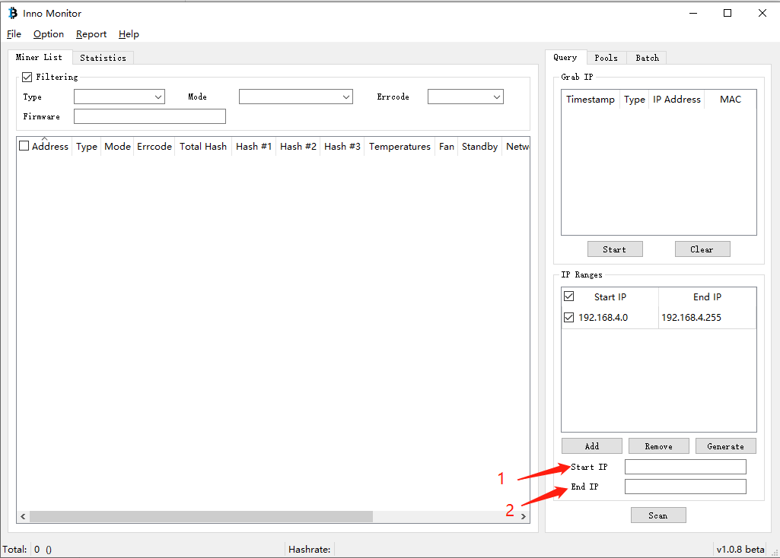

Figure 8

Click “Start” to grab the IP for all the miners selected.

**Configure the Pool in a Batch**

It is available to configure the pool of miners by the Batch Management Tool after scanning all the miners in the same way of configuring the pool in the console. Pls refer to Figure 9 for details:

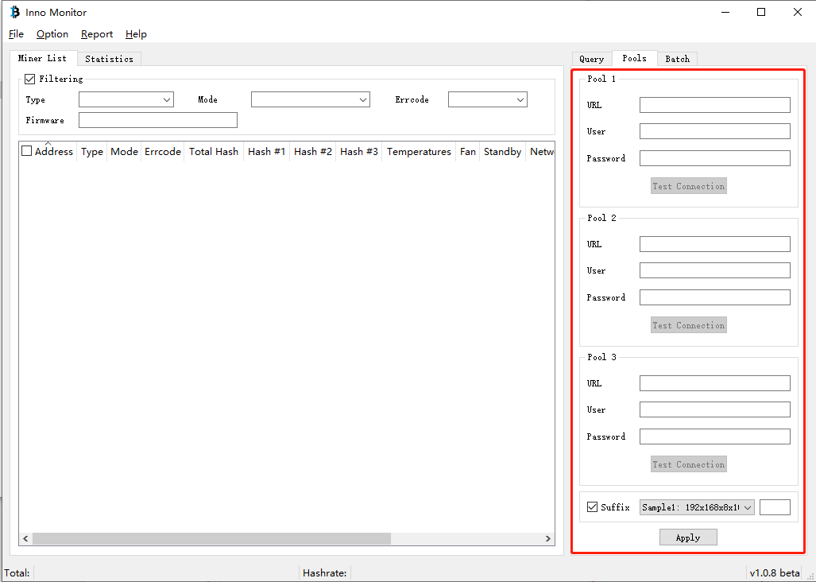

Figure 9

Fill in the URL, User and Password fields and Click “Apply” to realize pool configuration in a batch. (Notes: It is available to view the hash rate of each miner in the pool by checking the Suffix checkbox and naming it separately.)

**Upgrade the Firmware in a Batch**

(Notes: Only users whose user names are admin and passwords are real can upgrade the firmware in a batch.)

(1) Click the miner needing upgrading

(2) Select the corresponding firmware file downloaded

(3) Click “Start Upgrading” to upgrade the firmware

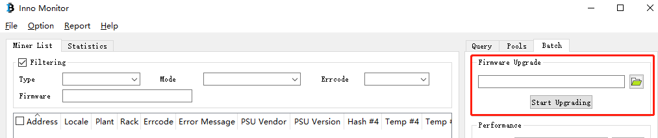

Figure 10

**Other Functions**

1. Modifying the performance mode in a batch: Select the miners and the mode needed from the performance mode list and click “Apply” to realize mode modification.
2. Changing passwords in a batch: Enter the username, old password, new password and confirmation password and click “Apply” to realize password modification.
3. Reboot: Select miners and click “Reboot” to reboot miners in a batch.
4. Reset to DHCP: Select miners and click “Reset to DHCP” to reset miners to the DHCP mode in a batch.
5. Led On: Select miners and click “Led On” to locate the miner rapidly as needed.
6. Led Off: The indicator can be turned off after locating the miner needed. The function is used with “Led On”.
7. Standby/Wakeup: Select miners and click “Standby”/ “Wakeup” to realize the corresponding functions in a batch.
8. Reset to factory: Select miners and click “Reset to Factory” to reset miners to factory mode in a batch.
9. Export:
10. Click “File”>> “Export All Miners”/ “Export Selected Miners” to export the information of all miners/ the selected miners.
11. Click “Report” and select from the dropdown list “Export Summary”/ “Export Pool Statistics”/ “Export Error Statistics”/ “Export All Statistics” to export the corresponding information of miners into report.

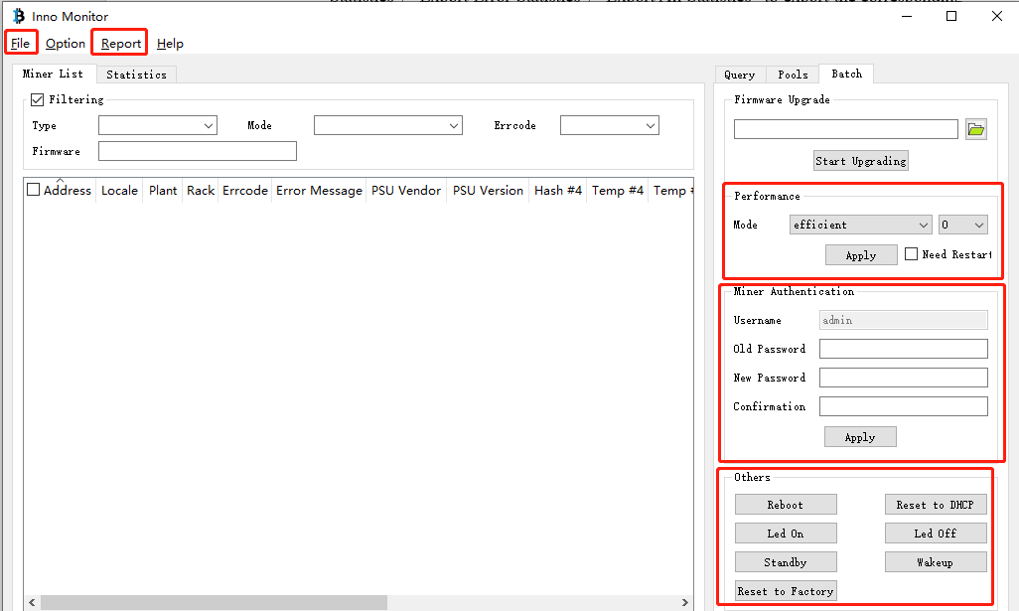

Figure 11

**Help**

Click “Help” to view information on Q &A, change log and so on. As for Q&A, pls refer to the Inno Monitor Q & A document for details.

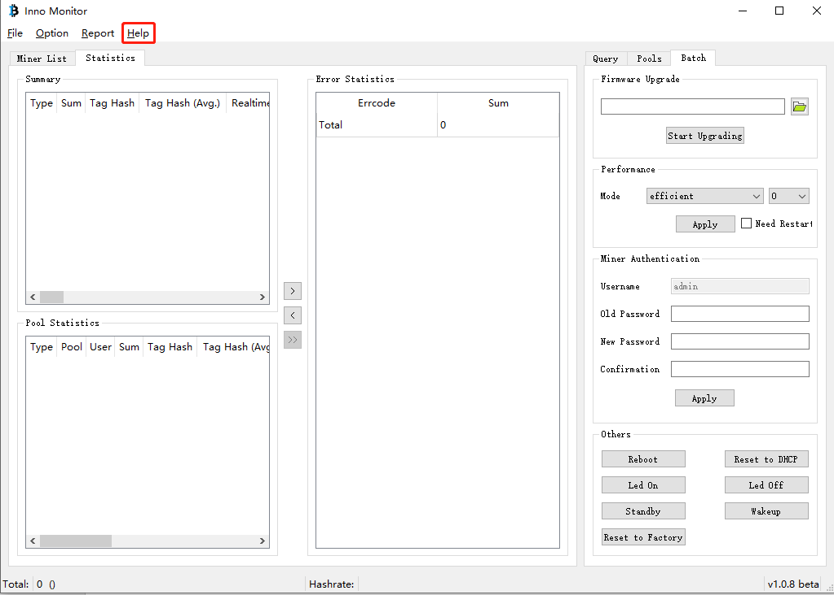

Figure 12