Web Component MV* Architecture — Technical Reference
A comparative study of two Web Component implementations: LcIssueElement (lc-payment-wc, A1 — Import LC Issue) · BalanceComponent (lc-issue-angular)
Version 2.0 · Revised 2026-07-21

Revision note (v2.0). This edition was re-verified line-by-line against the live source of both codebases (lc-payment-wc and lc-issue-angular) rather than against framework convention. Component A (LcIssueElement) is confirmed unchanged and accurate. Component B (BalanceComponent) and the cross-project claims about Angular’s role have been materially corrected: the lc-issue-angular source has evolved since v1.0, and Angular is no longer a passive host in that project. The specific corrections are called out in §4.3, §4.4, §6 and §8.

1. Purpose & Scope
This document explains how Model-View-Controller responsibilities (loosely referred to here as “MVV” / MVC / MVVM) are distributed across the Angular shell, the Web Component layer, and the backend API, using one Web Component from each of two related codebases as a worked example: LcIssueElement (A1 — Import LC Issue, in lc-payment-wc) and BalanceComponent (in lc-issue-angular).
The central finding — established by reading the source directly — is that the two projects follow different philosophies, and this is the most important correction in v2.0:
- In lc-payment-wc, Angular genuinely contributes no MV* responsibility. All state, event handling, and view rendering are owned entirely by the Web Component; Angular is a pure mount point.
- In lc-issue-angular, Angular is not passive. It owns a real reactive form (ngx-Formly FormGroup), bridges that form’s model into the Web Components by writing HTML attributes, and consumes an application event bus to gate submission. Here Angular takes an active Controller/ViewModel role.
In both projects, the authoritative business formula is computed server-side — that finding holds and is unchanged.

2. Executive Summary
- Angular’s role differs between the two projects. In lc-payment-wc it is a passive host — it mounts the custom element and does nothing else: no (change) bindings, no @Input/@Output, no FormGroup, no reading or writing of the component’s internal state. In lc-issue-angular it is an active orchestrator — a Formly-driven FormGroup whose valueChanges push values into the Web Components as HTML attributes, plus an EventBus subscription that enables the Submit button.
- The two components differ in how a field change reaches the server:
  - LcIssueElement (lc-payment-wc): submit-gated — a field change only updates local state; the API call fires only on explicit form submission (the exception being the per-charge currency dropdown, which recalculates immediately on change).
  - BalanceComponent (lc-issue-angular): attribute-reactive — it implements the native observedAttributes / attributeChangedCallback lifecycle, so any watched-attribute change auto-triggers a debounced (500 ms) recalculation with no submit action. Those attribute changes are driven externally by Angular (_push() on form.valueChanges) — so, unlike Component A, this loop is externally orchestrated.
- The authoritative “Model” — the real commission/margin/balance formula — lives server-side in both projects. Neither Web Component computes business numbers itself; each only formats and displays what the server returns. BalanceComponent’s own header comment states this explicitly (“NO arithmetic here”).
- EventBus reality (corrected). BalanceComponent broadcasts its result via a custom EventBus.emit('balance-resolved', …). In lc-issue-angular the EventBus is an active pub/sub backbone: charge-grid → payment-grid (charge-update, charge-remove, applicant-changed, fx-updated) and payment-grid → Angular (payment-ready, consumed by LcIssueComponent to enable Submit). However, the specific balance-resolved / balance-cleared events that BalanceComponent emits have no subscriber anywhere — not Angular, not a sibling component. And the named EventBusService wrapper referenced in a source comment still does not exist; Angular imports the raw EventBus singleton directly. So the narrowed, still-true finding is: BalanceComponent’s own broadcast is currently dead, even though the bus it uses is otherwise live.
- Dead / unfinished code in each project: lc-payment-wc defines ApiService.calcImportIssue() but never calls it (the widgets fetch() directly). lc-issue-angular emits balance-resolved/balance-cleared that nothing consumes, and carries a comment describing an EventBusService that was never built.

3. Component A — LcIssueElement (lc-payment-wc)
Status: verified against source, unchanged from v1.0.

3.1 Field Capture & Trigger Mechanism — Submit-Gated
Every input listens for the native change event and writes the new value into a private _form object. Numeric inputs use a bn() helper; selects use a bs() helper. This alone never calls the backend:
const bn = (id, k) => shadow.getElementById(id)
?.addEventListener('change', e => { _form[k] = Number(e.target.value); });
bn('marginRate','marginRate'); bn('commRate','commRate'); bn('tolerancePct','tolerancePct');
src/app/web-components/import/lc-issue.element.ts:126-129
The API call is triggered only when the form is submitted:
shadow.getElementById('form')
?.addEventListener('submit', e => { e.preventDefault(); this._calc(false); });
src/app/web-components/import/lc-issue.element.ts:118
The one exception is the per-charge currency dropdown (choosing which currency to pay margin/commission/SWIFT in), which recalculates immediately on change, without a submit step:
shadow.getElementById(`charge-ccy-${c.id}`)
?.addEventListener('change', e => { c.ccy = e.target.value; this._calc(true); });
src/app/web-components/import/lc-issue.element.ts:133-139

3.2 Server-Side Model — the Business Formula
The commission and margin math never runs in the browser. It is computed entirely inside the Express route handler:
const marginLcAmt = round(lcAmount * (marginRate / 100), dp(lcCurrency));
const lcBalance = round(lcAmount * (1 + tolerancePct / 100), dp(lcCurrency));
const rawCommTwd = round(lcBalance * r * (commRate / 100), 0);
const commTwd = Math.max(rawCommTwd, MIN_COMM); // 1,000 TWD floor
backend/server.js:101-107 (route: POST /api/import/issue/calc, server.js:81; MIN_COMM = 1000, server.js:22)

3.3 Cross-Functional Architecture
The diagram below traces the full request lifecycle for A1 — Import LC Issue: Browser → Angular shell (passive host) → Web Component (View + fused Controller/state) → Express API → server-side Model (formula) → response → re-render.
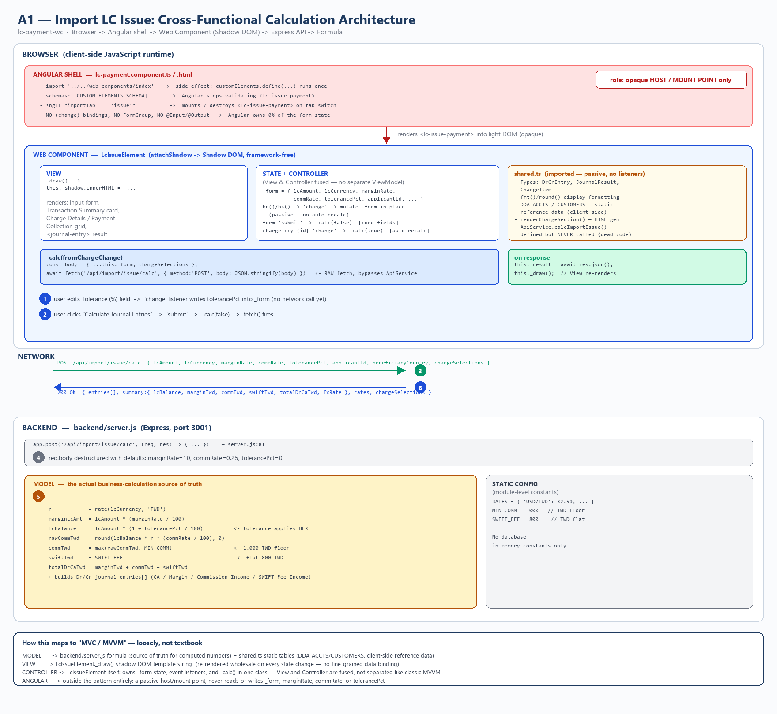
A1 Import LC Issue cross-functional architecture
Figure 1 — A1 Import LC Issue cross-functional architecture (Browser / Angular / Web Component / Express API / Model). Verified: every element in this diagram — server.js:81, the formula, MIN_COMM/SWIFT_FEE constants, the unused ApiService, and Angular’s opaque-host role — matches current source.

4. Component B — BalanceComponent (lc-issue-angular)
Status: re-audited against source; findings corrected from v1.0.

4.1 Native Reactivity — observedAttributes / attributeChangedCallback
Unlike LcIssueElement, BalanceComponent declares which HTML attributes it watches. The browser calls attributeChangedCallback automatically whenever one of them changes — the native Web Component analog to Angular’s ngOnChanges:
static get observedAttributes() {
return ['lc-amount', 'tolerance-pct', 'lc-currency'];
}
attributeChangedCallback(_, ov, nv) {
if (ov === nv) return;
if (this._s === 'resolved') this._s = 'stale';
this._schedule();
}
src/app/web-components/balance.element.ts:34-36 (observed), :46-50 (callback)
Who changes those attributes? Not an end user typing into the component — BalanceComponent has no inputs of its own. The watched attributes (lc-amount, tolerance-pct, lc-currency) are set by the Angular host, LcIssueComponent._push(), on every form.valueChanges (see §4.4). This is the key architectural link that v1.0 omitted.

4.2 Debounced Auto-Recalculation — No Submit Required
Every attribute change resets a 500 ms debounce timer; when it elapses, the component calls the backend on its own, with no user-initiated submit action:
_schedule() {
if (this._timer) clearTimeout(this._timer);
if (this._s !== 'stale') { this._s = 'pending'; this._draw(); }
this._timer = setTimeout(() => this._calc(), 500);
}
// _calc() → fetch('/api/balance/calc', { method:'POST',
// body: JSON.stringify({ lcAmount, lcCurrency, tolerancePct }) })
src/app/web-components/balance.element.ts:52-56 (schedule), :58-97 (calc), :73-77 (fetch body)

4.3 Outbound Broadcast — EventBus
On a successful response, the component broadcasts the result through a custom, hand-rolled pub/sub singleton (not the native CustomEvent/dispatchEvent API):
EventBus.emit('balance-resolved', { ...this._r }); // balance.element.ts:90
// shared.ts — EventBus.on() with late-subscriber replay:
on(type, fn) {
(_handlers[type] ||= []).push(fn);
if (type === 'balance-resolved' && _lastBalance.value) fn(_lastBalance.value); // replay
return () => { /* unsubscribe */ };
}
src/app/web-components/balance.element.ts:90; src/app/web-components/shared.ts:176-194
Finding (corrected in v2.0). shared.ts:150 comments that “Angular’s EventBusService wraps this same instance.” Checked directly against current source:
- There is no EventBusService class anywhere in lc-issue-angular/src — the only textual match for that name is the comment itself. Angular does not wrap the bus in a service; where it uses the bus, it imports the raw EventBus singleton directly.
- Angular does consume the bus — the v1.0 claim that “no file under src/app/features references EventBus” is now false. features/lc-issue/lc-issue.component.ts imports EventBus (line 8), subscribes EventBus.on('payment-ready', …) to enable Submit (line 41), and calls EventBus.reset() on destroy/reset (lines 50, 123).
- But balance-resolved specifically is unconsumed. A full scan of every EventBus.on(...) in the codebase finds subscribers only for payment-ready (Angular) and applicant-changed / charge-update / charge-remove / fx-updated (payment-grid). Nothing subscribes to balance-resolved or balance-cleared. BalanceComponent’s broadcast therefore lands nowhere — the same class of gap as lc-payment-wc’s unused ApiService.calcImportIssue(), narrowed to this one event rather than the whole bridge.
Full EventBus topology in lc-issue-angular (verified):
Event | Emitter | Subscriber(s)
charge-update | charge-grid | payment-grid
charge-remove | charge-grid | payment-grid
applicant-changed | charge-grid | payment-grid
fx-updated | charge-grid | payment-grid
payment-ready | payment-grid | Angular LcIssueComponent
balance-resolved | balance-component | (none)
balance-cleared | balance-component | (none)

4.4 Angular’s Active Role in lc-issue-angular (new in v2.0)
This section did not exist in v1.0 because v1.0 treated Angular as passive in both projects. Against current source that is incorrect for lc-issue-angular. LcIssueComponent (features/lc-issue/lc-issue.component.ts) is an active, stateful controller:
- It owns a reactive form. form = new FormGroup({}) driven by ngx-Formly (FormlyFieldConfig[]), with changeDetection: ChangeDetectionStrategy.OnPush. This form’s model is the real input ViewModel — LC amount, currency, tolerance, applicant, commission rate, etc.
- It bridges model → Web Components by writing attributes. On every form.valueChanges (debounced), _push() calls setAttribute(...) on #wc-balance (balance-component) and #wc-cgrid (charge-grid), which is precisely what triggers Component B’s attributeChangedCallback loop described in §4.1–4.2.
- It consumes the event bus. EventBus.on('payment-ready', …) flips isReady to enable the Submit button; EventBus.reset() clears subscriptions on destroy and on user reset.
- It is an NgModule app. Unlike lc-payment-wc’s standalone component, lc-issue-angular registers LcIssueComponent via app.module.ts.
In short, in lc-issue-angular Angular supplies the input ViewModel and the orchestration that feeds the Web Components; the Web Components own their own fetch/render loops and their own view state. This is a genuine split of Controller responsibility, not a passive host.

5. MV* Role Mapping
Neither component implements textbook MVVM (no observable bindings on the WC side, no separate ViewModel object inside the WC). The mapping below is descriptive.
Role | LcIssueElement (lc-payment-wc) | BalanceComponent (lc-issue-angular)
Model | backend/server.js formula (server.js:101-107) + shared.ts static tables (DDA_ACCTS, CUSTOMERS) | Server: POST /api/balance/calc (the only source of computed numbers). Plus an Angular-side input model: the Formly FormGroup model in LcIssueComponent.
View | _draw() → shadow-DOM innerHTML, re-rendered wholesale on every state change | _draw() → shadow-DOM innerHTML, driven by an explicit state machine (idle/pending/loading/resolved/stale/error)
Controller | Fused into the WC class: _form state + bn()/bs() listeners + _calc() | Split: the WC owns observedAttributes + _schedule()/_calc(); Angular LcIssueComponent owns the form, the _push() attribute bridge, and submit-gating via EventBus
Angular | Passive host only — mounts via *ngIf, CUSTOM_ELEMENTS_SCHEMA, zero data binding | Active — Formly FormGroup → _push() attribute bridge + EventBus.on('payment-ready'); there is no EventBusService wrapper (comment only)

6. Angular’s Role Across Both Projects
In lc-payment-wc, Angular’s lc-payment.component.ts has three responsibilities only: (1) import the web-components module once, as a side effect, to run customElements.define(); (2) declare CUSTOM_ELEMENTS_SCHEMA so the template compiler tolerates unknown elements/attributes; (3) toggle *ngIf to mount and unmount tabs. Because mounting is *ngIf-gated, switching away from a tab and back destroys and recreates the custom element — connectedCallback fires fresh, and any typed values or calculated results are lost, since Angular preserves no state on the component’s behalf. This is confirmed against current source and unchanged.
In lc-issue-angular, the equivalent host role is not passive (corrected from v1.0). LcIssueComponent runs a Formly-driven FormGroup, pushes its model into the Web Components as HTML attributes on every debounced valueChanges, and subscribes to the EventBus payment-ready signal to enable submission. The custom elements here are data-driven by Angular, not merely mounted by it. The one part of the source comment that remains inaccurate is the reference to an EventBusService — no such class exists; Angular uses the raw EventBus singleton.

7. Comparative Summary
Aspect | LcIssueElement (lc-payment-wc) | BalanceComponent (lc-issue-angular)
Change-capture API | Manual addEventListener('change') on self-rendered inputs | Native observedAttributes + attributeChangedCallback
Who drives the inputs | The end user, directly on the component’s own inputs | The Angular host _push(), on form.valueChanges
Trigger for server call | Explicit form submit (charge-ccy dropdown is the one auto-trigger exception) | Automatic, debounced 500 ms after any watched attribute changes
Outbound event channel | None — no dispatchEvent, no EventBus | Custom EventBus.emit('balance-resolved', …)
Is that outbound event consumed? | N/A (no outbound channel) | No — nothing subscribes to balance-resolved/balance-cleared; the EventBus is otherwise active (charge-grid → payment-grid → Angular payment-ready)
Angular’s role | Passive host (mount only) | Active — Formly form + attribute bridge + payment-ready consumer
Business formula location | backend/server.js (POST /api/import/issue/calc) | Backend (POST /api/balance/calc) — component explicitly comments “NO arithmetic here”
Unused / unfinished code | shared.ts ApiService.calcImportIssue() — defined, never called | balance-resolved/balance-cleared — emitted, never subscribed; EventBusService — named in a comment, never implemented

8. Conclusion
The two codebases do not follow the same architectural philosophy — the most important revision from v1.0.
lc-payment-wc is the pure-Web-Component pattern: all form state, event wiring, and rendering live inside the custom element; Angular is strictly a mount point; the server is the single source of truth for business calculations. That description is fully verified.
lc-issue-angular shares the “server owns the math” principle and the “Web Component owns its own view/fetch loop” principle, but Angular is an active participant here: a Formly FormGroup supplies the input ViewModel and an Angular _push() bridge drives the components via HTML attributes, while an EventBus carries component-to-component and component-to-Angular signals. It is closer to an MVVM arrangement with Angular as the ViewModel/orchestration layer than to the passive-host pattern.
Where each project has unfinished wiring:
- lc-payment-wc: an unused ApiService.calcImportIssue() abstraction — the components bypass it and fetch() directly.
- lc-issue-angular: a balance-resolved/balance-cleared broadcast from BalanceComponent that no one subscribes to, plus a stale source comment describing an EventBusService wrapper that was never built.
Both loose ends are worth closing before either pattern is extended to new components — either wire balance-resolved into whatever should react to it (or delete the emission), and either implement the EventBusService the comment promises or correct the comment.

Verification basis: source read directly from C:\Users\samfi\Downloads\outputs\lc-payment-wc and …\lc-issue-angular on 2026-07-21. Component A citations (lc-issue.element.ts:118/126-129/133-139, server.js:81/101-107/22) confirmed exact. Component B citations (balance.element.ts:34-36/46-50/52-56/90, shared.ts:150/176-194) confirmed; EventBus topology confirmed by full-tree grep of every emit()/on() call.

