SDLC AI Agents & Skills
Step-by-Step Installation Guide
Agency Agents + 8 Claude Code Skills | April 2026 | Windows / DOS Edition

Overview

This guide covers the complete installation of the Agency Agents library and the eight essential Claude Code Skills recommended for software companies following a full SDLC workflow. Together, these tools cover every phase from requirements analysis through deployment, security testing, and operations.

💡 Prerequisites (Windows): Install Git for Windows (git-scm.com), Node.js 18+ (nodejs.org), and Claude Code CLI via: npm install -g @anthropic-ai/claude-code | winget is required for PlanetScale: enable via Windows Package Manager (winget.run).

Priority | Label | When to Install
🔴 | Must Install | Core gaps — install immediately for all projects
🟡 | Strongly Recommended | Improves delivery quality — install for most projects
🟢 | As Needed | Install when the project specifically requires it

Part 1 — Agency Agents

Agency Agents is an open-source library of 144 pre-built AI agent personas covering 12 departments. For a software company it provides instant coverage of engineering, design, testing, product management, and project coordination roles — essentially filling any position not yet hired.

Step 1 · Clone the Repository
Run the following command in your terminal to clone the Agency Agents library to your local machine:

git clone https://github.com/msitarzewski/agency-agents.git
cd agency-agents

Step 2 · Install Dependencies
npm install
or
./scripts/install.sh --tool claude-code

Step 3 · Verify Available Agents
After installation, list the available agents to confirm everything is working:

dir agents\

You should see 144 agent definition files across 12 departments:

Department | # Agents | SDLC Relevance
💻 Engineering | 25 | ★★★★★ Critical
🧪 Testing | 8 | ★★★★★ Critical
🎨 Design | 8 | ★★★★★ Critical
🎬 Project Management | 6 | ★★★★★ Critical
📊 Product | 5 | ★★★★★ Critical
🛟 Support | 6 | ★★★★ High
📢 Marketing | 24 | ★★★ Medium
💼 Sales | 8 | ★★★ Medium
💵 Finance | 5 | ★★★ Medium
🎯 Specialized | 17 | ★★★★ High
💰 Paid Media | 6 | ★★ General
🎮 Game Development | 20 | ★★ Project-specific

https://github.com/msitarzewski/agency-agents

Key Engineering Agents for SDLC
The following agents from the Engineering department are the most directly useful for day-to-day software development:

- Frontend Developer — React / Vue / Angular UI implementation
- Backend Architect — API design and database architecture decisions
- Software Architect — System design and high-level architecture
- Security Engineer — Threat modelling and security code reviews
- DevOps Automator — CI/CD pipeline setup and automation
- Database Optimizer — SQL performance tuning and index design
- Code Reviewer — Pull request review and code quality gatekeeping
- Technical Writer — API documentation and internal knowledge bases
- SRE — Service reliability, SLOs, and incident response
- AI Engineer — ML model integration and LLM orchestration

Step 4 · Invoke an Agent
Agency Agents are invoked from within Claude Code by referencing the agent role name. Example:

Division | Agent | Full @ Syntax
Engineering | Security Engineer | @engineering-security-engineer.md
Engineering | Code Reviewer | @engineering-code-reviewer.md
Engineering | Frontend Developer | @engineering-frontend-developer.md
Engineering | Backend Architect | @engineering-backend-architect.md
Testing | Reality Checker | @testing-reality-checker.md
Marketing | SEO Specialist | @marketing-seo-specialist.md

ℹ️ No additional runtime install is required — the SKILL.md definitions are read by Claude Code automatically once the repo is cloned and referenced in your project context.

Part 2 — Claude Code Skills Installation

Skills are SKILL.md files that extend Claude Code with specialized domain knowledge. Unlike agents (which define personas), skills change how Claude behaves for specific task categories — such as always performing a security scan before deployment, or always generating an architecture diagram after design discussions.

🔑 Install all skills from your project root directory where Claude Code is configured.

🔴 Priority 1 — Must Install

1. Antigravity Awesome Skills

Field | Details
Priority | 🔴 Must Install
SDLC Phase | All SDLC phases (Requirements → Maintenance)
Fills Gap | Requirements analysis, Architecture documentation, API design standards, Technical debt management

Purpose:
A curated library of 1,234+ community skills installed in a single command. It is the highest-value single install for any software company because it simultaneously closes gaps in requirements analysis, architecture documentation, API design, PR workflow standardization, security-focused code review, and technical writing. Think of it as a skills operating system that other skills can complement.

Installation Command(s):
npx antigravity-awesome-skills --claude

https://github.com/sickn33/antigravity-awesome-skills

Key Sub-Skills / Features:
- @brainstorming — Structured requirements discussion and feature planning sessions
- @architecture — System architecture design with component-level planning
- @api-design-principles — REST API consistency, versioning, and endpoint naming conventions
- @doc-coauthoring — Structured technical documentation writing as part of the dev flow
- @create-pr — Standardized Pull Request creation with descriptions and checklists
- @security-auditor — Security-focused code review during development
- @debugging-strategies — Systematic debugging playbook for maintenance and operations
- @lint-and-validate — Lightweight code quality and linting checks

2. Code Reviewer (Simplify)

Field | Details
Priority | 🔴 Must Install
SDLC Phase | Development, Testing, Maintenance
Fills Gap | Technical debt accumulation, Ongoing code quality, Maintenance phase

Purpose:
Turns code quality review from a manual step into an automatic default after every code generation. It actively scans for reusable logic that should be extracted, functions violating Single Responsibility Principle, performance issues such as N+1 queries and unnecessary re-renders, dead code, unused imports, and inconsistent naming conventions. The result is that technical debt is caught and prevented continuously rather than discovered in expensive refactoring cycles.

Installation Command(s):
npx skills add anthropics/claude-code --skill simplify

Key Sub-Skills / Features:
- Auto-review — Runs automatically after every AI-generated or modified code block
- Simplification — Identifies over-abstracted logic and recommends clearer alternatives
- Pattern check — Flags code that is inconsistent with the rest of the codebase style
- Perf scan — Detects N+1 queries, blocking operations, and unnecessary re-renders

3. Shannon — AI Penetration Testing

Field | Details
Priority | 🔴 Must Install
SDLC Phase | Testing (Security), Pre-deployment Verification
Fills Gap | Active penetration testing (Agency Agents only provides static security code review)

Purpose:
Shannon is an autonomous penetration testing skill that executes real security attacks against your local or staging environment before every deployment. Unlike static security review (which only reads code), Shannon actively exploits vulnerabilities. It covers 50+ vulnerability types including SQL injection, XSS, SSRF, authentication bypasses, and IDOR, with a 96.15% exploit success rate and zero false positives — it only reports vulnerabilities that were actually exploited. Cost per test run is approximately $50, compared to thousands of dollars for manual penetration testing.

Installation Command(s):
npx skills add unicodeveloper/shannon -g -y

https://github.com/unicodeveloper/shannon

Key Sub-Skills / Features:
- Active exploits — Actually attempts SQL injection, XSS, SSRF, IDOR, auth bypass attacks
- Zero false positives — Only reports confirmed, successfully exploited vulnerabilities
- 96.15% success rate — Industry-leading detection rate across 50+ vulnerability types
- Pre-deploy gate — Designed to run before every staging or production deployment

Autonomous AI pentesting skill for Claude Code. Run /shannon commands directly from your Claude Code session.

Usage Examples

1. Full Pentest of a Local App
Run a complete autonomous pentest against an application running on localhost.
/shannon http://localhost:3000 myapp

2. Pentest a Staging Environment with a Named Workspace
Organise results under a named workspace for audit tracking.
/shannon --workspace=audit-q1 http://staging.example.com backend-api

3. Target Specific Vulnerability Categories
Limit the scope to selected OWASP categories (e.g. XSS and injection only).
/shannon --scope=xss,injection http://localhost:8080 frontend

4. Check Running Pentests
Display the status of any currently active pentest sessions.
/shannon status

5. View Latest Report
Print the most recent pentest findings with proof-of-concept details.
/shannon results

6. Stop a Running Pentest
Gracefully terminate an in-progress pentest session.
/shannon stop

🟡 Priority 2 — Strongly Recommended

4. Browser Use

Field | Details
Priority | 🟡 Strongly Recommended
SDLC Phase | Testing (E2E / UAT), Operations, Research
Fills Gap | User Acceptance Testing (UAT), end-to-end automated testing against staging

Purpose:
Gives Claude real control over a headless browser instance so it can navigate URLs, click elements, fill forms, extract JavaScript-rendered content, and take screenshots — all as part of natural language workflows. This transforms Claude from a code generator into a full end-to-end QA engineer. It fills the UAT gap that Agency Agents cannot cover: instead of just writing test scripts, Claude can execute them against a live staging environment and report with screenshots.

Installation Command(s):
npx skills add https://github.com/browser-use/browser-use --skill browser-use -y -g

https://github.com/browser-use/browser-use

Key Sub-Skills / Features:
- E2E Test Execution — Runs complete user flows (registration, checkout, login) on live environments
- Screenshot capture — Captures screenshots of errors or unexpected states automatically
- Dynamic content — Reads JavaScript-rendered pages that static scrapers cannot access
- Form automation — Fills and submits forms as a real user would, including file uploads

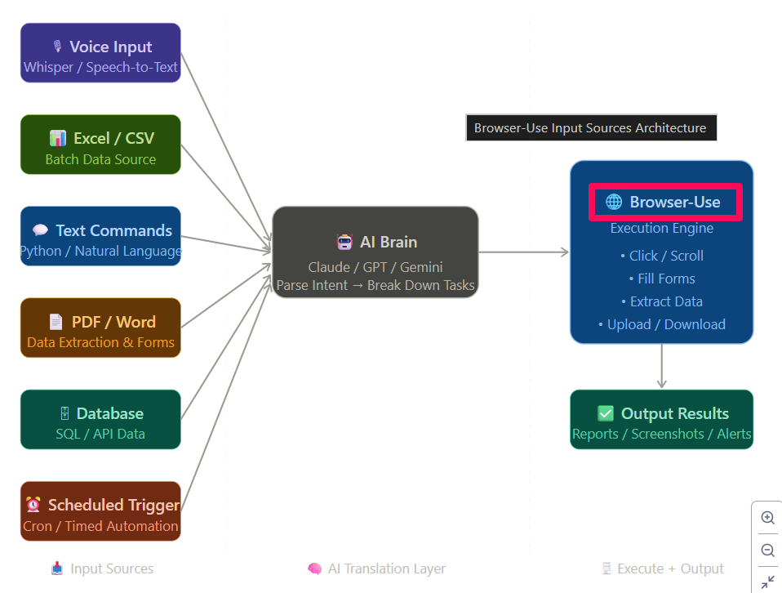

5. Excalidraw Diagram Generator

Field | Details
Priority | 🟡 Strongly Recommended
SDLC Phase | Requirements Analysis, System Design, Delivery Documentation
Fills Gap | Visual architecture documentation, Client-deliverable system design artifacts

Purpose:
Converts natural language architecture discussions directly into shareable visual architecture diagrams — API flow diagrams, database ER diagrams, microservice relationship maps, and data flow charts. Every system design decision becomes a deliverable artifact immediately, which is critical for client handover, team onboarding, and future maintenance reference. Agency Agents includes a Software Architect agent but produces no visual output; this skill closes that documentation gap.

Installation Command(s):
npx skills add https://github.com/coleam00/excalidraw-diagram-skill --skill excalidraw-diagram -y -g

https://github.com/coleam00/excalidraw-diagram-skill

Key Sub-Skills / Features:
- Auto-diagram — Generates Excalidraw diagrams from architecture conversation context
- Multiple types — Supports API flows, ER diagrams, sequence diagrams, microservice maps
- Shareable export — Outputs files ready to share or embed in documentation
- Natural language — No need to learn diagram syntax — describe in plain English

6. Google Workspace CLI (GWS)

Field | Details
Priority | 🟡 Strongly Recommended
SDLC Phase | Requirements Analysis, Deployment Coordination, Operations & Collaboration
Fills Gap | Requirements collection from existing docs, Delivery documentation management, Team communication automation

Purpose:
Automates the full Google Workspace ecosystem — Gmail, Google Docs, Sheets, Drive, and Calendar — via 50+ Google APIs. For teams already using Google Workspace, this means Claude can read requirements from Google Docs, track project status in Sheets, send deployment notifications via Gmail, manage meeting schedules in Calendar, and write meeting minutes directly to shared Drive documents. It bridges the gap between AI development work and operational team communication.

Installation Command(s):
npm install -g @googleworkspace/cli
gws –-help

gws auth setup
gws auth login
npx skills add https://github.com/googleworkspace/cli

https://github.com/googleworkspace/cli

Key Sub-Skills / Features:
- Gmail automation — Draft and send deployment notifications, client updates, and status emails
- Docs integration — Read requirements from and write documentation to Google Docs
- Sheets tracking — Update project trackers, test reports, and bug logs in Google Sheets
- Calendar management — Schedule sprint ceremonies, reviews, and client meetings automatically
- Drive storage — Save generated diagrams, reports, and deliverables directly to Drive

🟢 Priority 3 — Install As Needed

7. PlanetScale Database Skills

Field | Details
Priority | 🟢 As Needed (MySQL / PostgreSQL projects)
SDLC Phase | Development (Database Design), Deployment (Schema Migration)
Fills Gap | Proper schema design from scratch, Safe database migrations, Production schema rollback capability

Purpose:
Adds database-branch workflow management and schema-first design discipline to Claude Code. Instead of directly modifying production database schemas, every change is proposed through a branch (like a Git branch for databases), reviewed as a Deploy Request, and rolled back if needed. The skill also generates index-aware schemas from design discussions, preventing the common mistake of building a schema that works in development but degrades under production load. Recommended for any project using MySQL or a MySQL-compatible database.

Installation Command(s):
npx skills add planetscale/database-skills -y -g

https://github.com/planetscale/database-skills

Key Sub-Skills / Features:
- Branch workflow — Database changes go through branch → review → deploy, never direct to prod
- Schema generation — Produces index-aware schema designs from entity relationship discussions
- Deploy Requests — Every schema change is reviewable, approvable, and rollback-safe
- Migration tracking — Full history of schema changes with author and timestamp records

8. Valyu — Real-Time Professional Data

Field | Details
Priority | 🟢 As Needed (data-driven products)
SDLC Phase | Requirements Analysis, Development (Data-Driven Applications)
Fills Gap | Real-time external data access (all other tools are limited to training knowledge cutoff)

Purpose:
Connects Claude to 36+ real-time professional data sources including SEC filings, PubMed research papers, financial indicators, and regulatory documents. All other agents and skills rely on Claude's training data which has a knowledge cutoff date. Valyu gives Claude access to authoritative, up-to-date external data during planning and development — critical for products in fintech, healthcare, legal tech, or any domain where regulatory and market data changes frequently.

Installation Command(s):
npx skills add valyuAI/skills -y -g

https://github.com/valyuAI/skills

Key Sub-Skills / Features:
- SEC filings — Real-time access to SEC EDGAR documents for financial product development
- Research papers — PubMed and academic data for healthcare or research-based applications
- Financial signals — Live market data and economic indicators for fintech applications
- Regulatory data — Up-to-date regulatory and compliance information by jurisdiction

Part 3 — SDLC Coverage Summary

The table below shows how Agency Agents and each installed skill maps to SDLC phases, and what coverage level is achieved after installation:

SDLC Phase | Agency Agents Alone | After Installing Skills | Key Skills
Requirements Analysis | ⭐⭐ | ⭐⭐⭐⭐ | GWS + @brainstorming
System Design | ⭐⭐⭐⭐⭐ | ⭐⭐⭐⭐⭐+ | Excalidraw + @architecture
Database Design | ⭐⭐ | ⭐⭐⭐⭐⭐ | PlanetScale
API Design | ⭐⭐⭐ | ⭐⭐⭐⭐⭐ | @api-design-principles
Development | ⭐⭐⭐⭐⭐ | ⭐⭐⭐⭐⭐+ | Code Reviewer + PlanetScale
Technical Testing | ⭐⭐⭐⭐ | ⭐⭐⭐⭐⭐ | Browser Use + Shannon
UAT | ⭐⭐ | ⭐⭐⭐⭐ | Browser Use
Security Testing | ⭐⭐⭐ | ⭐⭐⭐⭐⭐ | Shannon + @security-auditor
Deployment | ⭐⭐⭐ | ⭐⭐⭐⭐ | GWS + @create-pr
Delivery Documentation | ⭐⭐ | ⭐⭐⭐⭐ | Excalidraw + GWS + @doc-coauthoring
Maintenance | ⭐⭐ | ⭐⭐⭐⭐ | Code Reviewer + @debugging-strategies
Real-Time Data | ⭐ (cutoff) | ⭐⭐⭐⭐⭐ | Valyu

— End of Installation Guide —

