**Christian Sfeir**

**Lab experiment 1**

**Objectives:**

The objectives of this experiment are:

* For a beginner to become familiar with the CMM332 board, as well as to begin using the AxIDE terminal emulator
* To learn how to create an ASCII file containing an assembly language program for the Motorola 68000 BCC
* To establish communication between the computer and the and CMM332 board, as well as to program the board
* To make sure the downloaded program works correctly

**Theory:**

This experiment deals with the CMM332 board which is an extension of the Motorola MC68332 BCC. The CMM332 contains a microcontroller unit, two 64K x 16 erasable programmable ROMs which use the M68CPU32BUG debug software, and finally 32k x 16-bit RAM. The CMM332 will be connected to a PC using a serial port, and the AxIDE software will be used in order to communicate with the device and will serve the purpose of an ANSI terminal emulator.

**Results and discussion:**

The CMM332 board was plugged in the computer, and the AxIDE application was set up in order to establish communication between the two machines. The first part of the experiment was to use the debugger in order to:

* Display and modify the register contents
* Display and modify memory contents at certain locations

The memory content at the location $3000 was displayed by using the memory display (MD) command:



Next, the memory at the address $4000 was modified to the following sequence: $474F4F44204A4F4212121202020. After having accomplished this, the memory displayed this message:



Next, a program was written (see appendix) and was compiled within the AxIDE emulator. Following that, it was downloaded to the CMM332 board, and it was then executed in the debugger. The CLR, MOVE, ADD, MULS, and DIVS commands worked correctly. The following sample was taken to demonstrate that:

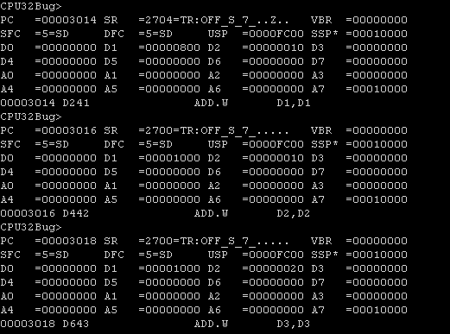

**Questions:**

1. A CPU (central processing unit) is a computer component that will carry out the instructions given to it by other sources, whether these instructions be to perform an arithmetic, logic or I/O operation. An MCU (microcontroller) is an integrated circuit that contains all the parts of a computer, including a CPU, RAM memory, ROM memory, and an I/O unit. An MCU contains more hardware and can accomplish more functions compared to a processor.
2. A register is a place within the CPU where a small amount of data can be stored and accessed very easily.
3. The PC (program counter) register has the task to fetch an instruction, as well as to point to the next instruction which is given to the CPU. The SR register contains information on the state of the processor, therefore information on the results of the previous operations. The D0-D7 processors are, for their part, reserved for storing the data. Finally, the A0-A7 registers are used to store the addresses at which the data is stored.
4. The .lst file is machine language while the .asm file is assembly language. Eventually, the .asm file will be translated to the machine file, thus generating the .lst file.
5. Machine code is a language written in binary which is read by the CPU and supplies the instructions the CPU must carry out.
6. The S-record file contains binary information in ASCII hexadecimal text. Its format is:

|  |  |  |  |  |  |
| --- | --- | --- | --- | --- | --- |
| S | Type | Byte count | Address | Data | Checksum |

**Conclusion:**

The ASCII file with the assembly code was successfully created and communicated to the CMM332 board. The corresponding program was successfully downloaded to the Motorola 68k and worked correctly. All these steps and components are essential to helping a beginner learn to use the CMM332 board as well as the AxIDE environment.

**Appendix:**

1. **Assembly language program.**

* Experiment 1

* Name: Christian Sfeir

* Date: September 25th, 2019

ORG $3000

CLR.L D1

CLR.L D2

CLR.L D3

CLR.L D4

MOVE.B #$01,D1

MOVE.B #$02,D2

MOVE.B #$03,D3

START

ADD D1,D1

ADD D2,D2

ADD D2,D3

MULS D1,D3

DIVS D2,D1

SUB D0,D0

BEQ START

END