**Christian Sfeir**

**Lab experiment 2**

**Objectives:**

The main objectives of this experiment are to differentiate the G (GO) and T (TRACE) commands on the debugger, all while assembling, downloading and modifying the memory content of a program.

**Introduction:**

The use of machine language by a programmer these days is rare, usually a program is written in assembly code and is converted into machine language where it is then loaded in the main memory in an S-Record file, and then it is then executed by the CPU. In order to assist in the conversion, the op-code instructions are given in the Motorola 68k programmer’s documentation. The instructions ADD and SUB will be focused on in this experiment.

**Results:**

The assembly code found in the appendix was written and compiled. The machine code was then obtained for the program and was run on the MC68000 using the T command. The result of this gives:

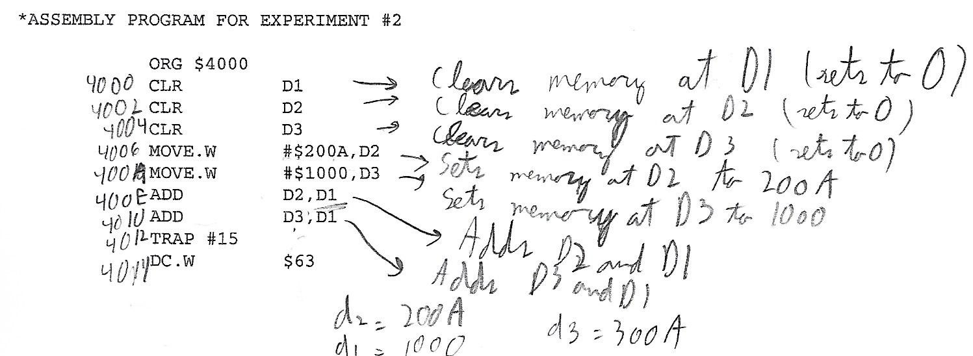

Next, the machine code was directly modified by changing the memory. In register D2, the value 200A was modified to 15ff, the value of 1000 in register D3 was changed to 00FF, and the program was modified for it to subtract D3 from D1 instead of adding them together. This was done by modifying the value at 4010 to 9243. The following result was obtained.

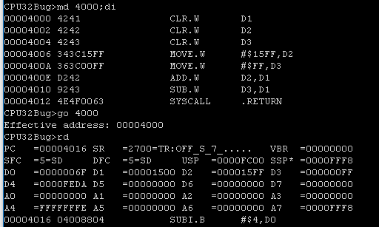

Finally, the program was executed using the GO debugger command over the T command.

**Questions:**

1. The main debugger commands used are MD, MM, GO and MS
2. The addressing mode which is used is mode 000 because the register numbers are Dn (where n is an integer)
3. The original program:
4. Clears registers D1, D2, and D3
5. Sets the memory at D2 to 200A
6. Sets the memory at D3 to 1000
7. Adds the value of D2 to D1
8. Adds the value of D3 to D1

The new program:

1. Clears registers D1, D2, and D3
2. Sets the memory at D2 to 15ff
3. Sets the memory at D3 to 00FF
4. Adds the value of D2 to D1
5. Subtracts the value of D3 from D1
6. The op-code bits originally given in appendix 4 were 1101 which is the same as an addition, however, this was wrong, as stated by the AS32. The actual correct op-code is 1001, once this was corrected, the subtraction worked and had effect.
7. The T command executes the code normally, only the user must manually rewrite the command and run for every step. In contrast, the GO command executes the whole code after only writing and running the command once.

**Conclusion:**

In this experiment, the use of the GO command was prioritized over the T command. The GO command is more efficient than T since it will display the program result instantly instead of having to always reissue the command. The memory in the program was directly modified using op-code, which made it possible to change an addition to a subtraction in the original assembly code.

**Appendix:**

Source code:

|  |
| --- |
| * Experiment 2  * Name: Christian Sfeir(40120536)  * Date: October 9, 2019  ORG $4000  CLR D1  CLR D2  CLR D3  MOVE.W #$200A,D2  MOVE.W #$1000,D3  ADD D2,D1  ADD D3,D1  TRAP #15  DC.W $63 |

