**Christian Sfeir**

**Lab experiment 3**

**Objectives:**

The objectives of this experiment are to produce an S-record file for a given code and to implement this code in the CMM-332 board.

**Introduction:**

Once assembly code is written, the assembler program will translate it into machine code. Machine code is the only thing that is executable by the CPU, once it is loaded in the memory. In Motorola’s case, the S-record file format is what is used to transfer data to the CMM-332 board. The S-record file contains ASCII text which includes the target address location, the length of a block of data, the data itself and checksum information.

**Results:**

The following assembly code was to be loaded to the CMM-332 board:

|  |
| --- |
| * Experiment 3  * Name: Christian Sfeir  * Date: October 23, 2019  ORG $4000  MOVE.W #$4, D0  MOVE.W #$5, D1  CLR D2  SUB #1, D0  ADD D1, D2  ADD D0, D2  TRAP #15  DC.W $63 |

This assembly code was converted in machine language. The following was obtained when manually converted:

|  |
| --- |
| S0050000414D6CS1074000303C000448S1074004323C000542S105400842422ES107400A0440000169S105400ED44197S1054010D44096S10540124E4F0BS7054014006343 |

And the following was the machine language found in the s19 file:

|  |
| --- |
| S00B00000000000000000000F4S1194000303C0004323C0005424204400001D441D4404E4F0063D1S705205C00007E |

The following result was obtained when running the code:

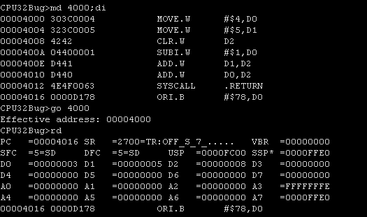

**Questions:**

1)

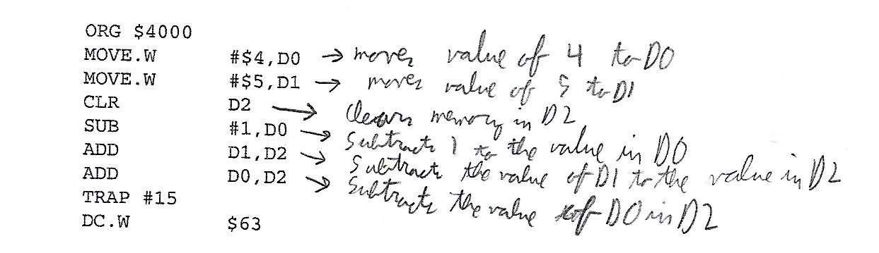

2) The checksum field ensures that the data in machine code is transferred correctly to the CMM-332 board

3) The last line of the S-record file can use many different records (S7, S8 or S9).

4)The assembler will convert assembly language in machine code, which is all the CPU can read. This will make coding a program less long and confusing for the programmer, since writing a program in assembler language is much easier then writing machine code. The loader program will communicate the machine code to the CPU in order to be executed.

5) The resulting string is: “GO HABS GO”

**Conclusion:**

In this experiment, the use of machine code over assembly code was prioritized. An S-record file with machine code in hexadecimal equivalent to a program in assembly code was produced and implemented to the CMM-332 board. The resulting code produced the same results as if the same program in assembly code was written.