Ansible:

Task 1:

sudo service ufw stop

sudo service ssh start

eval `ssh-agent -s`

sudo chmod 400 Jenkins.pem

ssh-add Jenkins.pem

ubuntu@ip-172-31-16-42:~$ sudo chmod 400 Jenkins.pem ssh-add Jenkins.pem

chmod: cannot access 'ssh-add': No such file or directory

Access the slave system from

master

ssh ubuntu@3.85.137.36

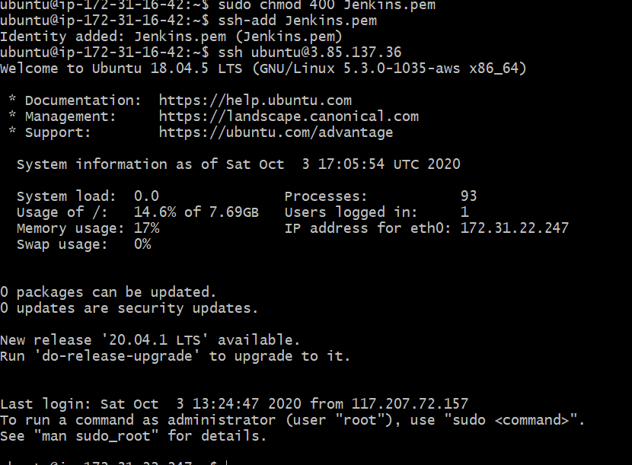

TASK 2:

sudo apt-add-repository ppa:ansible/ansible

ssh ubuntu@3.85.137.36

sudo apt-add-repository ppa:ansible/ansible

sudo apt-get update

sudo apt-get install ansible

ansible --version

Machine generated alternative text:
buntu@ip-172-31-16-42:-S ansible --version 
nsible 2.9.13 
config file = /etc/ansible/ansible.cfg 
confi gured module search path = 
[u ' /home/ubuntu/. ansi bl e/pl ugi ns/mod 
u ' /usr/share/ansi bl e/pl ugi ns/modul es ' ] 
ansible python module location = /usr/1ib/python2.7/di st-packages/ an 
executable location = /usr/bin/ansible 
python version — 
- 2.7.17 (default, Jul 20 2020, 7.5.0] 
buntu@i p-172-31-16-42 : -S 

TASK 3: HOW TO CONFIGURE AN ANSIBLE SLAVE:

-------------------

Task 3 :

sudo vi /etc/hosts

<Ipaddress> slave1

3.85.137.36 slave1

sudo vi /etc/ansible/hosts

sudo vi /etc/ansible/hosts

sudo vi /etc/ansible/hosts

sudo ansible -m ping slave1

Machine generated alternative text:
ubuntu@ip-172-31-22-247:-S exit 
1 ogout 
connection to 3.85 .137.36 closed. 
ubuntu@ip-172-31-16-42:-S ansible -m ping slavel 
slavel SUCCESS => { 
" ansi bl e _ facts" : 
"di scovered_i nterpreter_python": " /usr/bi n/python3" 
"changed": fal se, 
"PI ng": "pong" 

Task 4:

ansible -b -m user -a 'name=demo1' slave1

Machine generated alternative text:
ubuntu@ip-172-31-16-42:-S ansible -b -m user -a 'name=demol' 
sl avel I CHANGED 
" ansi bl e _ facts" : 
"di scovered_i nterpreter_python": " /usr/bi n/python3" 
"changed": true, 
"comment": ' 
"create_home": true, 
"group" • 
. 1001, 
"home": " /home/demol" , 
'name": "demol" , 
" shell " : 
" /bi n/sh" , 
"state": "present" , 
"system": fal se, 
"uid": 1001 
sl avel 

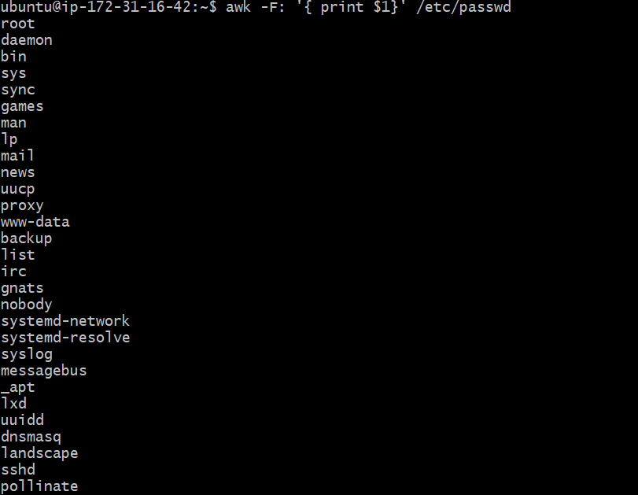

Task 5:

Install an Nginx package on slave:

ansible -b -m package -a 'name=nginx state=present' slave1

Machine generated alternative text:
ubuntu@ip-172-31-16-42:-S ansible -b -m package -a 'name=nginx state—present 
sl avel 
slavel SUCCESS 
" ansi bl e _ facts" : 
"di scovered_i nterpreter_python": " /usr/bi n/python3" 
"cache_update_time": 1599542285 , 
"cache_updated": fal se, 
"changed": fal se 
ubuntu@i p-172-31-16-42:-S 

Start Nginx service on slave:

ansible -b -m service -a 'name=nginx state=started' slave1

Machine generated alternative text:
ubuntu@ip-172-31-16-42:-S ansible -b -m service -a 'name=nginx state—started' 
avel 
slavel SUCCESS 
" ansi bl e _ facts" : 
"di scovered_i nterpreter_python": " /usr/bi n/python3" 
"changed": fal se, 
'name' : 
"ngn nx" , 
" state": "started" , 
" status" : 
" Acti veEnterTi mestamp 
"sat 2020-10-03 UTC" , 
"ActiveEnterTi mestampMonotonic • " 
". 14293859802" , 
"ActiveEXitTi mestampMonotonic • "0" 
"Activestate": "active" , 
"After": "system. slice sysinit.target systemd-journald.socket network. ta 
rget basic. target" , 
"Al ate": "no 
"Ambi entcapabiliti es": "" , 
"AssertResu1t : " 
" yes" , 
" AssertTi mestamp 
"sat 2020-10-03 UTC" , 
"AssertTi mestampMonotonic • " 
". 14293695483" , 
"Before": "multi -user . target shutdown . target" , 
"Bl ockIOAccounti ng": "no' 
"Blocklowei ght": " [not set) " , 
"CPUAccounti ng": "no' 

Stop the service in slave:

ansible -b -m service -a 'name=nginx state=stopped' slave1

Machine generated alternative text:
ubuntu@ip-l 
avel 
sl avel I CHANGED 
" ansi bl e _ facts" : 
"changed": true, 
"name' : "ngnnx" , 
ansn 
-m 
servi ce 
-a 
' name=nginx state—stopped ' 
sl 
"di scovered_i nterpreter_python": " /usr/bi n/python3" 
" state": " stopped" , 
" status" : 
"Acti veEnterTi mestamp • 
". "sat 2020-10-03 UTC" , 
" Acti veEnterTi mestampMonotoni c ' 
'14293859802" , 
"Acti veExi tTi mestampMonotoni c • 0 
"Activestate": "active" , 
"After": "system. slice sysinit.target systemd-journald.socket network. ta 
rget basic. target" , 
"Al 1 ate": "no 
"Ambi entcapabi liti es": , 
"AssertResu1t": " 
" AssertTi me stamp 
"sat 2020-10-03 UTC" , 

TASK 6: HOW TO START A SERVICE IN ANSIBLE SLAVE USING PLAYBOOK

------------

Clone the repository for the code:

git clone <https://github.com/AnjuMeleth/DevOpsMasterAnsible.git>

Create a playbook\_nginx.yml at /etc/ansible path:

sudo vi playbook\_nginx.yml

---

- hosts: all

become: true

tasks:

- name: install nginx

apt:

pkg: nginx

state: present

notify:

- run update

- name: start nginx service

service:

name: nginx

state: started

enabled: true

handlers:

- name: run update

apt:

update\_cache: yes

ansible-playbook playbook\_nginx.yml

Machine generated alternative text:
hosts: all 
become: true 
tasks : 
name: install nginx 
apt : 
pkg: nginx 
state: present 
noti fy : 
run update 
name: start nginx servi ce 
servi ce : 
name: ngnnx 
state: started 
enabled: true 
handl ers : 
name: run update 
apt : 
update_cache: yels 
"pl aybook_ngi nx . yml " 
20L, 
319C 

**Run the playbook:**

ansible-playbook playbook\_nginx.yml

Machine generated alternative text:
ubuntu@ip-172-31-16-42:-S ansible-playbook pl aybook_nginx.yml 
LAY 
TASK Facts] 
ok: CSI avel) 
TASK [install ngi nx] 
ok: CSI avel) 
TASK [start nginx servi ce] 
changed: CSI avel] 
LAY 
sl avel 
ki pped=0 
rescued—O 
ok=3 
changed—I 
unreachabl 
fai 1 ed=0 
s 
i gnored=0 

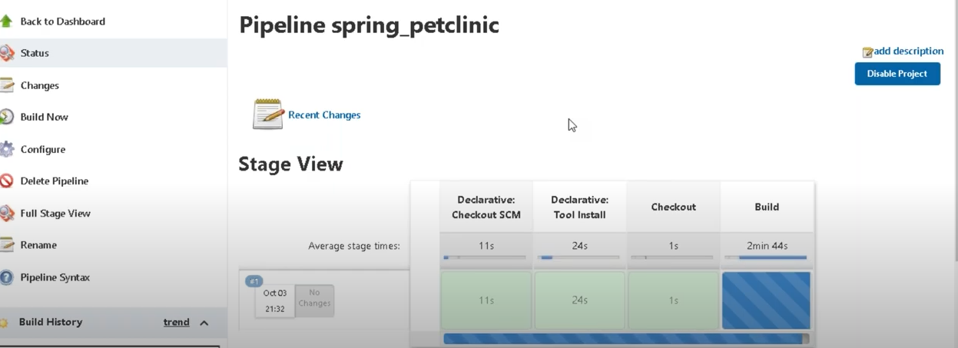

TASK 10:HOW TO START A COMPLEX SERVICE IN SLAVE USING ROLES:

**Create a role in /etc/ansible/roles:**

sudo ansible-galaxy init demo-role

Machine generated alternative text:
ubuntu@ip-l 
sudo ansible-gal axy init demo-role 
Role demo-role was created successfully 

**Edit demo-role/tasks/main.yml files:**

sudo vi main.yml

Machine generated alternative text:
# tasks file for demo-role 
name: Install nginx web server 
apt: pkg=nginx state—present update_cache=true 
noti fy : 
start nginx 
name: upl oad 
copy: src=fi 1 es/i ndex. html dest=/var/wov/html mode=0644 

Go to handlers folder and enter the handler details in main.yml

sudo vi main.yml

---

**# handlers file for demo-role**

- name: start nginx

service: name=nginx state=started

Machine generated alternative text:
ubuntu@ip-172-31-16-42: —'demo-role/handlers 
handlers file for demo-role 
name: start nginx 
servi ce: name=nginx state—start* 

Go to files folder and create a index.html file:

sudo vi index.html

<html>

<head>

<title>This is a sample page</title>

</head>

<body>

<h1>Here is a heading!</h1>

<p>Here is a regular paragraph. Wow!</p>

</body>

</html>

Machine generated alternative text:
ubuntu@ip-172-31-16-42: —'demo-role/files 
<head> 
<titl e>This is a sample page</title> 
</head> 
<h1>Here is a heading!</hl> 
<p>Here is a regular paragraph. 
bodp 
'/html' 
Wow ! 

Go to /etc/ansible and create a RolesDemo.yml file :

sudo vi RolesDemo.yml

---

- hosts: all

become: true

roles:

- role: demo-role

Machine generated alternative text:
hosts: all 
become: true 
roles: 
role: demo-role 

Run the RolesDemo.yml playbook:

Machine generated alternative text:
ans7b le. ct-g 
nosts 
les 
ubuntu@i p 
• /etc/ansib1eS sudo vi RolesDemo .yml 
-172-31-16-42 . 
ubuntu@i p 
• /etc/ansib1eS sudo vi RolesDemo .yml 
-172-31-16-42 . 
ubuntu@i p- 
/etc/ansib1eS ansible-pl aybook RolesDemo.ym1 
172-31-16-42. 
PLAY 
TASK Facts] 
ok: CSI avel) 
PLAY RECAP 
sl avel 
ki pped=0 
rescued—O 
ok-I 
changed—O 
unreachabl 
fai 1 ed=0 
s 
i gnored=0 
ubuntu@i p-172- 31-16-42 : /etc/ansi bl es 