Docker Tasks:

Install Docker

<https://github.com/AnjuMeleth/DevOpsMasterDocker.git>

Login the EC2

Go to /home/ubuntu

git clone <https://github.com/AnjuMeleth/DevOpsMasterDocker.git>

cd DevOpsMasterDocker /1\_installation

sh docker\_install.sh

Once completed for verification

sudo docker --version

Task 1

Machine generated alternative text:
ubuntu@ip-172-31-71-3:-/DevopsMasterDocker/1_insta11ationS sudo docker 
Docker version 19.03.13, build 4484c46d9d 
ubuntu@i P-172 - 31-71-3 : -/DevopsMasterDocker/1_i nstal 1 ati ons 
- -versi on 

Task 3:

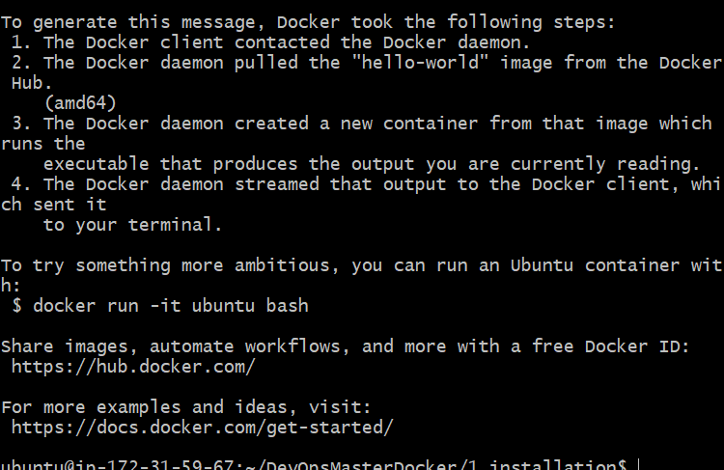

Task3:

Machine generated alternative text:
ubuntu@ip-172 
a 
PID TTY 
5180 pts/0 
5181 pts/0 
-31-59-67 
TIME 
nstal lati ons sudo ps 
CMD 
sudo 
ps 

Task 3:

Machine generated alternative text:
nsta11ationS sudo dock 
er ps -a 
CONTAINER ID 
STATUS 
a9b456734dba 
IMAGE 
ubuntu 
Exited (0) 3 minutes ago 
ago 
Idc064cd1bdd 
hel lo-world 
COMMAND 
PORTS 
" /bi n/bash " 
"[hello" 
CREATED 
NAMES 
4 minutes 
Myubuntu 
12 mi nute 
serene_hey 
s ago 
rovsky 
Exited (0) 12 mi nutes ago 
ubuntu@i P-172 - 31-59-67 : -/DevopsMasterDocker/1_i nstal 1 ati ons 

Task 4:

Machine generated alternative text:
Jnable to find image 'anjurose/jenkins:latest' 
latest: pulling from anjurose/jenkins 
locally 
3192219afd04: 
pull 
pull 
:c4fe40d0e61: 
Pull 
)d647f502a07: 
pull 
L08b8c498aa: pull 
Lbfe918b8aa5 : 
pull 
pull 
57e995ca322a: pull 
332 alded8a6e: 
pull 
F33aeeed6be4 • 
. pull 
Pull 
La6712b64155: 
pull 
208550beac25: pull 
13d384bd7a8f: 
pull 
ibf2b218a0cf• 
. pull 
)142fcea9307: pull 
20fbf3ed5b43: 
pull 
)2c2db3c8f58: pull 
311c6b2ea8e8: 
Pull 
712df7635215: pull 
compl ete 
compl ete 
compl ete 
compl ete 
compl ete 
compl ete 
compl ete 
compl ete 
compl ete 
compl ete 
compl ete 
compl ete 
compl ete 
compl ete 
compl ete 
compl ete 
compl ete 
compl ete 
compl ete 
compl ete 
gest: sha256: f8e2346ca4fd83a14d71f9f466a6dc8d7cbefaabdf9e0937bb7a4( 
;tatus: Downl oaded newer image for anjurose/jenkins: latest 
unning from: /usr/share/jenkins/jenkins.war 
vebroot: Envvars . masterEnvvars . get ("JENKINS_HOME") 
26, 2020 2:09:55 PM org.eclipse.jetty . util. log. Log initialized 
[NFO: Logging initialized @975ms to org.eclipse.jetty.util . log. Javaul 
il Log 
26, 2020 2:09:55 PM winstone. Logger loglnternal 
[NFO: Beginning extraction from war file 
26, 2020 2:09:55 PM org.eclipse.jetty.server.handler.contextHan& 
2r setcontextpath 
VARNING: Empty contextpath 
26, 2020 2:09:55 PM org.eclipse.jetty . server . server dostart 
CNFO: jetty-9.4.z-SNAPSHOT; built: 381Z; git: 
)b240169fcf1abbd86af36482d1c49826fa0b; jvm 1.8.0 
_ 242-b08 

sudodocker run --name jenkins

sudo docker run --name jenkins -p 50000:50000 -p 8085:8080 anjurose/jenkins

34.227.91.225:8085

Admin

admin123

Task

sudo docker run -it -p

3000:3000 -v

"$(pwd):/home/proje

ct:cached"

theiaide/theia

Task6:

Machine generated alternative text:
ubuntu@ip-172-31-59-67:-/DevopsMasterDocker/1_insta11ationS sudo dock 
er run -d hello-world 
d6c845007472f8ca85e2dd7b67a81dOc6992c8ca3fc4062c9cadf490c05e7e01 
ubuntu@i P-172 - 31-59-67 : -/DevopsMasterDocker/1_i nstal 1 ati ons 

Task 7

Machine generated alternative text:
ubuntu@ip-172-31-59-67:-/DevopsMasterDocker/1_insta11ationS sudo dock 
er run -d 
--name MYJenkins2 -p 50000: 50000 -p 8086: 8080 anjurose/jenk 
Od578384dd95fea7863df2f3e938b9968db4b281c45b5753fbb0106d216d168e 

Task 8:

Machine generated alternative text:
INFO : DVM is termi nating. shutting down Jetty 
ubuntu@ip-172-31-59-67:-/DevopsMasterDocker/1_insta11ationS sudo dock 
er run -it --name Myubuntul ubuntu 
Is 
dev home 
lib32 libx32 
mnt proc run 
boot etc 
lib 
1 i b64 
media opt root 
sbin 
root@497085ea491b:/# uname -srm 
Linux 5.3.O-1035-aws 
srv 
sys 
var 
usr 

Machine generated alternative text:
ubuntu@i P-172 - 31-59-67 : -/DevopsMasterDocker/1_i nstal 1 ati ons 
er ps 
CONTAINER ID 
STATUS 
497085ea491b 
IMAGE 
ubuntu 
PORTS 
COMMAND 
NAMES 
" /bi n/bash " 
Myubuntul 
sudo dock 
CREATED 
4 minutes 
up 4 minutes 
ago 
ubuntu@i P-172 - 31-59-67 : -/DevopsMasterDocker/1_i nstal 1 ati ons 

Machine generated alternative text:
Apps 
server 
Not secure 34.227.91.225:8088 
AXA Chrome 
Imported From IE 
PUIG CATW STACore 
Time Converter and... 
DevApp 
Welcome to nginx! 
Changing the IP Ad... 
If you see this page, the nginx web server is successfully installed and 
working. Further configuration is required. 
For online documentation and support please refer to nginx.org. 
Commercial support is available at nginx.com. 
Thank you for using nginx. 

sudo docker run -d --name nginx1 -p 8088:80 nginx:latest

<http://34.227.91.225:8088>

sudo docker exec -it nginx1 bash

cd /usr/share/nginx/html

apt-get update

apt-get install

vim

vim index.html

Task 10

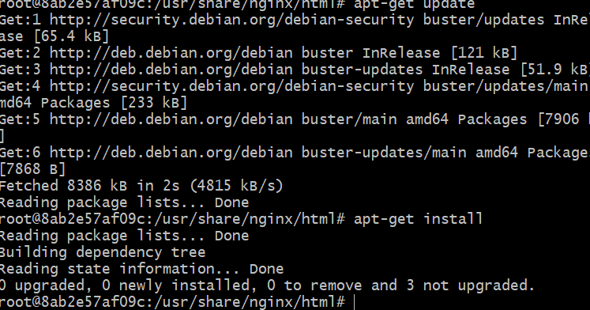

Task 11:, 12

Home work

sudo docker push christudasj/newnginx1

ubuntu@ip-172-31-59-67:~/DevOpsMasterDocker/1\_installation$ sudo docker ps -a

CONTAINER ID IMAGE COMMAND CREATED STATUS PORTS NAMES

8ab2e57af09c nginx:latest "/docker-entrypoint.…" About an hour ago Up 46 minutes 0.0.0.0:8088->80/tcp nginx1

497085ea491b ubuntu "/bin/bash" About an hour ago Up About an hour MyUbuntu1

0d578384dd95 anjurose/jenkins "/sbin/tini -- /usr/…" About an hour ago Exited (130) About an hour ago MyJenkins2

d6c845007472 hello-world "/hello" About an hour ago Exited (0) About an hour ago distracted\_dewdney

2c9d255cd1d6 anjurose/jenkins "/sbin/tini -- /usr/…" 2 hours ago Exited (130) About an hour ago jenkins

a9b456734dba ubuntu "/bin/bash" 2 hours ago Exited (0) 2 hours ago MyUbuntu

1dc064cd1bdd hello-world "/hello" 2 hours ago Exited (0) 2 hours ago serene\_heyrovsky

Push an image or a repository to a registry

ubuntu@ip-172-31-59-67:~/DevOpsMasterDocker/1\_installation$ sudo docker ps -a

CONTAINER ID IMAGE COMMAND CREATED STATUS PORTS NAMES

8ab2e57af09c nginx:latest "/docker-entrypoint.…" About an hour ago Up 46 minutes 0.0.0.0:8088->80/tcp nginx1

497085ea491b ubuntu "/bin/bash" About an hour ago Up About an hour MyUbuntu1

0d578384dd95 anjurose/jenkins "/sbin/tini -- /usr/…" About an hour ago Exited (130) About an hour ago MyJenkins2

d6c845007472 hello-world "/hello" About an hour ago Exited (0) About an hour ago distracted\_dewdney

2c9d255cd1d6 anjurose/jenkins "/sbin/tini -- /usr/…" 2 hours ago Exited (130) About an hour ago jenkins

a9b456734dba ubuntu "/bin/bash" 2 hours ago Exited (0) 2 hours ago MyUbuntu

1dc064cd1bdd hello-world "/hello" 2 hours ago Exited (0) 2 hours ago serene\_heyrovsky

sudo docker commit MyUbuntu1 christudasj/myubuntu1

sudo docker push christudasj/myubuntu1

Task 17:

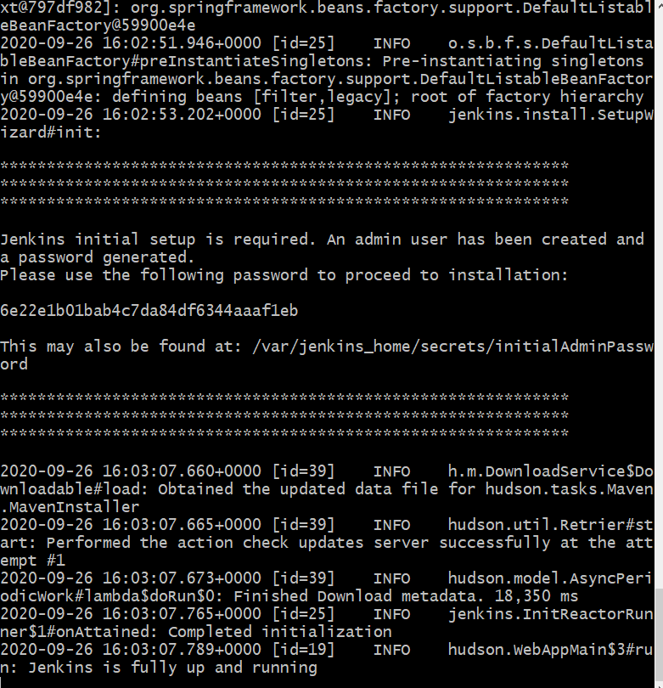

Machine generated alternative text:
nsta11ationS sudo dock 
er run -d 
-name MYJenkins -v my-vol :/var/jenkins_home -p 50000: 50000 
-p 80891: 8080 jenkins/jenkins 

sudo docker run -d --name MyJenkins -v my-vol:/var/jenkins\_home -p 50000:50000 -p 8085:8080 jenkins/jenkins

34.227.91.225:8085

sudo docker exec MyJenkins cat /var/jenkins\_home/secrets/initialAdminPassword

Task 19:

sudo docker run --name MyJenkins2 -p 50000:50000 -p 8080:8080 anjurose/jenkins

sudo docker cp MyJenkins2:/var/jenkins\_home ./copied\_data

sudo docker rm -f MyJenkins2

sudo docker run -p 50000:50000 -p 8081:8081 -v ~/copied\_data/jenkins\_home:/var/jenkins\_home --name DataJenkins anjurose/jenkins

Docker path :

<https://github.com/AnjuMeleth/DevOpsMasterDocker.git>

Task 20:

Phython Application:

--> ubuntu system

python

flask

Source code

running command - all as impage.

----------

Docker-file

-------

From ubuntu

phyton

From : Python:3

working directory

RUN -> install flask -> pip install flask ->

copy -> source code (web.python) copy web.ph ./web.py

sudo docker build . -t anjurose/mypythonapp1

sudo docker build . -t anjurose/mypythonapp1

sudo docker login

sudo docker push anjurose/pythonapp // tag then use our name

sudo docker push anjurose/mypythonapp1

sudo docker run -d --name MyApp -p 5000:5000 anjurose/pythonapp

sudo docker run -d --name MyApp -p 5000:5000 anjurose/pythonapp

http://<Ip Address>:5000

Task 21 and 22 home work:

Task 23:

Task 23

Bring up a wordpress - one container

application with a Maria DB == another containner

database. MariaDB could be

accessed by PHP my admin ==3 container

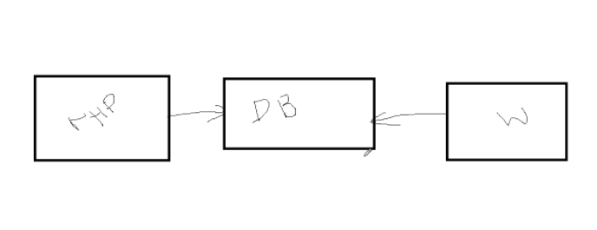

Machine generated alternative text:
inutes ago 
oenki ns 
Exited' (130) 30 mi nutes ago 
D at 
ubuntu@ip-172-31-59-11:-/DevopsMasterDocker/20_createImageS sudo docker 
e --name wordpressdb -d mari adb: latest 
unable to find image 'mari adb:latest' locally 
latest: pulling from library/mari adb 
d72e567cc804: 
pull 
Of3630e5ff08: 
pull 
b6a83d81d1f4: 
pull 
4bf2111ecf0e: 
pull 
9572d64978aO: 
pull 
bcc9953bffb3: 
pull 
de429570dda5 : 
pull 
3652bc6ea9f9: 
pull 
6e4bf87041c8: 
pull 
9cb9bba22391: 
pull 
9de10906fc5c: 
pull 
2c3a798c7a1f: pull 
compl ete 
compl ete 
compl ete 
compl ete 
compl ete 
compl ete 
compl ete 
compl ete 
compl ete 
compl ete 
compl ete 
compl ete 
Digest: sha256:9d27dd15564ba13a8ffa93beee20b39b7c14218c47ea296c6e11878a 
12 
Status: Downl oaded newer image for mari adb: latest 
dbba86abb6fOf4920e13532f247bfe67d16f89cee90e8d08cb9c78e7ede8ab8c 

Machine generated alternative text:
ubuntu@ip-172-31-59-11:-/DevopsMasterDocker/20_createImageS sudo docker 
-name wordpress 
--1 ink wordpressdb:mysql -p 8088: 80 -d wordpress 
unable to find image 'wordpress:latest' locally 
latest: pulling from library/wordpress 
d121f8d1c412 : 
pull 
58b3577b786a: 
pull 
60538287851f: 
pull 
c53ff72fe225: 
pull 
79b018c8773f: 
pull 
fbe3e00ac4b0• 
. pull 
ff35226e1df8: 
pull 
ab3b1d46dd82 : 
pull 
b29cdd230d9a: 
pull 
d466b05cf627: 
pull 
771f930f6d23: 
pull 
b89a2786f2a3: 
pull 
c35594c34f69: 
pull 
8e3c480bd8bf: 
pull 
2d3e26ca1157: 
pull 
ccOd53b93bc3: 
pull 
dbcd12305020: 
pull 
pull 
90356c70a472: 
ceb2ac363e49: 
pull 
202d7e2f6c6c: pull 
compl ete 
compl ete 
compl ete 
compl ete 
compl ete 
compl ete 
compl ete 
compl ete 
compl ete 
compl ete 
compl ete 
compl ete 
compl ete 
compl ete 
compl ete 
compl ete 
compl ete 
compl ete 
compl ete 
compl ete 
Digest: sha256:7b67b32c076e9463a804182e0356966829d5533184c5064e22a7b976 
4b 
Status: Downl oaded newer image for wordpress:latest 
65d215a7a351513b9ebddac70643d25d545c269c46413d73636e75dd67cfd77c 
ubuntu@i p -172-31-59-11 : -/DevopsMasterDocker/20_createImageS 

Bring up a wordpress - one container

application with a Maria DB == another containner

database. MariaDB could be

accessed by PHP my admin ==3 container

sudo docker run -e MYSQL\_ROOT\_PASSWORD=secret --name wordpressdb -d mariadb:latest

sudo docker run --name wordpress --link wordpressdb:mysql -p 8088:80 -d wordpress

sudo docker run --name myadmin -e MYSQL\_USERNAME=ROOT -e MYSQL\_ROOT\_PASSWORD=secret -d --link wordpressdb:mysql -p 8089:80 corbinu/dockerphpmyadmin

ubuntu@ip-172-31-59-11:~/DevOpsMasterDocker/20\_CreateImage$ sudo docker run --name myadmin -e MYSQL\_USERNAME=ROOT -e MYSQL\_ROOT\_PASSWORD=secret -d --link wordpressdb:mysql -p 8089:80 corbinu/dockerphpmyadmin

Unable to find image 'corbinu/dockerphpmyadmin:latest' locally

docker: Error response from daemon: pull access denied for corbinu/dockerphpmyadmin, repository does not exist or may require 'docker login': denied: requested access to the resource is denied.

See 'docker run --help'.

Task 24:

Task 24:

sudo chmod +x /usr/local/bin/docker-compose

docker-compose --version

task 25:

sudo docker-compose up -d

sudo docker-compose down

Task 25:

Machine generated alternative text:
• -/DevopsMasterDocker/24_composeS 
/docker-compose 
ubuntu@ip-172-31-59-11 
: -/DevopsMasterDocker /24_composeS 
docker-compose version 
1.25.5, build 8a1c60f6 
ubuntu@i p -172-31-59-11: -/DevopsMasterDocker /24_composeS 
.creating 24_compose_wordpress_db_1 . 
creating 24_compose_phpmyadmi n _ 1 
creating 24_compose_wordpress_1 
done 
done 
done 
ubuntu@i p -172-31-59-11: -/DevopsMasterDocker/24_composeS 
sudo chmod +x /usr/l ocal/bin 
docker-compose - -versi on 
sudo docker-compose up -d 
sudo docker-compose down 
Stoppi ng 
Stoppi ng 
Stoppi ng 
Removi ng 
Removi ng 
Removi ng 
Jubuntu@i 
24_compose_wordpress_1 
24_compose_phpmyadmi n _ 1 
24_compose_wordpress_db_1 . 
24_compose_wordpress_1 
24_compose_phpmyadmi n _ 1 
24_compose_wordpress_db_1 . 
done 
done 
done 
done 
done 
done 
p-172-31-59 
-11 : -/DevopsMasterDocker/24_composeS 

Task 26:

task 26:

sudo docker run -d --name nginx nginx:latest

sudo docker inspect nginx

sudo docker run -it --name bux --link nginx:nginx busybox

wget -O - <http://nginx:80/>

sudo docker inspect bux

sudo docker rm -f bux

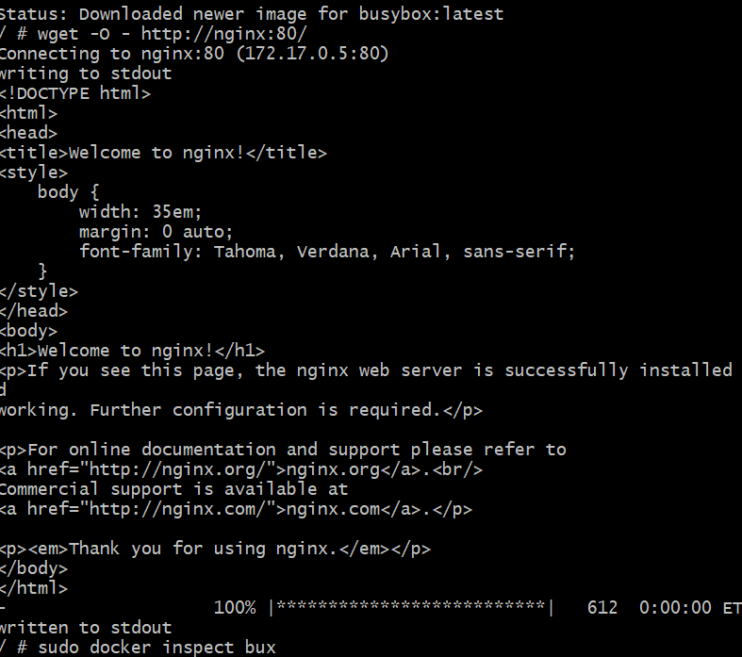

Task 28:

sudo docker swarm init --advertise-addr <Ip address>

sudo docker swarm init --advertise-addr 54.236.8.60

Sudo vi /etc/hostname

sudo reboot (on both node )

sudo docker node ls

git clone [https://github.com/AnjuMeleth /DevOpsMasterDocker.git](https://github.com/AnjuMeleth%20/DevOpsMasterDocker.git) sh docker\_install.sh

sudo docker swarm join --token <token>

sudo docker swarm join --token SWMTKN-1-1vj0w4mdkd9ycxw1q18t67j4lzwiuxeat0venpw9lryvudchtc-a6ld372hv6m8p7anf6wc3kilh 54.236.8.60:2377

sudo docker node ls

sudo docker swarm join-token worker

sudo docker swarm join-token manager

git clone <https://github.com/AnjuMeleth/DevOpsMasterDocker.git>

sh docker\_install.sh

sudo docker swarm join --token SWMTKN-1-1vj0w4mdkd9ycxw1q18t67j4lzwiuxeat0venpw9lryvudchtc-823dy23gz7epdmxulxcv8pct6 54.236.8.60:2377

sudo docker swarm join --token SWMTKN-1-1vj0w4mdkd9ycxw1q18t67j4lzwiuxeat0venpw9lryvudchtc-a6ld372hv6m8p7anf6wc3kilh 54.236.8.60:2377

sudo docker node ls

Machine generated alternative text:
Apps 
server 
Not secure 54.236.8.60:8003 
AXA Chrome 
Imported From IE 
It works! 

Task 29:

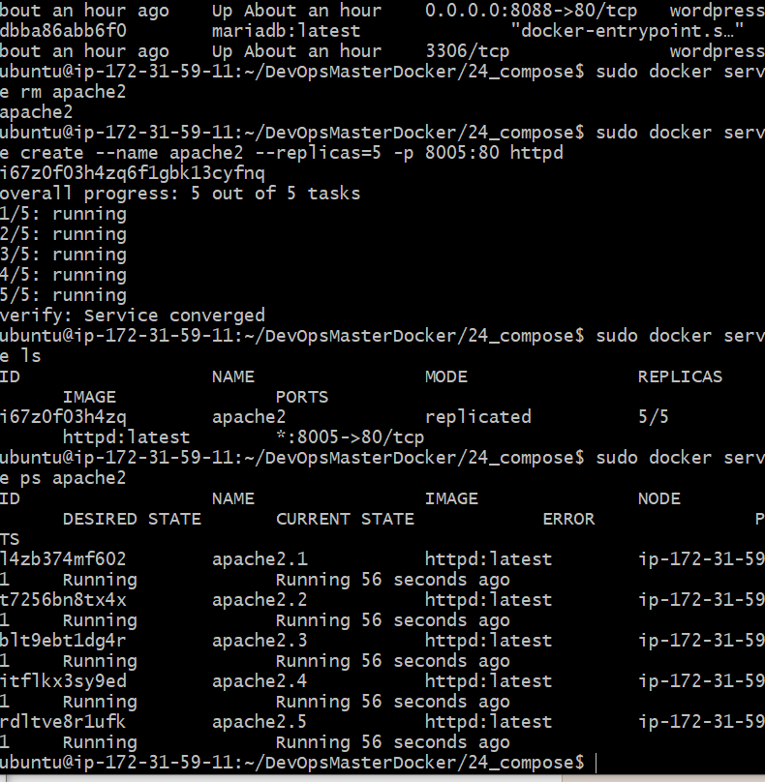

Task 28:

sudo docker service create --name apache2 --mode global -d -p 8003:80 httpd

x2wr7husyj51akq9mfu83r9zx

sudo docker service create --name apache4 --mode global -d -p 8003:80 httpd

sudo docker service ls

sudo docker service ps apache4

sudo docker service rm apache2

task 29:

sudo docker service create --name apache2 --replicas=5 -p 8005:80 httpd

sudo docker service ls

sudo docker service ps apache2

sudo docker ps

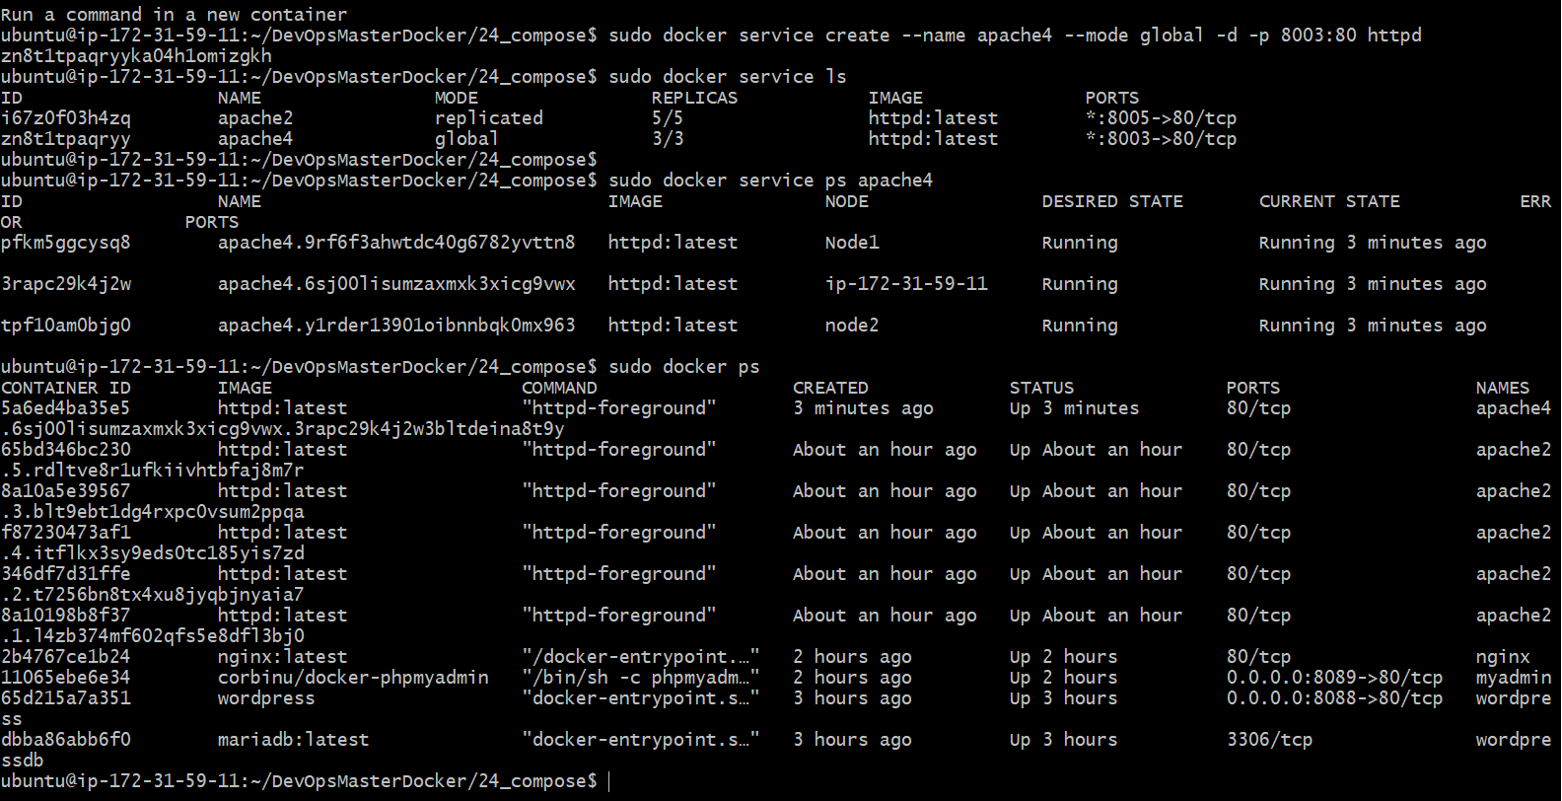

Task 30:

Task 30:

sudo docker swarm leave

sudo docker service ps apache2