TASK 1:HOW TO INSTALL NAGIOS IN UBUNTU 18.04

TASK 1:HOW TO INSTALL NAGIOS IN UBUNTU 18.04

1 Clone the repository git clone

<https://github.com/AnjuMeleth/DevOpsMasterNagios.git>

git clone <https://github.com/AnjuMeleth/DevOpsMasterNagios.git>

2 Run the installation script under 1\_installation folder.

Give the password for the nagiosadmin user

sh install\_nagios.sh

6 6 View the Nagios dashboard

http://<ipaddress>/nagios

<http://3.6.87.23/nagios>

Machine generated alternative text:
Nagios XI 
Easy Configuration 
Advanced Reporting 
Download 
Get Started 
Start monitoring your infrastructure 
Change the look and feel of Nagios 
Extend Nagios with hundreds of 
Nagios'@ 
Core 
Daemon running with PID 15557 
Nagios@ Core 
Version 4.4.5 
August 20, 2019 
Check for updates 
A new version of Nagios Core is available! 
Visit nagios.org to download Nagios 4.4.6. 
Nagios Log Server 
Monitor and analyze 
logs from anywhere 
Download 
Quick Links 
Nagios Library (tutorials and docs) 
Nagios Labs (development blog) 
Nagios Exchange (plugins and 
N 
agtos N 
Real-time netflow and 
bandwidth analysis 
Download 
Get sta... 

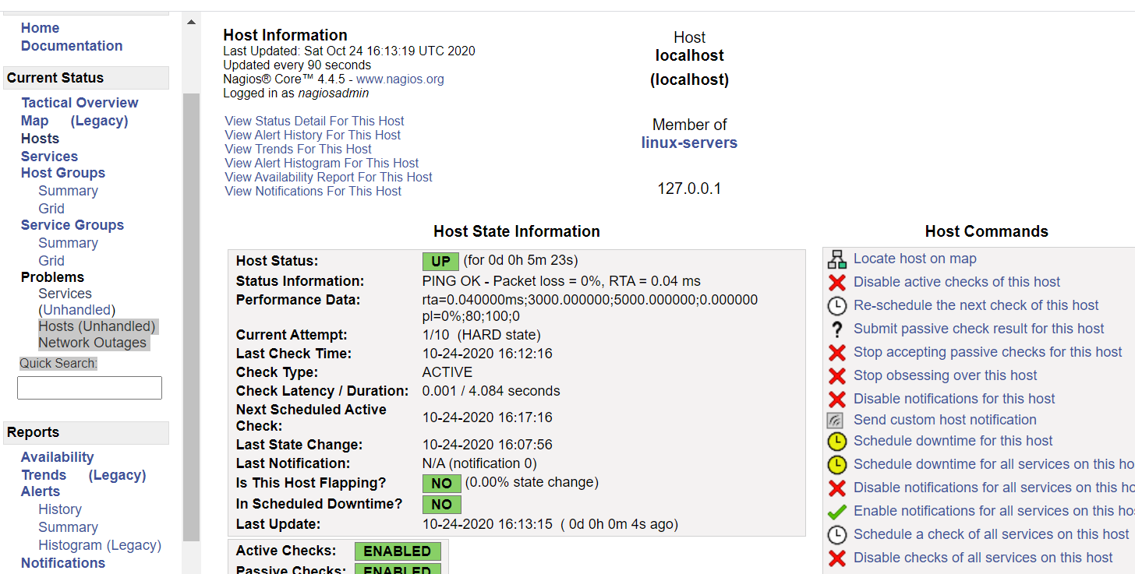

TASK 2:HOW TO PROVISION AN EC2 INSTANCE WITH ICMP ENABLED

1 Access AWS management console and create Ec2 with ICMP ipv4 also enabled

TASK 3: HOW TO MONITOR A LINUX SYSTEM

go the below folder

cd /usr/local/nagios/etc

ce object

1 Install NRPE plugin in the linux(monitored) system

sudo apt-get update

sudo apt-get install

nagios-nrpe-server

nagios-plugins

2 Edit the nrpe.cfg file in the linux system to enter the Nagios server

details in allowed\_hosts

sudo vi /etc/nagios/nrpe.cfg

allowed\_hosts=127.0.0.1,::1,<ip address>

3 Restart the nrpe sudo

/etc/init.d/nagiosnrpe-server restart

Machine generated alternative text:
# LOCALHOST.CFG - SAMPLE OBJECT CONFIG FILE FOR MONITORING THIS MACHINE 
•# NOTE : This config file is intended to serve as an *extremely* simple 
example of how you can create configuration entries to monitor 
the local (Linux) machine. 
HOST DEFINITION 
Define a host for the local 
machine 
define host { 
use 
1 i nux-server 
: it all variables that are defined 
server host template definition. 
host_name 
al i as 
address 
1 ocal host 
1 ocalhost 
127.0.0.1 
# HOST GROUP DEFINITION 
# Define an optional hostgroup for Linux machines 
define hostgroup { 
hostgroup_name 
alias 
INSERT - 
linux 
Linux 
-servers 
servers 
Name of host template to use 
This host definition will inher 
in (or inherited by) the linux- 
, The name of the hostgroup 
Long name of the group 
26,1 
TOP 

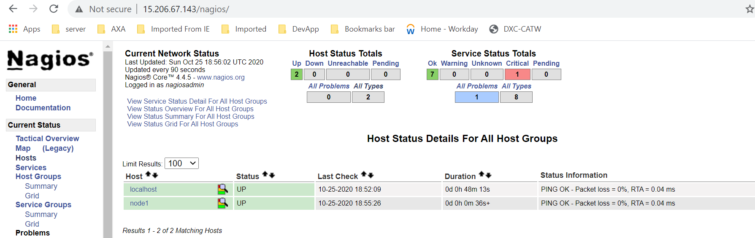

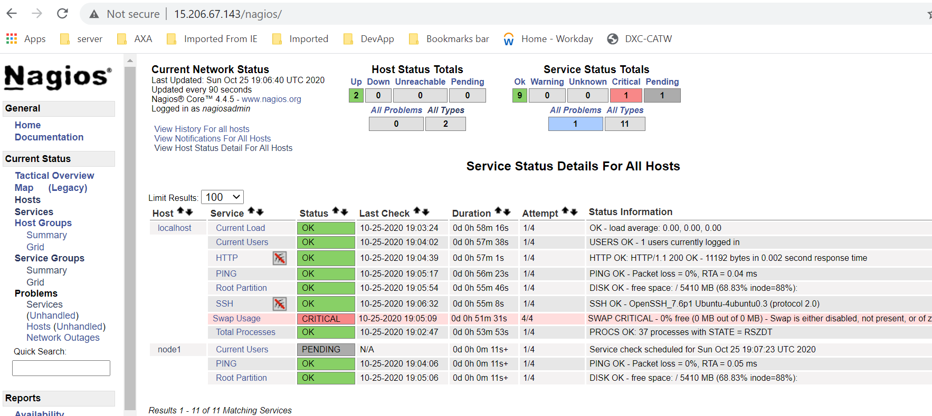

TASK 4:HOW TO MONITOR A WEB APPLICATION MANUALLY

1 Install docker in the monitored linux1 server

sudo apt-get install docker.io

2 Run the spring petclinic application

sudo docker run -d -p 8085:8080 anjurose/chefapp

3 Check if the application is up and running from the Nagios server

/usr/local/nagios/libexec/check\_http -I <ipaddress> -p 8085 -u

http://<ipaddress>:8085

Machine generated alternative text:
e 
o 
Nagios• 
Torah 
2020 
HTV 
Tot" 
Service Status Details For AN Hosts 
LGsOK. 
HTV OK MOH. 
wCCS swe 
25 

TASK 5:HOW TO MONITOR A WEB APPLICATION THROUGH NAGIOS DASHBOARD

1 Modify the configuration file in the /usr/local/nagios/etc/servers folder to include http testing (Code in 5\_webapp)

sudo vi linux1.cfg

2 Restart Apache and nagios server

sudo service apache2 restart

sudo service nagios restart

3 View the service in the Nagios dashboard

TASK 6: HOW TO SCHEDULE MONITORING OF A SERVICE AT A SPECIFIED TIME

1 Go to services -> select a service

2 Go to schedule the recheck of this service

3 Provide the time

TASK 7: HOW TO MONITOR A SERVICE EVERY 1 MINUTE

1 Modify the file /usr/local/nagios/etc/servers/lin ux1.cfg sudo

vi linux1.cfg

2 Put the code check\_interval 1

3 Restart Apache server and nagios

sudo service apache2 restart sudo service nagios restart

TASK 8: HOW TO CREATE A REPORT ON NAGIOS

1 Go to Reports -> Availability

2 Select report type -> Hosts 3 Select Hosts -> All hosts

4 Select report options (accept default) -> create availability report

TASK 9: HOW TO GET THE TRENDS IN NAGIOS DASHBOARD

1 Go to Availability -> Trends -> Standard

2 Select report type -> service Select Host -> linux1 Select service -> HTTP Select report period -> Today

3 Click Apply

Task: 8-and 9

Machine generated alternative text:
coy of up 
Rep«l 
Quick 
Step 3: Select Report 
Rep Mion: 
No 
CSV 

Machine generated alternative text:
Rep«l 
All Hosts 
ICL25-no 14.22 
Host State Breakdowns 
Sta. 