Puppet

Puppet Installation:

1.Clone the repository:

git clone <https://github.com/AnjuMeleth/DevOpsMasterPuppet.git>

<https://github.com/AnjuMeleth/DevOpsMasterPuppet.git>

2.Run the Puppet Master installationscript

sh puppetmasterinstall.sh

3. Edit the file /etc/default/puppetserver:

sudo vi /etc/default/puppetserver

JAVA\_ARGS="-Xms512m -Xmx512m -XX:MaxPermSize=256m"

JAVA\_ARGS="-Xms512m -Xmx512m -XX:MaxPermSize=256m"

4 Open port 8140:

sudo ufw allow 8140

5 Edit hosts file to enter the ipaddress of the master with a DNS name puppet

sudo vi /etc/hosts

54.87.144.102 puppert

6 .Start the puppetserver:

sudo systemctl start puppetserver

sudo systemctl status puppetserver

Machine generated alternative text:
•efault/puppetserver 
ons sudo 
sudo version 1.8.21p2 
sudoers policy plugin version 1.8.21p2 
sudoers file grammar version 46 
sudoers I/O plugin version 1.8.21p2 
lubuntu@i P-172 - 31-26-87 : -/DevopsMasterpuppet/1_Insta11 ati ons 

Machine generated alternative text:
;udo version 1.8.21p2 
;udoers policy plugin version 1.8.21p2 
;udoers file grammar version 46 
;udoers I/O plugin version 1.8.21p2 
sudo 
2tc/defau1t/puppetserver 
2tc/hosts 
2tc/hosts 
11 low 8140 
W les updated 
w les updated 
: -/DevopsMasterpuppet/1_Insta1 lati ons sudo 
-31-26-87 
: -/DevopsMasterpuppet/1_Insta1 lati ons sudo 
-31-26-87 
: -/DevopsMasterpuppet/1_Insta1 lati ons sudo 
-31-26-87 
• -/DevopsMasterpuppet/1_Insta1 lati ons sudo 
-31-26-87. 
2mct1 start puppetserver 
sudo 
2mct1 status puppetserver 
puppetserver . service - 
puppetserver servi ce 
Loaded: 
loaded (/1 ib/systemd/system/puppetserver. servi ce; dis 
: active (running) since sun 2020-10-04 13:50:25 UTC; 4 
Acti ve 
4257 Execstart=/opt/puppetl abs/ server/ apps/puppetserv 
process: 
: 4292 (java) 
Main PID 
Tasks: 
40 (limit: 4915) 
/ system. sl i ce/puppetserver . servi ce 
CGroup: 
1—4292 /usr/bi n/ java -xms512m -xmx512m -XX: MaxpermSiz 
•49:47 ip-172-31-26-87 systemd Starting puppetserve 
04 13. 
•49:47 ip-172-31-26-87 puppetserverC4257]: openJDK 64-8 
04 13. 
•50: 25 ip-172-31-26-87 systemdC1]: started puppetserver 
04 13. 

Task2 :

TASK 2:HOW TO INSTALL A PACKAGE IN PUPPET MASTER LOCALLY

sudo vi /etc/default/puppetserver

1. Go to manifests folder /etc/puppetlabs/code/environments/production/manifests/ :

cd /etc/puppetlabs/code/environments/production/manifests/

2.Create a file site.pp :

sudo vi site.pp

exec { 'apt-update': # exec resource named 'apt-update'

command => '/usr/bin/apt-get update' # command this resource will run

}

# install tree package

package { 'tree':

require => Exec['apt-update'], # require 'apt-update' before installing

ensure => installed,

}

3 .Run the manifests

sudo /opt/puppetlabs/bin/puppet apply site.pp

4 Check the version of tree installed :

tree --version

Machine generated alternative text:
ubuntu@i p -172 - 31-26-87 : /etc/puppetl abs/code/envi ronments/producti on/m 
ani festsS sudo vi site. pp 
ubuntu@i p -172 - 31-26-87 : /etc/puppetl abs/code/envi ronments/producti on/m 
ani festsS sudo /opt/puppetl abs/bin/puppet apply site. pp 
Notice: compiled catalog for ip-172-31-26-87.ec2.interna1 in environm 
ent production in 0.59 seconds 
Noti ce: [stage [mai n] [Mai n/ Exec Capt-update]/returns: executed successf 
ully 
Noti ce: [stage [mai n] [Mai n/package [tree] [ensure: created 
Notice: Applied catalog in 8.12 seconds 
ubuntu@i p -172 - 31-26-87 : /etc/puppetl abs/code/envi ronments/producti on/m 
ani festsS tree --version 
tree VI. 7.0 (C) 1996 
2014 by Steve Baker, Thomas Moore, Francesc RO 
cher, Florian Sesser, Kyosuke T0koro 
ubuntu@i p -172 - 31-26-87 : /etc/puppetl abs/code/envi ronments/producti on/m 
ani festsS 

Task 3: TASK 3: **HOW TO DO PUPPET AGENT INSTALLATION ON A SLAVE**

1. Clone the repository

git clone <https://github.com/AnjuMeleth/DevOpsMasterPuppet.git>

2. Run the Puppet agent installation script:

sh puppetagentinstall.sh

3. Open port 8140:

sudo ufw allow 8140

4. Edit hosts file to enter the ipaddress of the master and agent with a DNS name puppet

and puppet-agent

sudo vi /etc/hosts

54.87.144.102 puppet

3.83.234.47 puppet-agent

5. Start the puppet agent

sudo systemctl start puppet

sudo systemctl enable puppet

Machine generated alternative text:
:reated symlink /etc/systemd/system/multi -user. target. wants/puppet. servi ce 
)/systemd/system/puppet . servi ce . 
:reated symlink /etc/systemd/system/multi -user. target. wants/pxp-agent. serv 
(1 i b/ systemd/system/pxp-agent . servi ce . 
Qemoved /etc/systemd/system/multi -user. target. wants/pxp-agent. servi ce. 
-172-31-30-182. 
172-31-30-182 
172-31-30-182 
172-31-30-182. 
'rocessing triggers 
Ibuntu@ip-172 
W les updated 
w les updated 
Ibuntu@i p 
Ibuntu@i p- 
puppet 
Ibuntu@i p- 
le puppet 
Ibuntu@i p- 
-31-30-182 
libc-bin (2.27-3ubuntu1.2) 
ons sudo ufw allo 
• -/DevopsMasterpuppet/1_Insta1 lati ons sudo vi [etc/ 
: -/DevopsMasterpuppet/1_Insta1 lati ons sudo systemct 
: -/DevopsMasterpuppet/1_Insta1 lati ons sudo systemct 
• -/DevopsMasterpuppet/1_Insta11 ati ons 

TASK 6 :HOW TO INSTALL PDK

/etc/puppetlabs/code/environments/production/manifests/

1 Get the executable

sudo wget <https://apt.puppet.com/puppet-tools-release-bionic.deb>

2 Unpack

sudo dpkg -i puppet-tools-release-bionic.deb

3 Perform apt update

sudo apt-get update

4 Install PDK IN puppet master

sudo apt-get install pdk

5 Verify the PDK installation

pdk --version

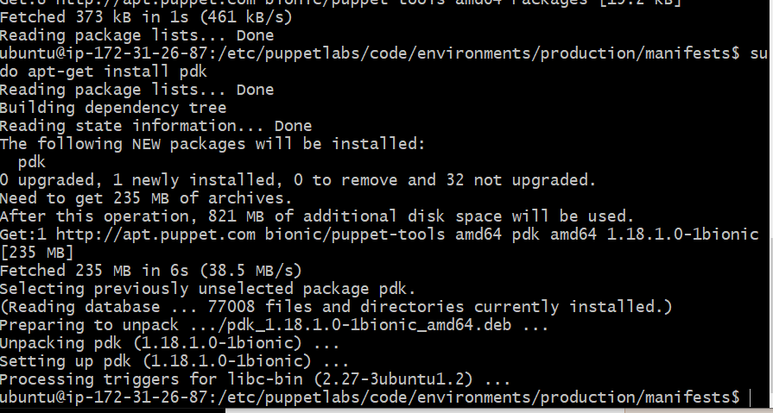

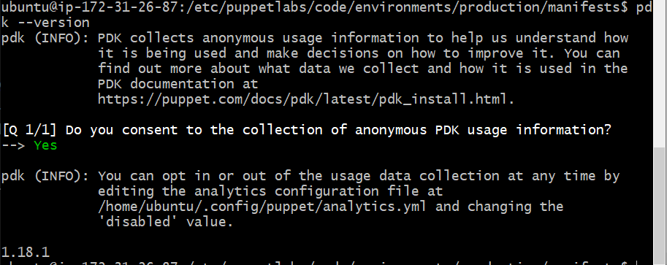

Task :7

Task 7 HOW TO CREATE A MODULE IN PUPPET

1 Create a folder and go to the folder

mkdir modules

cd modules

2. Create a puppet module nginx

pdk new module anju-nginx

3. Edit init.pp file in manifestsfolder of the nginx module

vi init.pp

4. Build the module. Make sure you are in the nginx module

pdk build nginx

5 Install module in our default path. Make sure you are in modules folder

sudo /opt/puppetlabs/bin/puppet module install ./nginx/pkg/anju-nginx-0.1.0.tar.gz

6. View the module in the path /etc/puppetlabs/code/environments/production/modules

cd /etc/puppetlabs/code/environments/production/modules

7. Edit the main manifest file in the default manifests path

sudo vi site.pp

8 Run the puppet agent in

slave

sudo /opt/puppetlabs/bin/puppet agent -t

class nginx{

exec { 'apt-update': # exec resource named 'apt-update'

command => '/usr/bin/apt-get update' # command this resource will run

}

# install tree package

package { 'nginx':

require => Exec['apt-update'], # require 'apt-update' before installing

ensure => installed,

}

service { 'nginx':

require => Exec['apt-update'], # require 'apt-update' before installing

ensure => running,

enable => true,

}

}

TASK 8 :HOW TO RUN SPECIFIC MANIFESTS

1 Create Testing environment and

development environment.

cd

/etc/puppetlabs/cod

e/environments/

sudo mkdir testing

sudo mkdir development

2 Create manifests folder inside the

testing and development

directories

sudo mkdir manifests

3 Create a file in the manifests folder

sudo vi site.pp

4 In the slave edit puppet.conf file in

/etc/puppetlabs/puppet

sudo vi puppet.conf

[agent]

environment = development

5 Run the puppet agent

sudo /opt/puppetlabs/bin /puppet agent -t

TASK 9: HOW TO DEPLOY AN APPLICATION ON A PUPPET SLAVE

# Steps Commands

1 Edit the manifest file in production environment

sudo vi site.pp

2 Run the puppet agent in the slave

sudo /opt/puppetlabs/bin /puppet agent -t