**CODE:**

**MainActivity.xml:**

<?xml version="1.0" encoding="utf-8"?>

<RelativeLayout xmlns:android="http://schemas.android.com/apk/res/android"

xmlns:tools="http://schemas.android.com/tools"

android:layout_width="match_parent"

android:layout_height="match_parent"

android:paddingBottom="20dp"

android:paddingLeft="20dp"

android:paddingRight="20dp"

android:paddingTop="20dp"

tools:context="MainActivity">

<TextView

android:layout_width="wrap_content"

android:layout_height="wrap_content"

android:text="Hello World!"

android:id="@+id/textView" />

<Button

android:layout_width="wrap_content"

android:layout_height="wrap_content"

android:text="Share App"

android:id="@+id/button"

android:layout_marginBottom="95dp"

android:layout_alignParentBottom="true"

android:layout_centerHorizontal="true" />

</RelativeLayout>

**MainActivity.java:**

package com.example.sharedataapp;

import androidx.appcompat.app.AppCompatActivity;

import android.content.Intent;

import android.os.Bundle;

import android.view.View;

import android.widget.Button;

public class MainActivity extends AppCompatActivity {

Button sharebutton;

@Override

protected void onCreate(Bundle savedInstanceState) {

super.onCreate(savedInstanceState);

setContentView(R.layout.activity_main);

sharebutton=(Button)findViewById(R.id.button);

sharebutton.setOnClickListener(new View.OnClickListener() {

@Override

public void onClick(View v) {

Intent shareIntent = new Intent(android.content.Intent.ACTION_SEND);

shareIntent.setType("text/plain");

shareIntent.putExtra(Intent.EXTRA_SUBJECT,"Insert Subject here");

String app_url = " <https://play.google.com/store/apps/details?id=my.example.javatpoint>";

shareIntent.putExtra(android.content.Intent.EXTRA_TEXT,app_url);

startActivity(Intent.createChooser(shareIntent, "Share via"));

}

});

}

}

**OUTPUT:**

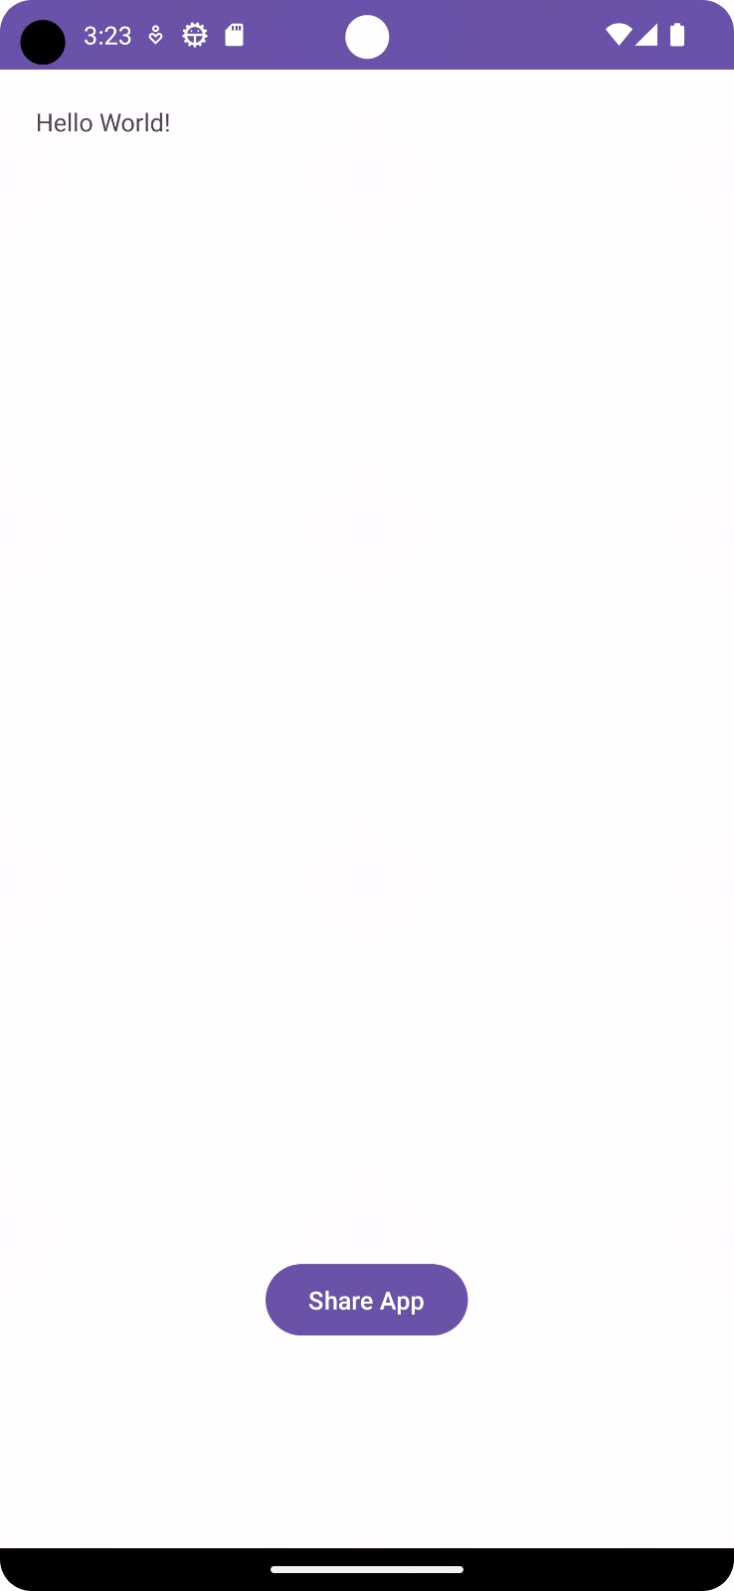

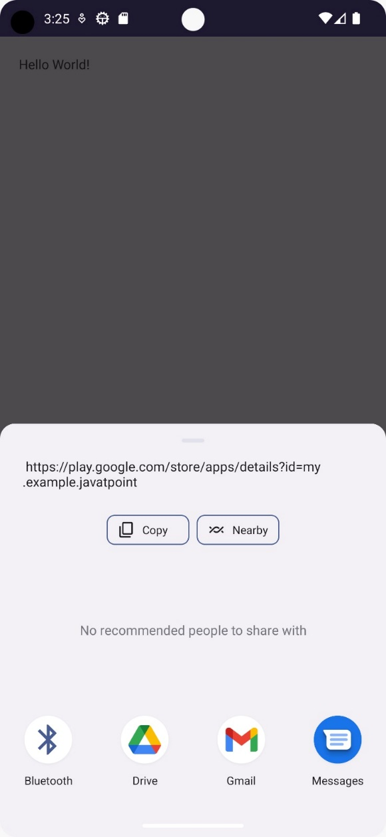

**CONCLUSION:**

**……………………………………………………………………………………………………………………………………………………………………………………………………………………………………………………………………………………………………………………………………………………………………………………………………………………………....**