**CODE:**

**IMPLICIT INTENT**

**Java code:**

package com.example.leenathree;

import androidx.appcompat.app.AppCompatActivity;

import android.content.Intent;

import android.os.Bundle;

import android.view.View;

public class MainActivity extends AppCompatActivity {

@Override

protected void onCreate(Bundle savedInstanceState) {

super.onCreate(savedInstanceState);

setContentView(R.layout.activity_main);

}

public void newScreen(View view)

{

Intent i = new Intent(getApplicationContext(),MainActivity2.class);

startActivity(i);

**XML Code:**

<?xml version="1.0" encoding="utf-8"?>

<androidx.constraintlayout.widget.ConstraintLayout xmlns:android="http://schemas.android.com/apk/res/android"

xmlns:app="http://schemas.android.com/apk/res-auto"

xmlns:tools="http://schemas.android.com/tools"

android:layout_width="match_parent"

android:layout_height="match_parent"

tools:context=".MainActivity">

<TextView

android:layout_width="wrap_content"

android:layout_height="wrap_content"

android:text="Welcome to New Page"

android:textAlignment="center"

android:textSize="28sp"

app:layout_constraintBottom_toBottomOf="parent"

app:layout_constraintEnd_toEndOf="parent"

app:layout_constraintHorizontal_bias="0.0"

app:layout_constraintStart_toStartOf="parent"

app:layout_constraintTop_toTopOf="parent"

app:layout_constraintVertical_bias="0.037"

android:gravity="center_horizontal" />

<Button

android:id="@+id/btn1"

android:layout_width="wrap_content"

android:layout_height="wrap_content"

android:layout_marginBottom="524dp"

android:onClick="newScreen"

android:text="@string/go_to_new_screen"

app:layout_constraintBottom_toBottomOf="parent"

app:layout_constraintEnd_toEndOf="parent"

app:layout_constraintHorizontal_bias="0.536"

app:layout_constraintStart_toStartOf="parent"

app:layout_constraintTop_toBottomOf="@+id/editText"

tools:ignore="UnknownIdInLayout,UsingOnClickInXml" />

</androidx.constraintlayout.widget.ConstraintLayout>

**OUTPUT:**

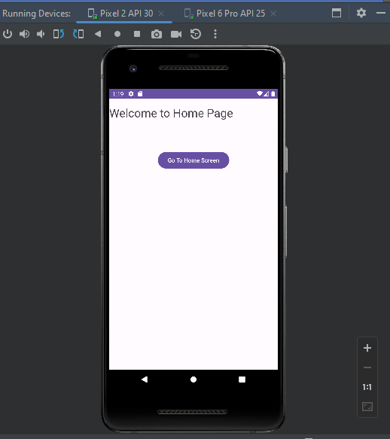

**EXPLICIT INTENT**

**Java code:**

package com.example.leenathree;

import androidx.appcompat.app.AppCompatActivity;

import android.content.Intent;

import android.os.Bundle;

import android.view.View;

public class MainActivity2 extends AppCompatActivity {

@Override

protected void onCreate(Bundle savedInstanceState) {

super.onCreate(savedInstanceState);

setContentView(R.layout.activity_main2);

}

public void homeScreen(View view)

{

Intent i = new Intent(getApplicationContext(), MainActivity.class);

startActivity(i);

}

**XML Code**

<?xml version="1.0" encoding="utf-8"?>

<androidx.constraintlayout.widget.ConstraintLayout xmlns:android="http://schemas.android.com/apk/res/android"

xmlns:app="http://schemas.android.com/apk/res-auto"

xmlns:tools="http://schemas.android.com/tools"

android:layout_width="match_parent"

android:layout_height="match_parent"

tools:context=".MainActivity2">

<TextView

android:id="@+id/editText"

android:layout_width="wrap_content"

android:layout_height="wrap_content"

android:gravity="center_horizontal"

android:text="Welcome to Home Page"

android:textAlignment="center"

android:textSize="28sp"

app:layout_constraintBottom_toBottomOf="parent"

app:layout_constraintEnd_toEndOf="parent"

app:layout_constraintHorizontal_bias="0.0"

app:layout_constraintStart_toStartOf="parent"

app:layout_constraintTop_toTopOf="parent"

app:layout_constraintVertical_bias="0.024" />

<Button

android:id="@+id/btn2"

android:layout_width="wrap_content"

android:layout_height="wrap_content"

android:onClick="homeScreen"

android:text="@string/go_to_home_screen"

app:layout_constraintBottom_toBottomOf="parent"

app:layout_constraintEnd_toEndOf="parent"

app:layout_constraintStart_toStartOf="parent"

app:layout_constraintTop_toBottomOf="@+id/editText"

app:layout_constraintVertical_bias="0.13"

tools:ignore="UsingOnClickInXml" />

</androidx.constraintlayout.widget.ConstraintLayout>

**OUTPUT:**

