VISITOR MANAGEMENT TOOL

A PROJECT REPORT

Submitted by

Afsana Kunjumohammed

Reg.No:MGP16MCA-D3

to

the APJ Abdul Kalam Technological University

in partial fulfillment of the requirements for

the award of the degree

in

MASTER OF COMPUTER APPLICATIONS


Department of Computer Applications SAINTGITS COLLEGE OF ENGINEERING Kottukulam Hills, Pathamuttom P.O., Kottayam 686 532

April, 2018

DECLARATION

I undersigned hereby declare that the project report “Visitor Management Tool” , sub-mitted for partial fulfillment of the requirements for the award of degree of Master of Technology of the APJ Abdul Kalam Technological University, Kerala is a bonafide work done by me under supervision of Ms. Rani Saritha R . This submission represents my ideas in my own words and where ideas or words of others have been included, I have adequately and accurately cited and referenced the original sources. I also declare that I have adhered to ethics of academic honesty and integrity and have not misrepre-sented or fabricated any data or idea or fact or source in my submission. I understand that any violation of the above will be a cause for disciplinary action by the institute and/or the University and can also evoke penal action from the sources which have thus not been properly cited or from whom proper permission has not been obtained. This report has not been previously formed the basis for the award of any degree, diploma or similar title of any other University.

Pathamuttom

16 March, 2018

Afsana Kunjumohammed

Reg.No:MGP16MCA-D3

DEPARTMENT OF COMPUTER APPLICATIONS

SAINTGITS COLLEGE OF ENGINEERING
Kottukulam Hills, Pathamuttom P.O., Kottayam 686 532.

(Approved by AICTE and affiliated to APJ Abdul Kalam Technological University)


CERTIFICATE

This is to certify that the report entitled “Visitor Management Tool” submitted by “Afsana Kunjumohammed , Reg.No:MGP16MCA-D3” to the APJ Abdul Kalam Technological University in partial fulfillment of the requirements for the award of the Degree of Master of Technology in Computer Applications (Computer Applications) is a bonafide record of the project work carried out by him/her under my/our guidance and supervision. This report in any form has not been submitted to any other University or Institute for any purpose.

Ms. Rani Saritha R Mr. Libin M Joseph

Internal Guide Project Co-ordinator

Dr. Rajesh K.S | Dr. M.D.Mathew
Head of the Department | Dr. M.D.Mathew
Head of the Department | Principal
Thesis Viva-voce held on:.................................................

External Examiner 1: External Examiner 2:

ABSTRACT

The project entitled Visitor Management Tool is a mobile application which can be installed and run in any of the platform such as Android, IOS and WUP . This appli-cation is developed using Xamarin technology and implements MVVM design pattern

.The mobile application can be used by employees of the UST Global Company and the administrator.

In this application,the employee need add the visitor the new joinee should complete a course which contains different modules such as HR,Employee Benefits & Policies etc.The content of the course will be videoes.After completing each module the new joinee has to attend a quiz and he/she has to score 80 percent or more.Failure in the quiz will leads to retake the course again otherwise the induction process will not be completed.

If he/she failed in the quiz the next chance for attending the quiz will be on next day not will be on the same day.The new joinees can view their progress of learning the course. The additional features of this project are push notification and App centre implementation.Through App centre implementation, we can know the status of our ap-plication that is how many are used the application and number of times the application crashed.

The administrator can add new country,new user,new course and new question.The administrator can also view all the countries,users,courses and questions that are added.

i

ACKNOWLEDGEMENT

If words are considered as symbols of approval and tokens of acknowledgement, then let words play the heralding role in expressing my gratitude. To bring something into existence is truly a work of God. I would like to thank God for not letting me down and showing me the silver lining in the dark clouds.

I would like to thank Dr. M D Mathew, Principal, Saintgits College of Engineering for his support and encouragement. I convey my heartfelt thanks to Dr. Rajesh K.S (Head of the Department of Master of Computer Applications, Saintgits College of En-gineering,) for providing an opportunity for the Thesis presentation. It is my pleasure to express my gratitude to the thesis coordinator Asst. Prof. Libin M Joseph, Depart-ment of Computer Applications, Saintgits College of Engineering whose support and constructive criticism has led to the successful completion of the task.

With the biggest contribution to this report, I would like to thank Assocate. Prof. Gopeekr-ishnan R, Department of Computer Applications who had given me full support in guid-ing me with stimulating suggestions and encouragement to go ahead in all the time of the this work.

I would also thank my institution and faculty, my family and friends without whom this thesis would have been a distant reality.

Afsana Kunjumohammed

ii

CONTENTS

Contents Page No.

ABSTRACT |  |  | i
ACKNOWLEDGEMENT |  |  | ii
LIST OF TABLES |  |  | v
LIST OF FIGURES |  |  | vi
Chapter 1: |  | INTRODUCTION | 1
1.1 | Problem Definition . . . . . . . . . . . . . . . . . . . . . . . . . . |  | 1
1.2 | About the Organization . . . . . . . . . . . . . . . . . . . . . . . . |  | 1
1.3 | Objective of the project . . . . . . . . . . . . . . . . . . . . . . . . |  | 5
Chapter 2: |  | LITERATURE SURVEY | 6
2.1 | Initial Investigation . . . . . . . . . . . . . . . . . . . . . . . . . . |  | 6
2.2 | Existing System . . . . . . . . . . . . . . . . . . . . . . . . . . . . |  | 6
2.3 | Proposed System . . . . . . . . . . . . . . . . . . . . . . . . . . . |  | 6
2.4 | Feasibility Study . . . . . . . . . . . . . . . . . . . . . . . . . . . |  | 7
 | 2.4.1 | Economic Feasibility . . . . . . . . . . . . . . . . . . . . . | 7
 | 2.4.2 | Technical Feasibility . . . . . . . . . . . . . . . . . . . . . | 7
 | 2.4.3 | Operational Feasibility . . . . . . . . . . . . . . . . . . . . | 8
 | 2.4.4 | Behavioral Feasibility . . . . . . . . . . . . . . . . . . . . . | 8
Chapter 3: SYSTEM ANALYSIS AND DESIGN |  |  | 9
3.1 | Software Requirement Specification . . . . . . . . . . . . . . . . . |  | 9
 | 3.1.1 | Product Scope . . . . . . . . . . . . . . . . . . . . . . . . . | 9
 | 3.1.2 | Product Perspective . . . . . . . . . . . . . . . . . . . . . . | 9
 | 3.1.3 | Product Features . . . . . . . . . . . . . . . . . . . . . . . | 9
3.2 | Unified Modeling Language (UML) . . . . . . . . . . . . . . . . . |  | 10
 | 3.2.1 | Use Case Diagram . . . . . . . . . . . . . . . . . . . . . . | 12
 | 3.2.2 | Data Flow Diagram . . . . . . . . . . . . . . . . . . . . . . | 14
 | 3.2.3 | Tables . . . . . . . . . . . . . . . . . . . . . . . . . . . . . | 17
 | 3.2.4 | Functional Requirements . . . . . . . . . . . . . . . . . . . | 19
 | 3.2.5 | Non-Functional Requirements . . . . . . . . . . . . . . . . | 19
3.3 | System Design . . . . . . . . . . . . . . . . . . . . . . . . . . . . |  | 20
3.4 | Tools And Platform . . . . . . . . . . . . . . . . . . . . . . . . . . |  | 24
 | 3.4.1 | Xamarin . . . . . . . . . . . . . . . . . . . . . . . . . . . . | 24

iii

 | 3.4.2 | Xamarin.Forms . . . . . . . . . . . . . . . . . . . . . . . . | 25
 | 3.4.3 | Xamarin.Forms Solution Architecture . . . . . . . . . . . . | 25
 | 3.4.4 | Model-View-ViewModel(MVVM) . . . . . . . . . . . . . . | 26
 | 3.4.5 | Microsoft Visual Studio 2017 . . . . . . . . . . . . . . . . . | 26
 | 3.4.6 | The .NET Framework . . . . . . . . . . . . . . . . . . . . . | 28
 | 3.4.7 | C-Sharp(C#) . . . . . . . . . . . . . . . . . . . . . . . . . | 29
 | 3.4.8 | Windows Azure Mobile Services . . . . . . . . . . . . . . . | 29
 | 3.4.9 | SQLite . . . . . . . . . . . . . . . . . . . . . . . . . . . . . | 30
Chapter 4: |  | SYSTEM TESTING | 33
4.1 | Testing Strategies . . . . . . . . . . . . . . . . . . . . . . . . . . . |  | 33
 | 4.1.1 | White-Box Testing . . . . . . . . . . . . . . . . . . . . . . | 34
 | 4.1.2 | Black-Box Testing . . . . . . . . . . . . . . . . . . . . . . | 35
 | 4.1.3 | Unit Testing . . . . . . . . . . . . . . . . . . . . . . . . . . | 36
 | 4.1.4 | Integration Testing . . . . . . . . . . . . . . . . . . . . . . | 36
 | 4.1.5 | Output Testing . . . . . . . . . . . . . . . . . . . . . . . . | 37
Chapter 5: |  | SYSTEM IMPLEMENTATION | 38
5.1 | Implementation Procedure . . . . . . . . . . . . . . . . . . . . . . |  | 39
5.2 | Implementation Plan . . . . . . . . . . . . . . . . . . . . . . . . . |  | 40
Chapter 6: |  | CONCLUSION | 42
Chapter 7: |  | REFERENCES | 43
Chapter 8: |  | APPENDICES | 44
8.1 | Screenshots . . . . . . . . . . . . . . . . . . . . . . . . . . . . . . |  | 44
REFERENCES |  |  | 55

LIST OF TABLES

No. Title Page No.

3.1 | tbl |  | Login . . . . . . . . . . . . . . . . . . . . . . . . . . . . . . . | 17
3.2 | tbl |  | Status . . . . . . . . . . . . . . . . . . . . . . . . . . . . . . . | 17
3.3 | tbl |  | Facility . . . . . . . . . . . . . . . . . . . . . . . . . . . . . . . | 17
3.4 | tbl |  | Location . . . . . . . . . . . . . . . . . . . . . . . . . . . . . . | 18
3.5 | tbl |  | Request . . . . . . . . . . . . . . . . . . . . . . . . . . . . . . | 18
3.6 | tbl |  | Visitor . . . . . . . . . . . . . . . . . . . . . . . . . . . . . . . | 18

v

LIST OF FIGURES

No. Title Page No.

3.1 | Symbols Used in Use Case . . . . . . . . . . . . . . . . . . . . . . | 13
3.2 | Use Case of Admin . . . . . . . . . . . . . . . . . . . . . . . . . . | 13
3.3 | Use Case of User . . . . . . . . . . . . . . . . . . . . . . . . . . . | 14
3.4 | Use Case of User . . . . . . . . . . . . . . . . . . . . . . . . . . . | 15
3.5 | MVVM Pattern in Xamarin . . . . . . . . . . . . . . . . . . . . . . | 27
8.1 | Login Page . . . . . . . . . . . . . . . . . . . . . . . . . . . . . . | 45
8.2 | Home Page . . . . . . . . . . . . . . . . . . . . . . . . . . . . . . | 46
8.3 | Add Visitor . . . . . . . . . . . . . . . . . . . . . . . . . . . . . . | 47
8.4 | Confirmation for Raising Request at the same time . . . . . . . . . | 48
8.5 | Raising Request . . . . . . . . . . . . . . . . . . . . . . . . . . . . | 49
8.6 | CancelRequest . . . . . . . . . . . . . . . . . . . . . . . . . . . . | 50
8.7 | Edit Visitor . . . . . . . . . . . . . . . . . . . . . . . . . . . . . . | 51
8.8 | Visitor’s List . . . . . . . . . . . . . . . . . . . . . . . . . . . . . | 52
8.9 | Admin Home Page . . . . . . . . . . . . . . . . . . . . . . . . . . | 53
8.10 | Admin Approval Page . . . . . . . . . . . . . . . . . . . . . . . . | 54
8.11 | LogOut . . . . . . . . . . . . . . . . . . . . . . . . . . . . . . . . | 55

vi

CHAPTER 1

INTRODUCTION

1.1 PROBLEM DEFINITION

Visitor Management Tool or VMT is one-stop solution for managing the details of visitors of UST Global.This helps to keep record of the wherebouts of the visitor inside the UST facility.Visitors need to be monitored for security compliances.The visitor Pass is a simple and efficient way for Facility Managers to keep track of visitors.This VMT application helps keep the records of visitors.

1.2 ABOUT THE ORGANIZATION

UST Global is an American multinational provider of Digital, IT services and solu-tions. The company has offices in USA, India, Mexico, UK, Malaysia, Philippines, Sin-gapore, Spain and Poland. UST Global is a leading provider of end-to-end IT services and solutions for Global 1000 companies. They use a client-centric Global Engagement Model that combines local, senior, on-site resources with the cost, scale, and quality ad-vantages of off-shore operations.This client-centric focus forms the basis for how they, as a company, operate and serve their clients. Commitment to long-term client success empowers every associate to provide value and flexibility beyond the contract.

UST Global offers a host of services in areas like Digital, Consulting, Managed Innovation, Human Centered Design, Advanced Analytics, Algorithms, Cyber Secu-rity, Engineering services, Embedded Engineering Product development, Tech build, Application Development, Enterprise Quality Assurance, Infrastructure, e-Commerce, Business Intelligence, Data Management, and BPO services. The company has three ”engines of innovation”. ”Infinity Labs” is a network of ”innovation gyms” where pro-fessionals are invited to experiment without fear of mistakes, ’Innovation Hub’ is UST’s Idea Management System and ’Open Minds’ is a collaboration space on the Web. The companys partnerships with industry leading product and solution companies enhance their service offerings and provide innovative solutions to their clients. This ecosystem

1

reduces implementation risks, complexity and ensures faster go-to-market by utilizing the collective expertise.In every business engagement, they seek the opportunity to build long-lasting, strategic relationships. The industry-leading expertise found within their Centers of Excellence (CoEs) plays a key role in their success with clients. The CoEs deliver pragmatic IT solutions that allow clients to consistently achieve their most criti-cal business objectives. Their Partner Program complements the Centers of Excellence. The program aims to develop strategic relationships with best-of-breed organizations to provide UST Global developers with advance access to new technology and educational resources.

UST Global Inc. provides consulting, technology build, application managed, infras-tructure managed, quality assurance and testing, business process outsourcing, product engineering, smart+connected community, mobility, and smarter city services to Global 1000 companies. It also offers uDispatch, a solution that provides real time GPS loca-tion tracking for optimized dispatch management, emergency routing, content capture, and lost/stolen device location for field service technicians; and iSales, a mobile solu-tion for field sales. In addition, the company offers IT portfolio analysis services that provide a set of findings and prioritized application rationalization initiatives that are aligned with the defined enterprise architecture; managed innovation services to pro-vide a platform that enable clients to get guidance from other associates, and reach out to analysts and experts to float ideas, as well as accelerate ideas into implementation; and retail in a box services that cover store-front, merchant, and customer services with focus on planning and design, development and deployment, testing and certification, and support services from a systems and business perspective. It serves healthcare and insurance, retail, financial services, transportation and logistics, manufacturing and au-tomotive, telecommunications, media and entertainment, utilities and energy, public, and hi tech sector clients.We adopt Six Sigma practices for developing our client-facing processes. Our centers in India are ISO 27001 certified and we were assessed PCMM level 5 in 2004. These certifications and practices provide a qualified foundation for all UST Global service offerings and enable our clients to benefit internally.

2

Services

From reducing data center incidents by 70percent and reducing TCO by 30percent at a leading global engineering firm, to providing end-to-end infrastructure support for over 30 million users at the largest municipal corporation in Asia, to man- aging the IT requirements of the worlds five largest retail giants, UST Global digital infrastructure services are todays go-to choice for enterprise digital trans- formation and data center management.

Enterprise Data Services

– Data Center Management

– Hosting Services

– IaaS, DBaaS, PaaS and SaaS

– Data Center Design, Build, Migration and Integration

– Server, Storage, Backup, Database Administration and Middleware

Enterprise Network Services

– Powered by UST Globals SECUREYES Integrated Application and Infras-tructure Monitoring Platform

– Network Availability and Performance Management

– Network Device Management Network Design and Build

– NOC and Command Center Operations

– SOC and Data Security Operations

Enterprise Productivity Services

– Powered by UST Globals Empower Self-Healing and End-User Em- pow-erment Platform

3

– Global Service Desk

– Global End-User Computing

– Global Mobile Device Management

– BYOD Enablement

– Virtualization

– Global Collaboration Services (Email, Chat, Video, Social)

Enterprise Cloud Services

– Hybrid Cloud Management Powered by UST

– Global FogPanel

– Cloud Migration & Optimization

– Cloud Monitoring & Operation

Enterprise Service Management

– Process Consulting

– ITIL Assessment & Implementation

– Tools Consolidation & Implementation

– Security Assessments & Audits

Our Values

The values are embraced in the hearts and minds of every UST Global employee, who then embodies these values and shares them throughout the company and with their clients. Across UST Global locations worldwide, we will find three core values at work: humility, humanity, and integrity.

HUMANITY

”Through business, we foster a strong sense of corporate social responsibility. UST Global was founded with intention to be a successful business that serves the greater good in society. Our goal is to contribute positively to the communities that we operate

4

in. Humanity is what connects us to the global human family and contributes to its progress. We believe that it is possible to build a highly successful business that has a noble social impact on society.

HUMILITY

”We listen, learn and help selflessly in our interactions with others. ” Humility is our personal and corporate commitment to place others before ourselves. We listen, learn and are empathetic in our interactions with associates, our colleagues, clients, vendors and the communities we operate in. Because we embrace the belief that everyone must be treated with dignity and respect, humility leads us to form better relationships with oneself and with others.

INTEGRITY

”We honor our commitments and act with responsibility in all our relationships. ” These values are the building blocks of our vibrant global work culture. (late) G A Menon, the late founder of our company, was fond of simple yet powerful quotes that he would often share with associates. We often refer to his quotes as they capture the essence of our values and culture. We have a fun, open, passionate, and fearless culture where decisions are made collectively. To operate successfully in such a dynamic environment, trust is a key element in everyday interactions. We believe that our business grows only as fast as our trust in one another expands. We do what we say we will do, and when we say, we will do it.

1.3 OBJECTIVE OF THE PROJECT

The main objective for developing this project is to keep records of the wherebouts of the visitors inside the UST Facility.This application helps the employee to raise a request for the visitor whenever needed as it is a mobile application.In this application ,the employee or the user enter the visitor details and need to raise a request for the corresponding visitor.The employee can update the visitor details and also the request details before the admin approve or reject the request.The Admin has the power to accept or reject the request.Only if the admin approves , the visitor gets the permission to visit the company.

5

CHAPTER 2

LITERATURE SURVEY

2.1 INITIAL INVESTIGATION

Visitor Management Tool is an Mobile Application which can be run and installed in any of the platform such as Android,iOS or WUP. UST Global is one of the leading multi-national company in India. There are different types of services which are pro-vided by the company. The existing system is a website known as Visitor Management Tool or VMT which can be accessed only through desktops or laptops. One of the rea-son for the development of the application is for the easy access by the users. There are certain drawbacks for the existing system such as Not user-friendly etc.

2.2 EXISTING SYSTEM

The company already have a website for the managing visitors which can be accessed by the employees . Certain drawbacks of the website leads to the development of the mobile application. The major drawbacks are as follows:

Cannot be accessed at any time when the user need : In oder to add a visitor or raise request for existing visitor,the user should login through the website either through desktop or laptop which is a difficult task.

Several bugs : The existing system contains several bugs which makes the system of low quality.

2.3 PROPOSED SYSTEM

The drawbacks of the existing system can be overcomed using the proposed sys-tem.The advantages of this mobile application over the existing web site are as follows:

User-friendly

6

Easily accessible at any time

Status of the request can be seen.

2.4 FEASIBILITY STUDY

The benefits of this application is that the users can easily interact and get the ser-vices without much complexity. Feasibility study is the second major step in the system development life cycle. Feasibility study is to determine whether the proposed sys-tem is technically, economically and behaviourally feasible in all respects. The anal-ysis is done by investigating the existing system in the area under investigation and generating an idea about the new system. Carrying out a feasibility study involves in-formation assess- ments, information collection and report writing. The information assessments phase identifies the information which is required to answer the contribu-tions to the overall objectives of the organization; cost and schedule constraints etc. Mainly three key considerations are involved in the feasibility analysis of our system are as follows:Three key considerations involved in the feasibility are:

2.4.1 Economic Feasibility

This involves questions such as whether the firm can afford to build the system, whether its benefits should substantially exceed its costs, and whether the project has higher priority and profits than other projects that might use the same resources Here there is no problem. For the proposed project VMT there is moderate cost because we need the only the required storage in the mobile inorder to install and run the applica-tion.

2.4.2 Technical Feasibility

In the case of technical feasibility, we dont need any additional hardware inorder to use and install the application.since the MVVM(Model View View-Model) method is used in this application all the data are secured and cannot be modified by the user.The project gives instant response to all sorts of queries that are being raised.

7

2.4.3 Operational Feasibility

Operational feasibility is mainly concerned with issues like whether the system will be used if it is developed and implemented. The VMT Ap- plication can be used easily and effectively.Since this application is developed using xamarin technology,the appli-cation can be installed and run in any of the operating system such as Android,iOS or windows.

2.4.4 Behavioral Feasibility

In todays world, where computer is an inevitable entity, the system like searching site, which requires no special efforts than surfing the net are enjoying wide acceptance. Thus, the organization is convinced that the system is feasible.

8

CHAPTER 3

SYSTEM ANALYSIS AND DESIGN

3.1 SOFTWARE REQUIREMENT SPECIFICATION

3.1.1 Product Scope

The project is specifically designed for the UST Global. The main operations are add the visitor,raising request for the corresponding visitor, approving/rejecting the request visitor etc. This project helps in managing the details of visitors in UST Global.This helps to keep record of the wherebouts of the visitor inside the UST facility.

3.1.2 Product Perspective

The Visitor Management Tool is a mobile application which is developed for manag-ing visitors of UST Global Company.UST Global is one of the leading Multi-National company which provides different services such as Mobility etc.Through this product, the employees can easily enter the visitor details and raise request for the corresponding visitor.It also becomes very useful for the company to keep records of the visitors inside the UST facility.

3.1.3 Product Features

The main features of the application are as follows: Easy accessible : Since the mobile application is cross-platform the users can installed and run in any of the operating system such as androis,ios or wup.The new joinees can undergo the induction process at any time when they are available.

Add Visitors details at any time : The user or the employee can enter the visitor details so that they can raise a request for that visitor when ever needed.

Raising the Request : The employee or the user have to raise a request for vis-itor if they want to visit the company.The employee must enter date of there ar-rival,facility and other details.

Can know the status of the Request : The user can know the status the request

9

whether the request is still pending for the approval of the admin or the request has been accepted or rejected by the admin.

In this application there are two modules such as admin and user(or employee).

Admin Module

The main task of admin is accepting/rejecting the request.Only when the approves the request the corresponding person has got the permission to visit the company.

User The user is the main backbone of the application.The user of this application will be the employee of this company.The user can:

– Add the Visitor Details

– Edit the visitor Details

– Raise a Request for the existing visitor.

– Edit the Request

– View the status of the Request

– Change Password

3.2 UNIFIED MODELING LANGUAGE (UML)

UML is a way of visualizing a software program using a collection of diagrams. The notation has evolved from the work of Grady Booch, James Rumbaugh, Ivar Jacobson, and the Rational Software Corporation to be used for object-oriented design, but it has since been extended to cover a wider variety of software engineering projects. Today, UML is accepted by the Object Management Group (OMG) as the standard for mod-eling software development. UML stands for Unified Modeling Language. UML 2.0 helped extend the original UML specifi- cation to cover a wider portion of software development efforts including agile practices. Improved integration between structural models like class diagrams and behaviour models like activity diagrams. Added the ability to define a hier- archy and decompose a software system into components and sub-components. The original UML specified nine diagrams; UML 2.x brings that num-ber up to 13. The four new diagrams are called: communication diagram, composite

10

structure diagram, interaction overview diagram, and timing diagram. It also renamed state chart diagrams to state machine diagrams, also known as state diagrams. Types of UML Diagrams The current UML standards call for 13 different types of diagrams: class, activity, object, use case, sequence, package, state, component, communication, composite structure, interaction overview, timing, and deployment. These diagrams are organized into two distinct groups: structural diagrams and behavioral or interaction diagrams. Structural UML diagrams :

Class diagram

Package diagram Object diagram

Component diagram

Composite structure diagram Deployment diagram

Behavioral UML diagrams

Activity diagram Sequence diagram Use case diagram State diagram
Communication diagram

Interaction overview diagram Timing diagram

11

3.2.1 Use Case Diagram

A use case diagram in the Unified Modeling Language (UML) is a type of behavioral diagram defined by and created from a Use-case analysis. Its purpose is to present a graphical overview of the functionality provided by a system in terms of actors, their goals, and any dependencies between those use cases. The main purpose of a use case diagram is to show what system functions are performed for which actor. Roles of the actors in the system can be depicted.

The main components of a use case diagram are:

Use Case : Each use case on the diagram represents a single task that the system needs to carry out. It is an external view of the system that represents some action the user might perform in order to complete a task. Some use cases may include or extend a task represented by another use case.

Actor: An actor is anything outside the system that interacts with the system to complete a task. It could be a user or another system. The actor ”uses” the use case to complete a task. The set of use cases that an actor has access defines the actor’s overall role in the system.

Association: The association is the link that is drawn between and actor and a use case. It indicates which actors interact with the system to complete the various tasks.

System Boundary: A rectangle box is drawn around the use cases, called the system boundary box, to indicate the scope of system. Anything within the box represents functionality that is in scope and anything outside the box is not.

Symbols Used

The following are the symbols used in the use case diagram.

12

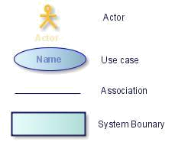

Figure 3.1: Symbols Used in Use Case

- Admin The Admin is the important actor in the Visitor Management Tool. He is having the privileges to access to the system and perform actions such as Login, Approve/Reject Request, Change Password, View Details.
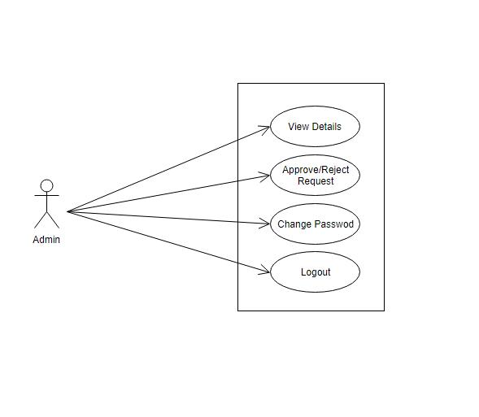

Figure 3.2: Use Case of Admin

13

b)User

The User or the employee is the backbone of the company. The User is the actor in the VMT application. User performs the actions such as Login, Change Password, Add Visitor, Add Request, Edit Visitor/Request, Cancel request, View details.
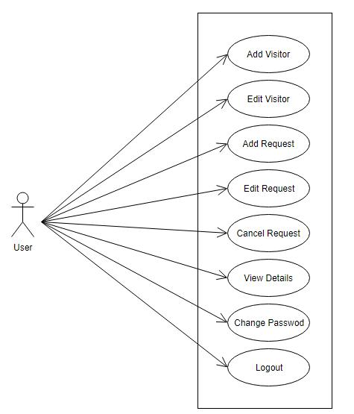

Figure 3.3: Use Case of User

3.2.2 Data Flow Diagram

A data flow diagram (DFD) is a network that describes the flow of information through system. It uses defined symbols like rectangles, circles and arrows, plus short text labels, to show data inputs, outputs, storage points and the routes between each des-tination.They represent one of the most integenious tools used for structured analysis. It has the purpose of clarifying system requirements and identifying major transfor-mations that will become programs in system design. Data flowcharts can range from simple, even hand- drawn process overviews, to in-depth, multi-level DFDs that dig progressively deeper into how the data is handled. It is the major starting point in the design phase that functionality decomposes the requirement specification down to the lowest level of detail. A DFD can often visually say things that would be hard to explain in words, and they work for both technical and nontechnical audiences.Each process in the system can be described with data flow diagram and can be broken into several an-other process to fully understand the system.In thenormal convention a DFD has four major sysmbols.

14

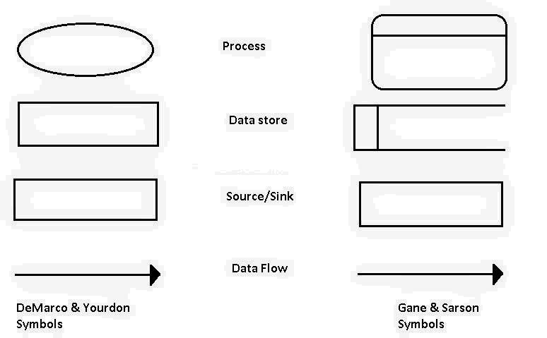

Figure 3.4: Use Case of User

Level 0 of VMT
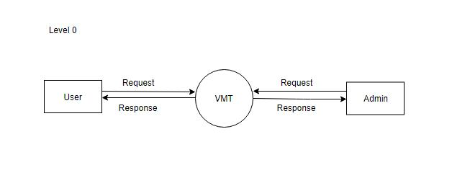

15

Level 1 of VMT
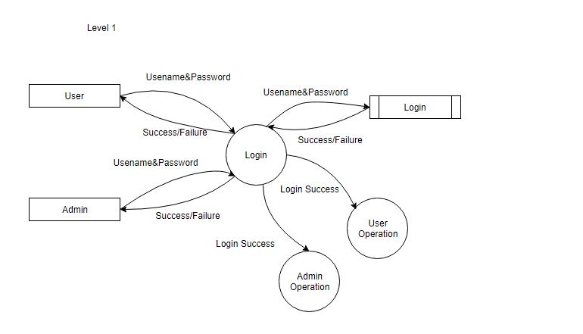

Level 2 of User
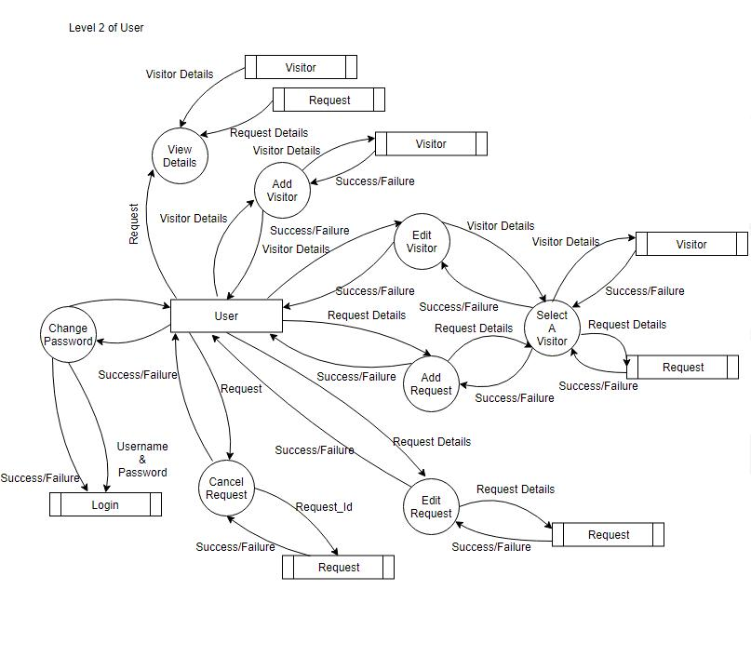

16

Level 2 of Admin
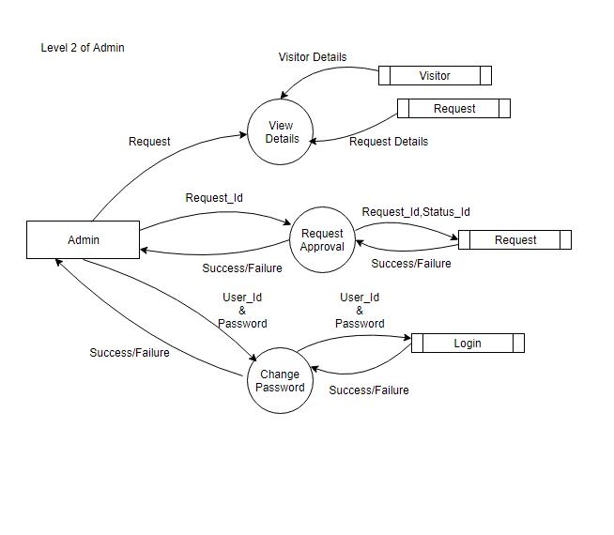

3.2.3 Tables

Table 3.1: tbl Login

No. | Column Name |  |  |  |  | Data Type | Constraints
1 | User |  | id |  |  | int | PrimaryKey,AutoIncrement
2 | Username |  |  |  |  | varchar
3 | Password |  |  |  |  | varchar
4 | User |  |  | Type |  | varchar

Table 3.2: tbl Status

No. | Column Name |  |  |  | Data Type | Constraints
1 | Status |  | id |  | int | PrimaryKey
2 | Status |  |  | name | varchar

Table 3.3: tbl Facility

No. | Column Name |  |  | Data Type | Constraints
1 | Facility |  | id | int | PrimaryKey,AutoIncrement
2 | Facility |  | name | varchar

17

Table 3.4: tbl Location

No. | Column Name |  |  | Data Type | Constraints
1 | Location |  | id | int | PrimaryKey,AutoIncrement
2 | Location |  | name | varchar

Table 3.5: tbl Request

No. | Column Name |  |  |  |  |  |  |  |  |  |  |  |  |  |  |  |  | Data Type | Constraints
1 | Request |  |  |  |  |  |  |  |  |  |  |  |  | id |  |  |  | int | PrimaryKey,AutoIncrement
2 | Visitor |  |  |  |  |  |  | id |  |  |  |  |  |  |  |  |  | int | ForeignKey
3 | Status |  |  |  |  | id |  |  |  |  |  |  |  |  |  |  |  | int | ForeignKey
4 | Location |  |  |  |  |  |  |  |  |  |  |  |  |  |  |  | id | int | ForeignKey
5 | Facility |  |  |  |  |  |  |  |  |  |  |  | id |  |  |  |  | int | ForeignKey
6 | User |  | id |  |  |  |  |  |  |  |  |  |  |  |  |  |  | int | ForeignKey
7 | Date |  | From |  |  |  |  |  |  |  |  |  |  |  |  |  |  | DateTime
8 | Date |  | To |  |  |  |  |  |  |  |  |  |  |  |  |  |  | DateTime

- Status Change Date DateTime

10 | Raised |  |  |  |  |  |  |  | date |  |  | DateTime
11 | Purpose |  |  |  |  |  |  |  |  |  |  | varchar
12 | Has |  |  |  | Asset |  |  |  |  |  |  | varchar
13 | Asset |  |  |  |  |  | Details |  |  |  |  | varchar
14 | Approved |  |  |  |  |  |  |  |  |  | By | varchar
15 | Approved |  |  |  |  |  |  |  |  |  | Status | varchar
16 | Comments |  |  |  |  |  |  |  |  |  |  | varchar
17 | To |  | Meet |  |  |  |  |  |  |  |  | varchar

Table 3.6: tbl Visitor

No. | Column Name |  |  |  |  |  |  |  |  |  |  |  |  |  |  |  |  |  | Data Type | Constraints
1 | Visitor |  |  |  |  |  |  |  |  |  |  |  |  |  | id |  |  |  | int | PrimaryKey,AutoIncrement
2 | User |  |  |  |  |  |  |  |  |  |  | id |  |  |  |  |  |  | int | ForeignKey
3 | First |  |  |  |  |  |  |  | Name |  |  |  |  |  |  |  |  |  | varchar
4 | Last |  |  |  |  | Name |  |  |  |  |  |  |  |  |  |  |  |  | varchar
5 | Contact |  |  |  |  |  |  |  |  |  |  |  |  |  |  |  |  | no | int
6 | Address |  |  |  |  |  |  |  |  |  |  |  |  |  |  |  |  |  | varchar
7 | Company |  |  |  |  |  |  |  |  |  |  |  |  |  |  |  |  |  | varchar

- Customer Type varchar

9 | Visitor |  |  |  | Image |  |  | varchar
10 | Email |  | Id |  |  |  |  | varchar
11 | IdProof |  |  |  |  |  | Type | varchar

- IdProof number varchar

- Commentsvarchar

18

3.2.4 Functional Requirements

Hardware Interfaces

Client Side :Any mobile which have an operating system such as An- droid, iOS or WUP with network connectivity.

Server Side :

– 4 GB or above RAM

– 40 GB or above Hard disk

Software Interfaces

Client side:Application called VMT to be installed in the mobile.

Server Side

– Microsoft Visual Studio 2017

– Xamarin

– SQLlite

Communication interfaces: The communication between different parts of the system is important since they depend on each other. It is achieved through inter-net.

3.2.5 Non-Functional Requirements

Performance Requirement

For the efficient performance of the application, network must have high bandwidth so that the task of centralized management does not lead to network jam. Also the hard disk capability must be high so that data can be effectively stored and retrieved. Security Requirement Security requirements of this application involves user authen-tication us- ing user name and password so that invalid users are restricted from data access. For the security of data, periodic database backups must be per- formed so that we can recover data in the case of data loss.

19

3.3 SYSTEM DESIGN

The most creative and challenging phase of the system lifecycle is the system design. The term design describes a final system and the process by which it is developed. It refers to the technical specifications that will be applied in implementing the candidate system. In system design, we move from the logical to the physical aspects of the life cycle.

The first step is to determine how the output is to be produced and in what format. Then input data and master files have to be designed at the next step and finally the im-pact of the candidate system on the user and organization are documented and evaluated by the management. After identifying the problem and the limitations of the existing system, a detailed design of the proposed system is conducted.

Free flow personnel interview and reference to previous records prepared manu-ally were the only methods taken to collect necessary information. At present, the all organizations are on the path of computerization process.

Design is the phase that indicates the final system. It is the solution, the translation of requirements into ways of meeting them. In this phase the following elements were designed namely, dataflow, data stores, processes, procedures. Firstly, the logical design was done where the outputs, inputs, databases and the procedures was formulated in a manner that meet the project requirements. After logical design physical construction of the system is done.

The database tables, input screens, output screens, output reports are designed. Af-ter analyzing the various functions involved in the system the database, labels a dic-tionaries designed. Care is taken for the field name to be in self-explanatory form. Unnecessary fields are avoiding so as not affecting the storage of the system.

Care must be taken to design the input screen in the most user-friendly way so as to help even the novice users make entries approximately in the right place. This is being accomplished by the use of giving online help messages, which are brief and cleanly prompts users for the appropriate action.

Design is the only way that we can accurately translate a customers requirements

20

into a finished software product or system. Without design, risk of building an unstable system exist one that will fail when small changes are made, one that will be difficult to test.

All input screens in the system are user friendly and are designed in such a way that even a layman can operate. The sizes of all the screens are standardized. Reports generate in this software give the finer accepts of the required information, which helps in taking vital decisions.

The importance of the software design can be stated with a single word quality. Design is a place where quality is fostered in software develop- ment. Design is the only way where requirements are actually translated into a finished software product or system.

There are two users in the system:

Admin : Administrator is the super user of the system. He/she have the privilege to the overall system. Administrator approves the request.

Employee:The Employee or the user is the backbone of the company .They can add the visitor details and raise request for the corresponding visitor.

Input Design : Input design is the process of converting user- oriented input into a computer based format. The goal of the de- signing input is to make data en-try as easy and free from error. In .NET, input to the system is entered through forms. A form is any surface on which information is to be entered, the nature of which is determined by what is already on that surface. If the data going into the system is incorrect, then processing and output will magnify these errors. So designer should ensure that form is accessible and understandable by the user. End users are people who communi- cate to the system frequently through the user-interface, the design of the input screen should be according to their recom-mendations. The following are the consideration given by the end-users for input design.

– The screens should be user-friendly and easy to operate.

21

– Proper validation of inputs to be provided.

The screens should be clear and enough information should be provided to guide the user to enter correct data. List of valid values for the field should be provided wherever possible. An analyst must always assume that errors will occur. They must be found during input and corrected prior to storing or processing data.

The application has been developed in a user friendly manner. The system accepts the needs from the user with simple and understand- able dialogs. The screens have been designed in such a way that during the processing the curser is placed in the position where the data must be entered.Security is provided in necessary areas.

The input screens of the design are designed with standard layouts, colors and with appropriate controls like option buttons, check boxes etc. for making the data entry process easy, error free, fast with less strain. Data validation methods are used to check the data entered and to display appropriate error messages if any errors are found.

Output Design : The most important thing about any system is what it produces. A system is judged to be a success or failure depending on whether its products are useful or not. So it is critical that we first specify what is required from the system. Once this had been done, we can concentrate on what is required from the system. Once this has been done we can concentrate on what is required to produce this output. In order to agree what results are to be produced by the system users are consulted to understand exactly what is required. On decisions which need to be made, is which medium to use for a particular output.

Database Design : Database design is the process of producing a detailed data model of a database. This logical data model con- tains all the needed logical and physical design choices and physical storage parameters needed to generate a design in a Data Definition Language, which can then be used to create a database. A fully attributed data model contains detailed attributes for each entity.

The term database design can be used to describe many different parts of the design of an overall database system. Principally, and most correctly, it can be

22

thought of as the logical design of the base data structures used to store the data. In the relational model these are the tables and views. In an object database the entities and relationships map directly to object classes and named relationships. However, the term database design could also be used to apply to the overall pro-cess of designing, not just the base data structures, but also the forms and queries used as part of the overall database application within the database management system (DBMS).

A database is an integrated collection of data and provides cen- tralized access to the data. Usually the centralized data managing software is called RDMS. The main significant difference between RDMS and other DBMS is the separation of data as seen by the program and data as stored in direct access to storage device. This is the difference between logical and physical data.

Design Process

Determine the purpose of the Database: This helps prepare for the remaining steps.

Find and organize the information required: Gather all of the types of information to record in the database, such as product name and order number.

Divide Information into tables: Divide information items into major entities or subjects, such as Products or Orders. Each subject then becomes a table.

Turn information items into columns: Decide what information needs to be stored in each table. Each item becomes a field, and is displayed as a column in the table.

Specify the primary key: Choose each tables primary key. The primary key is a column, or a set of columns, that is used to uniquely identify each row. An example might be Birth ID.

Setup the table relationships: Look at each table and decide how the data in one table is related to the data in other tables. Add fields to tables or create new tables to clarify the relationships, as necessary.

23

Refine the design: Analyze the design for errors. Create tables and add a few records of sample data. Check if results come from the tables as expected. Make adjustments to the design, as needed.

Apply the normalization rules: Apply the data normalization rules to see if tables are structured correctly. Make adjustments to the table.

3.4 TOOLS AND PLATFORM

3.4.1 Xamarin

Xamarin is one of the software company which is located in San Francisco. It pro-vides commercial software development tools that allow a user to develop applications for Android,iOS and Windows using c# language and Dot Net Framework.Xamarin is built on the Dot Net framework.It allows us to create applications that easily run across multiple platforms.

In xamarin, there are two types of applications which can be created.They are :

Native forms

Xamarin.Forms

Native Forms

Using Native forms, we can create Android as well iOS applications.There are three reasons to choose xamarin Native forms and they are as follows:

App ftle size to be small : The Xamarin.Forms abstraction layer that allows you to build for iOS and Android typically leads to a larger app size. Together with the increased overhead, this typically means the loading process for an app takes longer, particularly on Android. Xamarin and Microsoft have made great strides in per- formance improvements across the board for Xamarin since the two companies joined forces in early 2016. But theres no denying that a multi-platform app built in Xamarin.Forms can end up bigger and slower. So, if your

24

app needs to be lightning fast to deliver a great UX, you may want to choose Xamarin Native.

Complex UI or lot of animation : If your application has a com- plicated UI with lots of intensive graphics, you might need to go with Xamarin Native to ensure optimal performance. Xamarin.Forms, like the name indicates, was conceived to offer a UI framework geared for clear decision-based or form-based flows through an app. Highly dy- namic content may be better suited for an app thats coded in C# with Xamarin but designed on the native platforms in Xamarin.iOS and Xamarin.Android.

Use of a native feature thats not available on both plat- forms : Android and iOS seem to be chasing each other with each release in terms of what features each platform offers. But there are some features, and even UI controls, that are exclusive to one platform. Xamarin.Forms doesnt provide an abstraction for these features because theres nothing cross platform about them. As a simple example, iOS has a widget called a segmented control, for which Xamarin.Forms doesnt have an analogous control. You can always implement controls like this yourself in Xamarin.Forms, but thats more time spent developing UI widgets and less time spent polishing your business logic. So, if there are make-or-break UI ele- ments that you must have in your app and that arent cross platform, Xamarin Native is probably the way to go.

3.4.2 Xamarin.Forms

Xamarin.Forms is a cross-platform, natively-backed UI toolkit ab- straction that allows developers to create user interfaces that can be shared across Android, iOS, and Win-dows Phone. Because the user interfaces use the native controls of the target platforms, they have the appearance and, importantly, the responsiveness of natively built apps.

3.4.3 Xamarin.Forms Solution Architecture

Cross-platform project: The user-experience of a Xamarin.Forms application is usually defined in a cross-platform shared project (either a Portable Class Li-brary or a Shared Project) and com- bined with platform-specific projects that, at

25

the least, initial- ize the native platform rendering (note the call to Forms.Init() in the platform code samples below) and, more generally, ex- tend the user-experience and user-interface in platform-specific manners (for instance, by ac-cessing platform-specific sensors or capabilities).

iOS platform code: On the iOS platform, Visual Studio reg- isters a FormsAp-plicationDelegate as the entry point of the ap- plication, and immediately makes a call to Forms.Init.

Android platform code : The entry point on Android is a FormsAppCompat-Activity, and its OnCreate method must con- figure the tab bar and toolbars and call its base method before calling Forms.Init.

UWP code : The entry point for a Xamarin.Forms app on UWP is just the con-structor for a Application in App.xaml.cs in the UWP platform project. However, the application lifecycle on UWP is such that the call to Forms.Init must take place inside the OnLaunched method, and is guarded against being run more than once.

3.4.4 Model-View-ViewModel(MVVM)

Application developers use the Model-View-ViewModel (MVVM) pat- tern to create Xamarin.Forms apps that cleanly separate the concerns of data presentation and user interface from the concerns of data storage and manipulation. The Xamarin.Forms framework enables this by providing, among a few other related types, the BindableOb-ject and BindableProperty classes. Objects that inherit from Bind- ableObject can be bound to members of type BindableProperty on other objects.

A BindableObject maintains dictionary of BindableProperty names and an associ-ation with their corresponding binding contextssimply the object on which the Bind-ableProperty is defined and that the ap- plication developer has assigned to the Bindin-gObject.BindingContext propertythrough a Binding.

3.4.5 Microsoft Visual Studio 2017

Microsoft Visual Studio is an integrated development environment (IDE) from Mi-crosoft. It is used to develop computer programs, as well as web sites, web apps,

26

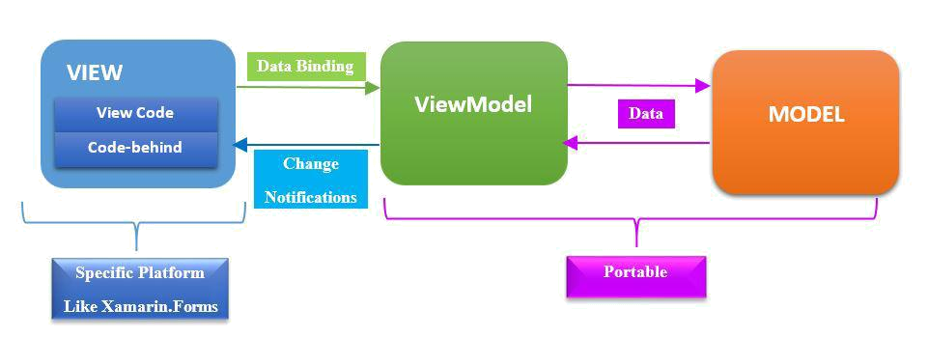

Figure 3.5: MVVM Pattern in Xamarin

web services and mobile apps. Visual Stu- dio uses Microsoft software development platforms such as Windows API, Windows Forms, Windows Presentation Foundation, Windows Store and Microsoft Silverlight. It can produce both native code and managed code.

Visual Studio includes a code editor supporting IntelliSense (the code completion component) as well as code refactoring. The inte- grated debugger works both as a source-level debugger and a machine- level debugger. Other built-in tools include a code profiler, forms designer for building GUI applications, web designer, class de-signer, and database schema designer. It accepts plug-ins that enhance the functionality at almost every levelincluding adding support for source control systems (like Subver-sion) and adding new toolsets like edi- tors and visual designers for domain-specific languages or toolsets for other aspects of the software development lifecycle (like the Team Foundation Server client: Team Explorer).

Visual Studio supports 36 different programming languages and allows the code editor and debugger to support (to varying degrees) nearly any programming language, provided a language-specific ser- vice exists. Built-in languages include C,C++, C++/CLI, Visual Basic .NET, C#, F#, JavaScript, TypeScript, XML, XSLT, HTML and CSS. Sup-port for other languages such as Python, Ruby, Node.js, and M among others is available via plug-ins. Java (and J#) were supported in the past.

27

Its one of the Microsofts product.The xamarin.forms package is installed in the vi-sual studio inorder to work with xamarin.forms.Unparalleled productivity for any dev, any app, and any platform.Visual Studio 2017 can be used to develop apps for Android, iOS, Windows, Linux, web, and cloud. Code fast, debug and diagnose with ease, test often, and release with confidence. You can also extend and customize Vi- sual Stu-dio by building your own extensions. Use version control, be agile, and collaborate efficiently.

3.4.6 The .NET Framework

The key features of the .NET Framework, includes the common lan- guage runtime, the

.NET Framework class library, and cross-language interoperability.

Common Language Runtime

The common language runtime is a run-time environment that man- ages the execu-tion of code and provides services that simplify the development process. The runtime makes the developers experience very simple, especially when compared to COM as it is today. In par- ticular, features such as user controls dramatically reduce the amount of code a developer must write in order to turn business logic into a reusable component.

Assemblies

Assemblies are collections of types and resources that forms logi- cal units of func-tionality. Assemblies are the fundamental units of deployment, version control, reuse, activation scoping and security permissions.

Common Type System

Identifies the type supported by the common language runtime.

Metadata and Self-Describing Components

Metadata and Self-Describing Components explain how the .NET Framework simpli-fies component interoperation by allowing compil- ers to emit additional declaration information, or metadata, into all modules and assemblies.

Cross Language Interoperability

Cross Language Interoperability explain how managed objects cre- ated in different programming languages can interact with one an- other.

28

.NET Framework Security

.NET Framework Security provides mechanism for protecting re- sources and code from unauthorized code and unauthorized users.

.NET Framework Class Library

.NET Framework Class Library provides programming information about the classes, interfaces, and value types that are included in .NET. This library provides access to system functionality and is de- signed to be the foundation on which .NET Framework applications, components, and controls are built.

3.4.7 C-Sharp(C#)

C-Sharp is the one of the most important language used in the .Net environment. It is a whole new language free of the background com- patibility curse with a whole bunch of new, exciting and promising features. It is an Object Oriented Programming Language and has at its core, many similarities in Java, C#, and Visual Basic. In fact, C# combines the power and efficiency of C++, the simple and clean Ob- ject Oriented design of java and the language simplification of Visual Basic. Like Java, C-Sharp also does not allow multiple inheritance or the use of pointers but provide garbage memory collection at run time, type, memory access checking.

3.4.8 Windows Azure Mobile Services

Windows Azure Mobile Services makes it incredibly easy to connect a scalable cloud backend to your client and mobile applications. It allows you to easily store structured data in the cloud that can span both devices and users, integrate it with user authentica-tion, as well as send out updates to clients via push notifications.

Storing Data in Cloud Storing data in the cloud with Windows Azure Mobile Ser-vices is incredibly easy. When you create a Windows Azure Mobile Ser- vice, we automatically associate it with a SQL Database inside Win- dows Azure. The Windows Azure Mobile Service backend then pro- vides built-in support for enabling remote apps to securely store and retrieve data from it (using secure REST end-points utilizing a JSON-based ODATA format) without you having to write or deploy any custom server code. Built-in management support is provided within the Windows Azure portal for

29

creating new tables, browsing data, setting indexes, and controlling access permissions

This makes it incredibly easy to connect client applications to the cloud, and enables client developers who dont have a server-code background to be productive from the very beginning. They can instead focus on building the client app experience, and leverage Windows Azure Mobile Services to provide the cloud backend services they require.

User Authentication and Push Notiftcations Windows Azure Mobile Services also make it incredibly easy to inte- grate user authentication/authorization and push notifications within your applications. You can use these capabilities to enable authenti-cation and fine grain access control permissions to the data you store in the cloud, as well as to trigger push notifications to users/devices when the data changes. Windows Azure Mobile Services supports the concept of server scripts (small chunks of server-side script that executes in response to actions) that make it really easy to enable these scenarios.

Manage and Monitor Mobile Service Just like with every other service in Win-dows Azure, you can moni- tor usage and metrics of your mobile service backend using the Dash- board tab within the Windows Azure Portal.The dashboard tab pro- vides a built-in monitoring view of the API calls, Bandwidth, and server CPU cycles of your Windows Azure Mobile Service. We can also use the Logs tab within the portal to re-view error messages. This makes it easy to monitor and track how your application is doing.

3.4.9 SQLite

SQLite is an in-process library that implements a self-contained, serverless, zero-configuration, transactional SQL database engine. It is a database, which is zero-configured, which means like other databases you do not need to configure it in your system.

SQLite engine is not a standalone process like other databases, you can link it stat-ically or dynamically as per your requirement with your application. SQLite accesses its storage files directly.

Why SQLite ?

30

SQLite does not require a separate server process or system to operate (serverless)

SQLite comes with zero-configuration, which means no setup or administration needed

A complete SQLite database is stored in a single cross-platform disk file

SQLite is very small and light weight, less than 400KiB fully configured or less than 250KiB with optional features omitted

SQLite is self-contained, which means no external dependencies SQLite transac-tions are fully ACID-compliant, allowing safe ac- cess from multiple processes or threads

SQLite supports most of the query language features found in SQL92 (SQL2) standard

SQLite is written in ANSI-C and provides simple and easy-to-use API

SQLite is available on UNIX (Linux, Mac OS-X, Android, iOS) and Windows (Win32, WinCE, WinRT)

Limitations of SQLite

RIGHT OUTER JOIN : Only LEFT OUTER JOIN is implemented

FULL OUTER JOIN : Only LEFT OUTER JOIN is implemented

ALTER TABLE : The RENAME TABLE and ADD COLUMN

variants of the ALTER TABLE command are supported. The DROP COLUMN, ALTER COLUMN, ADD CONSTRAINT are not supported
Trigger Support : FOR EACH ROW triggers are supported but not FOR EACH STATEMENT triggers

31

VIEWs : VIEWs in SQLite are read-only. You may not execute a DELETE, INSERT, or UPDATE statement on a view GRANT and REVOKE : The only access permissions that can be applied are the normal file access permissions of the un-derlying operating system.

32

CHAPTER 4

SYSTEM TESTING

4.1 TESTING STRATEGIES

A strategy for software testing integrates software test case design method in to a well planned series of steps that result in the suc- cessful construction of the software. The strategy provides a road map that describes the step to be conducted as part of testing, when these steps are planned and then undertaken, and how much effort, time and re-sources will be required. Therefore any testing strategy must incorporate test planning, test case, design, test execution and resultant data collection and evaluation.A software testing strategy should be flexible enough to promote a customized testingapproach. At the same time, it must be rigid enough to promote reasonable planningand manage-ment tracking as the project progresses. The general characteristics ofsoftware testing strategies are:

Testing begins at the component level and works outward toward the integration of the entire computer system

Different testing techniques are appropriate at different points in time

A strategy for software testing must accommodate low-level tests that are neces-sary to verify that a small source code segment has been correctly implemented as well as high-level tests that validate major system functions against customer requirements. A strategy must provide guidance for the practitioner and set of mild stones for the manager. Because the step on the test strategy occurs at a time when deadline pres-sure begins to rise, progress must be measurable and problem must surface as early as possible.

The software teams approach to testing is defining a plan that de- scribes an overall strategy and a procedure that defines specific test- ing steps and tests that will be con-ducted. In the proposed system, if the administrator makes any attempt to login to the application without entering his password, then the system will not allow the user to

33

login to the application.

4.1.1 White-Box Testing

White-box testing, also called as glass-box testing, is a test case de- sign method that goes to the control structure of the procedural design to derive test cases. Using white-box testing methods, the software engineer can derive test cases that

Guarantee that all independent paths within a module have been exercised at least once.

Exercise all logical decision on their true and false sides

Execute all loops at their boundaries and within their operational bounds. Exercise internal data structure to ensure their validity.

White-box testing was successfully conducted on our system. All independent paths within a module have been executed at least once and all logical decisions have been exercised on their true and false sides.

While white-box testing can be applied at the unit, integration and system levels of the software testing process, it is usually done at the unit level. It can test paths within a unit, paths between units dur- ing integration, and between subsystems during a systemlevel test. Though this method of test design can uncover many errors or prob-lems, it might not detect unimplemented parts of the specification or missing require-ments.Techniques used in white-box testing include:

API testing of the application using public and private APIs (application pro-gramming interfaces)

Code coverage creating tests to satisfy some criteria of code coverage (e.g., the test designer can create tests to cause all state- ments in the program to be exe-cuted at least once)

Fault injection methods intentionally introducing faults to gauge the efficency of testing strategies

34

Mutation testing methods Static testing methods

Code coverage tools can evaluate the completeness of a test suite that was created with any method, including black-box testing. This allows the software team to examine parts of a system that are rarely tested and ensures that the most important function points have been tested.Code coverage as a software metric can be reported as a per-centage for:

Function coverage, which reports on functions executed Statement coverage, which reports on the number of lines exe- cuted to complete the test

Decision coverage, which reports on whether both the True and the False branch of a given test has been executed

100% statement coverage ensures that all code paths or branches (in terms of control flow) are executed at least once. This is helpful in ensuring correct functionality, but not sufficient since the same code may process different inputs correctly or incorrectly.

4.1.2 Black-Box Testing

Black-box testing also called behavioral testing,

Incorrect or missing functions Interface errors
Errors on data structures or external database access Behavior or performance errors
Initialization and termination errors

Black-box testing was successfully conducted on our system. The system was di-vided into a number of modules and testing was con- ducted on each module. We have tested the system for incorrect or missing functions and interface errors. Performance errors and the flow of information between modules ensuring interface.

35

4.1.3 Unit Testing

Unit testing comprises the set of tests performed by an individual programmer prior to the integration of the system. Testing removes residual bugs and improves the reliability of the system. Testing allows the developer to find out the design faults if any, and enable correction if needed. Exhaustive unit testing has to be carried out to ensure the validity of the data. In order to successfully test the entire package, unit testing is carried out. Each module was tested as and when it was developed. Thus, it proved easier to conduct minute testing operation and correct them then and there.

4.1.4 Integration Testing

Bottom-up integration is the traditional strategy used to integrate the component of a software system into a functional whole. Bottom- up integration consists of unit testing, followed by subsystem testing and followed by testing of the entire system. Unit testing has the goal of discovering errors in the individual parts of the system. Parts are tested in isolation from one another in an artificial environment known as Test Harness, which consists of driver programs and data necessary to exercise the modules. Unit testing should be as ex- haustive as possible to entire that each representative case handled by each module has been tested. Unit testing is eased by a system structure that is composed of small loosely coupled modules.

A subsystem consists of several modules that communicate with each other through well defined interfaces. Normally, a subsystem implements a major segment of the total system. The primary pur- pose of the subsystem testing is to verify operation of the interfaces between modules in the subsystem. Both control and data interfaces must be tested. Large software system may require several levels of subsystem testing. Lower level subsystems are successively combined to form higher level subsystems.In most software systems, exhaustive testing of subsystem capabilities is not feasible due to the combina- tion complexity of the module interfaces. Therefore, test cases must be carefully chosen to exercise the interfaces in the desired manner.

36

4.1.5 Output Testing

Output testing of the proposed system is important since no system could be useful if it does not produce the required output. The output format on the screen is found to be correct, as the format was designed in the system design phase according to the user needs. For the hard copy also the output comes out as the specified requirements by the user. Hence output testing doesnt result in any correction on the system.

37

CHAPTER 5

SYSTEM IMPLEMENTATION

Implementation is the stage of the project where the theoretical de- sign is turned into a working system. The implementation of a system involves people from different sec-tions and systems analysts are con- fronted with the practical problem of controlling activities of peo- ple outside their own data processing sections. Prior to this point in the project, system analysts have interviewed staffs different sec- tions with the permis-sion of their respective managers but the im- plementation phase involves staff of user departments carrying out specific task, which require supervision and control to critical sched- ules. Some of these problems may also need to be employed on the task of im-plementation in addition to their own present departmental tasks. Implementation is the stage of the project where the theoret- ical design is turned into a working system. At this stage the main work load, the greatest upheaval and the major impact on the exist-ing system shifts to the user department. If the implementation is not carefully planned and controlled, it can cause chaos and confu- sion. Implementation includes all those activities that take place to convert from the old system to new system. The new system may be totally new, replacing an existing manual or automated system or it may be a major modification to an existing system. At this stage the main work load, the greatest upheaval and the major impact on the existing system shifts to the user department. If the implemen- tation is not carefully planned and controlled, it can cause chaos and confusion. Depending upon the nature of the system, extensive user training may be required. Programming itself is a design work.

The initial parameters of the management information system should be modified as a result of programming efforts; programming provides a reality test for the assump-tions made by the analyst. The imple- mentation of a system involves people from different sections and sys- tems analysts are confronted with the practical problem of controlling activities of people outside their own data processing sections. Prior to this point in the project, system analysts have interviewed staffs different sections with the permission of their respective managers but the implementation phase involves staff of

38

user departments carrying out specific task, which require supervision and control to critical schedules. Some of these problems may also need to be employed on the task of implementation in addition to their own present depart- mental tasks. Implementation includes all those activities that take place to convert from the old system to new sys-tem. The new system may be totally new, replacing an existing manual or automated sys- tem or it may be a major modification to an existing system. Proper implementation is essential to provide a reliable system to meet the organization requirements.

Successful implementation may not guarantee improvement in the organization us-ing the new system, but improper installation will prevent it. The implementation stage involves the following tasks.

Careful planning.

Investigation of system and constrains.

Design of methods to achieve the changeover. Training of staff in the changeover phase.

Evaluation of the changeover method.

The method of implementation and the time scale to be adopted are found out ini-tially. Next the system is tested properly and the same time users are trained in the new procedures.

5.1 IMPLEMENTATION PROCEDURE

Implementation of software refers to the final installation of the pack- age in its real environment, to the satisfaction of the intended users and the operation of the system. In many organizations someone who will not be operating it, will commission the software development project. People were not sure that the software is meant to make their job easier. In the initial stage, they doubt about the software but we have to ensure that the resistance does not built up as one has to make sure that:

The active user must be aware of using the system.

39

Their confidence in the software is built up.

Proper guidance is imparted to the user so that he is comfortable in using the application.

Before going ahead and viewing the system, the user must know that for viewing the result, the server program should be running in the server. If the server object is not up running on the server, the actual processes wont take place.

5.2 IMPLEMENTATION PLAN

Implementation includes all those activities that take place to con- vert from the old system to the new one. The new system may be totally new, replacing an existing manual or automated system. Proper implementation is essential to provide a reliable system to meet organization requirements Successful implementation may not guaran-tee improvement in the organization using the new system, but improper installation will prevent it. The process of putting the developed system in actual use in called sys-tem implementation. This includes all those activities that take place to convert from old system to the new system. The system can be implemented only af- ter through test-ing is done and if it is found to be working according to the specifications. The system personally checks the feasibility of the system. The implementation stages involve the following tasks.

Investigation of system and constraints.

Design of method to achieve the changeover. Training of the staff in the changeover phase. Evaluation of the changeover method.

The newly proposed system is implemented after the successful test- ing of the system.

Post Implementation Review: The final step of the systems ap- proach recognizes that an implemented solution can fail to solve the problem for which it was developed. The results of implementing a solution should be monitored and evaluated. This is

40

called post implementation review process, since the success of a solution is re- viewed after it is implemented. The focus on this step is to determine if the implemented solution has indeed helped the firm and selected business units to meet their system objectives.

41

CHAPTER 6

CONCLUSION

This project provided me with practical knowledge of not only programming in.NET MVVM and Xamarin technology, but also about procedures to be followed if a person wants to visit UST Global. It also provides knowledge about the latest technology used in developing web enabled applica- tion and client server technology that will be great demand in future. This will provide better opportunities and guidance in future in de-veloping projects independently.

42

CHAPTER 7

REFERENCES

Websites:

http://www.codeproject.com http://www.w3schools.com
http://www.stackoverflow.com http://www.xamarin.com
http://www.tutorialspoint.com

http://docs.microsoft.com/en-us/azure/app-service-mobile/app- service-mobile-xamarin-forms-get-started

43

CHAPTER 8

APPENDICES

8.1 SCREENSHOTS

44

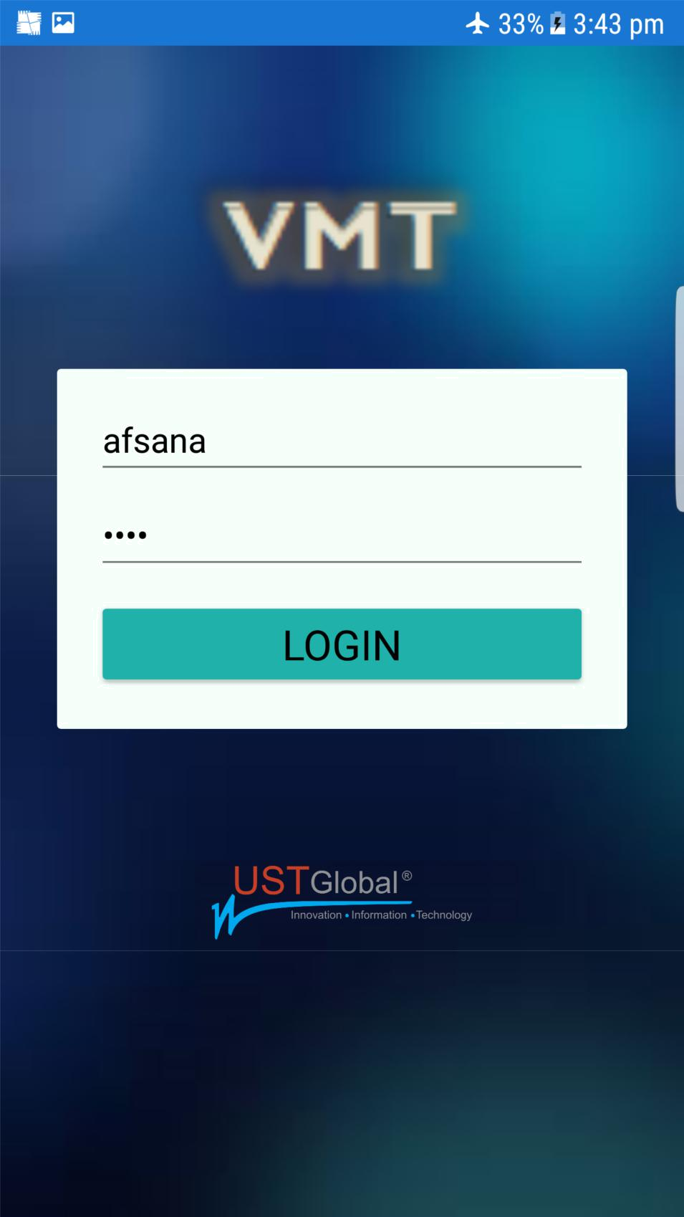

Figure 8.1: Login Page

45

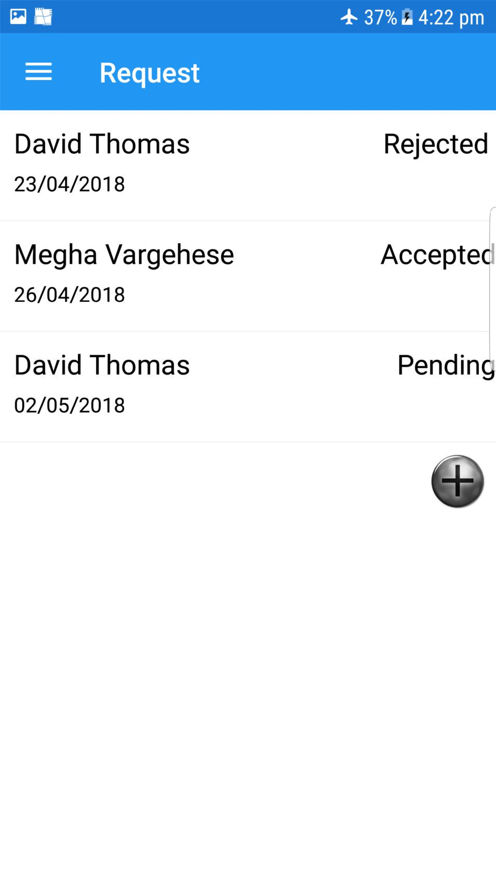

Figure 8.2: Home Page

46

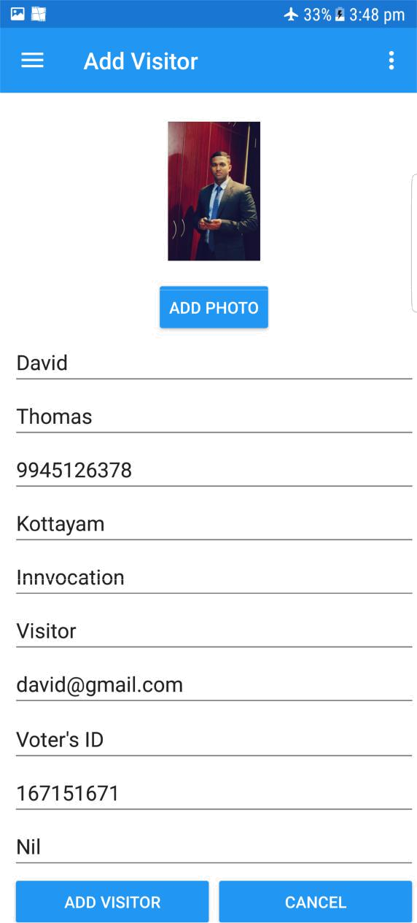

Figure 8.3: Add Visitor

47

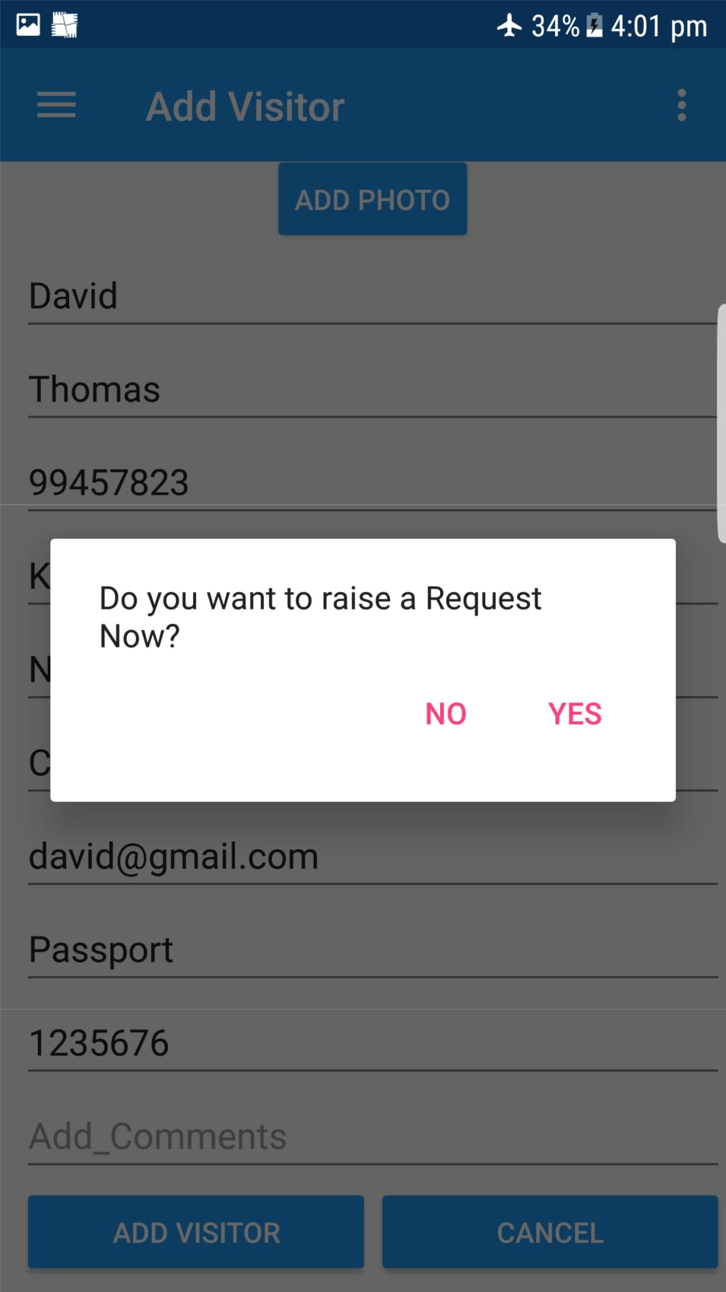

Figure 8.4: Confirmation for Raising Request at the same time

48

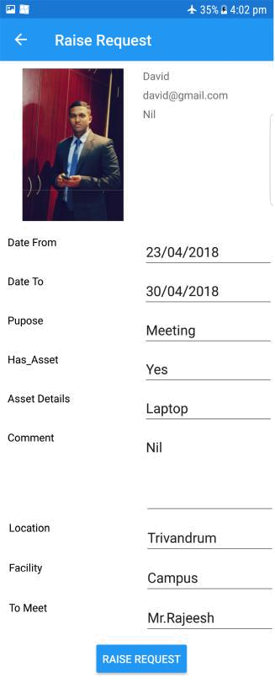

Figure 8.5: Raising Request

49

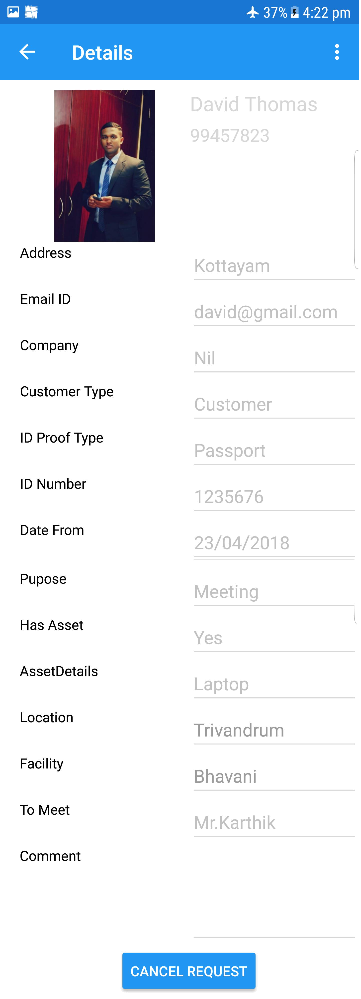

Figure 8.6: CancelRequest

50

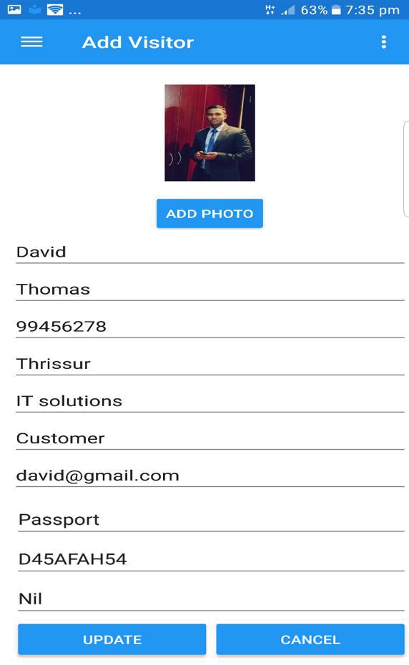

Figure 8.7: Edit Visitor

51



Figure 8.8: Visitor’s List

52

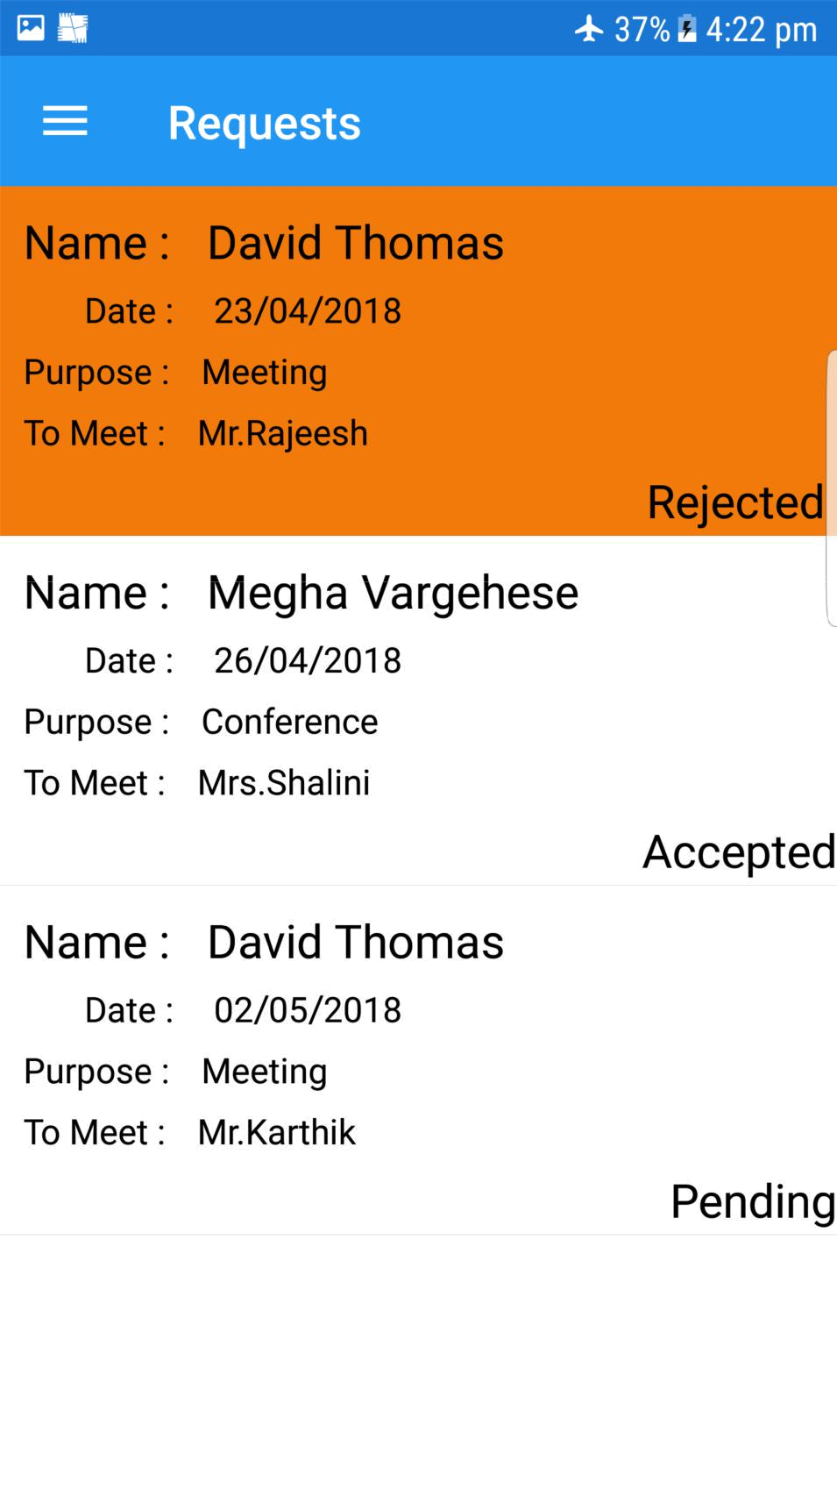

Figure 8.9: Admin Home Page

53

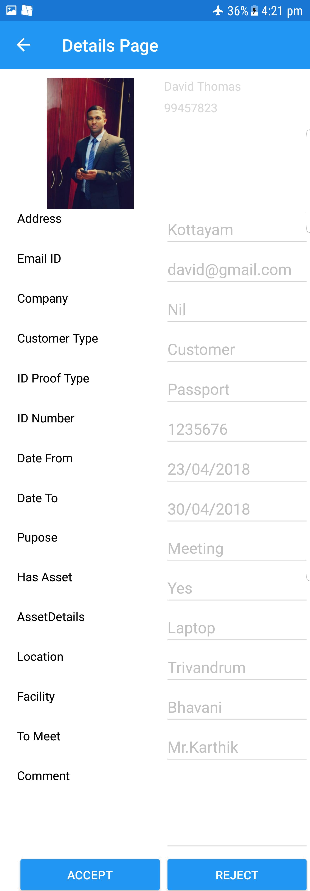

Figure 8.10: Admin Approval Page

54

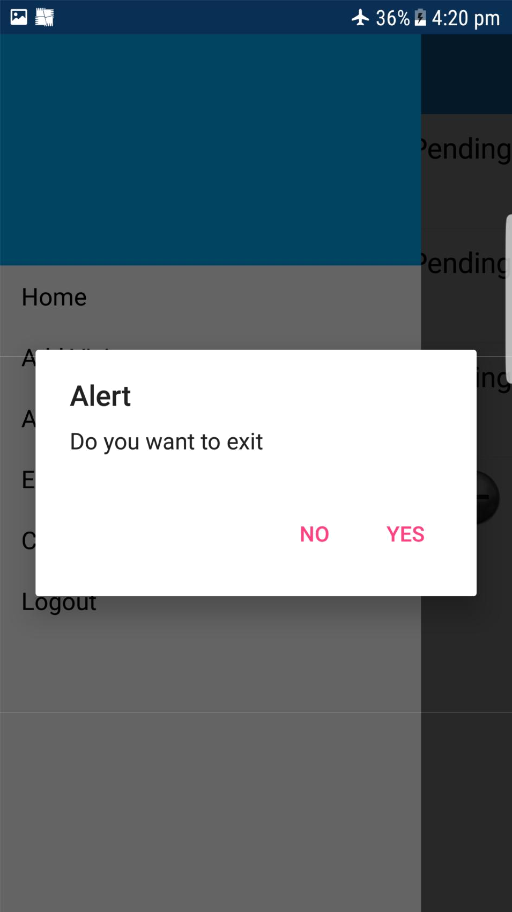

Figure 8.11: LogOut

55

