1. A customer informed their consultant that they have developed several formulations of petrol that gives different characteristics of burning pattern. The formulations are obtaining by adding varying levels of additives that, for example, prevent engine knocking, gum prevention, stability in storage, and etc. However, a third party certification organisation would like to verify if the formulations are significantly different, and request for both physical and statistical proof. Since the formulations are confidential information, they are not named in the dataset.

Please assist the consultant in the area of statistical analysis by doing this;

a. A descriptive analysis of the additives (columns named as “a” to “i”), which must include summaries of findings (parametric/non-parametric). Correlation and ANOVA, if applicable, is a must.

b. A graphical analysis of the additives, including a distribution study.

c. A clustering test of your choice (unsupervised learning), to determine the distinctive number of formulations present in the dataset.

(refer attachment : ingredients.csv)

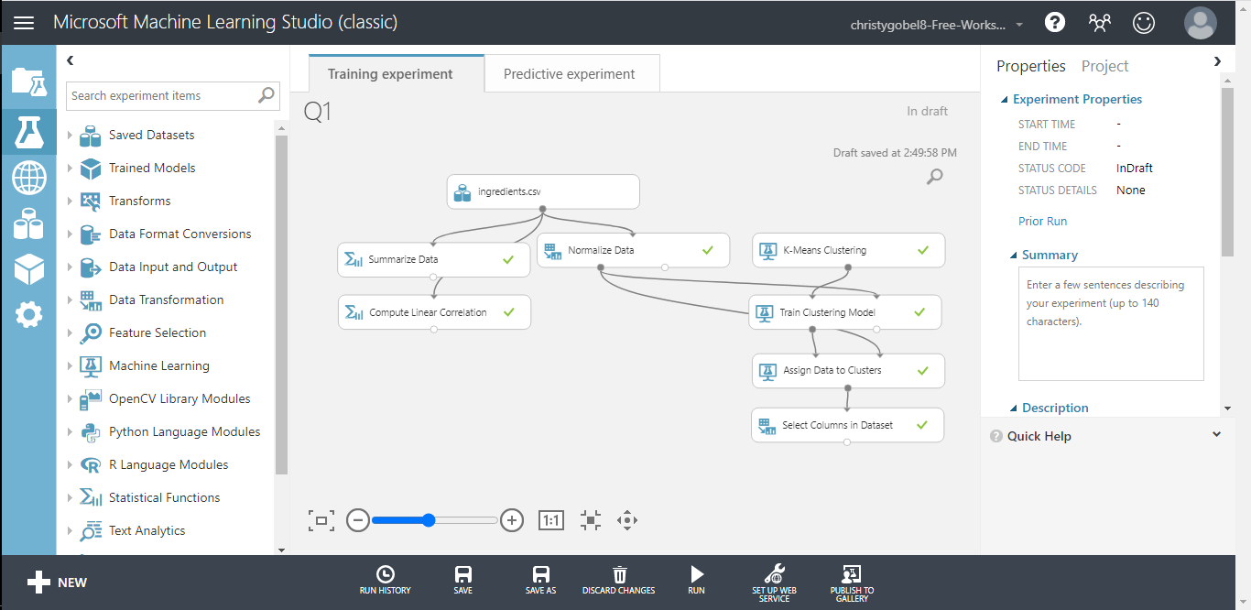

## **DESCRIPTIVE ANALYSIS AND CHECK MISSING VALUES**

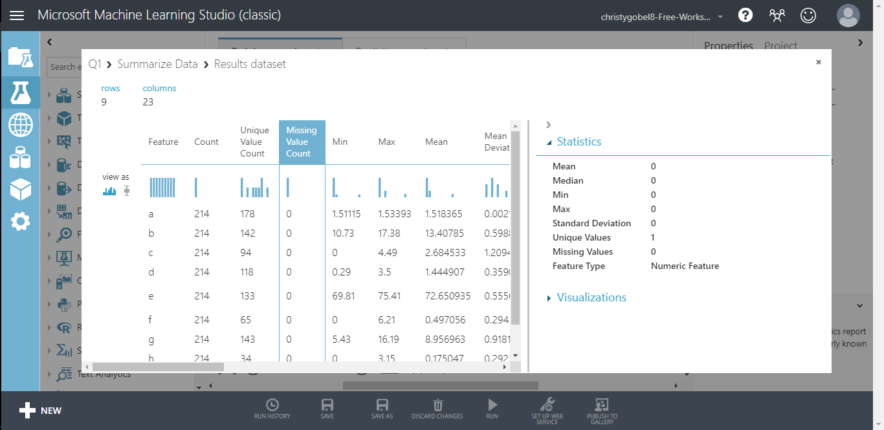

|  |  |  |  |  |  |  |  |  |  |
| --- | --- | --- | --- | --- | --- | --- | --- | --- | --- |
|  | a | b | c | d | e | f | g | h | i |
| Count | 214 | 214 | 214 | 214 | 214 | 214 | 214 | 214 | 214 |
| Missing Value Count | 0 | 0 | 0 | 0 | 0 | 0 | 0 | 0 | 0 |
| Min | 1.51115 | 10.73 | 0 | 0.29 | 69.81 | 0 | 5.43 | 0 | 0 |
| Max | 1.53393 | 17.38 | 4.49 | 3.5 | 75.41 | 6.21 | 16.19 | 3.15 | 0.51 |
| Mean | 1.518365 | 13.40785 | 2.684533 | 1.444907 | 72.65094 | 0.497056 | 8.956963 | 0.175047 | 0.057009 |
| Mean Deviation | 0.002121 | 0.598898 | 1.209406 | 0.359052 | 0.555696 | 0.294363 | 0.918127 | 0.29237 | 0.07748 |
| 1st Quartile | 1.516523 | 12.9075 | 2.115 | 1.19 | 72.28 | 0.1225 | 8.24 | 0 | 0 |
| Median | 1.51768 | 13.3 | 3.48 | 1.36 | 72.79 | 0.555 | 8.6 | 0 | 0 |
| 3rd Quartile | 1.519157 | 13.825 | 3.6 | 1.63 | 73.0875 | 0.61 | 9.1725 | 0 | 0.1 |
| Range | 0.02278 | 6.65 | 4.49 | 3.21 | 5.6 | 6.21 | 10.76 | 3.15 | 0.51 |
| Sample Variance | 0.000009 | 0.666841 | 2.08054 | 0.24927 | 0.599921 | 0.425354 | 2.025366 | 0.247227 | 0.009494 |
| Sample Standard Deviation | 0.003037 | 0.816604 | 1.442408 | 0.49927 | 0.774546 | 0.652192 | 1.423153 | 0.497219 | 0.097439 |
| Sample Skewness | 1.625431 | 0.454181 | -1.15256 | 0.90729 | -0.73045 | 6.551648 | 2.047054 | 3.416425 | 1.754327 |
| Sample Kurtosis | 4.931737 | 3.052232 | -0.41032 | 2.060569 | 2.967903 | 54.689699 | 6.681978 | 12.54108 | 2.662016 |

Summary :

* No missing values
* The values are close to the mean (low variance)

## **CORRELATION**

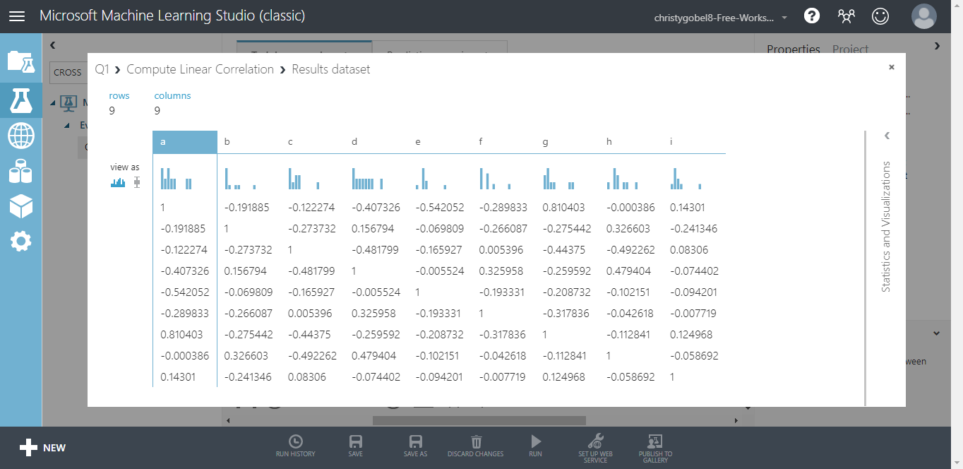

A correlation coefficient is a number between -1 and 1 that tells you the strength and direction of a relationship between variables. A correlation of 0 (uncorrelated variables) indicates no linear (straight line) relationship exists between the variables. A positive correlation close to +1 indicates a strong positive linear relationship. A correlation of 1 indicates a perfect linear relationship. A negative correlation close to −1 indicates a strong negative linear relationship. A correlation of −1 indicates a perfect inverse linear relationship.

## **ANALYZE THE DATA DISTRIBUTION**

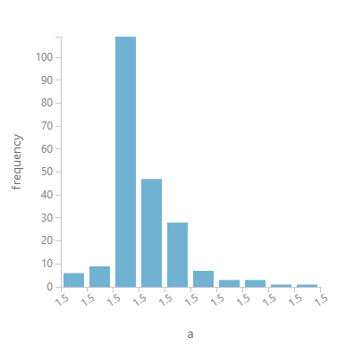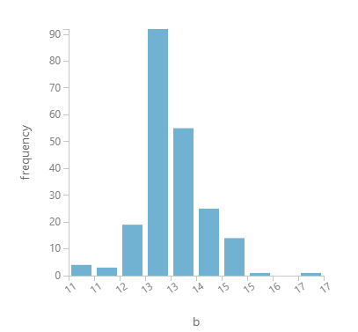

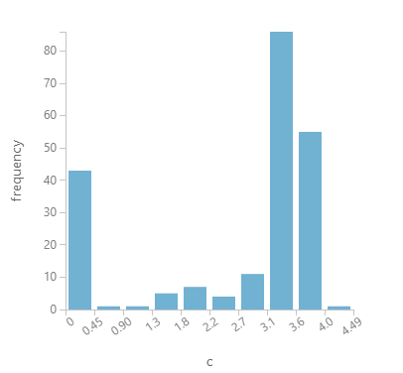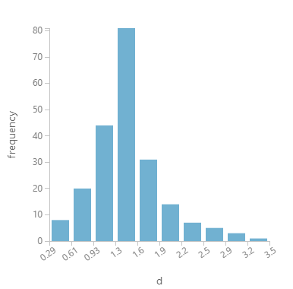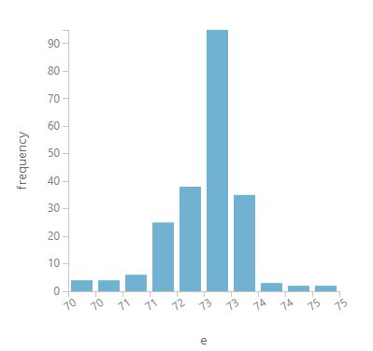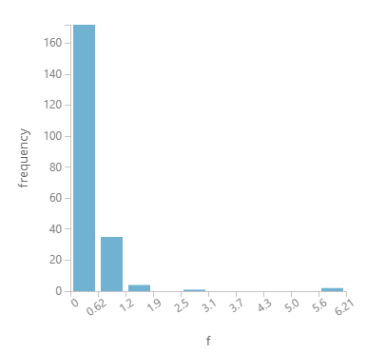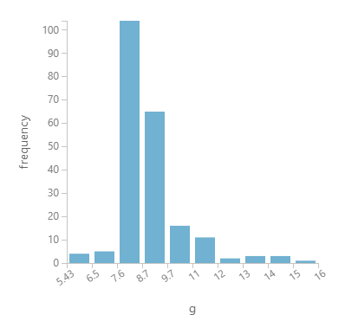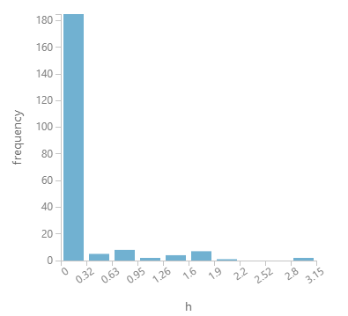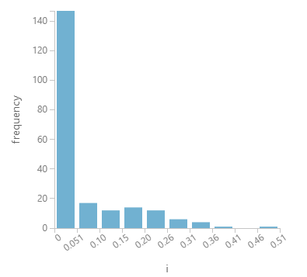

Normal distribution is a distribution that has most of the data in the center with decreasing amounts evenly distributed to the left and the right.

Summary:

Variable a, b, c, d, e, g are normally distributed.

## **K-MEANS CLUSTERING (UNSUPERVISED LEARNING)**

