JERSEY CONNECT: ONLINE PLATFORM FOR JERSEY BOOKING AND DESIGN

________________

A Capstone Project Proposal
Presented to
The Faculty of Department of Information Systems
Talibon Polytechnic College
San Isidro, Talibon, Bohol
________________

In Partial Fulfillment
of the Requirements for the Degree of
BACHELOR OF SCIENCE IN INFORMATION SYSTEMS

________________
Christy Mae R. Gurrea
Anamarie P. Boyles
Justine S. Punay

May 2026
APPROVAL SHEET

This Capstone Project with the title JERSEY CONNECT: ONLINE PLATFORM FOR JERSEY BOOKING AND DESIGN prepared and submitted by CHRISTY MAE R. GURREA, ANAMARIE P. BOYLES, JUSTINE S. PUNAY in partial fulfillment of the requirements for the degree in BACHELOR OF SCIENCE IN INFORMATION SYSTEMS has been examined and recommended for acceptance and approval for Oral Examination.

CAPSTONE PROJECT COMMITTEE

STANLEY CLARK M. DIPAY, PhD
Chairman

ALJOE ANTHONY V. BERDIN ASTRID P. VALMORIA, MAELT
Capstone Adviser English Critic

FLORDELIS A. TURTOGA, MAMT
Statistician

APPROVED by the Examining Panel during the Oral Examination held in May 2026 with the grade of ________.

PANEL OF EXAMINERS

STANLEY CLARK M. DIPAY, Ph.D.
Chairman

DIOSCORO A. AVERGONZADO, Ph.D. GISELO B. CAJES, Ph.D.
Member Member

ACCEPTED and APPROVED as partial fulfillment of the requirements for the degree in Bachelor of Science in Information Systems.

May 2026
Oral Defense Date STANLEY CLARK M. DIPAY, Ph.D., RGC., CSASS.
College President
ACKNOWLEDGEMENTS
The researchers would like to express their sincere gratitude to all the individuals who have contributed to the successful completion of this capstone project entitled Jersey Connect: Online Platform for Jersey Booking and Design.
First and foremost, the researchers thank God Almighty for the wisdom, strength, and perseverance He granted throughout this undertaking. Without His guidance, none of this would have been possible.
The researchers express their profound appreciation to their families for their unwavering love, moral support, and patience during the entire duration of this study. Their encouragement served as the greatest motivation to push forward.
Deep appreciation is extended to Stanley Clark M. Dipay, PhD, Committee Chairman, for his invaluable guidance and scholarly advice in shaping the direction of this capstone project.
The researchers are equally grateful to Aljoe Anthony Berdin, Capstone Adviser, for his technical mentorship, insightful feedback, and unwavering support throughout the development of the Jersey Connect platform.
Sincere thanks are given to Astrid P. Valmoria, MAELT, English Critic, for her meticulous review and constructive suggestions that significantly improved the clarity and quality of this paper.
The researchers also acknowledge the contributions of Flordelis A. Turtoga, MAMT, Statistician, for her assistance in the statistical analysis and data interpretation of the study.
Gratitude is also extended to the jersey shop owners, team managers, and sports enthusiasts of Talibon, Bohol, who generously shared their time and insights during the needs assessment phase and participated as evaluators of the developed system.
To the student respondents who willingly participated in the system testing and evaluation, the researchers are deeply thankful for your time and honest feedback.
Finally, to all the professors and colleagues of the Department of Information Systems of Talibon Polytechnic College who offered assistance and encouragement throughout the development of Jersey Connect this accomplishment is shared with all of you.

The Researchers

TABLE OF CONTENTS

TITLE PAGE ………………….……..…………….………… i

APPROVAL SHEET ……………………………………………….…... ii

ACKNOWLEDGEMENTS ……………………………………………….…… iii

TABLE OF CONTENTS ……………………………………………………. v

LIST OF FIGURE(S) ..…………………………………………………………. vii

Chapter Page

Chapter 1 – INTRODUCTION AND PROJECT CONTEXT ………………. 1

Project Context …………………………………… 1

Purpose and Description …………………………………… 2

Objectives of the Study ……………………….…………… 3

Statement of the Problem ………………………….………… 4

Scope and Limitation ………………….………………… 5

Research Methodology ………………….………………… 10

Research Design ………………….…….………………… 10

Research Environment ………………….………………… 11

Research Instrument ………………….………………… 12

Research Respondents ………………….………………… 12

Research Procedures ………………….………………… 13

Research Flow ………………….………………… 16

Chapter 2 – REVIEW OF RELATED LITERATURE/SYSTEMS…...….… 19

Related Literature …………………………………… 19

Related Studies ……………………….…………… 24

Conceptual Framework ……………………….…………… 30

Definition of Terms ……………….…………………… 33

REFERENCES …………………………………………….…………… 35

CURRICULUM VIATE ………………………………….…………… 37

LIST OF FIGURES
Figure Title Page
1 Input-Process-Output (IPO) Conceptual
Framework of the Study ……………………………………….. 24

Chapter 1

INTRODUCTION AND PROJECT CONTEXT

The rapid growth of digital commerce and customization technologies has fundamentally transformed how consumers interact with product-based businesses. In the sportswear and athletic jersey industry, customers increasingly demand personalized products, seamless purchasing experiences, and transparent order management. Traditional jersey ordering processes—characterized by face-to-face consultations, manual design approvals, and informal payment arrangements—can no longer adequately serve the expectations of a digitally connected clientele. The absence of structured digital platforms in local jersey businesses leads to operational inefficiencies such as design miscommunication, delayed order processing, and limited market reach, all of which directly diminish customer satisfaction and business profitability.
This growing gap between customer expectations and service delivery capabilities has necessitated the development of innovative digital solutions tailored to the jersey customization industry. JerseyConnect: An Online Platform for Jersey Booking and Design is a web-based system developed to bridge this gap by enabling users to configure jersey designs through a structured, form-driven workflow—browsing a catalog of pre-designed mockup templates, completing a step-by-step custom specification form, and uploading their own design files—place orders securely, and monitor the status of their transactions throughout the order lifecycle. The platform further integrates a real-time messaging feature via the WhatsApp Business Application Programming Interface (API), a comprehensive multi-status notification system, and a logistics module that facilitates shipping beyond local areas, real-time delivery tracking, and automated shipping fee computation. Through these integrated features, JerseyConnect aims to streamline jersey ordering workflows, expand business reach beyond geographic boundaries, and elevate the overall customer experience.
Project Context

The jersey and sports apparel customization industry has experienced increasing demand as sports leagues, school organizations, corporate teams, and recreational groups seek unique and professionally designed uniforms. Despite this growing market, many jersey suppliers—particularly small and medium-sized enterprises—rely heavily on manual, face-to-face processes for design consultation, order placement, and payment settlement. These traditional methods expose businesses to several operational challenges, including design misinterpretation, prolonged order turnaround times, disorganized inventory tracking, and limited geographic reach.
In the context of local jersey suppliers, customers typically submit handwritten design specifications or communicate their preferences verbally, leaving considerable room for error and misinterpretation. Payments are often handled exclusively in cash, and order status updates depend entirely on the vendor's initiative to contact the customer, providing no systematic or transparent tracking mechanism. Furthermore, delivery logistics are frequently informal, restricting businesses to serving only nearby customers and preventing them from accessing wider regional markets.
The adoption of e-commerce platforms and design customization tools has proven effective in addressing similar challenges in other business contexts. Platforms incorporating structured design specification tools, integrated payment gateways, and logistics management systems have enabled businesses to significantly enhance customer satisfaction and operational efficiency. However, equivalent locally developed solutions tailored to the Philippine context—particularly for jersey customization services—remain underdeveloped.
It is within this context that JerseyConnect was conceived. The platform was developed to address specific operational gaps identified in local jersey businesses by providing a centralized, web-based system that manages the entire order lifecycle—from design customization to final delivery. During the proposal defense, the panel of examiners identified three major areas requiring enhancement: the integration of a real-time communication feature, the development of a more robust notification system with message status tracking, and the inclusion of a logistics module capable of supporting shipments beyond the immediate locality. These panel recommendations have been systematically incorporated into the final design of JerseyConnect and are elaborated throughout this document.

Purpose and Description

JerseyConnect is a web-based platform designed to modernize and digitalize the jersey ordering and customization process. The system serves as an all-in-one solution for jersey suppliers and their customers, enabling seamless interaction from design conceptualization to product delivery. The platform allows customers to personalize jersey designs by browsing a curated catalog of pre-designed mockup templates and completing a step-by-step custom specification form, using structured dropdown selectors to indicate sizes, necklines, colors, and materials. A dedicated file upload subsystem further allows customers to submit their own vector graphics, team logos, and design references directly during the booking checkout, ensuring that the final product matches their exact specifications before an order is formally submitted.
Beyond design configuration, JerseyConnect facilitates end-to-end order management. Users can place orders directly through the platform, select from available payment methods, and receive automated confirmation of their transactions. The system integrates a real-time chat feature powered by the WhatsApp Business API, enabling direct and documented communication between customers and administrators regarding order specifications, revisions, and concerns. This communication channel ensures that all design consultations are recorded and accessible within the platform, reducing the risk of miscommunication.
The notification system in JerseyConnect is designed with multi-level status tracking, informing customers whether their messages or order updates have been sent, delivered, or seen. This feature provides transparency and reduces uncertainty throughout the order fulfillment process. Additionally, the platform incorporates a logistics module that supports shipping to addresses beyond the immediate local area. The logistics module includes a delivery tracking system, structured address management, and an automated shipping fee computation engine based on destination and parcel weight, enabling the business to expand its market reach geographically.
For administrators, JerseyConnect provides a dedicated dashboard for managing orders, inventory, and user accounts. Administrators can monitor active orders, update inventory levels, manage customer records, and configure delivery settings from a centralized management interface. The platform thus serves a dual purpose: enhancing the customer-facing ordering experience while simultaneously improving back-end operational efficiency for the business.
Objectives of the Study

The general objective of this study is to design, develop, and implement JerseyConnect: An Online Platform for Jersey Booking and Design that streamlines the jersey customization and ordering process through integrated digital features.
Specifically, this study aims to:
1. Develop a pre-designed mockup template catalog together with a step-by-step custom specification form—featuring dropdown selectors for sizes, necklines, colors, and materials—and a file upload subsystem that allows users to submit vector graphics, team logos, and design references during checkout;
2. Implement a secure order management system that enables customers to place orders, select payment methods, and receive automated order confirmations;
3. Integrate a real-time chat feature using the WhatsApp Business API to facilitate direct and documented communication between customers and administrators regarding design specifications and order concerns;
4. Design a comprehensive notification system that tracks and displays message and order update statuses, including sent, delivered, and seen indicators, to ensure communication transparency throughout the order process;
5. Develop a logistics module that supports shipping to destinations beyond local areas, incorporating real-time delivery tracking, structured address management, and automated shipping fee computation based on location and parcel weight;
6. Build an administrative dashboard that enables efficient management of orders, inventory records, and user accounts; and
7. Evaluate the system's usability, functionality, and overall performance based on feedback gathered from administrators and end-users using the ISO/IEC 25010 software quality model.

Statement of the problem

This study aims to design and develop JerseyConnect: An Online Platform for Jersey Booking and Design, a web-based system intended to address the inefficiencies of traditional, manual jersey ordering practices, the decentralized and unstructured communication of design specifications through informal messaging applications, and the difficulty of tracking customization files and order details in the absence of a centralized digital platform.
Specifically, this study sought answers to the following questions:
1. How should the system implement authentication, user management, and secure account environments to accommodate both sports teams or clients and shop administrators?
2. How should the system structure its order tracking catalog and configuration forms to capture complex design details—including sizing, dimensions, and fabric specifications—in a clear and organized manner without relying on live canvas drawing tools?
3. How should the file management backend systematically handle, validate, and store high-resolution image and vector design uploads to prevent data corruption and ensure the integrity of submitted files?
4. How should the status tracking mechanism update clients on the progression of their orders across defined phases, such as Pending, Designing, Printing, Sewing, and Ready for Pick-up?
5. How should the administrative billing, booking analytics, and report generation modules compile financial and booking data to support informed decision-making by business owners?
Significance of the Study

The development of JerseyConnect holds significant value for multiple stakeholders in the jersey customization and digital commerce ecosystem.
For local sports clothing manufacturers and shop owners, the platform provides a centralized, organized system for managing orders, design specifications, and customer records, resulting in increased operational organization and a marked reduction in errors arising from miscommunicated design layouts. The structured specification forms and file upload subsystem minimize the ambiguity historically associated with verbally or informally communicated design requirements, while the integration of a logistics module further enables businesses to expand their customer base beyond local geographic boundaries, increasing revenue potential.
For prospective clients and sports teams, JerseyConnect delivers a transparent and convenient ordering experience. The step-by-step custom specification form and file upload subsystem allow clients to specify exact sizing, color, and material preferences and to upload team logos and complete group rosters directly during checkout, substantially reducing design miscommunications, while the multi-status notification system ensures that customers are consistently informed of their order progress. The availability of real-time communication via the WhatsApp Business API provides immediate access to administrative support throughout the ordering process.
For the academic community, this study contributes to the growing body of knowledge on web-based e-commerce systems, real-time communication API integration, and logistics management within the context of small and medium enterprise digital transformation. The methodologies and frameworks applied in this study may serve as a reference for future researchers pursuing similar system development projects.
For the broader community, the platform supports the modernization of local business practices, contributes to digital inclusivity by making jersey customization services accessible to a wider geographic audience, and demonstrates the practical application of information technology in enhancing traditional commercial processes.

Scope and limitations

JerseyConnect covers the complete jersey ordering lifecycle, from design configuration to final delivery. The system includes: (1) a pre-designed mockup template catalog paired with a step-by-step custom specification form—featuring dropdown selectors for sizes, necklines, colors, and materials—and a file upload subsystem that allows customers to submit vector graphics, team logos, and design references directly at checkout; (2) an order placement and payment management module; (3) a real-time chat feature integrated via the WhatsApp Business API for customer-to-administrator communication; (4) a notification system supporting sent, delivered, and seen status tracking for messages and order updates; (5) a logistics module capable of handling deliveries to addresses beyond the local area, with delivery tracking, address management, and automated shipping fee computation; and (6) an administrative dashboard for managing orders, inventory, and user accounts. The platform functions strictly as a streamlined e-commerce order placement, design configuration tracker, booking ledger, and administrative management solution; design processing relies entirely on the structured specification form—through which customers indicate exact text, numbers, size breakdowns, color schemes, and collar choices—paired with the file upload utility, rather than on any interactive live-canvas editing, drag-and-drop graphics tool, or live 3D rendering capability.
The platform is intended for use by jersey suppliers operating small to medium-scale businesses and their customers, including sports teams, school organizations, and corporate clients. The system is accessible via standard web browsers and does not require mobile application installation.
Limitations

The following limitations apply to JerseyConnect: (1) the platform is designed for web-based access only and does not include a native mobile application; (2) the real-time chat feature is dependent on the WhatsApp Business API, and its functionality is subject to the terms, policies, and availability of the WhatsApp platform; (3) delivery tracking within the logistics module relies on integration with third-party courier services, and the accuracy of tracking data is contingent on the information provided by these external providers; (4) the system does not currently support multi-vendor functionality and is designed for single-business deployment; (5) the system evaluation is limited to user acceptance testing conducted with a defined sample of administrators and end-users within the target locale; and (6) the platform does not provide live rendering, drag-and-drop editing, or automated visualization of uploaded designs onto jersey mockups, as design verification is performed manually by administrators based on the submitted specification form and uploaded files.

Research Methodology

This study employed the Agile software development methodology, specifically the Scrum framework, to guide the design, development, and deployment of JerseyConnect. The Agile approach was selected for its iterative and incremental development cycles, which allowed the research team to continuously refine system features based on user feedback and panel recommendations. Development was organized into sprints, with each sprint targeting specific system modules including the mockup template catalog, custom specification form, and file upload subsystem, order management system, real-time chat integration, notification system, and logistics module.
System evaluation was conducted through user acceptance testing (UAT), employing a descriptive quantitative research design. Participants were provided with structured evaluation questionnaires based on the ISO/IEC 25010 software quality model, assessing the system across dimensions of functional suitability, usability, reliability, performance efficiency, and security.
Research Environment

The study was conducted in the context of a local jersey customization business operating in San Jose, Talibon, Bohol, Philippines. The business served as the primary deployment site and end-user environment for JerseyConnect. Development and testing phases were carried out using standard web development technologies, with the system hosted on a cloud-based server to ensure accessibility and scalability during evaluation.

Research Instrument

The primary research instrument used in this study was a structured questionnaire developed based on the ISO/IEC 25010 software quality standards. The questionnaire measured user perceptions of system quality across five dimensions: (1) functional suitability, assessing whether the system performs its intended functions correctly; (2) usability, measuring the ease with which users interact with the system; (3) reliability, evaluating the system's ability to maintain consistent performance; (4) performance efficiency, assessing system responsiveness; and (5) security, evaluating the system's capacity to protect data and user information. The instrument used a five-point Likert scale ranging from 1 (Strongly Disagree) to 5 (Strongly Agree).
Research Procedures

The development of JerseyConnect followed a structured sequence of activities. During the planning phase, the research team conducted an initial needs assessment with the target business to identify operational problems and system requirements. In the design phase, system architecture, database schemas, and user interface wireframes were developed. The development phase involved iterative coding and integration of system modules—including the WhatsApp API, notification system, and logistics module—incorporating the panel's feedback from the preliminary defense. In the testing phase, unit testing and integration testing were performed by the development team, followed by user acceptance testing with selected participants. During the evaluation phase, data collected through the questionnaire were analyzed using weighted mean and descriptive statistics to determine overall system performance and acceptability.

DEFINITION OF TERMS

The following terms are defined operationally as used in this study:
Admin Dashboard. A centralized web-based interface within JerseyConnect that allows system administrators to manage orders, monitor inventory levels, configure delivery settings, and maintain user account records.
Agile Software Development. An iterative software development methodology characterized by continuous collaboration, adaptive planning, and incremental delivery of functional system components.
Custom Specification Form. A step-by-step order configuration form within JerseyConnect that captures a client's exact design requirements—including sizing, dimensions, necklines, color schemes, and material choices—through structured dropdown selectors, eliminating the need for live canvas drawing tools.
Delivery Tracking. A feature within the logistics module of JerseyConnect that enables customers and administrators to monitor the real-time status and location of shipped orders from dispatch to final delivery.
File Upload Subsystem. A component of JerseyConnect's booking checkout that allows customers to submit vector graphics, team logos, and design reference files, systematically validating, processing, and storing high-resolution uploads to prevent data corruption and ensure file integrity.
ISO/IEC 25010. An international standard for software product quality that defines a framework for evaluating software systems based on characteristics including functional suitability, usability, reliability, performance efficiency, and security.
Logistics Module. A system component of JerseyConnect responsible for managing the shipping and delivery of ordered jerseys, encompassing address management, shipping fee computation, and delivery tracking functionalities.
Mockup Template Catalog. A curated collection of pre-designed jersey layouts presented within JerseyConnect from which clients may select a base design prior to completing the custom specification form.
Notification System. A feature of JerseyConnect that provides users with automated status updates for messages and orders, including sent, delivered, and seen status indicators, ensuring transparency throughout the order fulfillment process.
Real-Time Chat. A communication feature integrated into JerseyConnect via the WhatsApp Business API that enables synchronous, documented messaging between customers and administrators for order-related consultations.
Shipping Fee Computation. An automated process within the logistics module that calculates the applicable shipping cost for an order based on the destination address and parcel weight, ensuring accurate and consistent pricing for deliveries beyond the local area.
User Acceptance Testing (UAT). A phase of system evaluation in which target users interact with the deployed system and assess its performance based on predefined criteria, providing feedback that informs final system refinements.
WhatsApp Business API. A programming interface provided by Meta Platforms, Inc. that enables businesses to integrate WhatsApp messaging capabilities into their web-based systems, facilitating real-time, automated, and interactive customer communication.
Chapter 2

REVIEW OF RELATED LITERATURE/SYSTEMS

This chapter presents a review of related literature and studies that provide the theoretical and empirical foundations for JerseyConnect: An Online Platform for Jersey Booking and Design. The review covers works related to online ordering and e-commerce platforms, real-time communication and messaging API integration, digital notification systems, logistics and delivery management, and jersey customization systems. Each reviewed work is discussed in relation to the features and objectives of JerseyConnect.
Related Literature

Laudon and Traver (2020) provided a comprehensive framework for understanding the architecture of modern e-commerce systems in their book Electronic Commerce: Business, Technology, Society. They emphasized that successful e-commerce platforms require three integrated components: a user-facing interface that simplifies product selection and ordering, a back-end order and inventory management system, and a secure payment processing mechanism. The authors argued that businesses failing to integrate these three components into a unified digital platform consistently underperform relative to competitors who adopt comprehensive e-commerce solutions. This framework is directly reflected in the architecture of JerseyConnect, which integrates a customer-facing design and ordering interface, an administrative dashboard for order and inventory management, and a payment module into a single cohesive system.
Chaffey (2022), in his book Digital Business and E-Commerce Management, examined the role of customer experience design in the adoption and sustained use of online business platforms. He argued that platforms incorporating real-time feedback mechanisms—such as live design previews and instant order confirmation notifications—demonstrate significantly higher user satisfaction and conversion rates than static ordering systems. Chaffey further identified that the absence of real-time communication tools in e-commerce platforms is a primary driver of customer abandonment during the ordering process, as customers are unable to resolve concerns or clarify specifications without leaving the platform. These findings provide direct justification for JerseyConnect's structured design specification workflow and file upload subsystem, integrated WhatsApp Business API chat, and multi-status notification system.
Turban, Whiteside, King, and Outland (2017) examined the strategic dimensions of electronic commerce in their book Electronic Commerce: A Managerial and Social Networks Perspective. They documented that small and medium-sized enterprises integrating digital ordering and logistics management systems into their operations experience measurable improvements in customer reach, order accuracy, and revenue growth. The authors particularly emphasized that logistics integration—enabling businesses to manage shipping, track deliveries, and compute fees automatically—is a transformative capability that allows local businesses to compete in regional and national markets. Their analysis directly supports the inclusion of JerseyConnect's logistics module as a strategically critical feature, particularly in light of the panel's recommendation to expand the platform's delivery capabilities beyond local areas.
Kotler, Keller, and Chernev (2022), in their foundational text Marketing Management, discussed the critical role of integrated communication systems in building customer trust and loyalty in digital business environments. They argued that platforms providing customers with multi-channel, real-time communication options—including messaging APIs and automated notification systems—generate higher levels of perceived service quality and customer satisfaction than those relying on single-channel or asynchronous communication methods. The authors specifically identified read-receipt and delivery-confirmation functionalities in messaging systems as significant trust-building mechanisms in digital commerce, providing empirical grounding for the sent, delivered, and seen status indicators incorporated into JerseyConnect's notification system.
Chopra and Meindl (2021), in their seminal work Supply Chain Management: Strategy, Planning, and Operation, established that an effective logistics and delivery management system is a primary driver of customer satisfaction in e-commerce. They identified delivery time transparency, shipping cost accuracy, and real-time tracking as the three most critical determinants of post-purchase customer evaluation. Their supply chain optimization framework directly informed the design of JerseyConnect's logistics module, which addresses all three dimensions through its delivery tracking feature, automated shipping fee computation engine based on destination and parcel weight, and structured address management system. Chopra and Meindl's framework further supports the panel's recommendation to develop a logistics module capable of managing shipments beyond the local area, as geographic coverage expansion is identified as a key enabler of business growth in digital commerce.
Related Studies

Dela Cruz, Santos, Reyes, and Bautista (2023) conducted a study on the development and evaluation of a web-based customized apparel ordering system for a small garments business in Laguna, Philippines. Their system incorporated an interactive design customization interface with a real-time product preview feature, an online order placement module, and a basic order tracking functionality. The researchers evaluated the system using the ISO/IEC 25010 software quality framework and reported a weighted mean usability score of 4.62 out of 5.00, indicating a very high level of user satisfaction with the customization interface. Their study confirmed that real-time visual feedback during the design process significantly reduces the frequency of order revision requests and customer complaints related to design misinterpretation. While their live-preview architecture differs from the structured, form-driven approach adopted by JerseyConnect, their finding that clear, itemized capture of design details reduces revision requests and miscommunication directly supports JerseyConnect's use of a step-by-step custom specification form and file upload subsystem to precisely capture customer design requirements.
Ramirez, Flores, Castillo, and Navarro (2023) investigated the integration of the WhatsApp Business API into a web-based customer service and ordering platform for small and medium enterprises in the Philippines. Their study documented the technical implementation of the API and evaluated its impact on customer service responsiveness and satisfaction. The researchers reported that businesses implementing WhatsApp-based real-time communication within their digital platforms experienced a 47% reduction in average customer inquiry response time and a statistically significant improvement in customer satisfaction ratings compared to systems relying solely on email-based communication. Their technical documentation of API authentication, webhook configuration, and message template management provided a validated implementation reference for the real-time chat feature integrated into JerseyConnect.
Villafuerte, Andres, Samson, and Cruz (2022) developed and evaluated a logistics and delivery management system for a courier company operating across multiple provinces of the Philippines. Their system incorporated automated shipping fee computation based on destination zone and parcel weight, structured delivery address management, and real-time order tracking through API integration with third-party courier services. Post-implementation evaluation revealed that automated fee computation reduced billing discrepancies by 78% compared to manual calculation methods, and that real-time tracking significantly reduced the volume of delivery inquiry calls received by the company's customer service unit. The system architecture and evaluation findings of Villafuerte et al. (2022) served as a primary technical reference for the design and implementation of JerseyConnect's logistics module, particularly its shipping fee computation engine and delivery tracking feature.
Ocampo, Cabrera, Lim, and Fernandez (2023) evaluated the development of a jersey and sports uniform ordering platform for a local sports retailer in Metro Manila, Philippines. The system featured an online design submission form, order tracking notifications, and a payment processing module. However, the researchers identified critical limitations in the system's notification architecture, specifically noting that users could not determine whether their submitted orders or messages had been received and reviewed by administrators, leading to repeated follow-up inquiries and reduced customer confidence in the platform. Their study explicitly recommended the implementation of multi-level notification status indicators—such as sent, delivered, and seen confirmations—as a priority enhancement for future system versions. JerseyConnect directly addresses this identified gap through its comprehensive notification system, which provides customers with real-time visibility into the status of all communications and order updates.
Macaraeg, Sison, Delos Santos, and Aquino (2024) conducted a study on the development of an e-commerce platform with integrated logistics management for a regional food and grocery delivery service in Quezon Province, Philippines. Their system featured automated shipping fee computation, multi-address delivery management, and real-time delivery status tracking, with all logistics operations managed through a centralized administrative dashboard. The researchers evaluated the system using the ISO/IEC 25010 standard and reported high performance scores across all quality dimensions, with logistics functionality receiving the highest mean rating of 4.78 out of 5.00 among all evaluated features. Their findings confirmed that customers residing in areas previously outside the service coverage of the business demonstrated a strong preference for platforms offering transparent shipping fee computation and real-time delivery tracking, providing empirical support for the geographic expansion capabilities built into JerseyConnect's logistics module.
Conceptual Framework
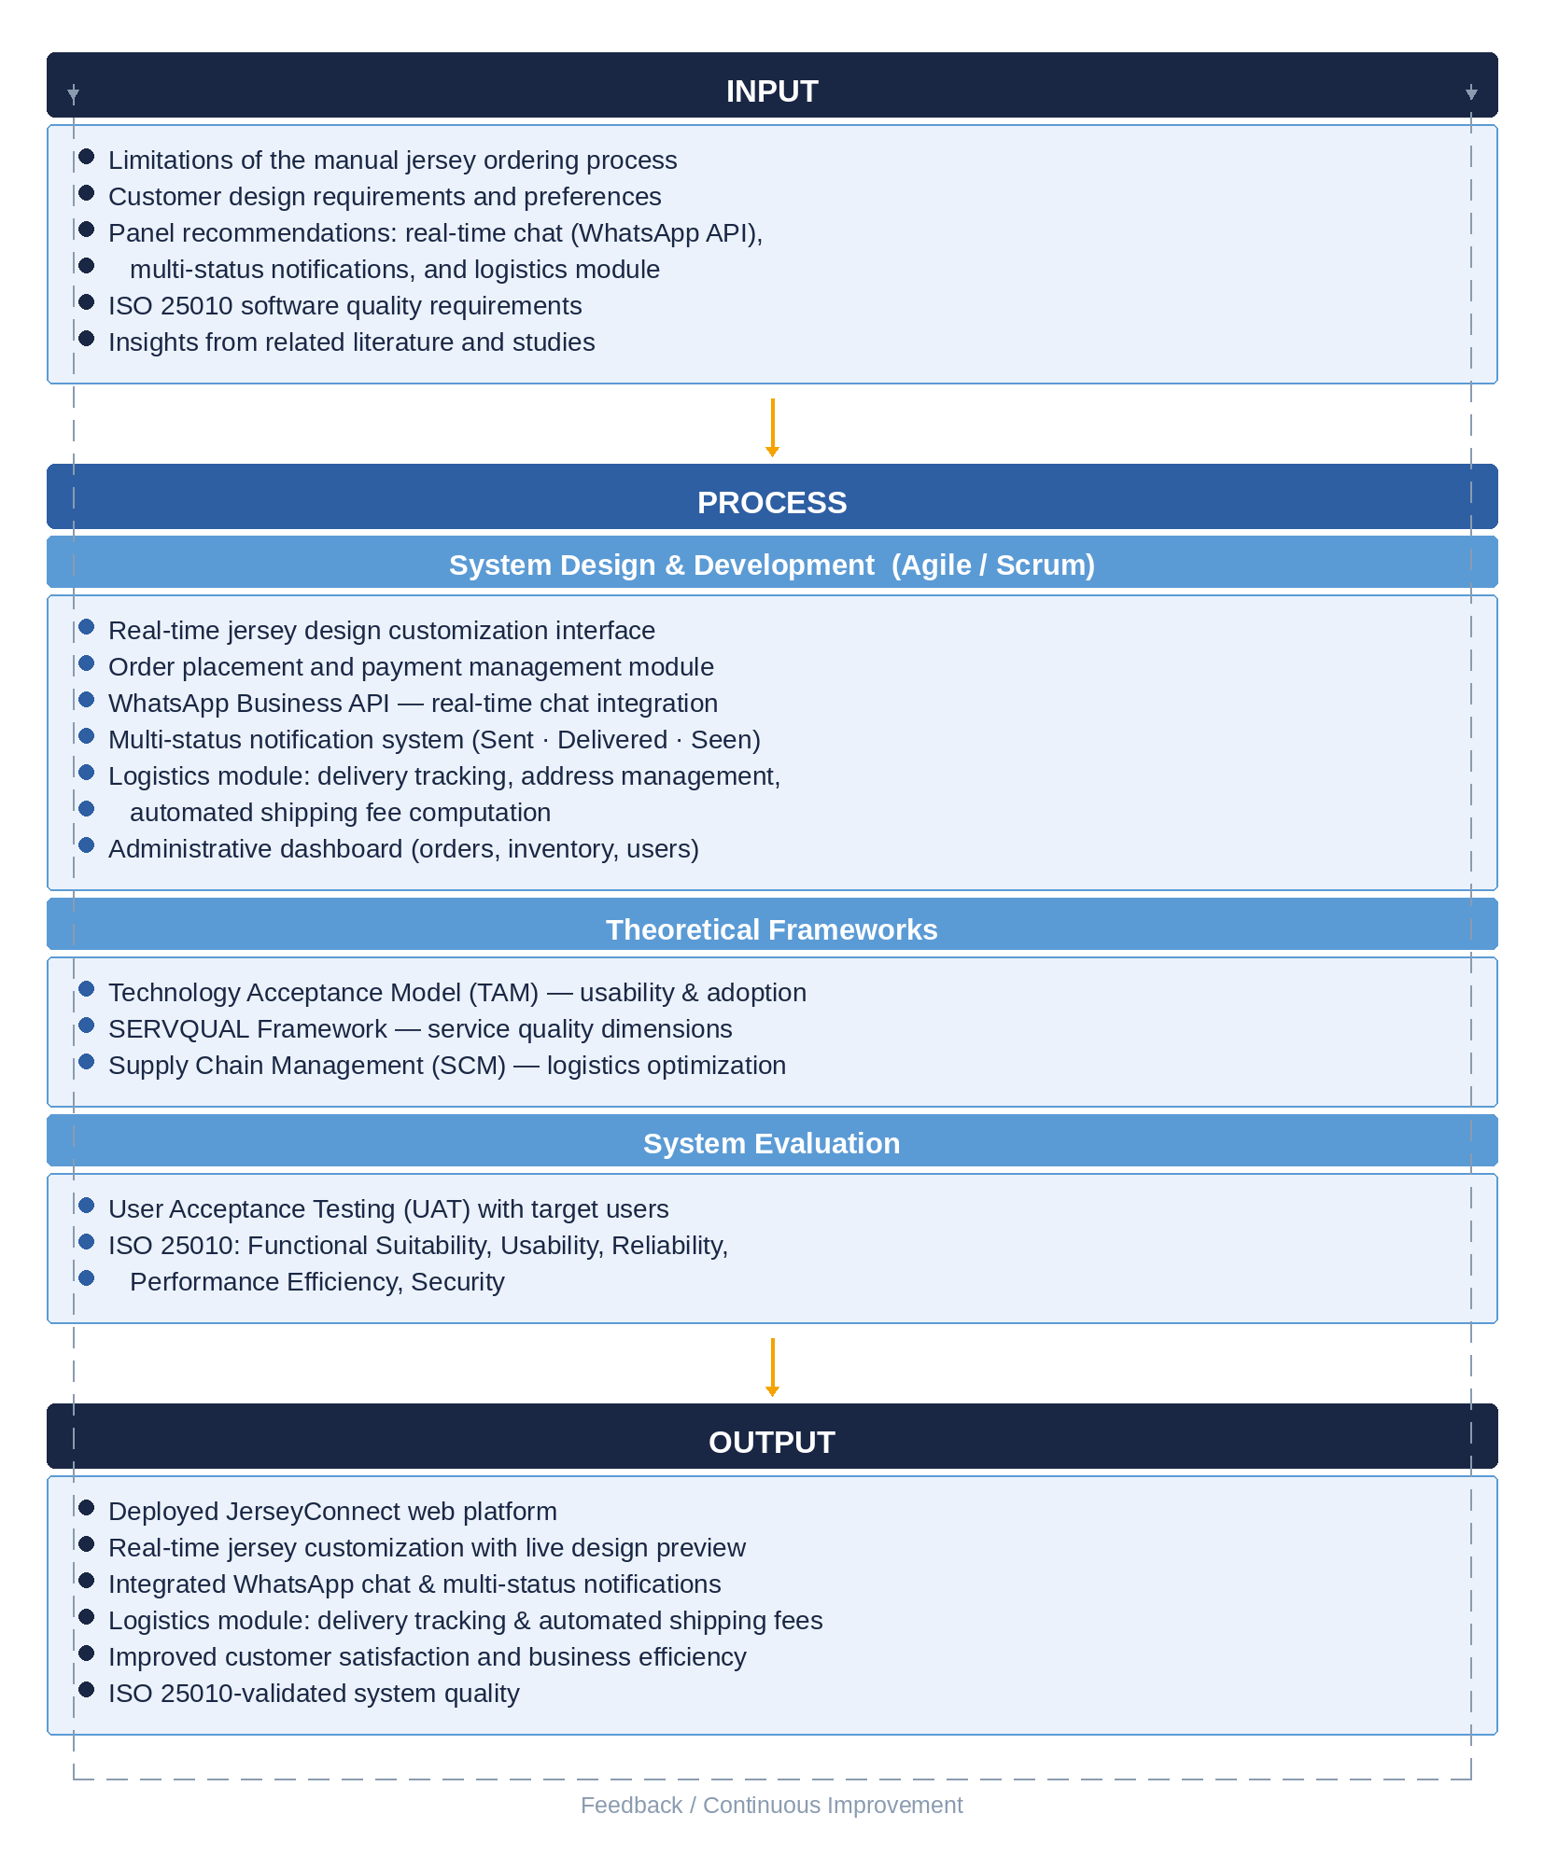

Figure 1. Conceptual Framework of JerseyConnect: An Online Platform for Jersey Booking and Design.

Figure 1 presents the conceptual framework of JerseyConnect, structured along three principal components: Input, Process, and Output. This Input-Process-Output (IPO) model illustrates how identified needs and theoretical foundations are systematically transformed into a functional web-based platform through a defined development and evaluation process.
The Input component encapsulates the foundational elements that informed the design and development of JerseyConnect. These include the identified limitations of the existing manual jersey ordering process, customer design requirements, the critical panel recommendations identified during the proposal defense—specifically the integration of a real-time chat feature via the WhatsApp Business API, the development of a multi-status notification system with sent, delivered, and seen indicators, and the inclusion of a logistics module—as well as ISO/IEC 25010 software quality requirements and insights drawn from the review of related literature and studies.
The Process component details the systematic activities undertaken to transform the identified inputs into the final system. These activities are organized into three phases: (1) System Design and Development, guided by the Agile software development methodology using the Scrum framework, which produced the core system modules including the mockup template catalog, custom specification form, and file upload subsystem, order and payment management module, WhatsApp Business API-integrated chat, multi-status notification system, logistics module with delivery tracking and automated shipping fee computation, and the administrative dashboard; (2) Application of Theoretical Frameworks, wherein the Technology Acceptance Model (TAM), the Service Quality (SERVQUAL) framework, and Supply Chain Management (SCM) theory provided the theoretical grounding for system design decisions; and (3) System Evaluation, conducted through User Acceptance Testing (UAT) using the ISO/IEC 25010 quality standard to assess the system across dimensions of functional suitability, usability, reliability, performance efficiency, and security.
The Output component represents the end products of the development and evaluation process. The primary output is the deployed JerseyConnect web platform, which delivers a form-driven jersey design configuration workflow—comprising the mockup template catalog, custom specification form, and file upload subsystem—integrated WhatsApp chat and multi-status notifications, and a fully functional logistics module encompassing delivery tracking, structured address management, and automated shipping fee computation. Secondary outputs include improved customer satisfaction and operational efficiency for the target business, and a system validated against the ISO/IEC 25010 software quality standard. A feedback loop is incorporated into the framework to signify that evaluation results and user feedback are used to drive continuous system improvement, ensuring that the platform remains responsive to evolving user needs.

Chapter 3

TECHNICAL BACKGROUND

This chapter presents the technical background that supports the development of JerseyConnect, the web-based custom jersey ordering and design-request management system proposed by the researchers. It describes the software and hardware requirements, the programming languages and development tools that were used, the database technology adopted, and the network and software architecture on which the system was built. It also discusses the security features that were incorporated into the system and, finally, presents the overall system architecture that shows how the different components work together.
3.1 Software Requirements

Since JerseyConnect is a web-based application, its technical foundation is anchored on a modern PHP stack. The system runs on PHP version 8.3 and is built using the Laravel Framework, specifically version 13.8. Laravel was chosen mainly because of its mature ecosystem, its built-in tools for authentication and security, and its convention-over-configuration structure that allows the developers to focus more on the actual business logic of the system rather than repetitive setup work. Backend dependencies are managed through Composer, while the frontend packages, including Vue and its supporting libraries, are managed through npm, as reflected by the presence of an .npmrc file in the project. A working installation of Node.js is likewise necessary to run the Vite build process, which compiles and bundles the frontend assets during development and for production. The exact Node.js version used by the researchers throughout development, v24.20.0, is indicated in Table 3.1. For the web server, either Nginx or Apache may be used once the system is deployed to a live environment, while the artisan serve command that ships with Laravel is sufficient for local development and testing. Table 3.1 summarizes these software requirements.
Table 3.1. Software Requirements

Component | Requirement
Server-side language runtime | PHP 8.3 or higher
Backend framework | Laravel Framework 13.8
Package manager (PHP) | Composer
Package manager (JavaScript) | npm
Node.js runtime | Required to run the Vite build process; Node.js v24.20.0 was used during development
Web server (production) | Nginx or Apache; php artisan serve for local development
Database server | MySQL (see Section 3.5)
Session, cache, and queue driver | Database driver, as configured in the environment file

3.2 Hardware Requirements

Unlike the software stack, hardware requirements are not something that can simply be read off from the codebase, since these largely depend on the actual machine used for development and on where the system will eventually be hosted. For this reason, the researchers document below the hardware setup that was used while building and testing JerseyConnect, as well as the minimum requirements expected on the side of the end user. The deployment target has not yet been finalized and is marked accordingly.
Table 3.2. Hardware Requirements

Item | Specification
Development machine | 13th Gen Intelº Core™ i5-1335U processor (10 cores / 12 threads, up to 4.6 GHz turbo), 8 GB RAM, 512 GB SSD storage, running Windows 11 Home (64-bit)
Deployment / server target | [TO BE FILLED IN: e.g., shared hosting plan, VPS specifications, or cloud tier]
Minimum client requirement | A device with a modern web browser (e.g., Chrome, Edge, Firefox, Safari) with JavaScript enabled, and a stable internet connection sufficient to load the Vite-bundled application and to interact with the Leaflet-based map used for selecting the delivery address

3.3 Programming Languages

Several programming languages were used in building JerseyConnect, each serving a specific layer of the system. PHP 8.3 handles the backend application logic, including the controllers, models, and middleware that make up the core of the Laravel application. TypeScript, version 5.6.3, is used on the frontend with strict mode enabled, which helps catch type-related errors early and keeps the client-side code more maintainable as the system grows. The actual user interface is built using Vue 3 single-file components, which allow markup, logic, and styling to live together in a single, organized file. Blade, Laravel's native templating engine, is used only in a limited way, mainly for the root application template, since Inertia.js takes over the rendering of the actual pages that the user interacts with. Lastly, SQL is used indirectly through Eloquent, Laravel's object-relational mapper, which generates MySQL-compliant queries for interacting with the database.

3.4 Development Tools

A number of supporting tools were used throughout the development of JerseyConnect to help streamline coding, testing, and styling. Vite, together with the laravel-vite-plugin and the Vue plugin for Vite, handles the bundling of frontend assets and provides hot module replacement during development. Styling is done through Tailwind CSS, extended with the forms plugin, using a custom theme composed of the ink, paper, panel, accent, and cobalt color palette, paired with the Inter, Bebas Neue, and IBM Plex Mono typefaces. Table 3.3 lists the rest of the development tools used and the purpose each one serves.
Table 3.3. Development Tools

Tool | Purpose
Vite, laravel-vite-plugin, @vitejs/plugin-vue | Frontend build, bundling, and hot module replacement
Tailwind CSS with @tailwindcss/forms | Utility-first styling and custom theming
vue-tsc | Type-checking for Vue single-file components
Laravel Pint | PHP code style and formatting
Composer | PHP dependency management
Pest PHP (with pest-plugin-laravel) | Automated testing, compatible with PHPUnit
fakerphp/faker | Generation of sample data for testing and seeding
Laravel Tinker | Command-line REPL for debugging and inspecting data
Ziggy | Exposes Laravel's named routes to the Vue/TypeScript frontend
composer dev script | Runs the local server, queue listener, and Vite dev server together

3.5 Database Technologies

JerseyConnect uses MySQL as its relational database management system, configured through the DB_CONNECTION and DB_DATABASE settings in the system's environment file. Data access is handled through Laravel's Eloquent ORM, which maps the system's models directly to their corresponding database tables. The database schema itself is version-controlled through thirteen migration files, which allow the structure of the database to be recreated consistently across different environments. Aside from storing the system's core data, the same MySQL database is also used to persist user sessions, cached data, and queued background jobs, rather than relying on a separate service such as Redis, keeping the overall technology stack simpler to maintain.

3.6 Network Architecture

JerseyConnect follows a client-server model that communicates over HTTP and HTTPS. On the client side, the browser runs a Vue 3 single-page application shell, while requests to the server are handled through Inertia.js rather than a traditional REST or JSON API. In practice, this means that Inertia requests return page components together with the data, or props, that those components need, instead of triggering a full page reload or a separate API call. As of this writing, the system does not expose a separate REST API for the single-page application, since Inertia already serves as the bridge between the Vue pages and the Laravel controllers. Static and user-uploaded files, such as jersey images, proof-of-payment screenshots, chat attachments, and the GCash QR code, are served from Laravel's public storage disk. A more detailed production network diagram, covering elements such as load balancing, HTTPS termination, and a possible content delivery network, will be finalized once the hosting environment for JerseyConnect has been decided. Figure 3.1 illustrates the general network setup of the system in its current form.

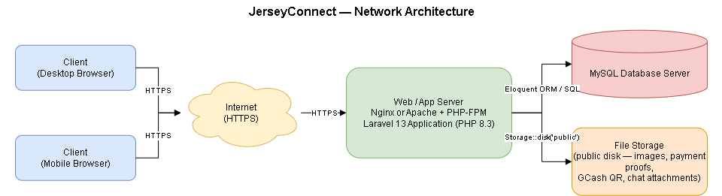
Figure 3.1. Network Architecture of JerseyConnect

3.7 Software Architecture

The system follows Laravel's standard Model-View-Controller, or MVC, pattern, but with Inertia.js taking the place of the traditional Blade view layer. Instead of returning Blade views, the controllers call Inertia::render() and pass the data fetched from the server directly as props into the corresponding Vue page component, giving the application single-page-app-like navigation without the overhead of maintaining a separate REST API. JerseyConnect is deployed as a single, monolithic application, meaning that the backend and the frontend build are shipped together rather than as separate microservices. Within the codebase itself, controllers, routes, and Vue pages are also organized by role, grouped under client, admin, and authentication namespaces, which keeps the code for each user type easy to locate and maintain as the system grows. Figure 3.2 presents this architecture in diagram form.
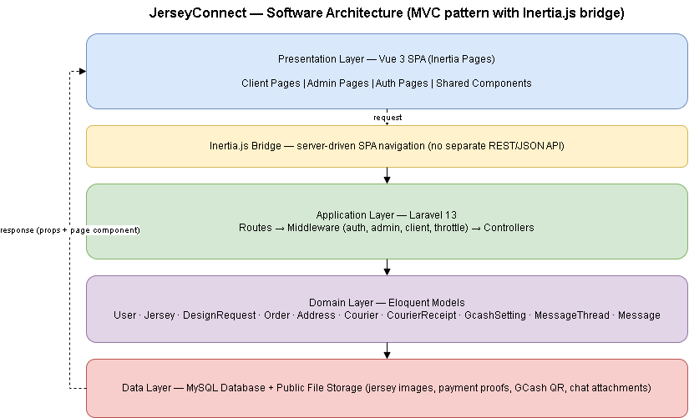

Figure 3.2. Software Architecture of JerseyConnect (Laravel MVC with Inertia.js)

3.8 Security Features

A number of security measures were built into JerseyConnect to protect user data and to keep the system's different modules properly separated. Authentication is handled through Laravel Breeze, using Laravel's built-in Auth facade for session and cookie-based login. Role-based access control is enforced through the role column in the users table, which distinguishes an admin account from a client account, and through two custom middleware classes: EnsureUserIsAdmin, which keeps non-admin users away from admin routes, and EnsureUserIsClient, which does the opposite and also prevents admin accounts from performing client-only actions. The users table also has a status column that can mark an account as active or inactive, although the exact point in the system where this is enforced still needs to be confirmed and described in detail if this control is to be reported as fully implemented. Passwords are hashed using bcrypt with a cost factor of twelve, and sensitive fields such as the password and remember token are hidden so that they never get serialized into the data sent to the browser. Laravel's default CSRF protection is applied through the standard web middleware group. Ownership of records is verified manually in the relevant controllers, such as the authorizeOwner methods found in the design request and order controllers, which return a forbidden response whenever a user tries to access a resource that does not belong to them. State-changing routes are also rate-limited, and uploaded files, such as proof-of-payment images, are validated for both file type and size before they are stored. Input validation is likewise applied throughout, including a regular expression that checks that GCash numbers follow the correct Philippine mobile number format.

3.9 System Architecture

Figure 3.3 shows the high-level architecture of JerseyConnect, illustrating how its main components interact with one another. At the topmost layer is the client browser, which runs the Vue 3 single-page application through Inertia and includes a Leaflet-based map component used for picking a delivery address. This layer communicates with the Laravel application through HTTP and HTTPS requests. Within the Laravel application, incoming requests pass through routes, then through the authentication and role-based middleware, before finally reaching the appropriate controller, which in turn interacts with the Eloquent models. From there, the system connects to two main resources: the MySQL database, where all core records are stored, and the public storage disk, which holds uploaded images such as jersey designs, proof-of-payment screenshots, chat attachments, and the GCash QR code.
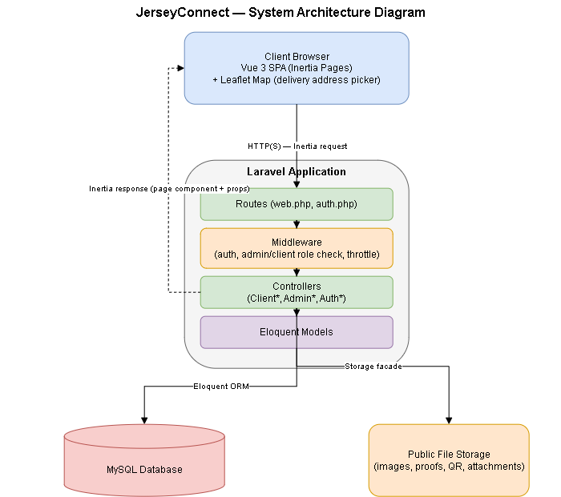

Figure 3.3. System Architecture Diagram of JerseyConnect

The system is further organized into three main modules based on user role. The client module covers jersey catalog browsing, submission and tracking of custom design requests, GCash payment together with proof-of-payment upload, order tracking, in-app messaging with the admin, and profile management. The admin module covers the sales and analytics dashboard, management of the jersey template catalog, review of design requests and approval of payments, management of order status and courier assignment, configuration of GCash account details, messaging with clients, and management of client accounts. Lastly, the authentication module, generated largely through Laravel Breeze, covers account registration, login, password reset, and email verification. Together, these modules make up the overall structure of JerseyConnect as a system intended to simplify how custom jersey orders are requested, discussed, paid for, and delivered.

REFERENCES

Chaffey, D. (2022). Digital business and e-commerce management (8th ed.). Pearson Education.

Chopra, S., & Meindl, P. (2021). Supply chain management: Strategy, planning, and operation (7th ed.). Pearson Education.

Davis, F. D. (1989). Perceived usefulness, perceived ease of use, and user acceptance of information technology. MIS Quarterly, 13(3), 319–340. https://doi.org/10.2307/249008

Dela Cruz, J. A., Santos, M. B., Reyes, C. D., & Bautista, R. M. (2023). Development and evaluation of a web-based customized apparel ordering system for a small garments business. Philippine Journal of Information
Systems, 9(1), 34–51.

Kotler, P., Keller, K. L., & Chernev, A. (2022). Marketing management (16th ed.). Pearson Education.

Laudon, K. C., & Traver, C. G. (2020). Electronic commerce: Business, technology, society (16th ed.). Pearson Education.

Macaraeg, F. B., Sison, R. C., Delos Santos, A. M., & Aquino, L. P. (2024). Development of an e-commerce platform with integrated logistics management for a regional delivery service. Asian Journal of Applied Computing, 10(2), 88–106.

Ocampo, M. G., Cabrera, R. F., Lim, J. T., & Fernandez, G. R. (2023). Development of a jersey and sports uniform ordering platform: Evaluation and recommendations. Journal of Technology and Innovation in Education, 9(3), 201–218.

Parasuraman, A., Zeithaml, V. A., & Berry, L. L. (1988). SERVQUAL: A multiple-item scale for measuring consumer perceptions of service quality. Journal of Retailing, 64(1), 12–40.

Ramirez, J. P., Flores, D. A., Castillo, K. M., & Navarro, B. S. (2023). WhatsApp Business API integration in web-based ordering platforms for SMEs: Impact on response time and customer satisfaction. Philippine Computing Journal, 18(1), 34–51.

Turban, E., Whiteside, J., King, D., & Outland, J. (2017). Electronic commerce: A managerial and social networks perspective (9th ed.). Springer.

Villafuerte, C. D., Andres, M. B., Samson, R. T., & Cruz, M. P. (2022). Logistics and delivery management system for a multi-province courier company: Automated fee computation and real-time tracking. Philippine Journal of Information and Communication Technology, 4(3), 67–84.
CURRICULUM VITAE

CHRISTY MAE R. GURREA
Purok 5, San Jose, Talibon, Bohol
6325 Philippines
Cellphone Number: 0953 347 8843
Email Address: christymaegurrea14@gmail.com

Personal Data:
Age: 21
Birthdate: November 17, 2004
Civil Status: Single
Religion: Roman Catholic
Father’s Name: Alejandro Auxtero Gurrea
Mother’s Name: Ma. Belen Cajes Gurrea
Educational Attainment:
Tertiary: Bachelor of Science in Information System
Talibon Polytechnic College
San Isidro, Talibon, Bohol
Secondary: San Jose National High School
San Jose, Talibon, Bohol
Elementary: Alejandro P. Gurrea Elementary School
San Jose, Talibon, Bohol



ANAMARIE P. BOYLES
Purok 1, Catoogan, Trinidad, Bohol
6011 Philippines
Cellphone Number: 0953 495 1018
Email Address: anamarieboyles282@gmail.com

Personal Data:
Age: 26
Birthdate: November 6, 1999
Civil Status: Single
Religion: Roman Catholic
Father’s Name: Aurelio Dilao Boyles
Mother’s Name: Hicolita Evangelista Boyles

Educational Attainment:
Tertiary: Bachelor of Science in Information System
Talibon Polytechnic College
San Isidro, Talibon, Bohol
Secondary: Tagum Sur National High School
Tagum Sur, Trinidad, Bohol
Elementary: Tagum Sur Elementary School
Tagum Sur, Trinidad, Bohol



JUSTINE S. PUNAY
Purok 5, San Isidro, Talibon, Bohol
6326 Philippines
Cellphone Number: 0992 733 5613
Email Address: justinespunay@gmail.com

Personal Data:
Age: 20
Birthdate: July 16, 2005
Civil Status: Single
Religion: Roman Catholic
Father’s Name: Junrey Moralde Punay
Mother’s Name: Virginia Sabalones Punay
Educational Attainment:
Tertiary: Bachelor of Science in Information System
Talibon Polytechnic College
San Isidro, Talibon, Bohol
Secondary: Cansojong National High School
Cansojong, Talisay City, Cebu
Elementary: Hingotanan Elementary School
Hingotanan, Bien Unido, Bohol

