#include <iostream>

using namespace std;

int main()

{

/\*Using print statements\*/cout << "Print first " << endl;

cout << "Print second " << endl;

/\*Using println statements\*/cout << "Print third" << endl;

cout <<"Print fourth" << endl;

cout<< "Print fifth" << endl;/\*Get the color and display it\*/

cout << "What is your favorite color?" << endl;/\*Get the num of apples and display\*/

cout << "How many apples do you have?" << endl;

}

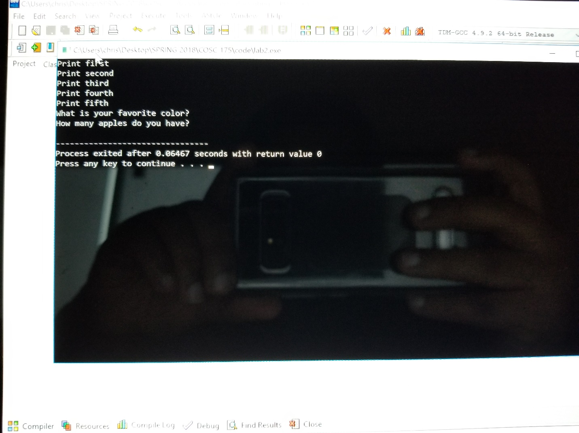

2)

Output: how many apples do you have?

Output: what is your favorite color?

Output: print fifth

Output: print fourth

Output: print third

Output: print second

1

1

Output: print first

3) Having a readable and clear code is important for the coder and other people working on his/her code. When you code a program you’re not the only person working on it, you have coworkers that are working on the program too. And since most programs like the apps on our phones have more than 1000 line its better to making the code clear, with comments to show what you did in some parts of the code and better spacing between lines of code, which will help your coworker or anyone else looking at your code to better understand what you wrote.