Java Socket Communication

Socket Communications in Java
- A socket is a bi-directional communication channel. It’s the most fundamental means of client-server communications across the network.
- There are two types of sockets: Stream sockets (connection oriented) and Datagram sockets (connectionless).
- Socket operations at the client side are different from those at the server side.

Stream Type Sockets

Socket Operations at Server Side
A server is always waiting for being connected. It need not initiate a connection to a host. So a server socket need only specify its own port number.
- create a server socket:
ServerSocket (port)
ServerSocket s = new ServerSocket(8189);
- accept an incoming connection:
Socket snew = s.accept ();

Socket Operations at Client Side
A client needs to specify the host address and the port number of the server process.
- create a client socket:
Socket (host, port)
s = new Socket (“java.sun.com”, 8189)

Close a Socket
s.close();

Read / Write through a Socket

- get I/O data streams out of the socket s:
InputStream ins = s.getInputStream ();
OutputStream outs = s.getOutputStream();
Notice: “ins” and “outs” are of the same type as “System.in” and “System.out”

- get I/O reader and writer
BufferedReader in = new BufferedReader(new inputStreamReader(ins));
PrintWriter out = new PrintWriter(outs, true); // “true” makes socket flush

- read / write to I/O reader or writer:
String str = in.readLine();
out.println ( “Echo:” + str + “\r”);
An example of client connecting to a “time of a day” service:
- “time of a day” server sends back the time when it receives a connection request. So client need not write to the socket to ask for information.
class ClientSocket {
public static void main(String[] args ) {
try {
Socket s = new Socket("cs.ust.hk", 13);
BufferedReader in;
in = new BufferedReader(new InputStreamReader(s.getInputStream()));
while ((str = in.readLine()) != null)
System.out.println(str);
} catch (Exception e) { System.out.println(e);}
}
}
Example of a server
class EchoSvr {
public static void main(String[] args ) {
String rdata;
try {
ServerSocket s = new ServerSocket(8999);
Socket con = s.accept();

BufferedReader in;
in = new BufferedReader(new InputStreamReader(con.getInputStream()));
PrintWriter out = new PrintWriter(con.getOutputStream(), true);

while ((rdata = in.readLine())!= null) {
System.out.println(rdata);
out.println(rdata);
}
} catch (Exception e) { System.out.println(e);}
}

Multi-thread Server Implementations

- The server waits all the time for client connections at the server socket by accept().
- Each time when a connection accepted, the server spawns a new thread to handle the incoming connection, and itself is back waiting for new connections.
While (true) {
Socket incoming = s.accept( );
new HandlerThread(incoming).start();
}
- A thread dies after serving a client’s connection.

Implement the Echo server as multi-threaded:

// full code in ~jia/java/net/ThreadEchoSvr.java
class HandlerThread extends Thread
{ Socket incoming; int cnt;
HandlerThread(Socket s, int c)
{ incoming = s; cnt = c; }
public void run() {
try {
BufferedReader in;
in = new BufferedReader(new InputStreamReader(
incoming.getInputStream()));
PrintWriter out = new
PrintWriter(incoming.getOutputStream());
String str;
while ((str = in.readLine()) != null) {
out.println("Echo (" + counter + "): " + str + "\r");
if (str.equals("Bye.")) break;
}
incoming.close();
} catch (Exception e) { System.out.println(e); } }
}
For testing the threaded echo server, you can run:
ss4e > java ThreadedEchoServer
slx1> telnet ss4e.cs.cityu.edu.hk 8189
slx2> telnet ss4e.cs.cityu.edu.hk 8189

class ThreadEchoSvr
{ public static void main(String[] args )
{ int i = 1;
try
{ ServerSocket s = new ServerSocket(8189);

for (;;) // remember the format of multi-thread!!
{ Socket incoming = s.accept( );
new HanderThread(incoming, i).start();
i++;
}
} catch (Exception e) { System.out.println(e); }}
}
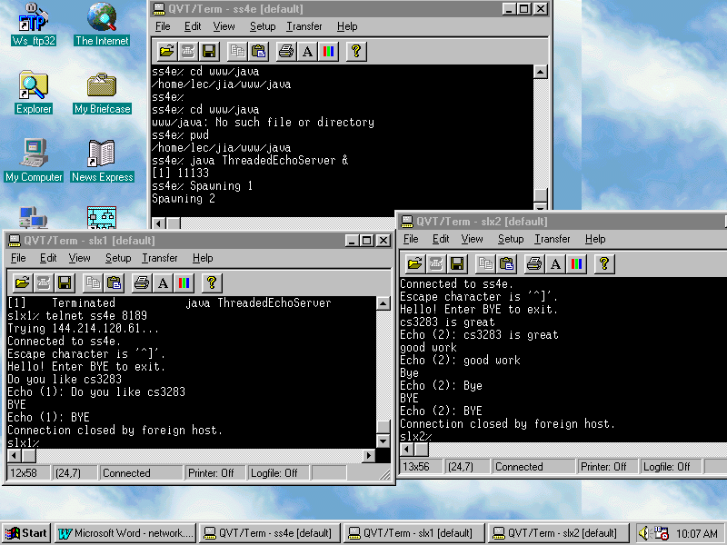
Applet Communicates with Server using Sockets

- For security reasons, applets can only make socket connections back to its home web server site.
- You need to run the server at the web-server site in advance.
- The communication between the applet and the server bypasses the HTTP server. It is often used for the web applications that require both servers and clients interactions.

// ~java/net/AppletSocket.java
public class AppletSocket extends Applet {
public void init() {
try {
Socket s = new Socket("sus12.cs.cityu.edu.hk",
11113);
in = new BufferedReader(new
InputStreamReader(s.getInputStream()));
out = new PrintWriter(s.getOutputStream(), true);
........
out.println("This is a test "+y);
rdata = in.readLine();
.........
} catch (Exception e) { System.out.println(e);}
}
…………

Datagram Sockets

Java Datagram sockets are connectionless. The underlying protocol is usually UDP. The central concept of datagram sockets is “DatagramPacket”.

Datagram Packets
A DatagramPacket object contains four parts:
- Sender’s InetAddress and port_no
- Receiver’s InetAddress and port_no
- byte [] data
- int data_size

InetAddress object (defined in java.net.InetAddress)
It contains two fileds: hostname (a string), which is the name of the host, e.g., “sus1.cs.cityu.edu.hk” and address (an int), which is a 32-bit IP address. You may
create an InetAddress object by method:

InetAddress InetAddress.getbyName(String hostname)

e.g.,
InetAddress
addr = InetAddress.getByName(“ue3k1.cs.cityu.edu.hk”)

Construct a DatagramPacket to be sent

Construct a DatagramPacket to be sent
DatagramPacket(byte buffer[], int len, InetAddress dest_ia, int dest_port)
e.g.,
String s = "This is a test of UDP Datagram sockets.";
byte [] data = new byte[s.length()];
data = s.getBytes(); // convert a string to an array of bytes to fit in a packet
try {
InetAddress addr = InetAddress.getByName("ue3k1.cs.cityu.edu.hk");
} catch (UnknowHostException e) { System.out.println(e);}
int port = 33333;
DatagramPacket outp = new DatagramPacket(data, data.length, addr, port);

Notice: The maximal size of a datagram packet is 64K (including UDP & IP headers). But, choosing packetsize of 8K is a good compromise.

Process a Received DatagramPacket

Construct a DatagramPacket for receiving a packet
DatagramPacket(byte buffer[], int len)

Get information from a DatagramPacket
Since a DatagramPacket contains both data and address information, the following four methods are used on a DatagramPacket object:
public InetAddress getAddress()
it returns the remote host’s Internet address. If the datagram was received from the Internet, it returns the sender’s host address. If it was locally constructed and about to be sent, it returns destination’s host address.
public int getPort()
it returns the port number of the remote address of a datagram, similar to “getAddress()”.
public int getLength()
it returns the number of bytes of the data in the datagram (not include any headers).
public byte[] getData()
it returns a byte array in the datagram. The number of bytes in the array should equal to the value returned from “getLength()”.

Example of processing a datagram packet

…………..
DatagramPacket inp = new DatagramPacket(data, 512);
ds.receive(inp); // receive a packet from socket ds
System.out.println(inp.getAddress());
System.out.println(inp.getPort());
System.out.println(inp.getLength());
System.out.println (new String(inp.getData()));
………………

You often need the following methods to convert a byte array into a string:
public String String(byte[] array) // convert a whole array
public String String(byte[] array, int offset, int n)

Datagram Sockets
Since the addresses are already embedded in datagrams, a socket of Datagram type is simply an input/output port for sending/receiving datagrams.

Construct a socket at Server side
public DatagramSocket(int port)
The port number will be referenced by potential senders that send datagrams to this socket.

Construct a socket at Client side
public DatagramSocket()
There is no need to specify a port number. The sender does not care about its own port number and the receiver’s addr & port number is already embedded in the datagram packet.

Send / Receive DatagramPackets
public void send(DatagramPacket dp)
public void receive(DatagramPacket dp)

Example of Datagram Sockets (client)
// ClntUDPSocket.java
class ClntUDPSocket {
public static void main(String[] args ) {
String s = "This is a test of UDP Datagram sockets.";
byte [] data = new byte[s.length()];
data = s.getBytes();
try {
InetAddress addr = InetAddress.getByName("sus12.cs.cityu.edu.hk");
int port = 33333;
DatagramPacket outp = new DatagramPacket(data, data.length, addr, port);
DatagramPacket inp = new DatagramPacket(new byte[512], 512);
DatagramSocket ds = new DatagramSocket();
ds.send(outp);
ds.receive(inp);
System.out.println(new String(inp.getData()));
} catch (Exception e) { System.out.println(e);}}}
Example of Datagram Sockets (server)

// SvrUDPSocket.java
class SvrUDPSocket {
public static void main(String[] args ) {
byte [] data = new byte[512];
try {
int port = 33333;
DatagramSocket ds = new DatagramSocket(port);
DatagramPacket inp = new DatagramPacket(data, 512);
ds.receive(inp);
DatagramPacket outp = new DatagramPacket(inp.getData(),
inp.getLength(), inp.getAddress(), inp.getPort());
ds.send(outp);
} catch (Exception e) { System.out.println(e);}}}

