Chris White
CSCI 412
assignment 3 writeup
11/1/18
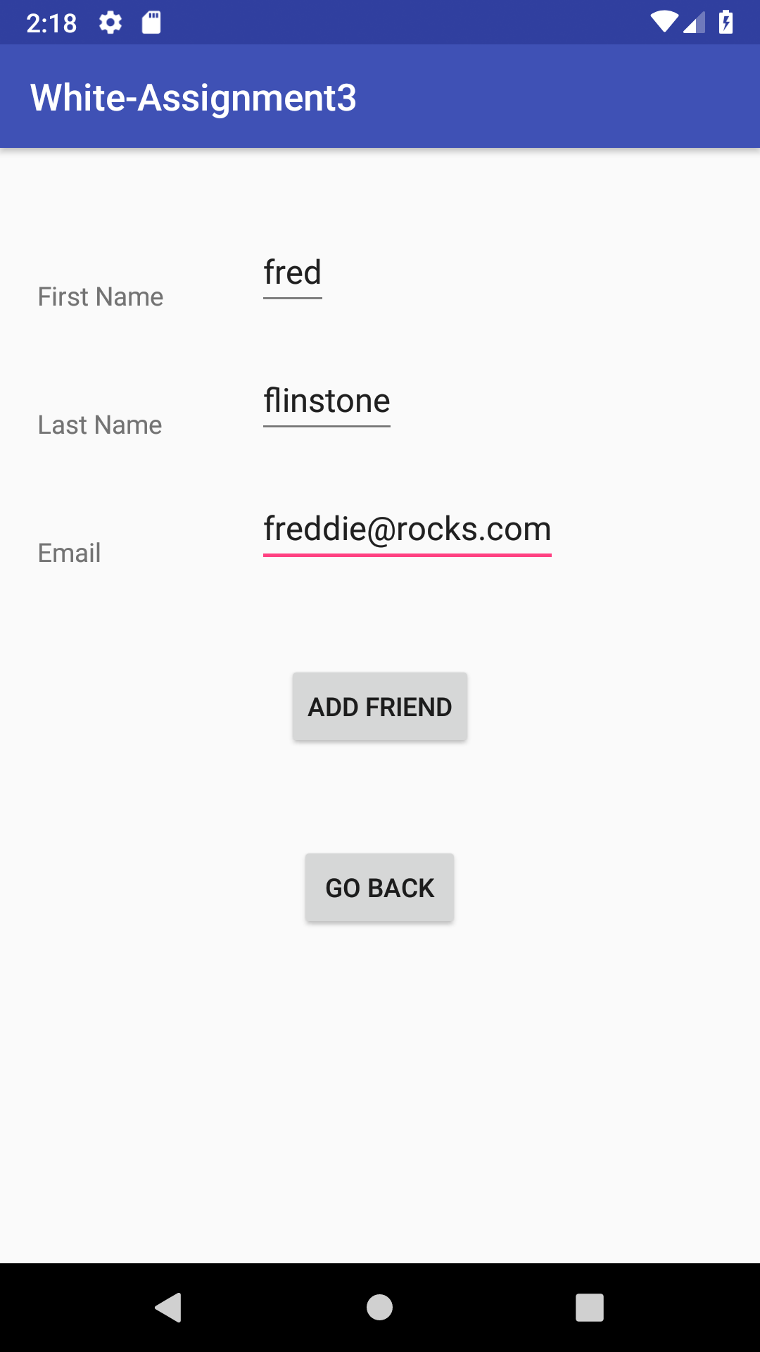
This is the add friend screen you type in there first name, last name and email and then click “ADD FRIEND” to add them to the database.

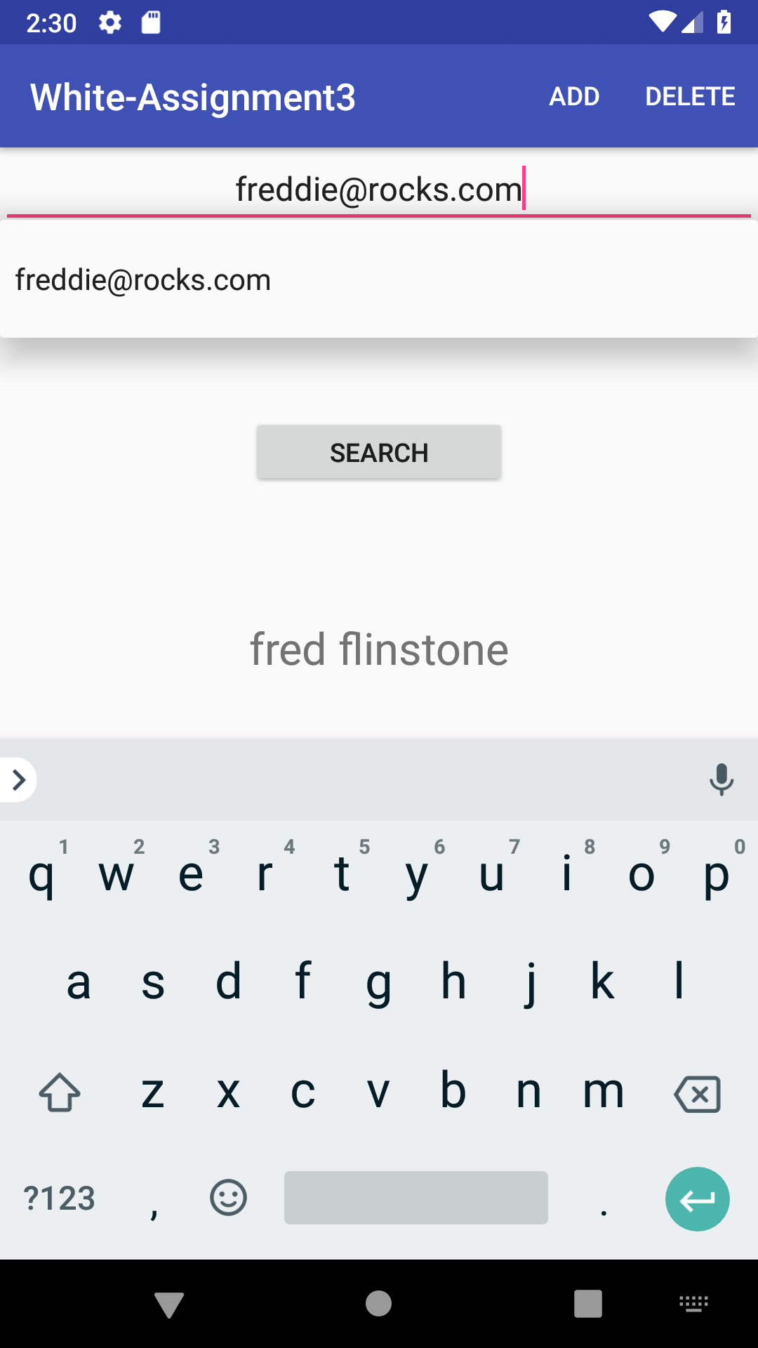
This is the search friends screen and also the MainActivity. You can search your friends by email using the auto complete feature, hit search and their first and last name will be displayed below.

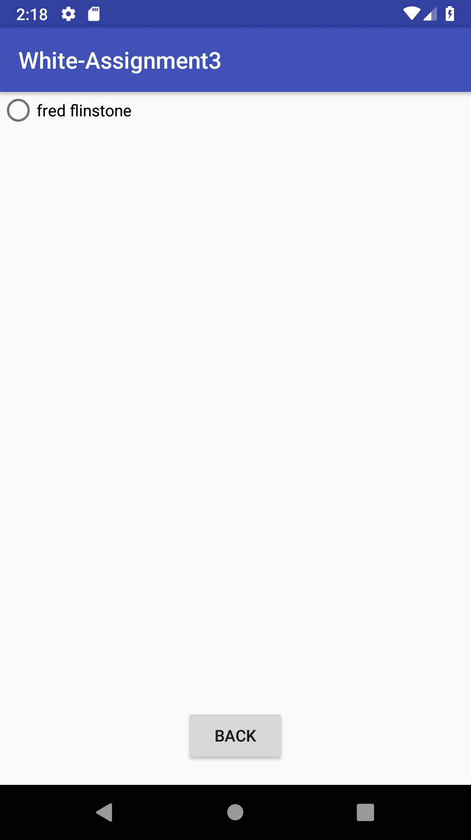

This is the delete friend page all you have to do is select their radio group button and they instantly get deleted. You can press the “BACK” button to go back to the MainActivity.

This Assignment took me approximately 7.5 hours

I thought this assignment was appropriately difficult by that is mostly because I had a lot of help from the slides I thought it was defiantly easier then assignment 2 (which I thought was really hard).

The only thing that isn’t working is if you have two friends with the same email then the second friends name wouldn’t appear on the main activity but, this shouldn’t be an issue because an email is appose to be a unique identifier.

My biggest problem was getting the search bar to suggest friends.

I expect to get full points on this assignment.

