**Phase H: Initial Implantation**

**Group Report**

**GROUP: W**

***Grading Rubric***

|  |  |  |  |
| --- | --- | --- | --- |
| **Item** | **Possible Points** | **Comments** | **Score** |
| Implementation | 8 | Can rotate a building off the grid! It’s also possible to place a building on another. However, there are a number of things that are blocked, and overall there is some good work here. | 8 |
| Report | 5 | Build directions work, but there were some vague areas and specified the wrong file to run.  I do think the report could have been a bit more explicit. | 4 |
| Group work: time logging, meetings | 2 |  | 2 |
| Total | 15 |  | 14 |

|  |  |  |  |
| --- | --- | --- | --- |
| **Meeting** | **Date** | | **Present & Contributing** |
| Initial discussion | 4/23/2012 | | Chris Wald, Dillon Hiatt, Zach Gerner ,Harry Schultz |
| Final Review | 4/25/2012 | | Chris Wald, Dillon Hiatt, Zach Gerner ,Harry Schultz |
| **Team Member** | **Hours** | **Implemented portions** | |
| Dillon Hiatt | 2hrs 50mins | Grid on SnapProto | |
| Chris Wald | 3:05 | SplashScreen (and 1 line in SnapProto to run SplashScreen) | |
| Zach Gerner |  |  | |
| Harry Schultz | 3:30 |  | |

***Initial Implementation:***

We plan to implement the splash screen, placing of the buildings, and the GUI. The splash screen will occur on the startup phase. The placing of the building will occur when the user and the computer player place their buildings on the game board grid. The GUI is the game board itself, which will be a 10x10 grid.

We got the placing of the buildings on the grid and the splash screen implemented. The user will click on a radio button to select the building that will be place on the grid. The buildings can rotate vertically as well horizontally. If the user wants to change the location of a building on the grid, the user can remove the building and then relocate it. After all of the buildings are place on the grid, the user will press the continue button and the placement form will close. The splash screen is an extended Jframe that will appear for about 5 seconds before the building placement form will appear on the startup of the game.

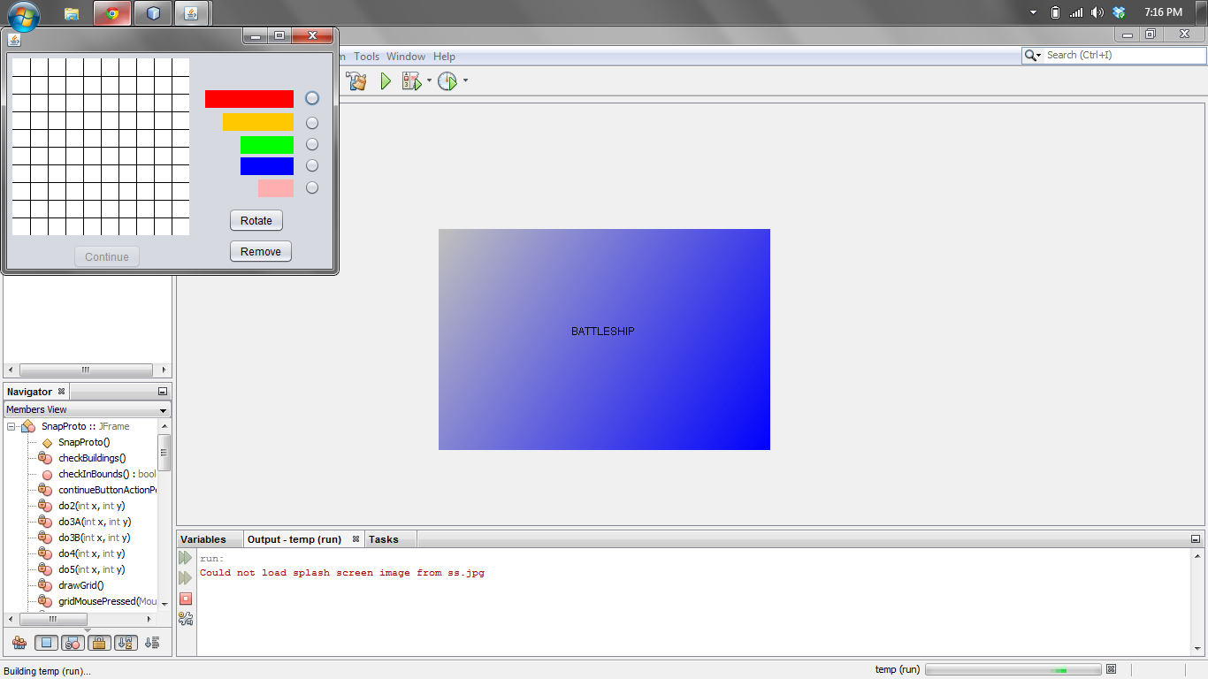The user can build the program by navigating to the folder where the project is located and use the javac*.java command and then type java Snap

