# Phase E: User Interface Prototype

### Group Report

### GROUP: W

#### Grading Rubric

|  |  |  |  |
| --- | --- | --- | --- |
| **Item** | **Possible Points** | **Comments** | **Score** |
| Prototype | 10 |  |  |
| Report | 3 |  |  |
| Group work: time logging, meetings | 2 |  |  |
| Total | 15 |  | 0 |

|  |  |  |
| --- | --- | --- |
| **Meeting** | **Date** | **Present & Contributing** |
| Initial discussion | 3/15/2012 | Zach, Chris, Dillon |
| Final Review | 3/27/2012 | Zach, Dillon, Harry |
| **Team Member** | **Hours** | **Explanation, if necessary** |
| Zach Gerner | 2:30 hours |  |
| Dillon Hiatt | 2:30 hours |  |
| Harry Schultz | 1:00 hours |  |
| Chris Wald | 2:30 hours |  |

#### Prototype Report:

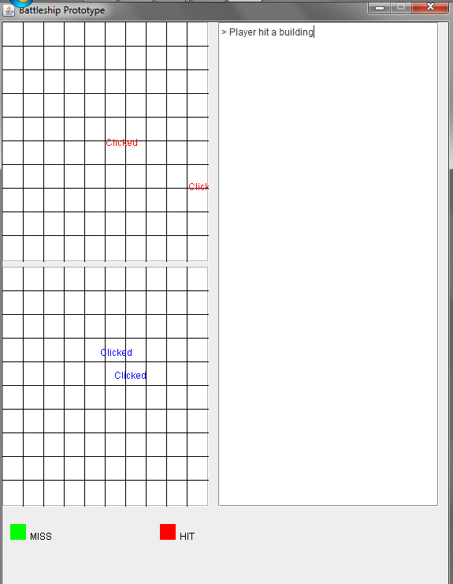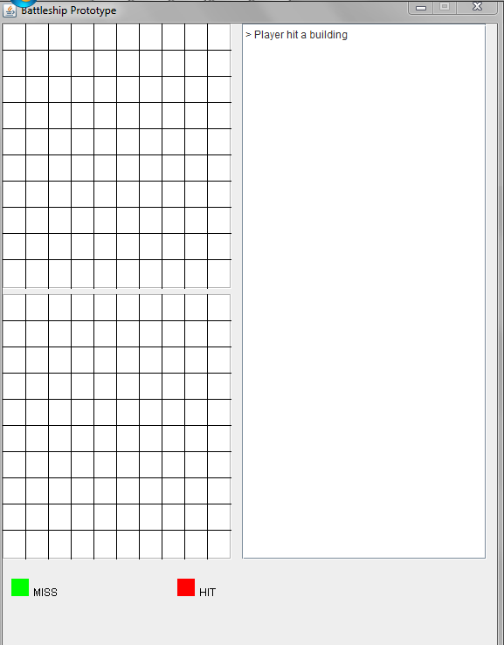

We prototyped the main GUI that will be used to play our game. This window will be used to place buildings as well as guessing their locations. The top grid displays were the player has guessed. The bottom grid is used to mark were the players buildings are buried. The text box on the right will log the recent actions that have occurred in the game. In conclusion, we have decided that we will need to create two more prototypes to test our building placement system and the computer player system.