Final Project Report: AI-Powered Personal Study Assistant
Course: CPSC 8740 Author: Chris Williams

Application online at: https://studyai-frontend-9zny.onrender.com/

Project code available at: https://github.com/chriswil/cpsc8740-final/

1. Project Overview and Plan
The AI-Powered Personal Study Assistant is a full-stack web application that transforms how students learn from complex materials. The platform combines intelligent document processing with evidence-based learning techniques to create a comprehensive study environment.

Core Capabilities
- Document Processing: Upload and parse PDFs, PowerPoints, and Word documents with automatic text extraction
- AI-Generated Study Aids: Automatically create flashcards and quizzes from uploaded content
- Conversational Q&A: Chat with an AI assistant grounded in the user’s specific documents
- Spaced Repetition: SM-2 algorithm implementation for optimized long-term retention
- Progress Analytics: Dashboard tracking study streaks, time spent, and review schedules

Technical Stack
Layer | Technologies
Frontend | React 18, Vite, Tailwind CSS, Recharts
Backend | FastAPI, SQLAlchemy, PostgreSQL
AI | Anthropic Claude Haiku 4.5, Ollama (local alternative)
Deployment | Docker, Render.com, Nginx

The project followed an Agile methodology over 8 weeks, with iterative delivery across defined phases.

Development Timeline
Phase | Week | Focus
MVP & Foundation | 1–2 (Oct 6–19) | Backend/frontend scaffolding, document upload
AI Study Tools | 3–4 (Oct 20–Nov 2) | Claude integration, flashcard/quiz generation
Interactive Features | 5 (Nov 3–9) | Chat interface, search, auto-categorization
Progress Tracking | 6 (Nov 10–16) | Analytics API, dashboard visualizations
Spaced Repetition | 6 (Nov 10–16) | SM-2 algorithm, review mode
Deployment | 7 (Nov 17–23) | Docker containerization, Render.com hosting
Testing & Documentation | 8 (Nov 24–30) | Usability testing, WCAG audit, final report

Development Practices
- Version Control: Git with feature branches and pull requests
- API-First Design: OpenAPI/Swagger documentation auto-generated by FastAPI
- Iterative UI Development: Component-based React architecture enabling incremental feature delivery

Data Collection and Preprocessing
This application does not train custom models; instead, it processes user-uploaded documents for AI consumption.

Document Parsing Pipeline
Upload → Format Detection → Text Extraction → Chunking → AI Processing
Format | Library | Extraction Method
PDF | PyPDF2 | Page-by-page text extraction
PPTX | python-pptx | Slide text and notes extraction
DOCX | python-docx | Paragraph and table text extraction

2. AI Tool Setup

Development Environment
The development environment was built around PyCharm as the primary IDE, providing integrated terminal access, Git version control, and Python virtual environment management. Google's Gemini (Antigravity AI) assisted with code generation, debugging, and the WCAG accessibility audit. Docker containers were used to ensure consistency between development and production: separate Dockerfiles for frontend (Nginx-served React build) and backend (uvicorn-served FastAPI), orchestrated locally via `docker-compose.yml`. SQLite serves as the development database, with PostgreSQL configured for production deployment on Render.com.

Model Selection
For processing incoming data in uploaded documents, this project leverages large language models via API with carefully engineered prompts.
Primary Model: Anthropic Claude Haiku 4.5. Initially prototyped with OpenAI GPT-3.5 but migrated to Haiku 4.5 due to more reliable structured JSON output, better instruction-following for complex generation tasks, and improved cost efficiency at expected usage volumes.
Alternative: Ollama with Llama 3 for privacy-focused, offline-capable deployment. This is configurable via environment file.

AI-Powered Features
Feature | Prompt Strategy | Output Format
Flashcard Generation | Extract key concepts; format as Q&A pairs | JSON array of {front, back} objects
Quiz Generation | Create multiple-choice questions with explanations | JSON with questions, options, correct answers
Conversational Q&A | Document-grounded chat with source citations | Natural language with reference markers
Auto-Categorization | Classify document by academic subject | Single category label

Challenges
Challenge | Solution
Inconsistent JSON formatting | Added explicit format instructions; implemented response cleaning function to strip markdown wrappers
Hallucinated content in Q&A | Grounded responses by including document text in context; instructed model to cite sources
Variable flashcard quality | Refined prompts to specify “one concept per card” and “testable knowledge” criteria

3. User Interface Design and Integration

Design Principles
- Minimal Cognitive Load: Students process complex material; the interface stays out of the way
- Progressive Disclosure: Core features visible immediately; advanced options revealed contextually
- Immediate Feedback: Every action provides clear status indication

Key Components
Component | Purpose | Key Interactions
Document Library | Central hub for uploaded materials | Upload, search, filter, delete
Flashcard Viewer | Card-based review interface | Flip animation, SM-2 rating buttons
Quiz Interface | Multiple-choice assessment | Answer selection, immediate feedback
Chat Window | Document-grounded Q&A | Message history, source citations
Dashboard | Progress analytics | Streak display, time charts, due reviews
Document Library is the central hub for uploaded materials. File upload, search for document titles in the user library, filtering, and deletion of uploaded documents are accomplished in this component.
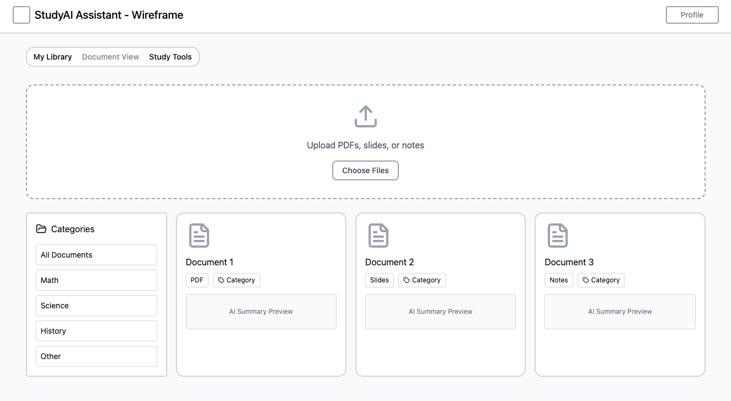
Figure 1: Document Library – wireframe generated with Figma

The Dashboard contains progress analytics and infographics regarding the current state of study, including streak display (number of sequential days studied, time chart for time spent, etc.)

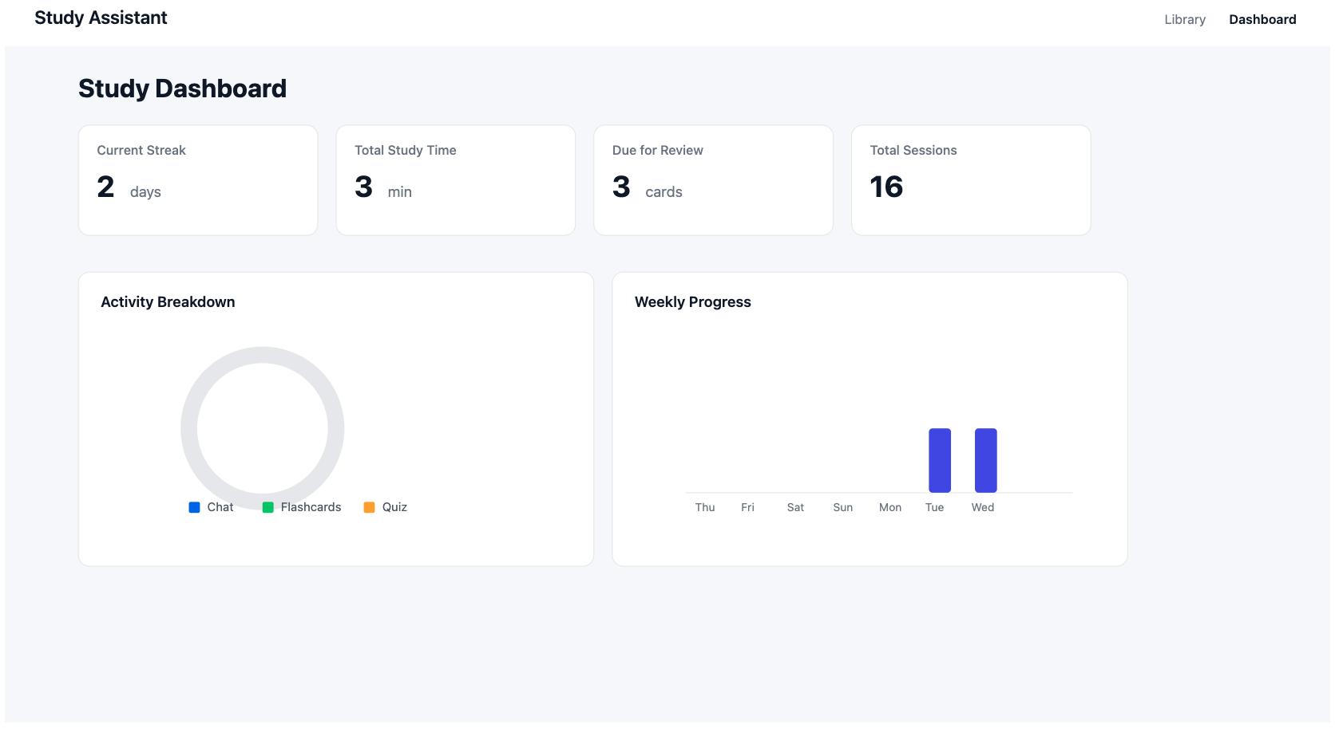
Figure 2: Dashboard – wireframe generated with Claude Opus 4.5

4. Testing and Refinement

Testing Methodology
Usability Testing - 5 participants - Task-based evaluation – 15-20 minutes per session
Accessibility Audit - Standard: WCAG 2.1 Level AA performed by Claude Opus 4.5 - Scope: All 7 primary frontend components. Overall WCAG Compliance after testing and refinement was ~92%.

Key Findings and Fixes
Issue Source | Finding | Fix Implemented
Usability | Generation status unclear | Spinner + disabled state during AI processing
Usability | Flashcard count not configurable | Added dropdown selector (5, 10, 15 cards)
Accessibility | Upload Zone keyboard-inaccessible | Added role="button", tabIndex, onKeyDown handler
Accessibility | Missing focus indicators | Added focus:ring-2 to all interactive elements
Accessibility | Icon-only buttons unlabeled | Added descriptive aria-label attributes
Accessibility | Color-only quiz feedback | Added ✓/✗ icons alongside color indicators
Remaining Issues - Focus trap in modals was attempted using focus-trap-react but caused breaking behavior and was reverted. Medium-priority WCAG fixes (aria-live regions, skip-to-content link) were completed.

5. Conclusions
The AI-Powered Personal Study Assistant successfully demonstrates the integration of large language models into an educational technology application. Key accomplishments include:
- Functional full-stack application with document processing, AI-generated study aids, and spaced repetition
- Production deployment on Render.com with Docker containerization
- 92% WCAG 2.1 Level AA compliance following accessibility audit and remediation
- Iterative development with user feedback integration

Technical Insights
- LLM selection matters: Migrating from OpenAI to Anthropic significantly improved structured output reliability
- Async architecture is essential: FastAPI’s async support prevented blocking during AI response generation
- Accessibility requires early investment: Retrofitting ARIA labels and keyboard support proved more time-consuming than building them in initially

Limitations
- No user authentication (single-user mode only)
- Limited mobile responsiveness
- No OCR for scanned/image-based documents
- Incomplete focus management in modal dialogs

6. Future Work

Short-Term Improvements
- Complete remaining WCAG medium-priority fixes (aria-live regions, skip-to-content link)
- Resolve modal focus trap implementation
- Add data table alternatives for dashboard charts

Feature Enhancements
- User authentication and multi-user support
- OCR integration for scanned documents

Scalability Considerations
- Performance monitoring integration (New Relic/Datadog)
- Caching layer for repeated AI queries
- Load balancing for concurrent users

Research Directions
- A/B testing of different spaced repetition algorithms
- Adaptive quiz difficulty based on user performance
- Learning analytics to identify struggling concepts

