# intro

Install git lfs – I had to request for install on this computer others may have it, contact Jack (John Coughlin <amathsys@uw.edu>) if needed on other linux box

Git lfs will be useful for the new high res gif (>100mb) upload & will not impact pulling the original main branch down

Amath intranet

<https://depts.washington.edu/amath/private/computing/computing/>

Any linux computer can run this with some python3 env config

I used Cubano bc it had good RAM & CPU is better than my laptop i7 maybe… actually I have no idea why it runs better than my development laptop but it saves my fan from pegging & some node + numerics combo came to a halt on a relatively new mac intel chip.

Some of the lab computers are more popular than others by looking at resource plot

Cubano now also has git lfs installed thanks to Jack at Amath sys admin, the other lab boxes may not yet

Terminal:

ssh <uwnetid>@<server>.amath.washington.edu

eg:

ssh mikewill@cubano.amath.washington.edu

mikewill@cubano.amath.washington.edu's password: *

88

88

88

,adPPYba, 88 88 88,dPPYba, ,adPPYYba, 8b,dPPYba, ,adPPYba,

a8" "" 88 88 88P' "8a "" `Y8 88P' `"8a a8" "8a

8b 88 88 88 d8 ,adPPPPP88 88 88 8b d8

"8a, ,aa "8a, ,a88 88b, ,a8" 88, ,88 88 88 "8a, ,a8"

`"Ybbd8"' `"YbbdP'Y8 8Y"Ybbd8"' `"8bbdP"Y8 88 88 `"YbbdP"'

Please use screen for long computations.

The sysadmin email address is amathsys@uw.edu

Last login: Sun May 16 09:13:01 2021 from 108.36.82.235

mikewill@cubano:~$

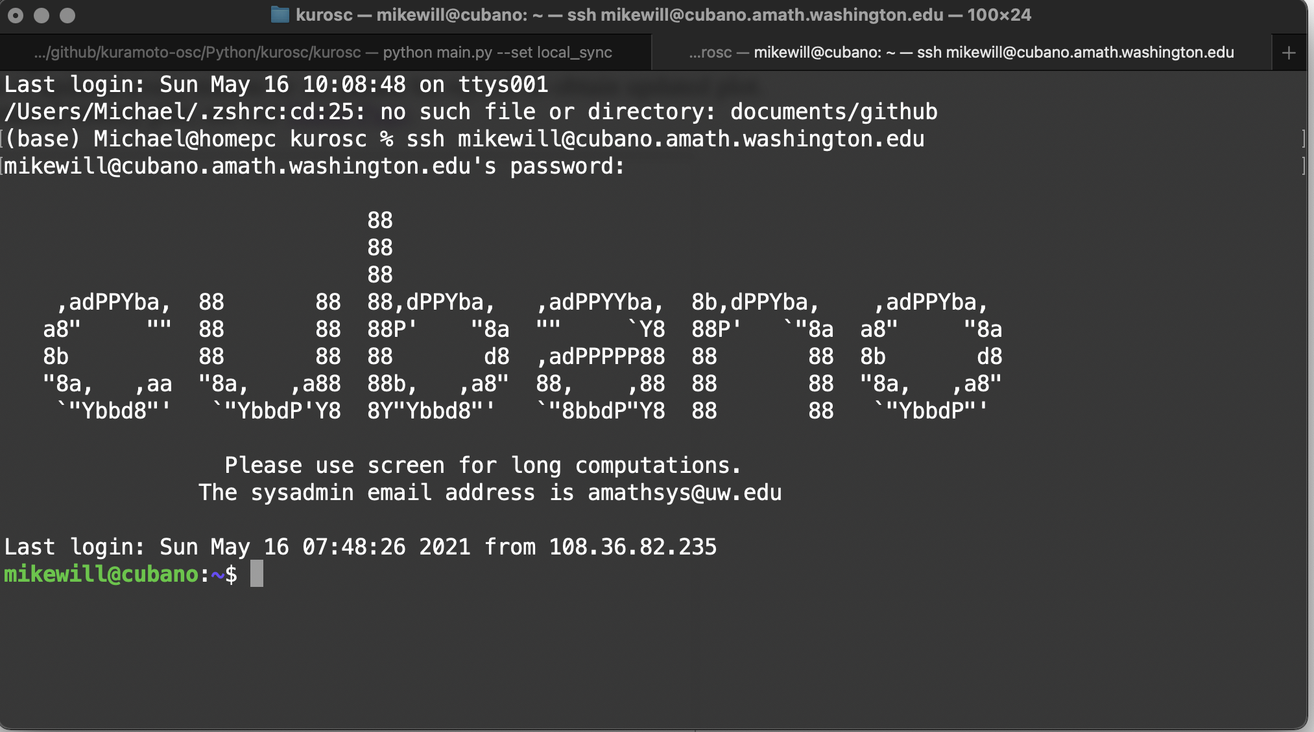

Get the https: clone link from:

https://github.com/chriswilly/kuramoto-osc

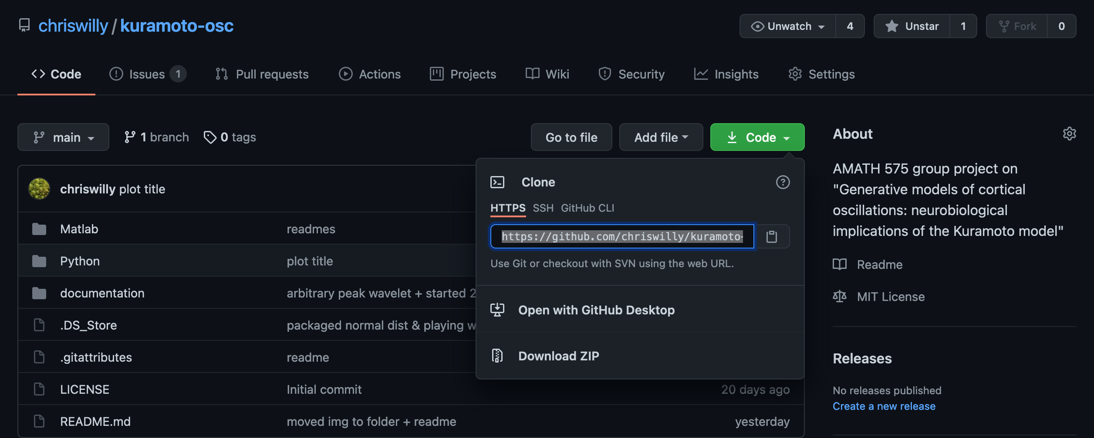

git clone <https://github.com/chriswilly/kuramoto-osc.git>

or use ssl, I don’t think I have the repo set up w/ keys tho :/

# configure

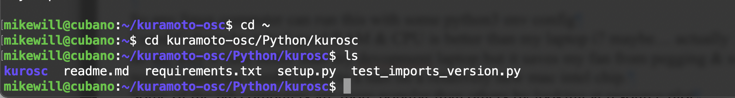

git lfs install

### may only work on Cubano, ask Jack the sysadmin if you need help setting up on other machine

git checkout -b <initials_day>

eg: git checkout -b mw_saturday

<do work making files…>

git add .

git commit -m "change message"

git push -u origin <initials_day>

that creates a new branch on the linux box

I see my downloaded branches by

git branch

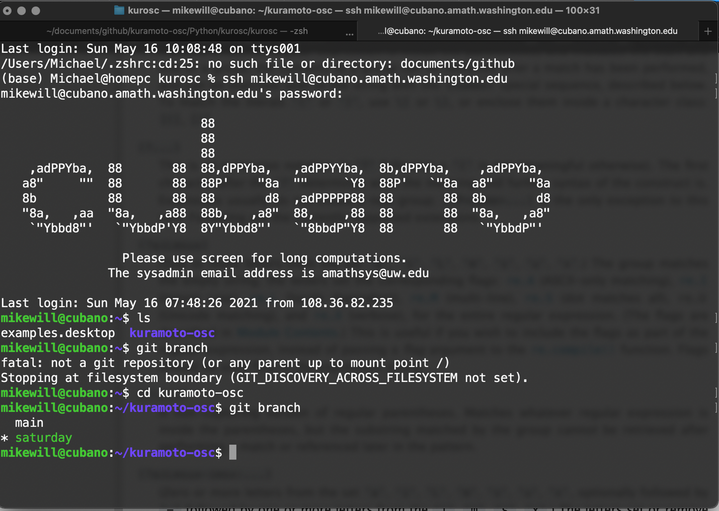

https://github.com/git-guides/git-push

# python3 env

cd kuramoto-osc/Python/kurosc

ls…

kurosc readme.md requirements.txt setup.py test_imports_version.py

###now ensure we have requirements

pip3 install --upgrade pip

pip3 install requirements.txt

pip3 install --upgrade scipy

## when I started before scipy was outdated & requires scipy >0.19 for solve_ivp, now is 1.5…

# if we run

python3 test_imports_version.py

Imported Version

re 2.2.1

argparse 1.1

scipy 1.5.4

setuptools 39.0.1

matplotlib 3.0.3

pathlib does not have version info

json 2.0.9

sys 3.6.7 (default, Oct 22 2018, 11:32:17)

[GCC 8.2.0]

shutil does not have version info

datetime does not have version info

numpy 1.19.5

sympy 1.8

imageio 2.9.0

importlib does not have version info

10 of 14 imported libraries provide '__version__' or 'version'

& 13 out of 13 lines imported from requirements

Advanced clean up:

git stash

git branch -D <branch>

