PROBONO_CASES_APP

Legal professionals lack a dedicated mobile application to efficiently track and manage their volunteer cases, widely known as pro bono cases. Current methods involving use of spreadsheets, paper files, and general-purpose tools create inefficiencies, reporting challenges, and risk of missed deadlines. This administrative burden discourages pro bono participation, reduces the effectiveness of provided services, and ultimately limits access to justice for underserved populations who depend on these volunteer legal services. Thus, giving birth to the idea of creating a pro bono case app to track and give feedback on various cases tried, settled and dismissed, as well creating proper storage of these legal findings for future reference and exemplary action of the generations to come serving as examples and findings of how law was handled in given generations.

**Technologies & Tools**

* Language: Kotlin
* Framework: Jetpack Compose
* UI Design: Material Design Components
* Database: Room Database (for storing case and user data)
* APIs: Court API (for legal references), Notification API (for reminders)
* Authentication: Firebase Authentication
* Storage: SharedPreferences for lightweight local storage

**UI/UX Considerations**

User friendly

Accessibility

Responsive to user interactions

The target audience for this application is to serve the learned fellows who are required by law to at least have a few pro bono cases worked on a way to give back to the community much as these cases as usually handled by legal clinics with limited resources to work on these cases but rather get aid from nonprofit organizations, well-wishers or corporate law firms with vast resources.

On the other hand, the application is not only limited to the law practitioners but also can be accessed by anyone with interest of acquainting him or herself with legal knowledge especially to keep up with current affairs.

The personas created include demographic information, professional background, specific pain points related to pro bono work, goals they hope to achieve, and their technology profile. These personas represent the spectrum of users who would benefit from a dedicated pro bono case tracking solution. Due to time I managed to come up with three but in the upcoming project completion more personas will be created to expound on the idea being given life to, to serve legal purposes.

<https://www.figma.com/design/IH6JaOXGIYHMg33pqXFiiJ/personas.?m=auto&t=NlXJJjha4NJ0tZHC-6>.. Use that link to connect to Figma to access a clearer copy of the personas.

While creating this application, I have tried to incorporate the major legal competitive factors followed when analysing free work done for the betterment of which termed as pro bono cases. In the analysis I have covered general legal practice management systems, specialised pro bono management tools and generic management tools. These involve payable software and IT innovations in. I had to make use of the search engines, and I borrowed some knowledge from AI for better analysis.

**General Legal Practice Management Systems**

**1. Clio**

**Company:** Clio (Themis Solutions Inc.)  
**Founded:** 2008  
**Pricing:** $39-$99/user/month  
**Platform:** Web, iOS, Android

**Key Features:**

* Matter management
* Time tracking
* Document management
* Client portal
* Billing and invoicing
* Trust accounting
* Calendar and tasks

**Pro Bono Specific Features:**

* Ability to tag matters as pro bono
* Time tracking for non-billable work
* Basic reporting on pro bono hours

**Strengths:**

* Comprehensive practice management solution
* Well-established with large user base
* Strong mobile applications
* Robust integration ecosystem

**Weaknesses:**

* Not specifically designed for pro bono work
* Expensive for solo practitioners or non-profits
* Complex interface with steep learning curve
* Limited specialized reporting for pro bono metrics
* No features for legal aid organization coordination

**2. MyCase**

**Company:** MyCase (AffiniPay)  
**Founded:** 2010  
**Pricing:** $49-$89/user/month  
**Platform:** Web, iOS, Android

**Key Features:**

* Case management
* Document storage
* Client communications
* Time tracking
* Billing
* Calendar

**Pro Bono Specific Features:**

* Basic case labeling for pro bono work
* Time tracking without billing
* Standard reporting capabilities

**Strengths:**

* User-friendly interface
* Affordable mid-tier pricing
* Good client communication tools
* Solid document management

**Weaknesses:**

* Limited customization for pro bono workflows
* Reporting not tailored to pro bono needs
* No specific features for legal aid organizations
* Limited integration options

**3. PracticePanther**

**Company:** PracticePanther (Paradigm)  
**Founded:** 2012  
**Pricing:** $49-$89/user/month  
**Platform:** Web, iOS, Android

**Key Features:**

* Case management
* Automated workflows
* Document automation
* Time and expense tracking
* Billing and payments
* Client portal

**Pro Bono Specific Features:**

* Matter classification for pro bono
* Time tracking for non-billable work
* Basic reporting

**Strengths:**

* Automation capabilities
* Intuitive user interface
* Strong mobile apps
* Extensive integration options

**Weaknesses:**

* No dedicated pro bono tracking features
* Expensive for occasional pro bono practitioners
* Limited specialized reporting
* Not tailored for legal aid coordination

**Specialized Pro Bono Management Tools**

**4. LegalServer**

**Company:** LegalServer  
**Founded:** 2001  
**Pricing:** Custom pricing, typically $85-$150/user/month  
**Platform:** Web (limited mobile functionality)

**Key Features:**

* Case management for legal aid organizations
* Volunteer attorney management
* Client intake and eligibility screening
* Document generation
* Reporting and outcomes tracking
* Grant compliance tools

**Pro Bono Specific Features:**

* Pro bono attorney portal
* Case assignment and matching
* Volunteer hour tracking
* Impact measurement
* Detailed pro bono program reporting

**Strengths:**

* Specifically designed for legal aid and pro bono programs
* Comprehensive volunteer management
* Strong reporting for funders and stakeholders
* Eligibility and intake screening tools
* Outcome tracking

**Weaknesses:**

* Expensive for smaller organizations
* Complex implementation process
* Limited mobile functionality
* Primarily designed for organizations, not individual attorneys
* Dated user interface

**5. Pro Bono Manager**

**Company:** Pro Bono Net  
**Founded:** 2001  
**Pricing:** Custom pricing based on organization size  
**Platform:** Web only

**Key Features:**

* Pro bono opportunity posting
* Attorney matching
* Case placement tracking
* Volunteer management
* Program reporting
* Integration with Pro Bono Net platform

**Pro Bono Specific Features:**

* All features focused on pro bono administration
* Volunteer skills database
* Pro bono hour certification
* Recognition programs
* Impact reporting

**Strengths:**

* Specifically designed for pro bono program administration
* Strong volunteer management capabilities
* Good reporting for program managers
* Integration with Pro Bono Net resources

**Weaknesses:**

* No mobile application
* Focused on administrators, not individual attorneys
* Limited case management capabilities
* Dated user interface
* Complex implementation

**6. JusticeServer**

**Company:** JusticeServer  
**Founded:** 2012  
**Pricing:** Based on number of users, typically $50-$75/user/month  
**Platform:** Web only

**Key Features:**

* Pro bono case referral system
* Volunteer attorney portal
* Document management
* Case status tracking
* Basic time recording
* Outcome reporting

**Pro Bono Specific Features:**

* Case matching algorithm
* Volunteer attorney portal
* Pro bono hour tracking
* Limited matter management
* Program reporting

**Strengths:**

* Focused on pro bono case placement
* Good volunteer-legal aid coordination
* Specifically designed for pro bono workflows
* Reasonable pricing

**Weaknesses:**

* Limited mobile access
* Basic time tracking capabilities
* Limited document management
* Not designed for individual attorney use
* Regional implementation (not nationwide)

**Generic Project Management Tools**

**7. Trello**

**Company:** Atlassian  
**Founded:** 2011  
**Pricing:** Free-$17.50/user/month  
**Platform:** Web, iOS, Android

**Key Features:**

* Kanban board interface
* Task management
* Basic collaboration
* Checklists
* File attachments
* Automation with paid tiers

**Pro Bono Specific Features:**

* None (general-purpose tool)

**Strengths:**

* Very low cost or free
* Intuitive, visual interface
* Excellent mobile apps
* Quick setup with no training
* Flexibility to create custom workflows

**Weaknesses:**

* No legal-specific features
* Limited reporting capabilities
* No time tracking in base version
* No document generation
* No client management features

**8. Asana**

**Company:** Asana, Inc.  
**Founded:** 2008  
**Pricing:** Free-$24.99/user/month  
**Platform:** Web, iOS, Android

**Key Features:**

* Task and project management
* Multiple project views (list, board, timeline)
* Team collaboration
* Workflow automation
* Goal tracking
* Reporting dashboards

**Pro Bono Specific Features:**

* None (general-purpose tool)

**Strengths:**

* Robust free tier
* Excellent mobile experience
* Multiple visualization options
* Good reporting dashboards
* User-friendly interface

**Weaknesses:**

* No legal-specific terminology or workflows
* No document management
* No time tracking in base version
* No client portal
* Requires significant customization for legal use

**Emerging Trends in the Market**

1. **Cloud-Based Solutions** - Market increasingly moving away from on-premise software to cloud-based solutions with mobile access
2. **Mobile-First Design** - Growing expectation for full-featured mobile applications, not just web interfaces
3. **AI Integration** - Emerging use of AI for case matching, document analysis, and outcome prediction
4. **Impact Measurement** - Increasing focus on measuring and reporting social impact of pro bono work
5. **Integration Capabilities** - Greater demand for systems that connect with other platforms (court filing systems, document automation, etc.)

**Gap Analysis & Opportunity**

**Unmet Market Needs:**

1. **Mobile-First Pro Bono Solution** - No existing solution offers a truly mobile-first experience designed specifically for pro bono case tracking
2. **Individual Attorney Focus** - Most specialized pro bono tools target organizations rather than individual practitioners
3. **Simplified Tracking** - Current legal practice management systems are complex and expensive for the limited needs of pro bono tracking
4. **Cross-Organizational Coordination** - Limited tools for attorneys who take cases from multiple legal aid organizations
5. **Cost-Effective Solution** - Large gap between free generic tools and expensive legal-specific systems

As you can see that the analysis isn’t brief but really detailed so I tried to come up with a tabled position matrix that also involved some aspects as explained below.

The proposed Pro Bono Case Tracker app can differentiate by:

1. **Mobile-First Design** - Building specifically for mobile use cases, recognizing that most pro bono work happens outside normal office hours
2. **Simplified Workflow** - Focusing exclusively on pro bono tracking without the complexity of full practice management
3. **Affordability** - Providing a cost-effective solution appropriate for occasional pro bono practitioners and smaller organizations
4. **Cross-Program Integration** - Creating a platform that works across multiple legal aid organizations
5. **Impact Visualization** - Developing compelling ways to visualize and share the impact of pro bono contributions

**Competitive Positioning Matrix**

|  |  |  |  |  |  |
| --- | --- | --- | --- | --- | --- |
| Competitor | Mobile capability | Pro bono specific | Individual attorney focus | Ease of use | Affordability |
| Clio | high | Low | medium | medium | low |
| MyCase | Medium | Low | High | High | Medium |
| PracticePanther | Medium | Low | Medium | Medium | Low |
| Legal Sever | Low | High | Low | Low | Low |
| Pro bono Manager | None | High | Low | Medium | Medium |
| Justice Server | Low | High | Medium | Medium | Medium |
| Trello | High | None | High | High | High |
| Asana | High | None | Medium | High | High |
| Case tracker | High | High | High | High | High |

**Core Features**

These address the fundamental needs of legal professionals managing pro bono cases:

1. **Case Management**
   * Dashboard with visual status indicators
   * Comprehensive case details tracking
   * Mobile-optimized document management
   * Deadline and calendar integration
   * Log and track cases categorized as **won**, **lost**, or **pending**.
   * Monitor which lawyers handled cases and which judges ruled on them.
2. **Time Tracking**
   * One-tap timer and manual entry options
   * Voice-to-text notes for quick documentation
   * Visualizations of time spent by case/activity
3. **Reporting**
   * Bar association reporting formats
   * Impact metrics and visualizations
   * Exportable in multiple formats
   * Real-time updates on case progress with notifications.

**Advanced Features**

These enhance productivity and effectiveness:

1. **Collaboration Tools**
   * Team coordination for shared cases
   * Supervision workflows for mentoring
   * Internal messaging and notifications
2. **Client Management**
   * Secure communication channels
   * Meeting preparation tools
   * Status update automation
3. **Knowledge Management**
   * Resource library by practice area
   * Template repository
   * Jurisdiction-specific information (Monitor which lawyers handled cases and which judges ruled on them.)
4. **Legal Aid Integration**
   * Organization profiles and requirements
   * Case placement coordination
   * Hour certification

**Innovative Features**

These differentiate the app from competitors:

1. **AI-Powered Assistance**
   * Smart deadline suggestions
   * Document analysis and classification
   * Task recommendations based on case type
2. **Gamification & Recognition**
   * Achievement system for milestones
   * Impact visualization
   * Optional community features
3. **Enhanced Connectivity**
   * Integration with calendars and cloud storage
   * Export capabilities for various reporting needs
   * Court system connections (future phase)

For the UI mock-ups and designs you will be seeing them in the sample display, I tried to organise them inform of screens with each screen representing an aspect of the app constituting to the whole pro bono case work.

Main Navigation:

* Using Navigation Compose for screen navigation
* Implementing bottom navigation for easy access to main features
* Handling deep linking for notifications

Case List Screen:

* Grid/List view of all cases
* Filtering options by status
* Search functionality
* Quick action buttons

Case Detail Screen:

* Comprehensive case information
* Time tracking
* Document attachments
* Notes and updates
* Court date calendar

Lawyer & Judge Tracking Screen**:**  
Uses a tabbed interface to switch between lists of lawyers and judges, each with performance metrics and a simple search/filter functionality.

Add/Edit Case Screen:

* Form validation
* Date pickers
* Status selection
* Client information
* Case details

This is a challenging task to come up with in a short period of time but nevertheless I came up with a table to help me manage the time its only updated to current tasks, I keep updating whenever I am going to work on the project.

Initially by the tenth week of the trimester the application will be functioning and ready for the final user testing and submitted for grading and marketing to law firms with interest in keeping their pro bono cases in check or maybe for public use.

|  |  |  |
| --- | --- | --- |
| Period | Coverage | Achievement |
| Week 1-2 | Knowledge on the course unit, introduction to software in use (Android Studio), starter practice for acquaintance. | Ability to start and work on projects guided by the lecturer. |
| Week 3 | Subject of examination, choosing a project to work on  Planning and analysis. | Chose to work on the pro bono case app  Necessary research on the project of interest such as target group, features among other. |
| Week 4 and 5 | Design the outlook and navigation  Sharing project with lecturer for guidance and time approval  Submit first part of the project for assessment and constructive feedback from the lecturer. | Establish project structure and technology stack Create initial UI mock-ups and wireframes Set up version control and development environment  Develop core screens (Dashboard, Case List, Case Details, Lawyer/Judge Tracking) using Jetpack Compose  Integrate navigation and basic layout components |
|  |  |  |
|  |  |  |

Reference Disclosure

In the codes that I have submitted that constitute my Pro bono cases application, there are topics I have covered but we haven’t actually covered them in class but due to the demand to at least come up with something impressive to sell the idea to you and the whole world I needed to borrow some knowledge outside of class teachings from various search engines, streaming apps and AI itself.

The codes you will review contain both lecture notes and research I made to at least get to the point where I submit what the application screens should look like and better.

IMAGERY

I have chosen to call this part of the project imagery because in reference toto literature’s figurative speeches, imagery is when the writer tries to describe ab action using undrawn images but rather images created by written words to paint a good picture of what the scenario is and to help the reader and to whom the message is being delivered to understand. Below are screenshots briefly explains how the screens are going to look like after full development of the Pro bono cases app.

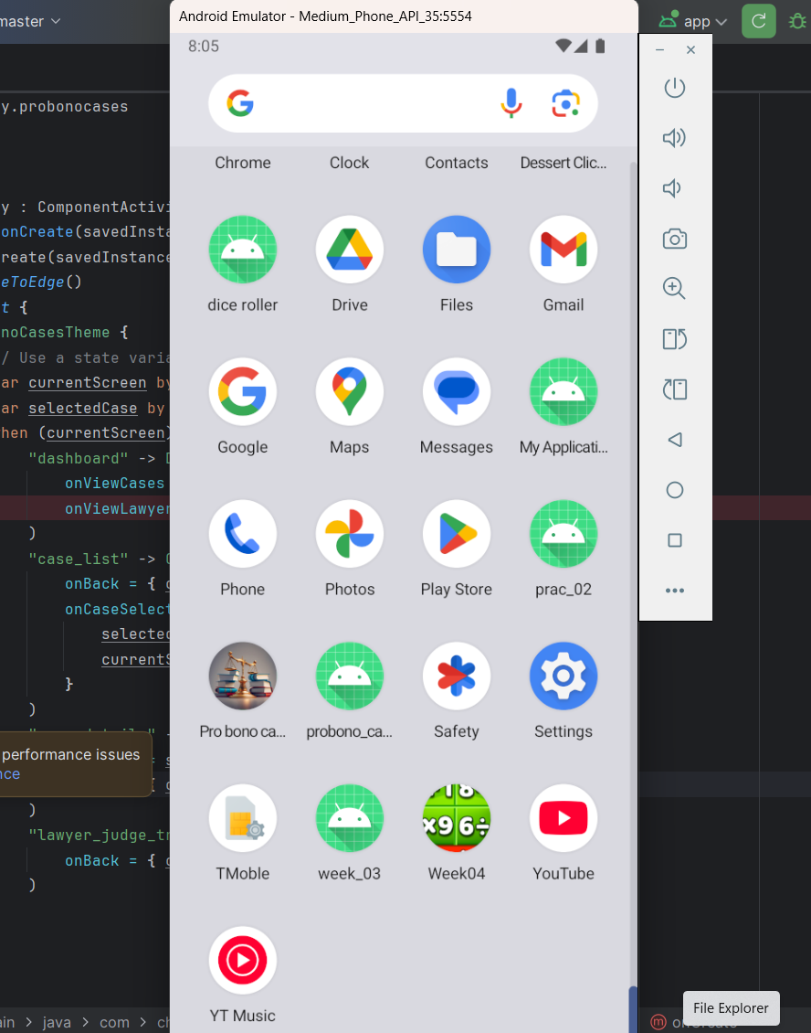

***After the codes have been run using android studio, the apps appear like that, and our pro bono app can be identified by the law weighing scale and books significant of law.***

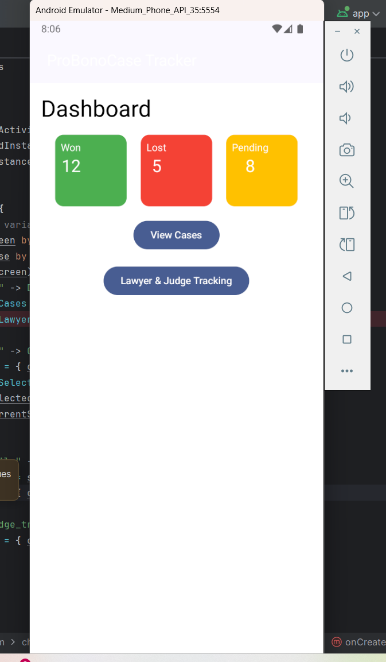

***That the first screen its labelled dashboard but as we progress, I will find of not physically showing it off as the dashboard. It contains the case summaries, case listings and lawyers and judges that took part or are and will take part in given cases. It’s still limited on information but, if need be, I will improve and include anything that needs to be.***

***This is the case listing screens that is going have all information on given cases and if time is my best ally I will have to include a pat where the user can as well search for more cases that are not listed to broaden their understanding and in other words make references using other cases.***

***Displayed information about the case will look like that, although this is not the final decision because a better idea could come up and updates will be made both in the codes and on paper, though this is just the ideal idea of how I want the screens to look like.***

***The above is how the judge and lawyer description screen will look like.***

***Now those are some of the major screens I had come up with but like I mentioned earlier, its just a snippet of what the idea project should look like more ideas are bound to be thought of along the way so many changes are expected to happen.***

CONSIDERATIONS ON THE GIT HUB AS REGARDS TO THIS PROJECT

I really did not make any commits but as I progress to the final steps that are going to guide me on the final development process of the app, I will be committing all my steps especially steps that are a success.

[chriswoodrodney/code_review: project under review](https://github.com/chriswoodrodney/code_review/tree/master)- link to the repository for my assignment.

**Please ignore the cache and focus on the app and once you open the app click on src>main>java/com/chrisy/pro bono cases>main.kt**