Work on this lab with a new partner: someone with whom you have not yet worked.

Write the code for the lab below and each partner must upload the zipped src folder to the learning hub (learn.bcit.ca 🡪 Activities 🡪 Assignments 🡪 Lab3) before the start of lesson 4.

Include your full name and your partner’s full name at the top of each file, using a Java Javadoc   
/** @author */ tag (for example: /** @author Paul Mills and Jason Harrison */).

Create a Novel class with private instance variables, constructor parameters, and accessor methods for “title”, “author name”, and “year published”

Create a BookStore class that contains an instance variable for the BookStore’s name (e.g. “Books-R-Us”). The BookStore constructor will not accept a name of “Amazon” (in any letter casing), however; if the name is “Amazon”, change it to “Chapters” instead. The BookStore contains a second instance variable that is an ArrayList of 109 Novel references; the BookStore constructor populates the ArrayList with the following data:

|  |  |  |
| --- | --- | --- |
| **Title** | **Author** | **Year Published** |
| null reference | | |
| The Adventures of Augie March | Saul Bellow | 1953 |
| All the King’s Men | Robert Penn Warren | 1946 |
| American Pastoral | Philip Roth | 1997 |
| An American Tragedy | Theodore Dreiser | 1925 |
| Animal Farm | George Orwell | 1946 |
| Appointment in Samarra | John O'Hara | 1934 |
| null | null | 0 |
| null | "author name 1" | 0 |
| "" | null | 0 |
| null | "" | 0 |
| "title 1" | null | 0 |
| "" | "" | 0 |
| "" | "author name 2" | 0 |
| "title 2" | null | 0 |
| Are You There God? It's Me, Margaret. | Judy Blume | 1970 |
| The Assistant | Bernard Malamud | 1957 |
| At Swim-Two-Birds | Flann O'Brien | 1938 |
| Atonement | Ian McEwan | 2002 |
| Beloved | Toni Morrison | 1987 |
| The Berlin Stories | Christopher Isherwood | 1946 |
| The Big Sleep | Raymond Chandler | 1939 |
| The Blind Assassin | Margaret Atwood | 2000 |
| Blood Meridian | Cormac McCarthy | 1986 |
| Brideshead Revisited | Evelyn Waugh | 1946 |
| The Bridge of San Luis Rey | Thornton Wilder | 1927 |
| Call It Sleep | Henry Roth | 1935 |
| Catch-22 | Joseph Heller | 1961 |
| The Catcher in the Rye | J.D. Salinger | 1951 |
| A Clockwork Orange | Anthony Burgess | 1963 |
| The Confessions of Nat Turner | William Styron | 1967 |
| The Corrections | Jonathan Franzen | 2001 |
| The Crying of Lot 49 | Thomas Pynchon | 1966 |
| A Dance to the Music of Time | Anthony Powell | 1951 |
| The Day of the Locust | Nathanael West | 1939 |
| Death Comes for the Archbishop | Willa Cather | 1927 |
| A Death in the Family | James Agee | 1958 |
| The Death of the Heart | Elizabeth Bowen | 1958 |
| Deliverance | James Dickey | 1970 |
| Dog Soldiers | Robert Stone | 1974 |
| Falconer | John Cheever | 1977 |
| The French Lieutenant's Woman | John Fowles | 1969 |
| The Golden Notebook | Doris Lessing | 1962 |
| Go Tell It on the Mountain | James Baldwin | 1953 |
| Gone with the Wind | Margaret Mitchell | 1936 |
| The Grapes of Wrath | John Steinbeck | 1939 |
| Gravity's Rainbow | Thomas Pynchon | 1973 |
| The Great Gatsby | F. Scott Fitzgerald | 1925 |
| A Handful of Dust | Evelyn Waugh | 1934 |
| The Heart Is a Lonely Hunter | Carson McCullers | 1940 |
| The Heart of the Matter | Graham Greene | 1948 |
| Herzog | Saul Bellow | 1964 |
| Housekeeping | Marilynne Robinson | 1981 |
| A House for Mr. Biswas | V.S. Naipaul | 1962 |
| I, Claudius | Robert Graves | 1934 |
| Infinite Jest | David Foster Wallace | 1996 |
| Invisible Man | Ralph Ellison | 1952 |
| Light in August | William Faulkner | 1932 |
| The Lion, The Witch and the Wardrobe | C.S. Lewis | 1950 |
| Lolita | Vladimir Nabokov | 1955 |
| Lord of the Flies | William Golding | 1954 |
| The Lord of the Rings | J.R.R. Tolkien | 1954 |
| Loving | Henry Green | 1945 |
| Lucky Jim | Kingsley Amis | 1954 |
| The Man Who Loved Children | Christina Stead | 1940 |
| Midnight's Children | Salman Rushdie | 1981 |
| Money | Martin Amis | 1984 |
| The Moviegoer | Walker Percy | 1961 |
| Mrs. Dalloway | Virginia Woolf | 1925 |
| Naked Lunch | William Burroughs | 1959 |
| Native Son | Richard Wright | 1940 |
| Neuromancer | William Gibson | 1984 |
| Never Let Me Go | Kazuo Ishiguro | 2005 |
| 1984 | George Orwell | 1948 |
| On the Road | Jack Kerouac | 1957 |
| One Flew Over the Cuckoo's Nest | Ken Kesey | 1962 |
| The Painted Bird | Jerzy Kosinski | 1965 |
| Pale Fire | Vladimir Nabokov | 1962 |
| A Passage to India | E.M. Forster | 1924 |
| Play It as It Lays | Joan Didion | 1970 |
| Portnoy's Complaint | Philip Roth | 1969 |
| Possession | A.S. Byatt | 1990 |
| The Power and the Glory | Graham Greene | 1939 |
| The Prime of Miss Jean Brodie | Muriel Spark | 1961 |
| Rabbit, Run | John Updike | 1960 |
| Ragtime | E.L. Doctorow | 1975 |
| The Recognitions | William Gaddis | 1955 |
| Red Harvest | Dashiell Hammett | 1929 |
| Revolutionary Road | Richard Yates | 1961 |
| The Sheltering Sky | Paul Bowles | 1949 |
| Slaughterhouse-Five | Kurt Vonnegut | 1969 |
| Snow Crash | Neal Stephenson | 1992 |
| The Sot-Weed Factor | John Barth | 1960 |
| The Sound and the Fury | William Faulkner | 1929 |
| The Sportswriter | Richard Ford | 1986 |
| The Spy Who Came in from the Cold | John le Carré | 1964 |
| The Sun Also Rises | Ernest Hemingway | 1926 |
| Their Eyes Were Watching God | Zora Neale Hurston | 1937 |
| Things Fall Apart | Chinua Achebe | 1959 |
| To Kill a Mockingbird | Harper Lee | 1960 |
| To the Lighthouse | Virginia Woolf | 1929 |
| Tropic of Cancer | Henry Miller | 1934 |
| Ubik | Philip K. Dick | 1969 |
| Under the Net | Iris Murdoch | 1954 |
| Under the Volcano | Malcolm Lowry | 1947 |
| Watchmen | Alan Moore and Dave Gibbons | 1986 |
| White Noise | Don DeLillo | 1985 |
| White Teeth | Zadie Smith | 2000 |
| Wide Sargasso Sea | Jean Rhys | 1966 |

The BookStore class has a public static void main() method which creates a BookStore object. The main method also takes commandline arguments, the first of which will be the name of the BookStore; store the first commandline argument as the name of the BookStore (unless it is “Amazon”…see above).

Here is a snapshot of some of the code:

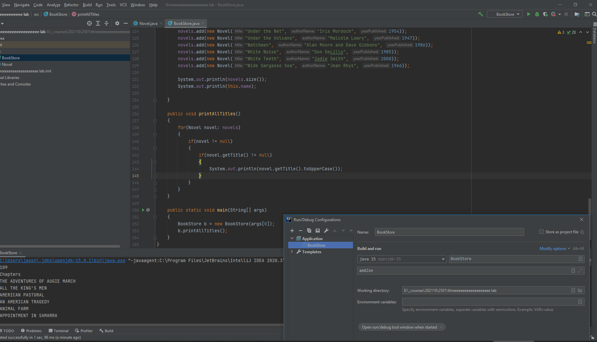

Create the following BookStore methods. Do proper null and blank checking so that no crashes occur and no empty/blank strings appear:

|  |  |  |
| --- | --- | --- |
| **Method name** | **Parameters** | **Resulting behavior** |
| printAllTitles | none | Prints all titles in UPPERCASE (except null Novels and null titles, which are ignored) |
| printTitlesContaining | String substring  boolean caseSensitive | Prints all titles that contain the specified substring; if caseSensitive is false, then the match is in any letter casing (e.g. “The” is the same as “the”); if caseSensitive is true then the match must include letter casing (e.g. “The” is different than “the”) |
| printTitlesOfLength | int length | Prints all titles that are of exactly the specified length |
| printNameStartsEndsWith | String substring | Prints all author names that either start or end with substring, in lowercase…the substring match is case insensitive (e.g. “aN” is the same as “An”, etc) |
| getLongest | String property | If the property argument is “author” (in any letter casing) then return the longest author name (by finding it using a foreach loop); if the property argument is “title” (in any letter casing) then return the longest title (by finding it using a foreach loop); if the property argument is something else then return null |
| main | String[] args | Creates BookStore object and passes args[0] to BookStore constructor as its name property  Calls all of the BookStore methods listed above, in this table |

Sample correct output when the BookStore’s methods are called from BookStore.main():

|  |  |
| --- | --- |
| **BookStore method name** | **Expected Output** |
| printAllTitles | THE ADVENTURES OF AUGIE MARCH  ALL THE KING’S MEN  AMERICAN PASTORAL  AN AMERICAN TRAGEDY  ANIMAL FARM  APPOINTMENT IN SAMARRA  TITLE 1  TITLE  ARE YOU THERE GOD? IT'S ME, MARGARET.  THE ASSISTANT  AT SWIM-TWO-BIRDS  ATONEMENT  BELOVED  THE BERLIN STORIES  THE BIG SLEEP  THE BLIND ASSASSIN  BLOOD MERIDIAN  BRIDESHEAD REVISITED  THE BRIDGE OF SAN LUIS REY  CALL IT SLEEP  CATCH-22  THE CATCHER IN THE RYE  A CLOCKWORK ORANGE  THE CONFESSIONS OF NAT TURNER  THE CORRECTIONS  THE CRYING OF LOT 49  A DANCE TO THE MUSIC OF TIME  THE DAY OF THE LOCUST  DEATH COMES FOR THE ARCHBISHOP  A DEATH IN THE FAMILY  THE DEATH OF THE HEART  DELIVERANCE  DOG SOLDIERS  FALCONER  THE FRENCH LIEUTENANT'S WOMAN  THE GOLDEN NOTEBOOK  GO TELL IT ON THE MOUNTAIN  GONE WITH THE WIND  THE GRAPES OF WRATH  GRAVITY'S RAINBOW  THE GREAT GATSBY  A HANDFUL OF DUST  THE HEART IS A LONELY HUNTER  THE HEART OF THE MATTER  HERZOG  HOUSEKEEPING  A HOUSE FOR MR. BISWAS  I, CLAUDIUS  INFINITE JEST  INVISIBLE MAN  LIGHT IN AUGUST  THE LION, THE WITCH AND THE WARDROBE  LOLITA  LORD OF THE FLIES  THE LORD OF THE RINGS  LOVING  LUCKY JIM  THE MAN WHO LOVED CHILDREN  MIDNIGHT'S CHILDREN  MONEY  THE MOVIEGOER  MRS. DALLOWAY  NAKED LUNCH  NATIVE SON  NEUROMANCER  NEVER LET ME GO  1984  ON THE ROAD  ONE FLEW OVER THE CUCKOO'S NEST  THE PAINTED BIRD  PALE FIRE  A PASSAGE TO INDIA  PLAY IT AS IT LAYS  PORTNOY'S COMPLAINT  POSSESSION  THE POWER AND THE GLORY  THE PRIME OF MISS JEAN BRODIE  RABBIT, RUN  RAGTIME  THE RECOGNITIONS  RED HARVEST  REVOLUTIONARY ROAD  THE SHELTERING SKY  SLAUGHTERHOUSE-FIVE  SNOW CRASH  THE SOT-WEED FACTOR  THE SOUND AND THE FURY  THE SPORTSWRITER  THE SPY WHO CAME IN FROM THE COLD  THE SUN ALSO RISES  THEIR EYES WERE WATCHING GOD  THINGS FALL APART  TO KILL A MOCKINGBIRD  TO THE LIGHTHOUSE  TROPIC OF CANCER  UBIK  UNDER THE NET  UNDER THE VOLCANO  WATCHMEN  WHITE NOISE  WHITE TEETH  WIDE SARGASSO SEA |
| b.printAllTitlesContaining("the", false); | The Adventures of Augie March  All the King’s Men  Are You There God? It's Me, Margaret.  The Assistant  The Berlin Stories  The Big Sleep  The Blind Assassin  The Bridge of San Luis Rey  The Catcher in the Rye  The Confessions of Nat Turner  The Corrections  The Crying of Lot 49  A Dance to the Music of Time  The Day of the Locust  Death Comes for the Archbishop  A Death in the Family  The Death of the Heart  The French Lieutenant's Woman  The Golden Notebook  Go Tell It on the Mountain  Gone with the Wind  The Grapes of Wrath  The Great Gatsby  The Heart Is a Lonely Hunter  The Heart of the Matter  The Lion, The Witch and the Wardrobe  Lord of the Flies  The Lord of the Rings  The Man Who Loved Children  The Moviegoer  On the Road  One Flew Over the Cuckoo's Nest  The Painted Bird  The Power and the Glory  The Prime of Miss Jean Brodie  The Recognitions  The Sheltering Sky  The Sot-Weed Factor  The Sound and the Fury  The Sportswriter  The Spy Who Came in from the Cold  The Sun Also Rises  Their Eyes Were Watching God  To the Lighthouse  Under the Net  Under the Volcano |
| b.printAllTitlesContaining("the", true); | All the King’s Men  The Catcher in the Rye  A Dance to the Music of Time  The Day of the Locust  Death Comes for the Archbishop  A Death in the Family  The Death of the Heart  Go Tell It on the Mountain  Gone with the Wind  The Heart of the Matter  The Lion, The Witch and the Wardrobe  Lord of the Flies  The Lord of the Rings  On the Road  One Flew Over the Cuckoo's Nest  The Power and the Glory  The Sound and the Fury  The Spy Who Came in from the Cold  To the Lighthouse  Under the Net  Under the Volcano |
| b.printAllTitles(13); | The Assistant  The Big Sleep  Call It Sleep  Infinite Jest  Invisible Man  The Moviegoer  Mrs. Dalloway  Under the Net |
| printNameStartsEndsWith(“aN”) | ian mcew**an**  **an**thony burgess  **an**thony powell |
| System.out.println(b.getLongest("xyz")); | null |
| System.out.println(b.getLongest("AutHor")); | Alan Moore and Dave Gibbons |
| System.out.println(b.getLongest("titlE")); | Are You There God? It's Me, Margaret. |