CIA1 - MLOps Experiment: Dry Bean Classification Pipeline
Dataset: UCI Dry Bean Dataset (13,611 samples, 16 shape features, 7 bean classes)
Models: KNN, SVM (RBF), Random Forest
Tools: MLflow, DVC, Kubeflow Pipelines (KFP v2), Feast, Google Vertex AI
Name / Reg. No.: ____________________

Task 1: MLOps Lifecycle Analysis
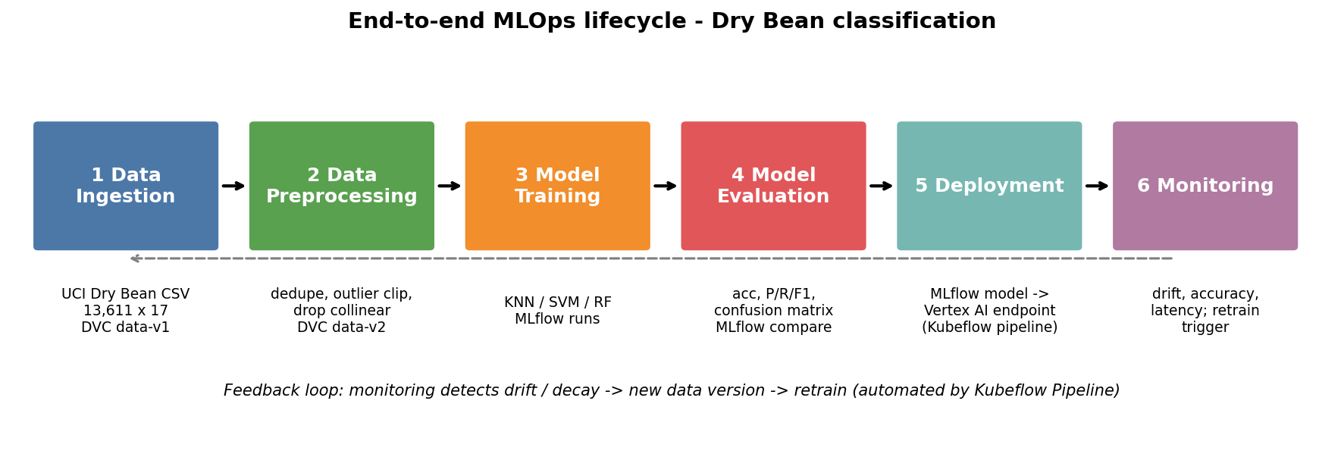
- Data ingestion: Dry Bean CSV (13,611 x 17) pulled from the UCI repository; tracked by DVC as data-v1.
- Data preprocessing: Remove 68 duplicate rows, clip outliers at 3xIQR, drop 5 features that correlate >0.98 with others (Perimeter, ConvexArea, EquivDiameter, Compactness, ShapeFactor3). Standardisation is applied inside the model pipeline (no leakage). Output tracked as data-v2.
- Model training: KNN, SVM and Random Forest, two hyper-parameter settings each, 80/20 stratified split (seed 42); every run logged to MLflow.
- Model evaluation: Train/test accuracy, weighted precision/recall/F1, confusion matrix; runs compared in MLflow; the model must pass an accuracy gate (>= 0.90).
- Deployment: Best model (SVM, C=10) saved as a joblib/MLflow artifact and served from a Vertex AI endpoint (cloud/deploy_vertex.py); gated by the Kubeflow pipeline.
- Monitoring: Endpoint latency/error metrics, feature-skew and drift detection on the 11 input features, periodic accuracy checks on labelled samples. A drift alarm creates a new data version and re-triggers the pipeline.

Task 2: Experiment Tracking with MLflow
src/train.py trains each model with two parameter settings on both dataset versions (12 runs) and logs parameters (model, hyper-parameters, data version, data md5, row/feature counts), train and test accuracy, weighted precision / recall / F1, a confusion-matrix figure and the model itself. Run `mlflow ui --backend-store-uri sqlite:///mlflow.db` to compare runs interactively (select runs, then Compare).
Data | Model | Parameters | Train acc | Test acc | Precision | Recall | F1
v1 | KNN | n_neighbors=5 | 0.9415 | 0.9166 | 0.9174 | 0.9166 | 0.9168
v1 | KNN | n_neighbors=15, weights=distance | 1.0000 | 0.9188 | 0.9197 | 0.9188 | 0.9190
v1 | RandomForest | trees=100, depth=10.0 | 0.9652 | 0.9207 | 0.9211 | 0.9207 | 0.9207
v1 | RandomForest | trees=300, depth=None | 1.0000 | 0.9218 | 0.9219 | 0.9218 | 0.9217
v1 | SVM | C=1, kernel=rbf | 0.9338 | 0.9221 | 0.9224 | 0.9221 | 0.9222
v1 | SVM | C=10, kernel=rbf | 0.9397 | 0.9243 | 0.9243 | 0.9243 | 0.9243
v2 | KNN | n_neighbors=5 | 0.9454 | 0.9118 | 0.9123 | 0.9118 | 0.9119
v2 | KNN | n_neighbors=15, weights=distance | 1.0000 | 0.9169 | 0.9179 | 0.9169 | 0.9171
v2 | RandomForest | trees=100, depth=10.0 | 0.9672 | 0.9195 | 0.9200 | 0.9195 | 0.9196
v2 | RandomForest | trees=300, depth=None | 1.0000 | 0.9206 | 0.9206 | 0.9206 | 0.9205
v2 | SVM | C=1, kernel=rbf | 0.9347 | 0.9247 | 0.9250 | 0.9247 | 0.9248
v2 | SVM | C=10, kernel=rbf | 0.9415 | 0.9251 | 0.9253 | 0.9251 | 0.9251

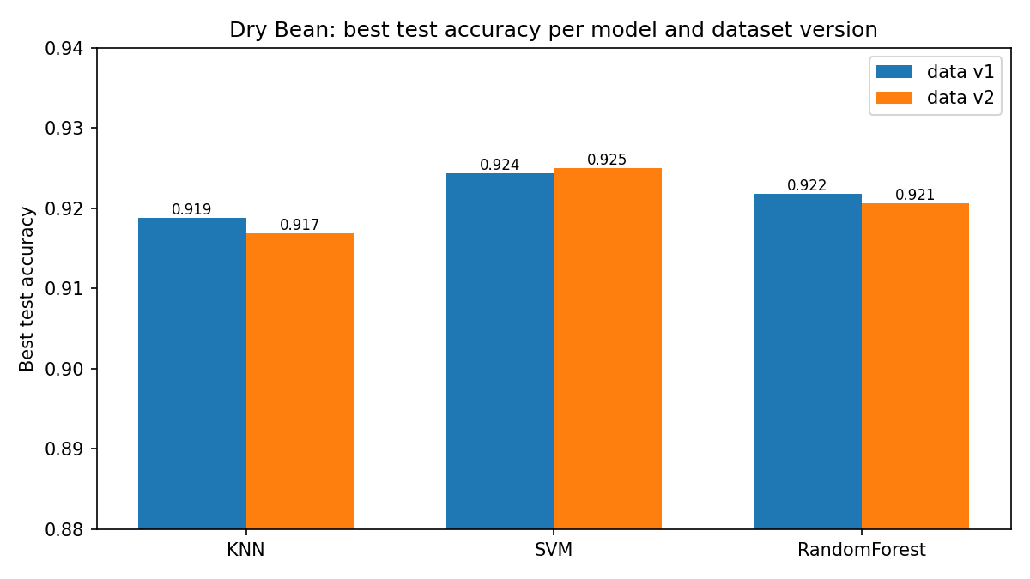
Findings: all three model families land between 91% and 92.5% test accuracy. SVM (C=10) is best on both versions (0.9243 on v1, 0.9251 on v2). KNN with distance weighting and the 300-tree forest reach 100% training accuracy but only ~92% test accuracy, i.e. they overfit; SVM has the smallest train/test gap. Data v2 helped SVM slightly (+0.04 to +0.26 points) but was marginally worse for KNN and Random Forest (-0.1 to -0.5 points). With a single split these differences are small and should not be over-interpreted (cross-validation is the next step). The main value of v2 is correctness: removing duplicates avoids identical rows landing in both train and test.

Task 3: Dataset Versioning with DVC
Commands used (from the project root):
- git init && dvc init
- dvc add data/dry_bean.csv && git add data/dry_bean.csv.dvc data/.gitignore && git commit -m "Data v1" && git tag data-v1
- python src/preprocess.py data/dry_bean.csv data/tmp.csv && mv data/tmp.csv data/dry_bean.csv
- dvc add data/dry_bean.csv && git commit -am "Data v2" && git tag data-v2
- dvc get . data/dry_bean.csv --rev data-v1 -o versions/dry_bean_v1.csv
- git diff data-v1 data-v2 -- data/dry_bean.csv.dvc
 | data-v1 (original) | data-v2 (preprocessed)
DVC md5 | 41d2e6df4a41366cfca4ad0b15b3efec | 30208868094c0850d74e44b77a138ab3
Size | 3,827,737 bytes | 2,752,200 bytes
Rows | 13,611 | 13,543 (-68 duplicates)
Columns | 17 | 12 (5 collinear features dropped)
Max Area | 254,616 | 136,680 (outliers clipped)
Class balance | DERMASON 26.1% ... BOMBAY 3.8% | DERMASON 26.2% ... BOMBAY 3.9% (unchanged)
Best test accuracy | 0.9243 (SVM) | 0.9251 (SVM)

Benefits of data versioning:
- Reproducibility: a Git commit plus the .dvc file pins the exact bytes (md5) used for any experiment; MLflow stores the same md5 with each run, linking model to data.
- Git stays small: Git stores only a tiny pointer file while the data lives in the DVC cache / remote (S3, GCS).
- Safe experimentation and rollback: switch between data-v1 and data-v2 with git checkout + dvc checkout.
- Auditability and collaboration: diffs of .dvc files show when and how a dataset changed; teammates pull identical data.
- Enables automation: pipelines can request a dataset by revision (the dvc_rev parameter of our Kubeflow pipeline).

Task 4: Workflow Automation Design (Kubeflow Pipelines)
kubeflow/pipeline.py defines the workflow with KFP v2 and compiles to kubeflow/dry_bean_pipeline.yaml, which can be uploaded to a Kubeflow cluster or Vertex AI Pipelines (compiled successfully; not run on a cluster). kubeflow/run_local.py executes the same five stages locally as the simulated workflow (accuracy 0.9251, gate passed).
Step | Component | What it does
1 | data_collection | Fetches the dataset at a given DVC revision; emits a Dataset artifact
2 | data_validation | Schema, null, label-set and row-count checks; fails the run on bad data
3 | train | Scaling + SVM pipeline, stratified split; emits Model and test-set artifacts
4 | evaluate | Computes accuracy/F1, logs Metrics, returns pass/fail against threshold 0.90
5 | deploy | Runs only if evaluation passes (dsl.If); uploads the model to Vertex AI and deploys an endpoint

Flow: data_collection -> data_validation -> train -> evaluate -> [accuracy >= 0.90] -> deploy.
How automation improves reproducibility and scalability:
- Reproducibility: each step is a containerised component with pinned inputs, parameters and a data revision, so a run can be re-executed identically; inputs/outputs are tracked as artifacts with lineage.
- No manual errors: validation and the quality gate run every time, so bad data or weak models never reach deployment.
- Scalability: each step runs in its own pod, so heavy steps can request more CPU/GPU, run in parallel (e.g. a hyper-parameter sweep) and be cached when inputs are unchanged.
- Continuous training: the same pipeline can be scheduled or triggered by a drift alarm or a new data version.

Task 5: Feature Store and Cloud Platform Study

Part A: Feast feature store
Three model features were registered in a Feast repo (feature_repo/features.py): Area (pixels in the bean region), AspectRation (major / minor axis length) and ShapeFactor1. One entity (bean, key bean_id), one FeatureView (bean_features), parquet offline store and SQLite online store. Output of src/feast_demo.py:
--- offline (training) ---
bean_id event_timestamp Area AspectRation ShapeFactor1
0 0 2026-10-02 00:00:00+00:00 28395.0 1.197191 0.007332
1 1 2026-10-02 00:00:00+00:00 28734.0 1.097356 0.006979
2 2 2026-10-02 00:00:00+00:00 29380.0 1.209713 0.007244
--- online (inference) ---
bean_id AspectRation Area ShapeFactor1
0 0 1.197191 28395.0 0.007332
1 1 1.097356 28734.0 0.006979
2 2 1.209713 29380.0 0.007244
How Feast keeps training and inference consistent:
- Single definition: features are declared once in code and registered in the Feast registry; training and serving both read that definition, preventing training-serving skew.
- Training: get_historical_features() does a point-in-time-correct join of features to labelled entity rows, avoiding future-data leakage.
- Inference: materialize copies the latest values to the online store; get_online_features() returns the same features with low latency by entity key (the two outputs above match).
- Reuse and governance: other models can reuse the same features; the registry gives discoverability, ownership and versioning.

Part B: AWS SageMaker vs Google Cloud Vertex AI
Criterion | AWS SageMaker | Google Vertex AI
Services offered | Studio, Data Wrangler, Feature Store, Pipelines, Model Registry, Clarify, Model Monitor, Ground Truth; deep S3/IAM/Lambda integration | Workbench notebooks, Feature Store, Vertex Pipelines (runs KFP v2 directly), Model Registry, Model Monitoring, Model Garden; BigQuery/GCS integration
Experiment tracking | SageMaker Experiments, plus managed MLflow tracking | Vertex AI Experiments / TensorBoard; MLflow can be self-hosted
AutoML support | SageMaker Autopilot (tabular, with explainability) | Vertex AI AutoML (tabular, image, text, video) - broader modality coverage
Deployment options | Real-time, serverless, asynchronous and batch transform endpoints, multi-model endpoints, edge | Online endpoints (autoscaling), batch prediction, private endpoints, custom containers
Cost considerations | Pay per instance-hour / per request; Savings Plans and Spot training; real-time endpoints bill while up (serverless scales to zero) | Pay per node-hour for training and prediction; committed-use discounts; endpoints bill while deployed, so undeploy when idle; new accounts get free credits
Fit for this project | Good if data already lives in AWS | Chosen: our KFP v2 pipeline compiles to YAML that Vertex Pipelines runs unchanged

Pricing and features change often, so check the current pricing pages before launching. Note: cloud/deploy_vertex.py is written but was NOT executed (it needs a GCP project and billing). Run it before the demo if a live deployment is required.

Repository layout
- data/dry_bean.csv.dvc - DVC pointer (git tags data-v1, data-v2)
- src/ - preprocess.py, train.py, compare.py, diagram and report builders
- kubeflow/ - pipeline.py, dry_bean_pipeline.yaml, run_local.py
- feature_repo/ - Feast definitions
- cloud/deploy_vertex.py - Vertex AI deployment
- mlflow.db - tracked experiments

