Which of the following is a situation under which using a waterfall model may be undesirable?
Frequently changing requirements
Mission-critical use case
Customer with clear objective
Large development team
The Elaboration stage in the Rational Unified Process includes which of the following activities:
Implement further improvement from initial version
Implement initial version
Determining features
Testing/using the software
A team of 6 developers have been assigned to develop a web application to monitor statuses of the used 3rd party services (whose requirements can be updated frequently and which are not mission/financial/safety-critical ones). Which of the following software development models best suits the purpose?
Waterfall Model
Spiral Model
Scrum Model
Chaos Model
Extreme Programming (XP) has which of the following advantages?
Comprehensive documentation is prepared throughout the process.
The customers are closely engaged throughout the process, not just only the beginning.
All features are released at once
The resulting software has high fault tolerance.
Scrum Process does not include which of the following activities?
Daily Scrum Meeting
Quarterly Team Reflection
Prioritizing Product-Backlog Tasks
Delivering Product Increment After a Sprint
Which of the following projects prefers plan-driven methodology over agile methodology?
Chatting-room website
Video-game simulator
Phone calculator
Software for rockets
Which of the following situations belongs to risks in software development? Choose the single best answer.
Late delivery
Wrong feature requirement
Team dissolution
All of above
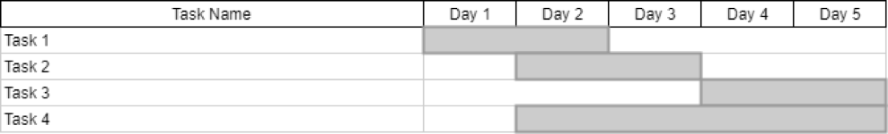For the above Gantt chart, which of the following statements is wrong?
The relationship between tasks 1 and 2 satisfies the Start-To-Start constraint.
The relationship between tasks 2 and 3 satisfies the Finish-To-Start constraint.
The relationship between tasks 3 and 4 satisfies the Finish-To-Finish constraint.
The relationship between tasks 1 and 4 satisfies the Finish-To-Start constraint.
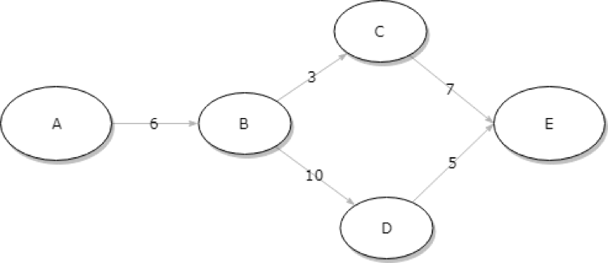
For the above PERT chart, which of the following is the correct critical path sequence?
B->C->E
B->D->E
A->B->C->E
A->B->D->E
In a PERT chart, which of the following statements is correct?
An arrow edge between two events indicates the data flow across the two events
The label on the arrow edge represents the importance of the event
The graph for the PERT chart is a directed acyclic graph
Events on the critical paths have slack time
For a software project, a free lancer developer, Jane, stores all her source code and digital assets, which she values at $50,000, on a single hard drive. The hard drive has a failure probability of around 2.00%. What is the risk exposure to a drive failure for the software project?
$50,000
$1,000
$49,000
The preceding free lancer developer, Jane, decides to purchase an off-site backup plan. What type of risk mitigation strategy is she using?
Risk avoidance
Risk protection
Risk acceptance
Risk monitoring
Which of the following is not an XP practice?
Test-driven development
Planning game
Pair programming
Sequential design
A team of software engineers decide to use Agile methodology for their new software project. Which of the following is not a justifying reason for their choice?
The customers are constantly anticipating new features for the software to be developed
As a start-up company, the development team is rather small
In a recently conducted questionnaire, the software engineers in the team commonly indicate that they prefer an ordered culture
Majority of the software engineers in the team are having high skill levels, being hired from top software companies in recent years.
A software system contains two components. Between the following two practices, which one will usually cost fewer man-hours to produce the two components?
Two developers working in parallel
Two developers engaging in pair-programming developing the components sequentially

