In Class diagrams, relationship between part and whole can be represented by which of the following ?
Generalization
Aggregation
Division
None of the above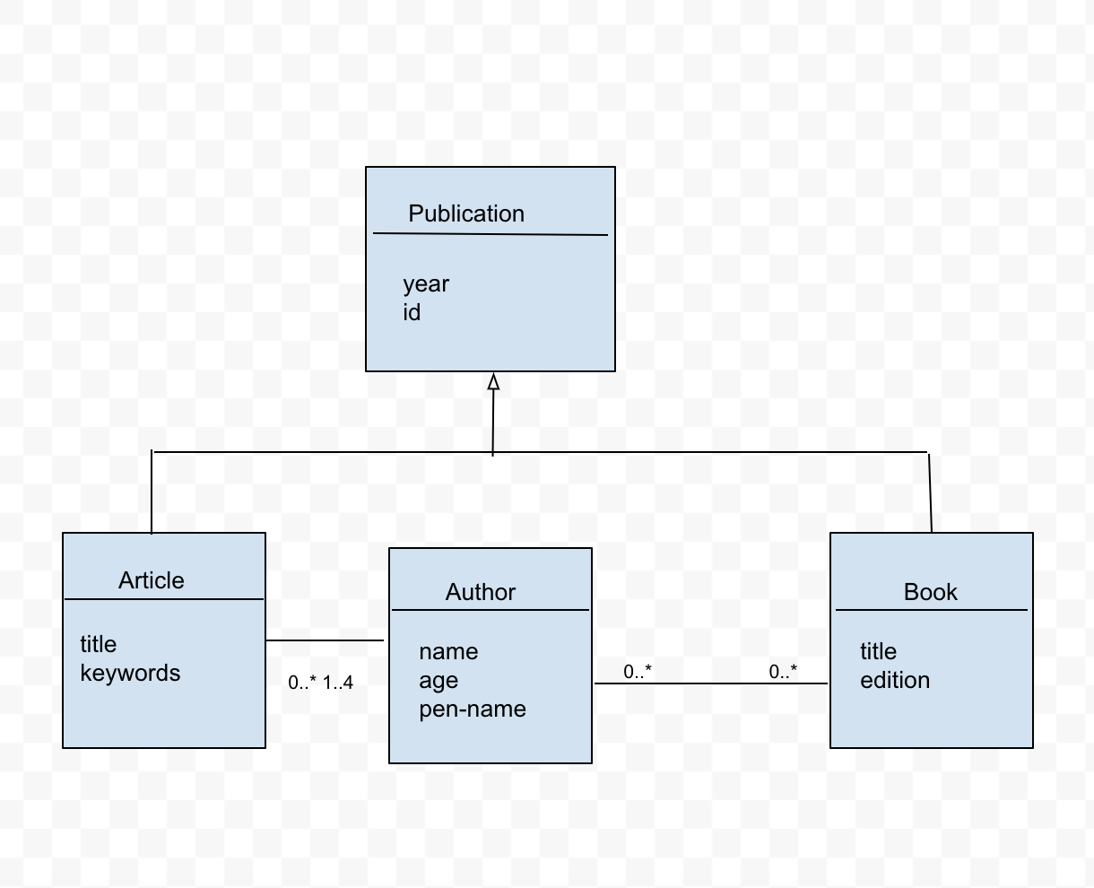Consider the above Class Diagram when answering the following question:
Which of the following statements is True about Author ?
An author may have written nothing.
Every author has contributed up to four articles.
Every author has contributed at least one article and at least one book.
Every book has up to one author.
Consider the Class diagram in Question 2
Which relationship best describes the relationship between Publication and Article?
Composition
Generalization
Aggregation
None of the above
Consider the class diagram from Question 2
Which of the following statements is NOT True about the Class Diagram ?
Every publication has an Author.
Every Article has at least one Author
Not every Book has an Author
None of the above
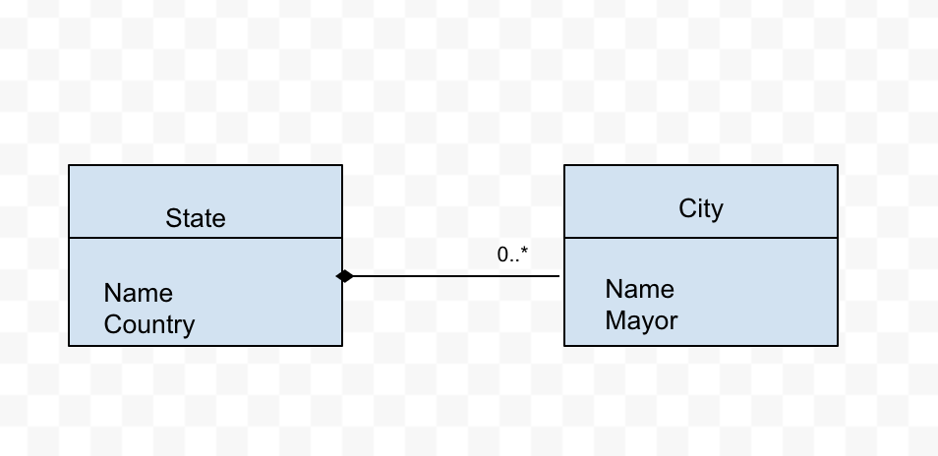Based on this Class diagram, which of the following statements about the City and State classes is correct ?
No two cities can have the same name.
Each city can be in zero or one states
Each city is in exactly one state
No two states can have the same name.
P restaurant wants to automate ordering of pizzas for customers. The following are the requirements.
Two sizes of pizzas are available: large, small
Each pizza can have two different sauces and two different bases
A customer can order a pizza or a drink
Which of the following is LEAST likely to be a class or attribute for the above requirements?
Pizza
Order
Customer
Sauce
Drink
Size
From the requirements stated in Question 6, answer the following question:
Which of the following is MOST likely to be an operation?
Base
Order
Sauce
None of the above
In UML diagrams, how are abstract classes distinguished from concrete classes?
They are shown in the same way
Class names for abstract classes are shown in italics
Class names for concrete classes are shown in italics
Abstract classes are shown as boxes with bold outlines
Which of the following terms best describes the case where a Queue class is implemented using an internal instance of Array for storing the elements in the queue?
Creation
Composition
Generalization
Singularity
Is the following statement True or False?
UML class diagrams are a good way to represent the algorithmic nature often interactions between classes.
True
False
The vertical dimension of a sequence diagram represents which of the following ?
Message
Time
Objects
Replies
Is the following statement True or False?
Class Diagrams can show timing-related information.
True
False
Which of the following determines the order of events in a Sequence Diagram ?
The order of events based on their object-creation time
The order of events based on their triggering time
The order of events based on their importance
The order of events based on their duration time

