1. 下载elasticsearch6.5软件包,解压缩放到c盘根目录
2. 下载安装jdk1.8版本,并安装调试
3. 下载nodejs 6版本,安装调试
4. 启动执行,双击bat文件启动

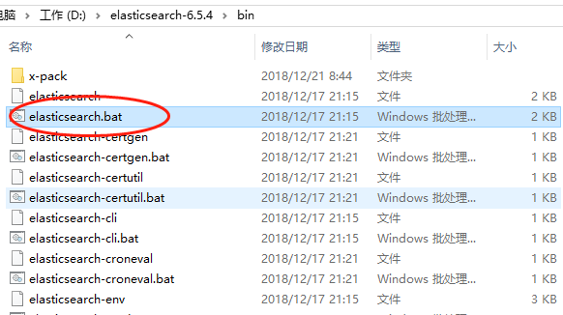

可以在控制台中看见打印输出的内容

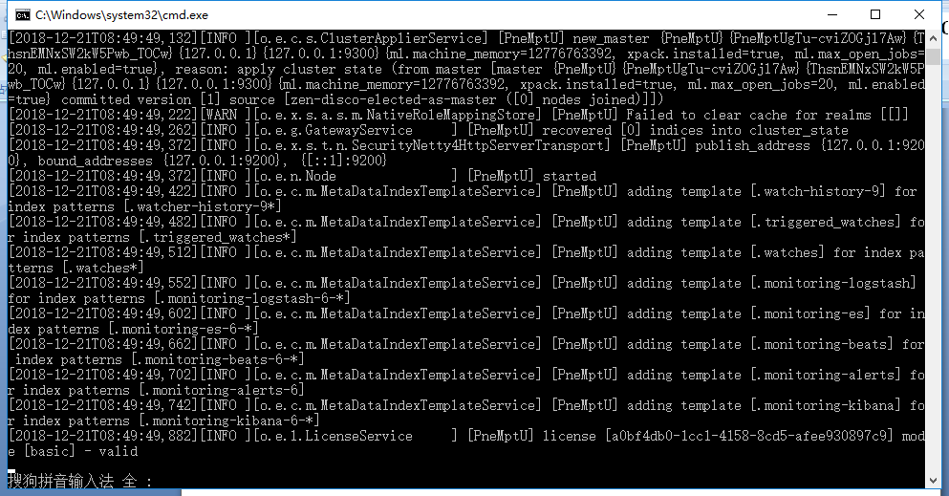

浏览器中输入:http://localhost:9200

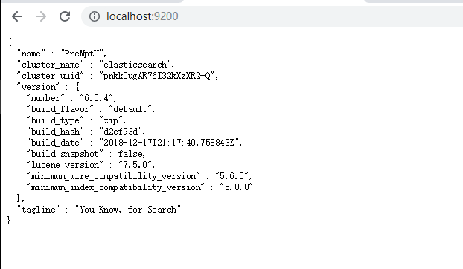

表示可以用了

1. 下载安装elasticsearch-head集群控制管理插件

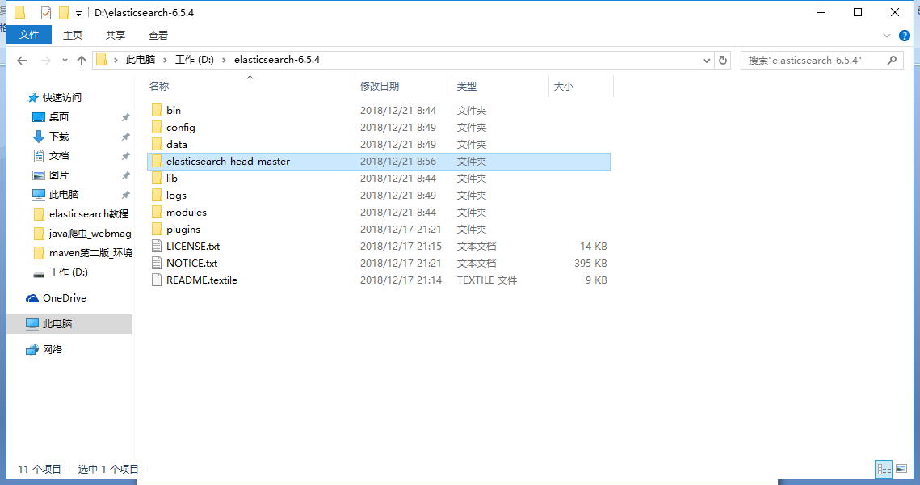

1. 更新elasticsearch-head

在cmd下,进入到C:\elasticsearch-6.5.4\elasticsearch-head-master文件夹中,执行命令: git clone git://github.com/mobz/elasticsearch-head.git

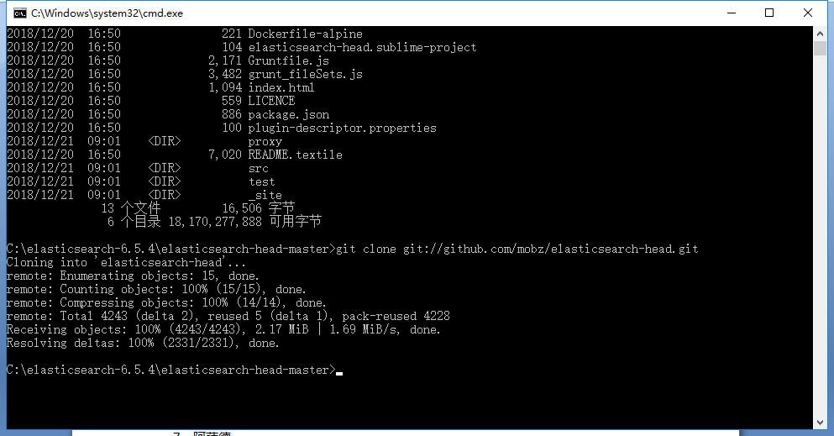

可以在文件夹里看见elasticsearch-head安装成功

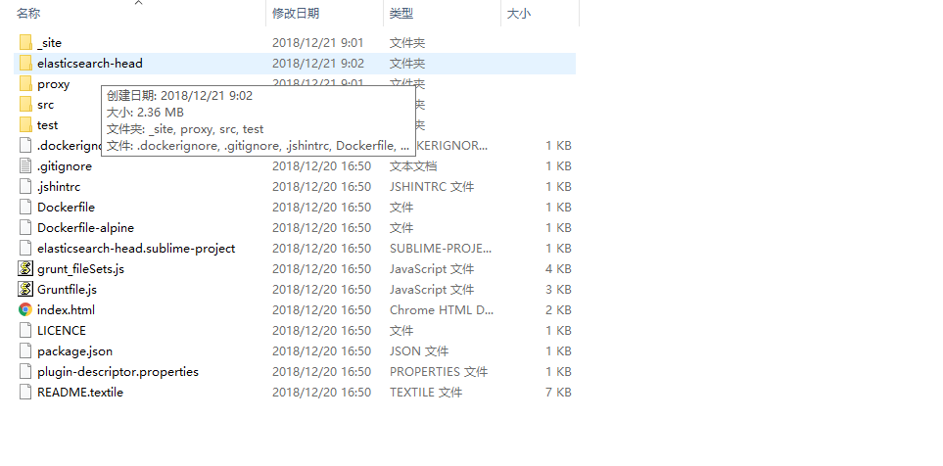

1. 安装grunt插件

进入到head安装目录下执行npm install -g grunt-cli

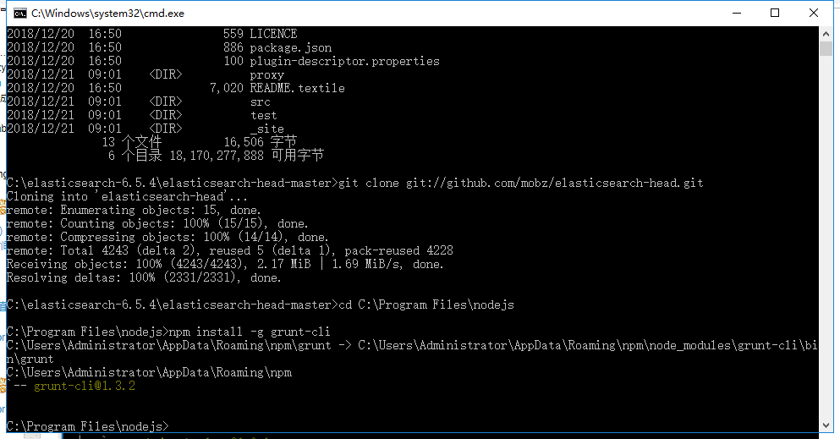

然后执行淘宝镜像安装

npm install -g cnpm --registry=https://registry.npm.taobao.org

然后在head文件夹下执行依赖安装

cnpm install

1. 修改head源码

打开head文件夹,修改文件Gruntfile.js

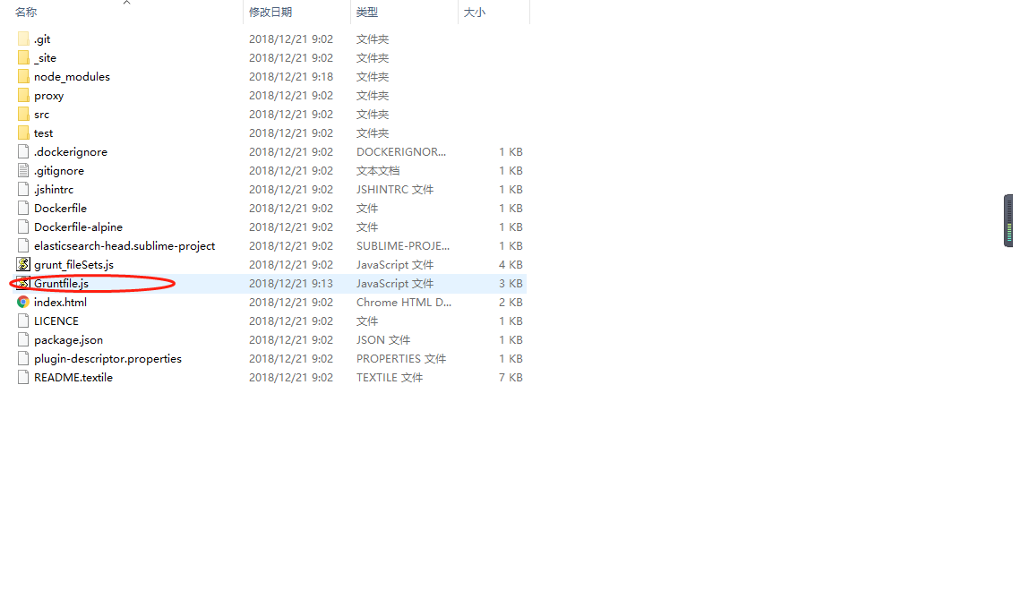

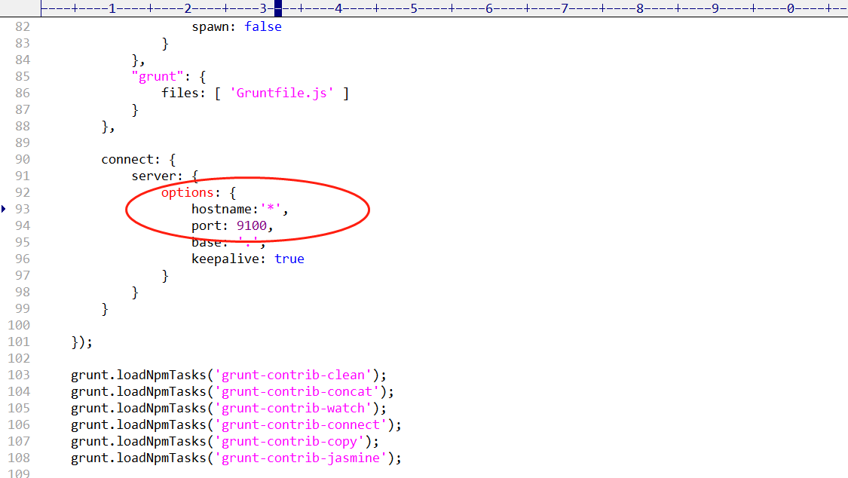

修改C:\elasticsearch-6.5.4\elasticsearch-head-master\elasticsearch-head\_site下的app.js文件

把最后一项localhost修改成要连接的服务器的ip地址,本机的话可以省略

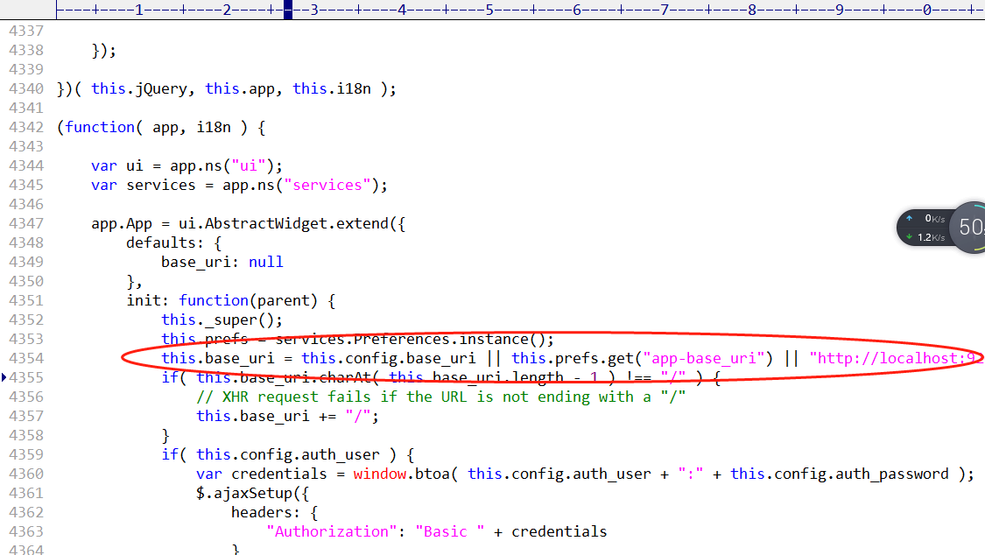

1. 修改elasticsearch.yml文件

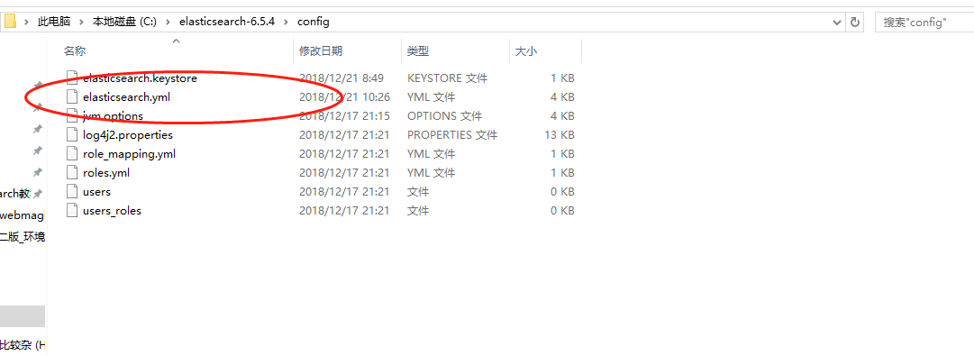

# ======================== Elasticsearch Configuration =========================

#

# NOTE: Elasticsearch comes with reasonable defaults for most settings.

# Before you set out to tweak and tune the configuration, make sure you

# understand what are you trying to accomplish and the consequences.

#

# The primary way of configuring a node is via this file. This template lists

# the most important settings you may want to configure for a production cluster.

#

# Please consult the documentation for further information on configuration options:

# https://www.elastic.co/guide/en/elasticsearch/reference/index.html

#

# ---------------------------------- Cluster -----------------------------------

#

# Use a descriptive name for your cluster:

#

#cluster.name: my-application

#应用名称

cluster.name: ictr_ElasticSearch

#

# ------------------------------------ Node ------------------------------------

#

# Use a descriptive name for the node:

#

#node.name: node-1

#节点名称

node.name: ictr_node1

node.master: true

#

# Add custom attributes to the node:

#

#node.attr.rack: r1

node.attr.rack: r1

#

# ----------------------------------- Paths ------------------------------------

#

# Path to directory where to store the data (separate multiple locations by comma):

#

#path.data: /path/to/data

path.data: /data/elasticsearch

#

# Path to log files:

#

#path.logs: /path/to/logs

#

# ----------------------------------- Memory -----------------------------------

#

# Lock the memory on startup:

#

#bootstrap.memory_lock: true

#

# Make sure that the heap size is set to about half the memory available

# on the system and that the owner of the process is allowed to use this

# limit.

#

# Elasticsearch performs poorly when the system is swapping the memory.

#

# ---------------------------------- Network -----------------------------------

#

# Set the bind address to a specific IP (IPv4 or IPv6):

#

#network.host: 192.168.0.1

network.host: 127.0.0.1

#

# Set a custom port for HTTP:

#

http.port: 9200

#

# For more information, consult the network module documentation.

#

# --------------------------------- Discovery ----------------------------------

#

# Pass an initial list of hosts to perform discovery when new node is started:

# The default list of hosts is ["127.0.0.1", "[::1]"]

#

#discovery.zen.ping.unicast.hosts: ["host1", "host2"]

discovery.zen.ping.unicast.hosts: ["127.0.0.1", "[::1]"]

#

# Prevent the "split brain" by configuring the majority of nodes (total number of master-eligible nodes / 2 + 1):

#

#discovery.zen.minimum_master_nodes:

#

# For more information, consult the zen discovery module documentation.

#

# ---------------------------------- Gateway -----------------------------------

#

# Block initial recovery after a full cluster restart until N nodes are started:

#

#gateway.recover_after_nodes: 3

#

# For more information, consult the gateway module documentation.

#

# ---------------------------------- Various -----------------------------------

#

# Require explicit names when deleting indices:

#

#action.destructive_requires_name: true

http.cors.enabled: true

http.cors.allow-origin: "*"

action.auto_create_index: .security,.monitoring*,.watches,.triggered_watches,.watcher-history*

xpack.security.enabled: false

xpack.monitoring.enabled: true

xpack.graph.enabled: false

xpack.watcher.enabled: false

xpack.ml.enabled: false

#xpack.security.audit.enabled: true

#http.cors.allow-headers: Authorization

#action.auto_create_index: .security,.monitoring*,.watches,.triggered_watches,.watcher-history*,.ml*

#action.auto_create_index: *

#vm.max_map_count=262144

1. 启动elasticsearch

打开elasticsearch.bat文件,启动服务

然后进入到C:\elasticsearch-6.5.4\elasticsearch-head-master\elasticsearch-head

执行:npm run start

打开浏览器可以见到服务器端

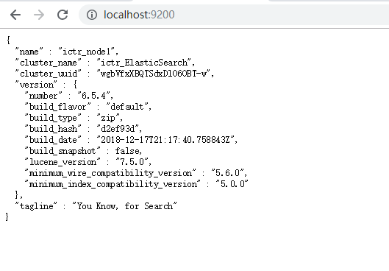

集群端

