# Requirements:

1 build a kafka environment in a static ip address which had zookeeper running for selecting the leader broker

2 Having several other static ip address computer/end point to connect to the kafka server but not directly sending massage to kafka port 9092

3 Each end point will use TCP server socket to communicate to kafka server with SSL encryption

4 TCP socket server side on kafka will never stop unless to be asked to do so

5 TCP socket server side will receive the massage which is sending from client and then run Kafka Producer API to produce the massage to broker

6 Using Kafka consumer API to indicate the massage had been successfully injected into Kafka system

## Code generation process:

1 reviewing the TCP socket server knowledge on reference book, understanding the TCP socket need a handshake, and if for one lived socket, only one massage could be handled.

2 looking on the requirements email and start to produce some code module on single socket communication between client and server

3 keeping programming on single communication to achieve the massage producing to kafka and run consumer on kafka by using subprocess (run in parallel)

4 could poll kafka server log to client side

5 could poll consumer data from consumer API from client side

6 call Alister to re-identify multiple thread needed

7 looking original library for python socket server and looking ThreadMaxIn with serve.forever()

8 writing down steps to build multiple threads on socket server

9 re-building the multiple threads code based on steps

10 test server side

11 write client side

12 test on multiple IP

13 check kafka consumer

14 writing comments

15 review and learn from new knowledge

## Running instruction and testing screen shot:

1 server start: python servernew.py

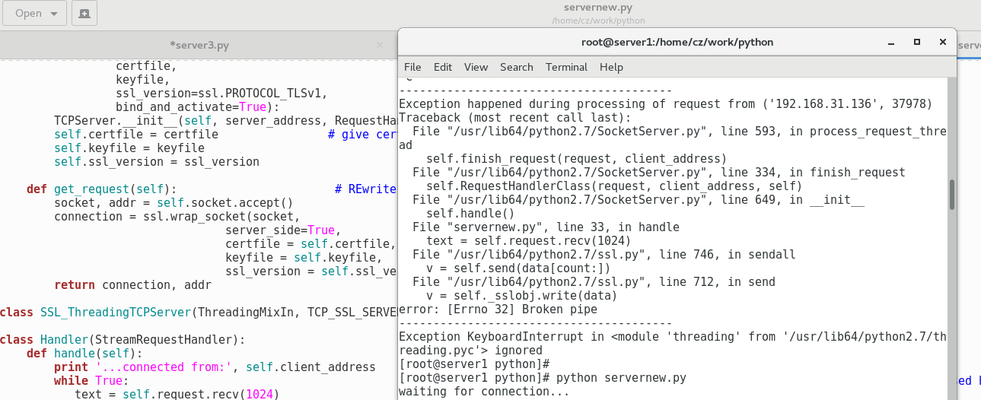

2 client 1 start: python cliennew.py

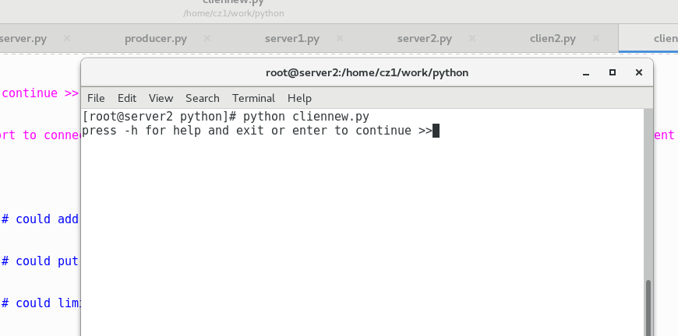

3 client 2 start: python cliennew.py

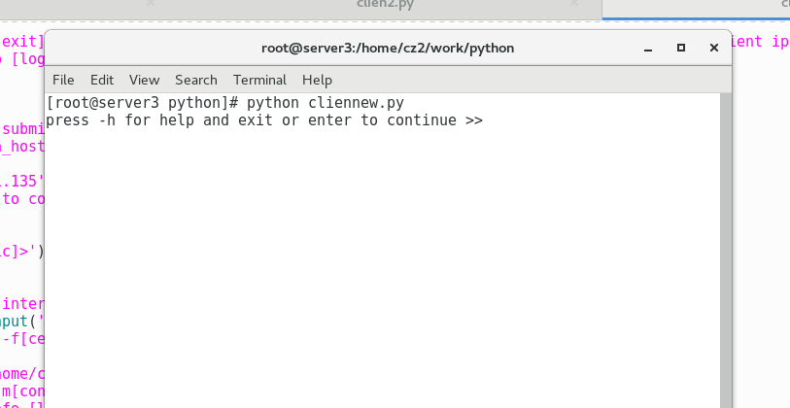

4 client 1 typing command for connection and sending massage: enter for default and massage no space(could keep improving this feature)

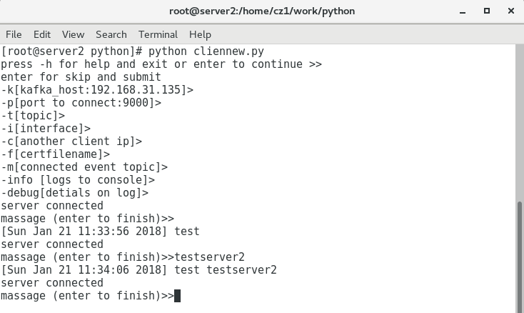

5 client 2 typing command and sending massage: enter for default and massage no space(could keep improving this feature)

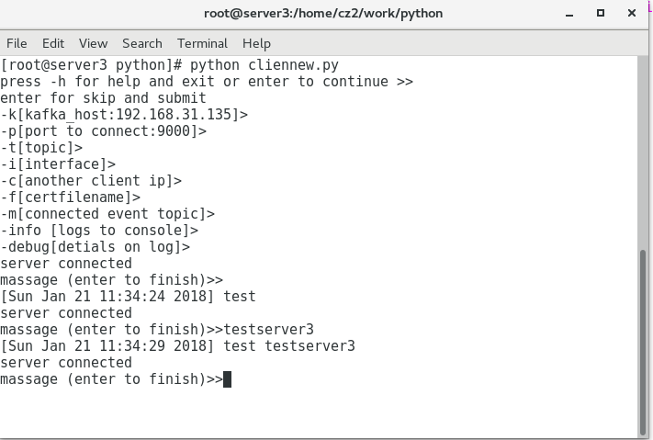

6 check client 1 massage on server and kafka consumer: run consumer API on python consumer.py on kafka server

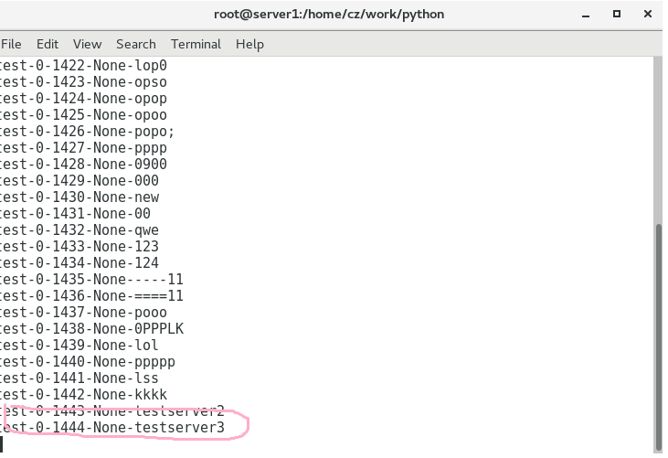

7 Done