3a)

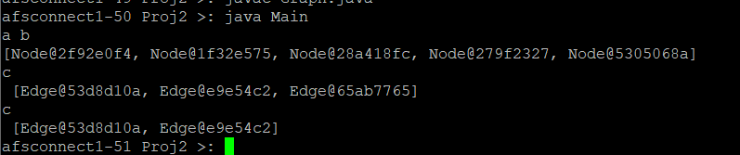

3b)



3c) (Node 0, Node 2, Node 3 first destination which would be heading back to node y in this case)



3d)

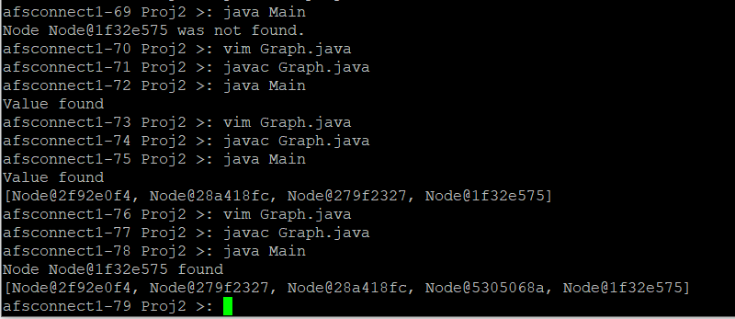

3e)

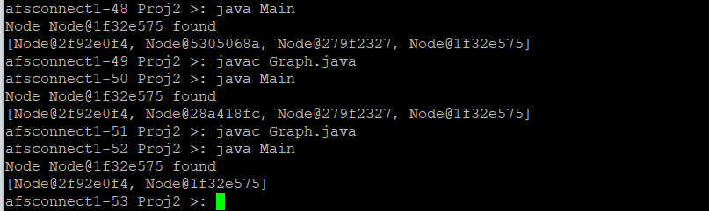

3f)