With a very large audit table (devops2-ctms.imedidata.net – Forest data) attempting to view the CSV audit log for a study (1672), the system cuts off the request after 5 minutes before the data can be returned:

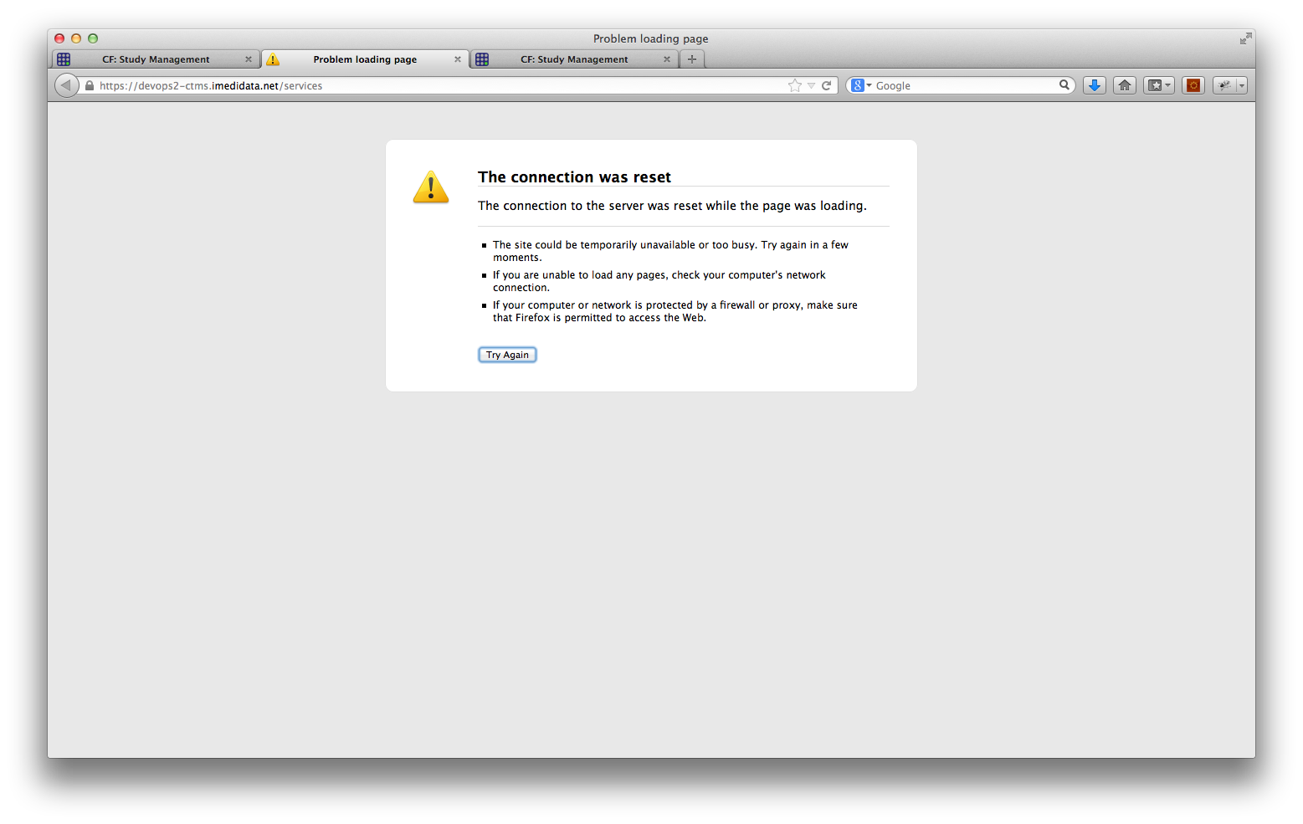

With a smaller audit table (ctms-validation2.imedidata.net), attempting to get the CSV audit log for a study (.01CTMS(Aux)) returned a file – see separate attachment PreFix-RecordAuditTrail.csv