HowTo MicroMacroVerse:

Start the application with atom on a local server. Select code and on the index.html “Start Project”.

Now you should see the Animated View. To deactivate this view press “C”. Now you can move with left click on your mouse the view rotation. With “W” and “S” is the movement implemented. So press “W” to move forward and press “S” to move backward.

On the next side are a short description of the scenes.

General Description

Relevant for all scenes

* All scenes have a skybox with 6 sides to should an environment.
* All scenes use a phong shader (generally set to the root Node)

1. Scene Solarsystem

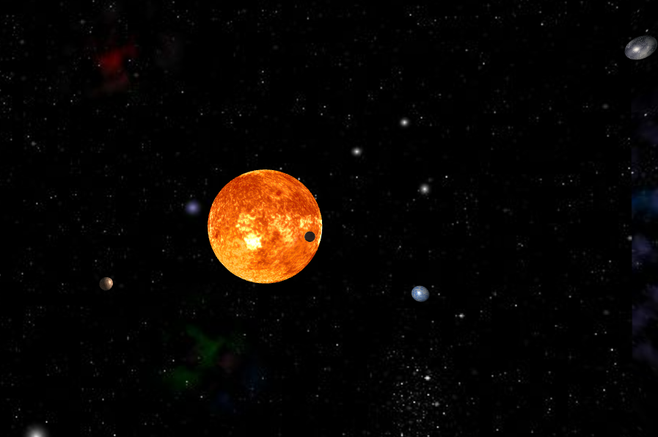

Solarsystem

This scene shows a Solarsystem with planets rotating around the sun in the middle of the scene. The light source in this scene is the sun which you can see on the planets. The planets are only lighted on the sun faced side.

1. Scene Earth with Birds

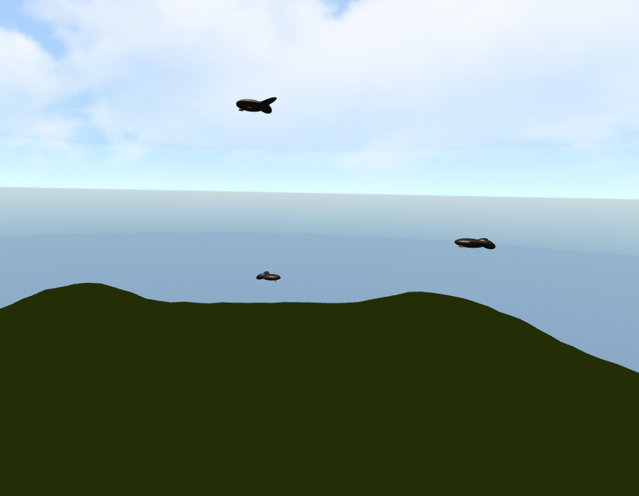

Earth

Deeper look on one earth like planet. There are 3 birds flying around. On the ground is a Heightmap implemented which shows a hilly landscape. The heightmap uses the vertexes of the plane and generate with an heightmap this hilly structur.

**Special Effect**

* Heightmap

1. Scene Atom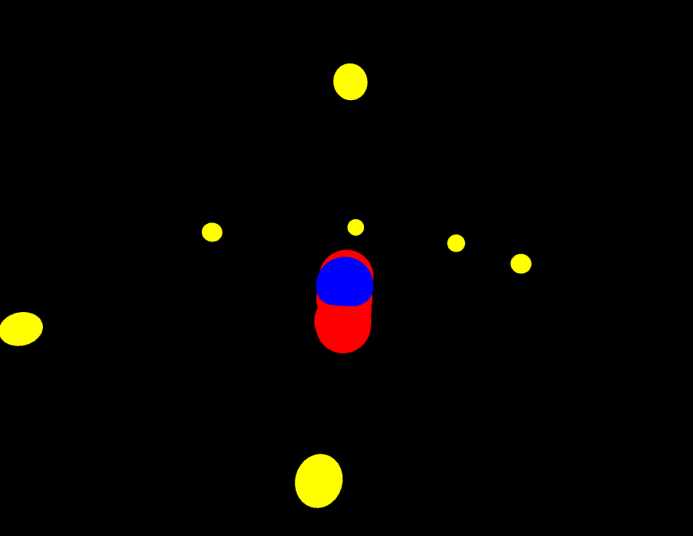

Atom

The last scene is detail look on one atom of the clouds in scene 2. There are 7 electrons rotating around a nucleus with 7 protons and 7 neutrons. We use for the colors of the atoms a color shader which just sets the color brute force.